ACTIVITY1

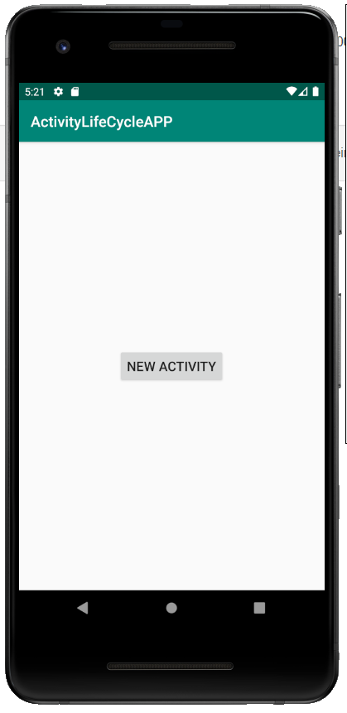

ACTIVITY2

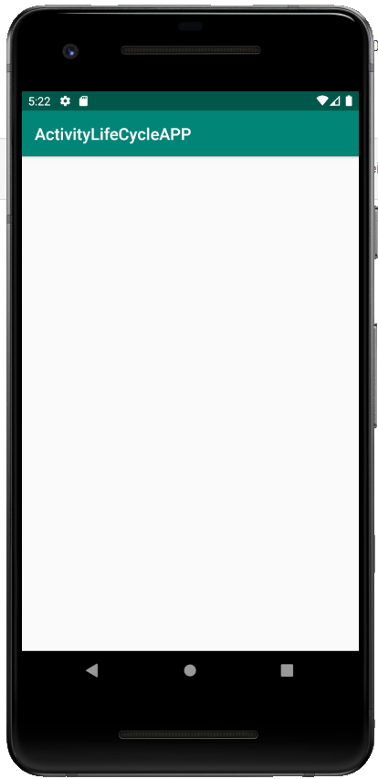

打开app，进入1

2019-11-27 17:10:25.810 17410-17410/com.example.activitylifecycleapp I/Activity1: Method in OnCreate

2019-11-27 17:10:25.813 17410-17410/com.example.activitylifecycleapp I/Activity1: Method in OnStart

2019-11-27 17:10:25.815 17410-17410/com.example.activitylifecycleapp I/Activity1: Method in OnResume

点击打开2

2019-11-27 17:12:22.653 17410-17410/com.example.activitylifecycleapp I/Activity1: Method in OnPause

2019-11-27 17:12:22.729 17410-17410/com.example.activitylifecycleapp I/Activity2: Method in OnCreate

2019-11-27 17:12:22.731 17410-17410/com.example.activitylifecycleapp I/Activity2: Method in OnStart

2019-11-27 17:12:22.732 17410-17410/com.example.activitylifecycleapp I/Activity2: Method in OnResume

2019-11-27 17:12:23.429 17410-17410/com.example.activitylifecycleapp I/Activity1: Method in OnStop

退回1

2019-11-27 17:13:21.131 17410-17410/com.example.activitylifecycleapp I/Activity2: Method in OnPause

2019-11-27 17:13:21.144 17410-17410/com.example.activitylifecycleapp I/Activity1: Method in OnRestart

2019-11-27 17:13:21.144 17410-17410/com.example.activitylifecycleapp I/Activity1: Method in OnStart

2019-11-27 17:13:21.145 17410-17410/com.example.activitylifecycleapp I/Activity1: Method in OnResume

2019-11-27 17:13:21.719 17410-17410/com.example.activitylifecycleapp I/Activity2: Method in OnStop

2019-11-27 17:13:21.726 17410-17410/com.example.activitylifecycleapp I/Activity2: Method in OnDestroy

返回home

2019-11-27 17:16:05.236 17410-17410/com.example.activitylifecycleapp I/Activity1: Method in OnPause

2019-11-27 17:16:06.047 17410-17410/com.example.activitylifecycleapp I/Activity1: Method in OnStop

返回该app

2019-11-27 17:17:03.698 17410-17410/com.example.activitylifecycleapp I/Activity1: Method in OnRestart

2019-11-27 17:17:03.702 17410-17410/com.example.activitylifecycleapp I/Activity1: Method in OnStart

2019-11-27 17:17:03.703 17410-17410/com.example.activitylifecycleapp I/Activity1: Method in OnResume

关闭1

2019-11-27 17:17:35.572 17410-17410/com.example.activitylifecycleapp I/Activity1: Method in OnPause

2019-11-27 17:17:36.272 17410-17410/com.example.activitylifecycleapp I/Activity1: Method in OnStop

2019-11-27 17:17:46.876 17410-17410/com.example.activitylifecycleapp I/Activity1: Method in OnDestroy