Project

- Create a folder called learn_git

- Cd (change directory) into the learn_git folder.

- Create a file called third.txt.

- Initialize an empty git repository

- Add third.txt to the staging area.

- Commit with the message "adding third.txt".
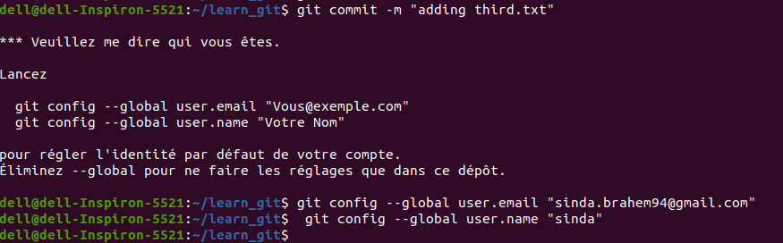
- Check out your commit with git log
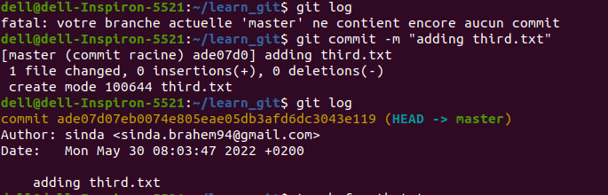
- Create another file called fourth.txt.

- Add fourth.txt to the staging area.

- Commit with the message "adding fourth.txt"

- Remove the third.txt file.

- Add this change to the staging area. (Using the command "git add . "

- Commit with the message "removing third.txt".

- Check out your commits using git log.

- Change your global settings to core.pager=cat - you can read more about that here.

- Write the appropriate command to list all the global configurations for git on your machine.

- You can type git config --global to find out how to do this.

