RETAIL SALES DATA ANALYSIS
A Data Analysis Project Using Python

Prepared by: Sinda Hachem
Tools: Python, Pandas, Matplotlib
Dataset: Retail Sales Dataset (1,000 transactions)

1. Introduction
This project analyzes retail transaction data to understand sales performance, customer purchasing patterns, and revenue distribution across product categories and genders. Python was used to explore the dataset, calculate key metrics, and create visualizations.

2. Project Objectives
- Explore the dataset and examine data quality.
- Calculate total revenue and average transaction amount.
- Compare revenue across product categories.
- Compare revenue by gender.
- Examine monthly revenue trends.

3. Tools and Methodology
Python was used as the programming language. Pandas was used to load, inspect, group, and summarize the data. Matplotlib was used to generate charts. The analysis included checking missing values and duplicate rows, calculating summary statistics, grouping revenue by category and gender, and aggregating revenue by month.

4. Dataset Overview
The dataset contains 1,000 transactions and 9 columns. These include transaction ID, date, customer ID, gender, age, product category, quantity, price per unit, and total amount.
Missing values: 0. Duplicate rows: 0.

5. Key Performance Indicators
Metric | Result
Total revenue | 456,000.00
Number of transactions | 1,000
Average transaction amount | 456.00

6. Revenue by Product Category
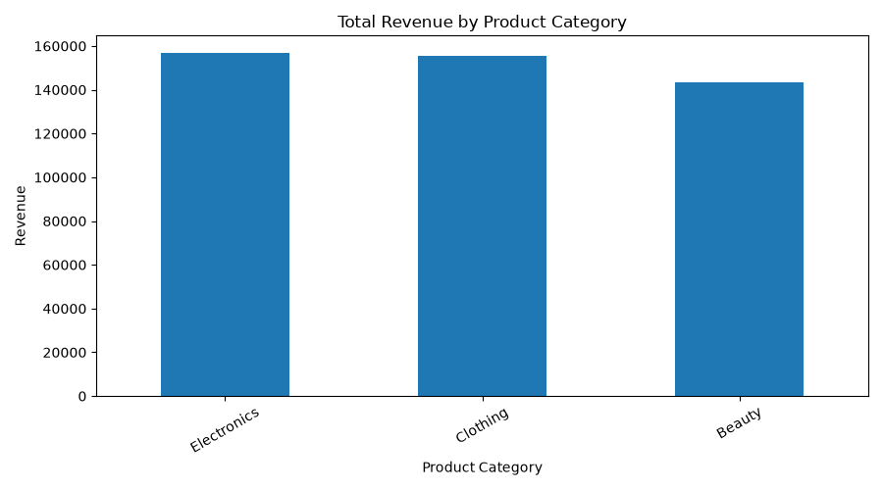
- Electronics: 156,905.00
- Clothing: 155,580.00
- Beauty: 143,515.00
Electronics generated the highest revenue among the categories in this dataset. Clothing followed closely, while Beauty generated the lowest total revenue.

7. Revenue by Gender
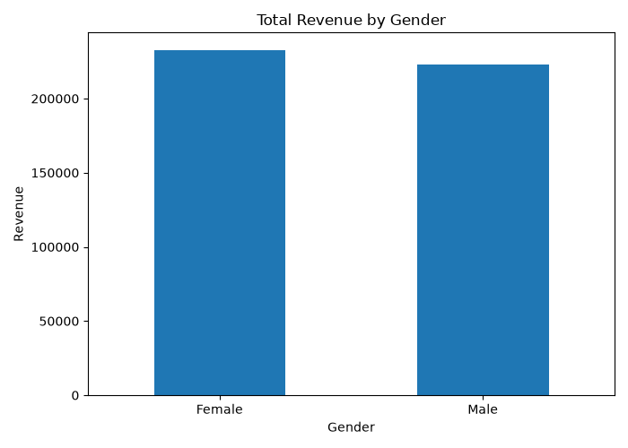
- Female: 232,840.00 (51.1% of revenue)
- Male: 223,160.00 (48.9% of revenue)
Female customers contributed slightly more total revenue than male customers. This comparison describes revenue, not the number of customers or the average spending per customer.

8. Monthly Revenue Trend
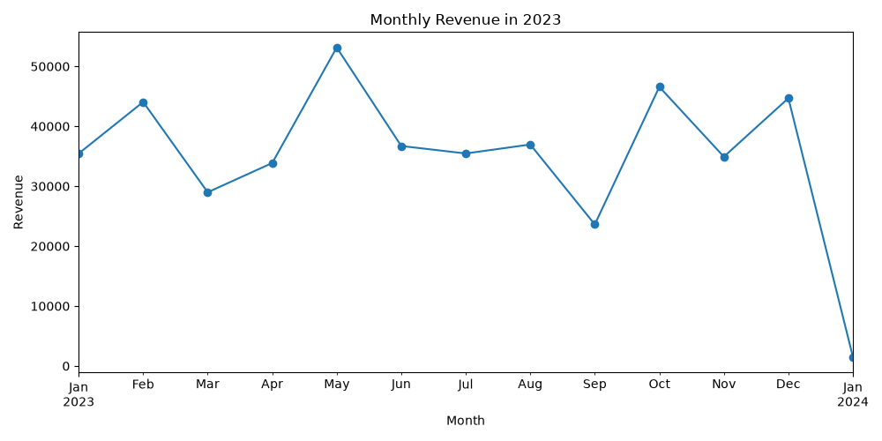
The highest-revenue month in the available data was May 2023, with revenue of 53,150.00.
Monthly totals can help a retailer identify stronger and weaker periods and plan inventory and promotions. The chart should be reviewed before making business decisions.

9. Conclusion
The analysis covered 1,000 transactions and recorded total revenue of 456,000.00. The average transaction amount was 456.00. Electronics was the leading product category by revenue, and female customers contributed slightly more revenue than male customers. The dataset contained no missing values or duplicate rows according to the checks performed.

10. Recommendations and Limitations
- Investigate why Electronics generated the highest revenue and whether this pattern continues over time.
- Review monthly trends before planning promotions and inventory.
- Compare transaction counts and average transaction amounts by category and gender for deeper insights.
- Check profit margins and operating costs before treating revenue as business profitability.
- Confirm the dataset's currency and time coverage before presenting results to decision-makers.
Limitation: This report summarizes the available dataset. It does not establish why customers made purchases, and revenue alone does not measure profit.

