===============================================================================
4. BUSINESS SUMMARY REPORT
===============================================================================
*/

SELECT
'Total Sales' AS measure_name,
ROUND(SUM(total_price_usd)::NUMERIC, 2) AS measure_value
FROM sales

UNION ALL

SELECT
'Total Quantity',
ROUND(SUM(quantity)::NUMERIC, 2)
FROM sales

UNION ALL

SELECT
'Average Order Value',
ROUND(AVG(total_price_usd)::NUMERIC, 2)
FROM sales

UNION ALL

SELECT
'Total Orders',
COUNT(DISTINCT id_order_number)::NUMERIC
FROM sales

UNION ALL

SELECT
'Total Customers',
COUNT(DISTINCT customer_id)::NUMERIC
FROM sales

UNION ALL

SELECT
'Total Products',
COUNT(DISTINCT product_id)::NUMERIC
FROM sales;

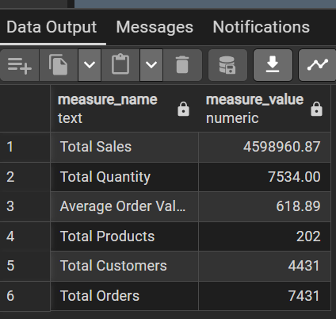

===============================================================================
5. MAGNITUDE ANALYSIS
===============================================================================
*/

-- Revenue by Country
SELECT
billing_address_country,
ROUND(SUM(total_price_usd)::NUMERIC, 2) AS total_revenue
FROM sales
GROUP BY billing_address_country
ORDER BY total_revenue DESC;
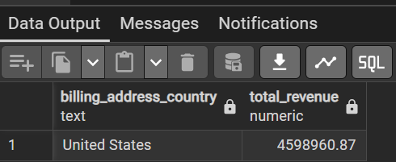

-- Revenue by Province
SELECT
billing_address_province,
ROUND(SUM(total_price_usd)::NUMERIC, 2) AS total_revenue
FROM sales
GROUP BY billing_address_province
ORDER BY total_revenue DESC;
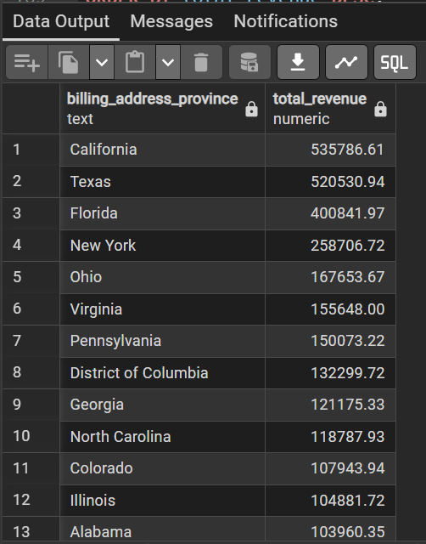

-- Orders by Payment Gateway
SELECT
gateway,
COUNT(DISTINCT id_order_number) AS total_orders
FROM sales
GROUP BY gateway
ORDER BY total_orders DESC;

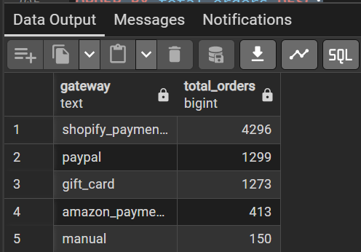
-- Revenue by Customer
SELECT
customer_id,

CONCAT(
billing_address_first_name,
' ',
billing_address_last_name
) AS full_name,

ROUND(SUM(total_price_usd)::NUMERIC, 2) AS total_revenue

FROM sales

GROUP BY
customer_id,
full_name

ORDER BY total_revenue DESC;
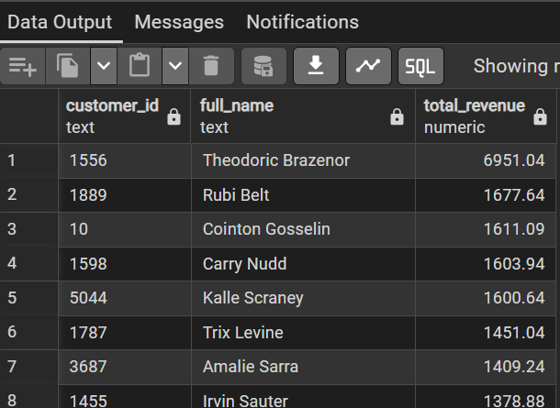

/*
===============================================================================
6. RANKING ANALYSIS
===============================================================================
*/

-- Top 5 Customers by Revenue
SELECT
customer_id,

CONCAT(
billing_address_first_name,
' ',
billing_address_last_name
) AS full_name,

ROUND(SUM(total_price_usd)::NUMERIC, 2) AS total_revenue

FROM sales

GROUP BY
customer_id,
full_name

ORDER BY total_revenue DESC

LIMIT 5;
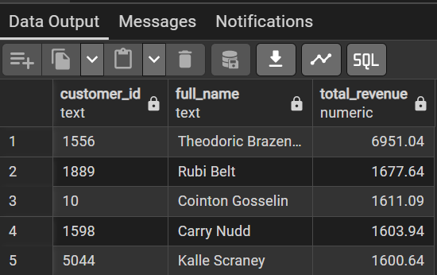

-- Top 5 Products by Revenue
SELECT
product_id,

ROUND(SUM(total_price_usd)::NUMERIC, 2) AS total_revenue

FROM sales

GROUP BY product_id

ORDER BY total_revenue DESC

LIMIT 5;
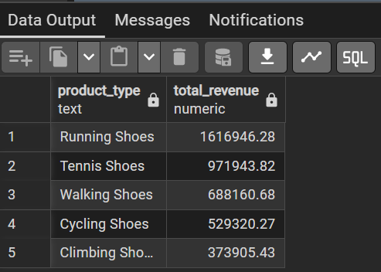

-- Lowest Performing Products
SELECT
product_id,

ROUND(SUM(total_price_usd)::NUMERIC, 2) AS total_revenue

FROM sales

GROUP BY product_id

ORDER BY total_revenue ASC

LIMIT 5;
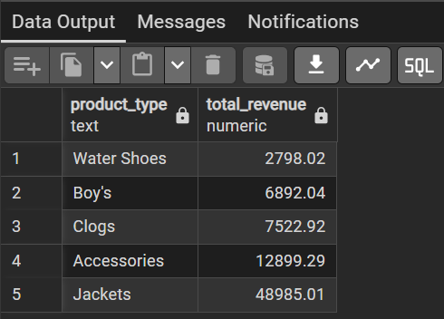

===============================================================================
7. DAILY SALES ANALYSIS
===============================================================================
Purpose:
- Analyze sales by weekday
- Arrange days Monday → Sunday
===============================================================================
*/

SELECT

CASE
WHEN EXTRACT(DOW FROM invoice_date) = 0 THEN 7
ELSE EXTRACT(DOW FROM invoice_date)
END AS day_number,

TRIM(TO_CHAR(invoice_date, 'Day')) AS day_name,

ROUND(SUM(total_price_usd)::NUMERIC, 2) AS total_sales,

COUNT(DISTINCT id_order_number) AS total_orders

FROM sales

GROUP BY
day_number,
day_name

ORDER BY day_number;
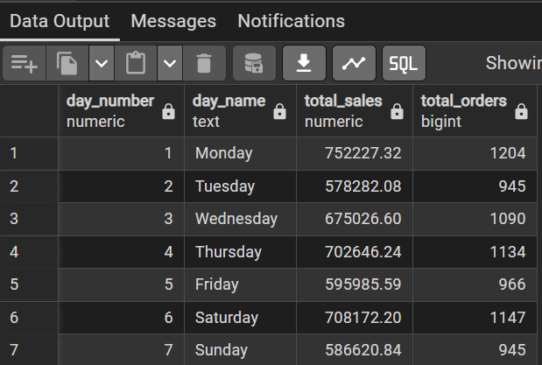

/*
===============================================================================
8. CUSTOMER SEGMENTATION ANALYSIS
===============================================================================
*/

WITH customer_spending AS
(
SELECT

customer_id,

ROUND(SUM(total_price_usd)::NUMERIC, 2) AS total_spending

FROM sales

GROUP BY customer_id
)

SELECT

customer_segment,

COUNT(*) AS total_customers

FROM
(
SELECT

customer_id,

CASE
WHEN total_spending > 5000 THEN 'VIP'
WHEN total_spending BETWEEN 1000 AND 5000 THEN 'Regular'
ELSE 'New'
END AS customer_segment

FROM customer_spending

) t

GROUP BY customer_segment;

/*
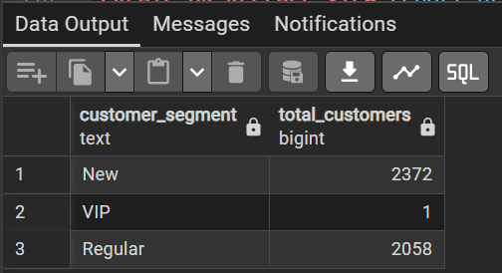
===============================================================================
9. PRODUCT REPORT VIEW
===============================================================================
*/
DROP VIEW IF EXISTS report_products;

CREATE OR REPLACE VIEW report_products AS

WITH product_summary AS
(
SELECT

product_id,

COUNT(DISTINCT id_order_number) AS total_orders,

COUNT(DISTINCT customer_id) AS total_customers,

CAST(SUM(total_price_usd) AS NUMERIC(12,2)) AS total_sales,

CAST(SUM(quantity) AS NUMERIC(12,2)) AS total_quantity,

CAST(AVG(total_price_usd) AS NUMERIC(12,2)) AS avg_price,

MAX(invoice_date) AS last_sale_date,

MIN(invoice_date) AS first_sale_date

FROM sales

GROUP BY product_id
)

SELECT

product_id,

total_orders,

total_customers,

total_sales,

total_quantity,

avg_price,

last_sale_date,

AGE(last_sale_date, first_sale_date) AS product_lifespan,

CASE
WHEN total_sales > 50000 THEN 'High Performer'
WHEN total_sales > 10000 THEN 'Mid Range'
ELSE 'Low Performer'
END AS product_segment

FROM product_summary

ORDER BY total_sales DESC;
