ABSTRACT

Now a days it is essential to assess our knowledge at regular time intervals . it is better if we have a platform where we can not only learn a subject but also assess it by taking quiz. In this project we tried to give all material related to a subject such as its syllabus, video modules, lecture notes. It also provides the student to evaluate the understanding level by taking quiz. To evaluate the performance over a period of time we are storing marks of each quiz in our database.
The whole process of assigning test and evaluating their scores after the test, was done manually till date. It is very time consuming. Also it is difficult to keep the answer sheets being generated as well as the maintenance of the record of each examination. The chance of loss of records is high and record searching is difficult. Result processing takes more time and the presence of more invigilators is a must if there are more number of students to write the exam.
Here the students can learn and assess themselves and their scores are recorded and maintained in the database which saves time and improves confidence in students as they assess themselves whenever they want.

INDEX

- INTRODUCTION -[07]
1.1. Brief Introduction About Project
1.2. Existing System
1.3. Proposed System
- SOFTWARE REQUIREMENT SPECIFICATION -[09]
2.1. Introduction -[09] 2.1.1. Product Overview
2.2. Specific requirements -[10]
2.2.1. External Interface Requirements
2.2.2. Software Product Feature
2.2.3. Software System Attribute
- SOFTWARE DESIGN -[11]
3.1. High Level Design -[11]
3.2. Detailed Design Documentation -[11]
3.2.1. Sequence Diagrams
3.2.2. Activity Diagrams
3.2.3. Class Diagram
3.3. Module List -[18]
- IMPLEMENTATION AND SCREENSHOTS -[19]
- SOFTWARE TEST DOCUMENTATION -[26]
5.1. Unit Test Documentation(UTD) -[26]
5.2. Integration Test Documentation(ITD) -[30]
- CONCLUSION -[32]
- Bibliography -[33]

1. INTRODUCTION

Online quiz is being launched because a need for a destination that is beneficial for both instructors and students. Students can download and share materials for particular subject, can give exams and view their results. This site is an attempt to remove the existing flaws in the manual system of conducting exams.

Purpose:
Our project “A Self learning Platform” fulfills the requirements of the teachers to conduct the quiz online. Only Instructor can add the materials and quizzes for all subject and also can put a notice if they want to display any information.
Students can give exams without the need of going to any physical destination. They can view the result at the same time.
Thus the purpose of this site is to provide a system that saves the efforts and time of both the teachers and students.
1.2. Existing System
Teaching , conducting exams and assessing student often involves lots of paper work, sheets and other manual data entry tasks. There is also little visibility among the guides and student as to what the status of each test is during the course of a semester.
Nowadays many web sites are there like NPTEL, MIT Course, Coursera and Udacity etc.
1.3. Proposed System
The SELF LEARNING PLATFORM is to replace the existing system with a software solution. This system is accessed through Internet by hitting the URL provided by the organization. And the users who want to use this application should be registered with their details. This system allows both new and old users. And then he has his own user id and account. Then he will be treated as a member of the site and allowed to use the system by reading and giving exams there by assessing himself.
SELF LEARNING PLATFORM
To overcome the problems in the existing system the proposed system is able to track the overall students tasks and saves each team student's time.
DISCUSSION FORUM
To overcome the problems in the current messaging system the proposed system provides a discussion form feature integrated in to the teamwork network to keep a running record of all conversations held by members of registered users.

Provides the following features.

- Faster processing.
- Maintaining all information regarding a particular subject.
- Better accuracy in learning a subject.
- Fast retrieval of Information.
- Easy to use and learn.
- Self evaluation.
- Statistics to check the progress.

2. SYSTEM SPECIFICATIONS
2.1. Introduction
The main aim of the system is to develop a web based program for reading, taking quizzes and displaying discussion purpose of a user and displaying them in GUI format.

This system contains following operations like

Registration
Login
Notices
Discussions
2.1.1. Product Overview
The objective of this system is to develop a web application to facilitate discussions. The login screen can be opened by clicking the icon given to the user. Multiple users can access the system simultaneously. Here the subject name is clickable. The user can click one subject one subject at a time. There is user verification, the user must give correct username while login. The username is previously denied and allocated to the user. Upon giving wrong username then it display a text of wrong user name in the login screen. The discussion forums contain unlimited number of queries and its answers sent by different registered users.

2.2. Specific Requirements

2.2.1. External Interface Requirements
User Interface User interface include various GUI screens.
1. Login screen
This screen contain user name and password, after entered user credentials click on a login button.
2. Registration screen
This will acquire to display username, password, department, date of birth ,email id.
3.Discussions screen
This will display all the discussions and the users can post the comment on this.

Hardware interface
Internet cable.
Software interface
The software interface required are
Server TOMCAT
Browser
Java programming language
2.2.2. Software Product Feature
Reading discussions and notices and display in GUI format.
Remotely login.
2.2.3. Software System Attribute
Reliability This product can effectively run in any environment with free from error.
Availability This system is available to user all the time.
Security The person whose login account is present in the server is expected to login to the system.
Maintainability This system is maintainable for any change or any fault in the future.
Portability This system can run in Linux like Ubuntu, OpenSuse platform and can also run anywhere
Performance It will provide better performance for its purpose.

3. SOFTWARE DESIGN
3.1. High Level Design
User Interface
1. User should have minimum knowledge in using a browser (Internet Explorer or Netscape Navigator).
- User Interacts with the software product through the WebPages and its options.
- If user wants to use this system he should have the login id and password.
Actors
The main actors of the system are.
1. Instructor
2.Student
3.2. Detailed Design Diagram
Primary Model Elements of UML
Error: Reference source not found

Node: A Hardware device upon which software nay reside and/or execute.

Note: A Comment, Explanation or annotation.

`

Package: A container of elements.

UML DIAGRAMS
Sequence -1

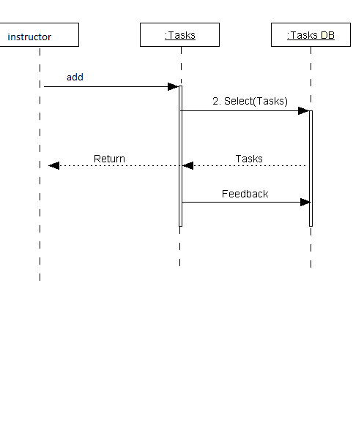

Sequence-2

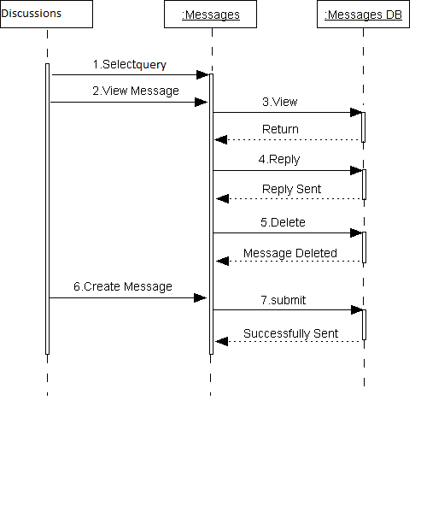

Sequence-3

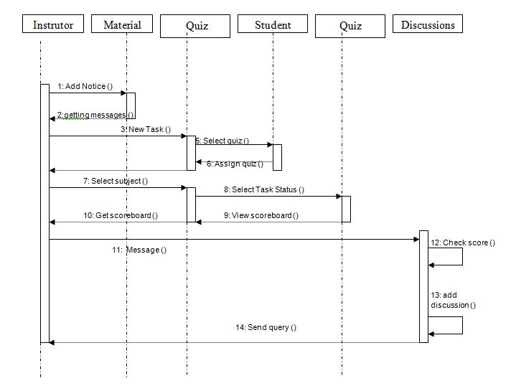

Activity-1
Instructor System
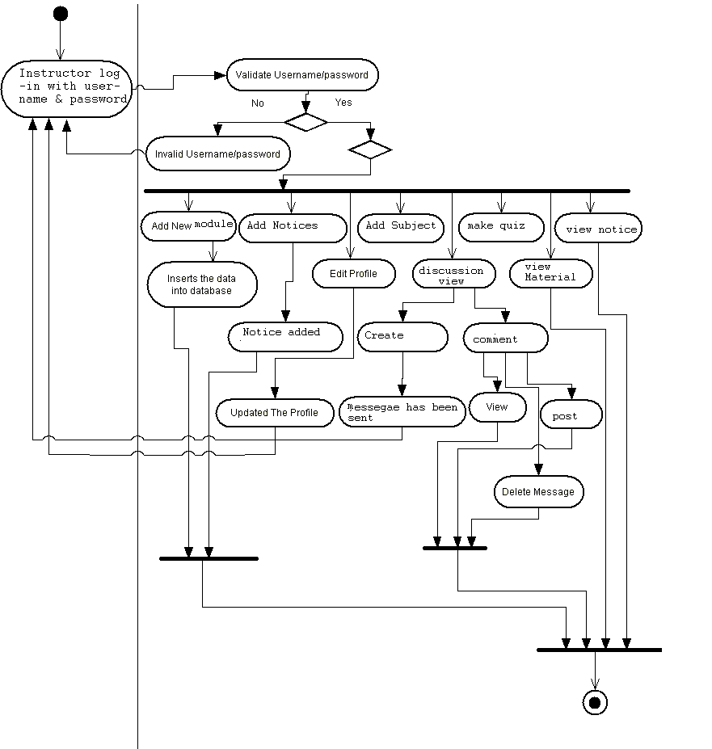

Activity-2
Student System

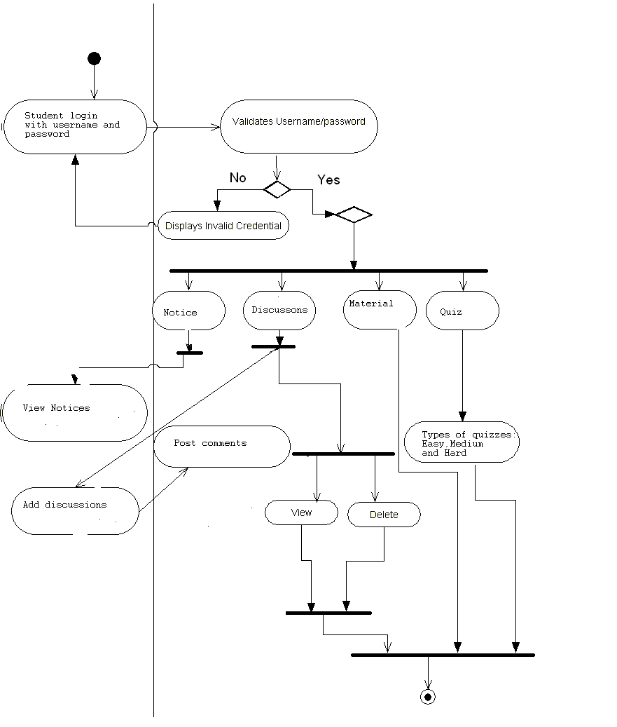

Class Diagram with associations
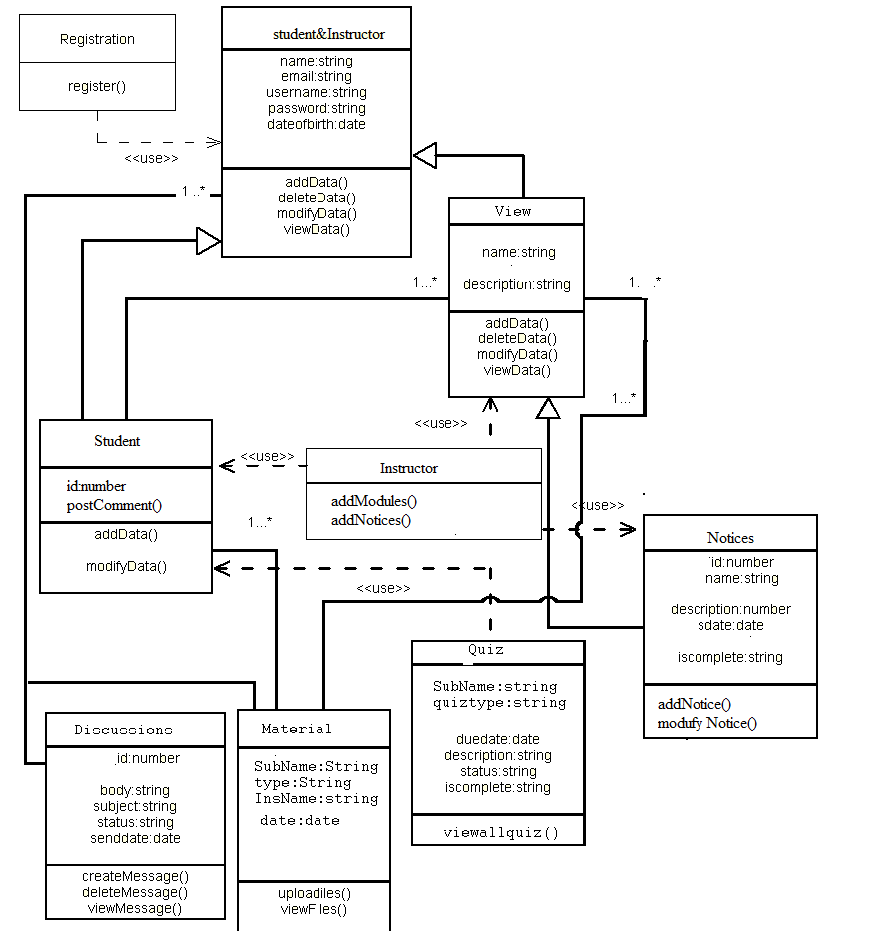

Module List
1. Student or instructor registration
2. Member login & password
3. Add Material
4.Add Notices and Display
5. Quiz
6. Discussion forums
7. Display Result statistics

4. IMPLEMENTATION AND SCREENSHOTS
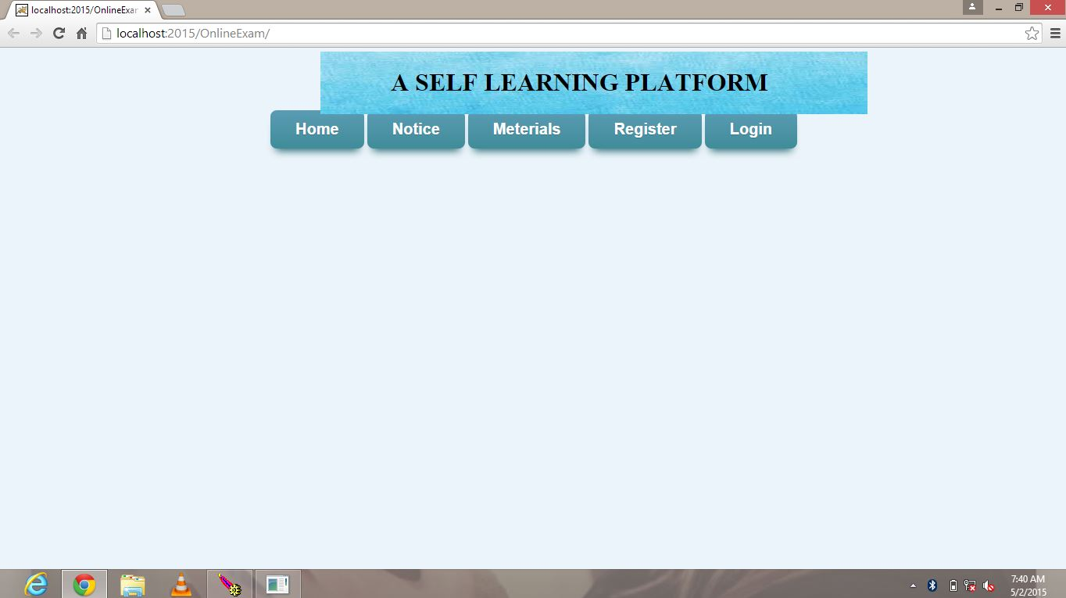
WELCOME PAGE

Steps:
1. To login through this form you have to register first. If you are already registered please login.
2. REGISTER:
INSTRUCTOR REGISTRATION
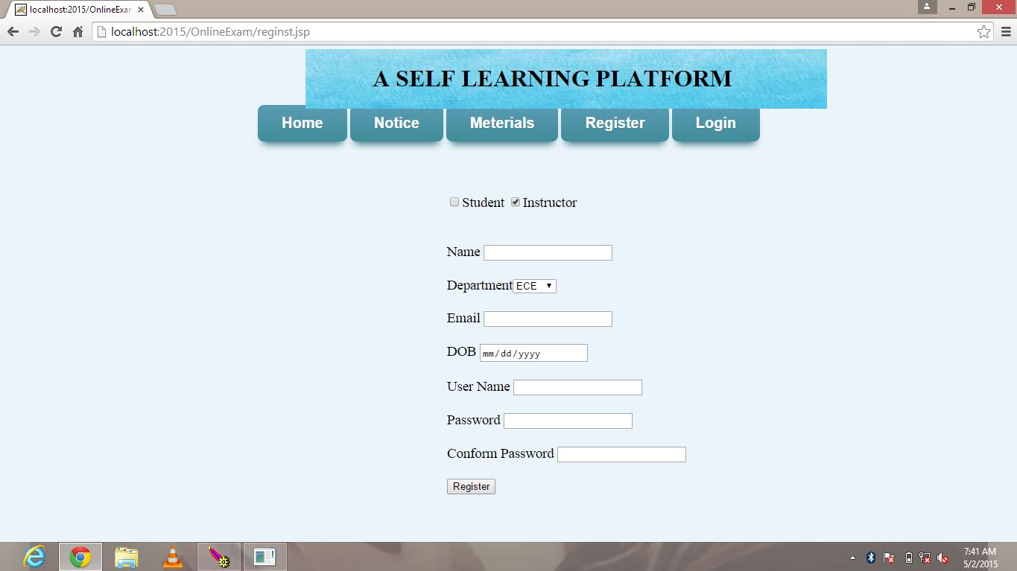
STUDENT REGISTRATION
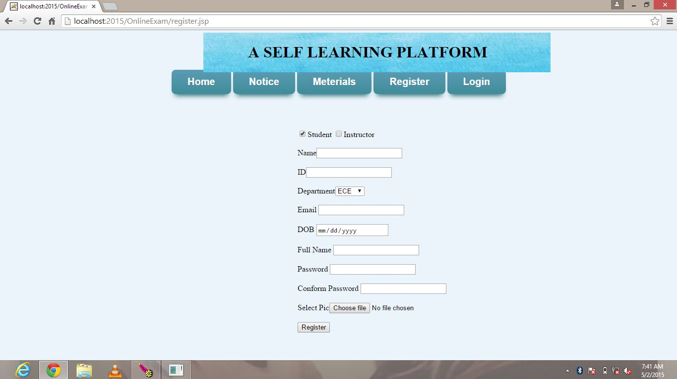
Fill all the details and do login.
3. LOGIN PAGE
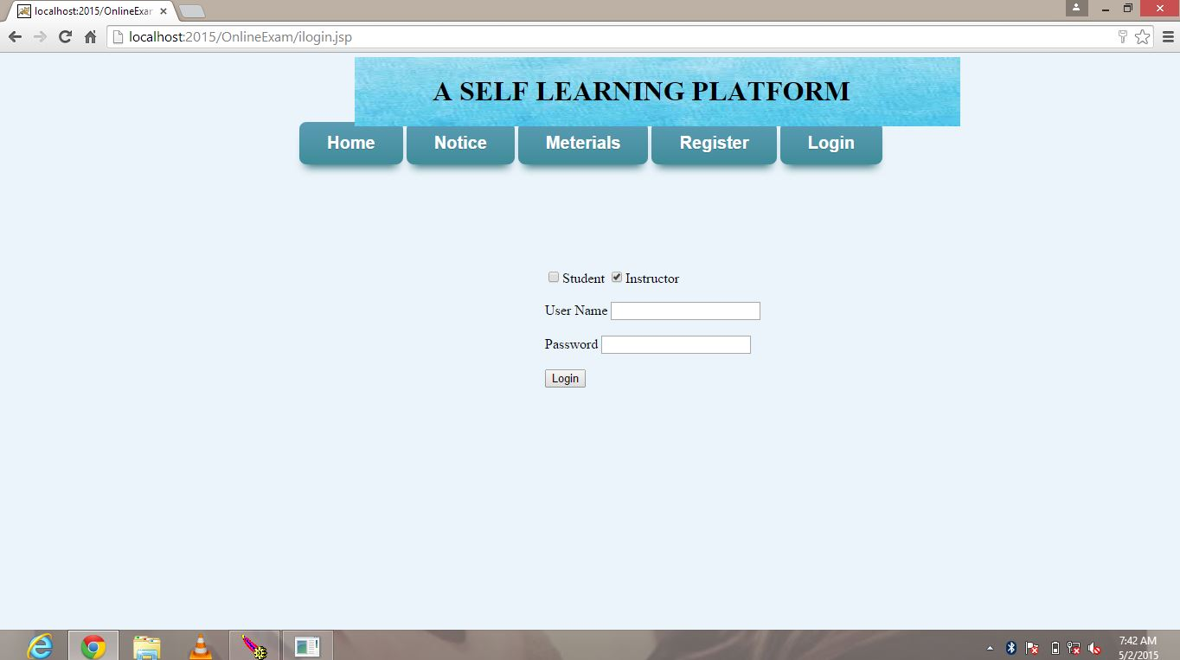
Depending upon your category you can perform action accordingly.
4. When category as Instructor: can add material, notices, quizzes
Instructor HOMEPAGE
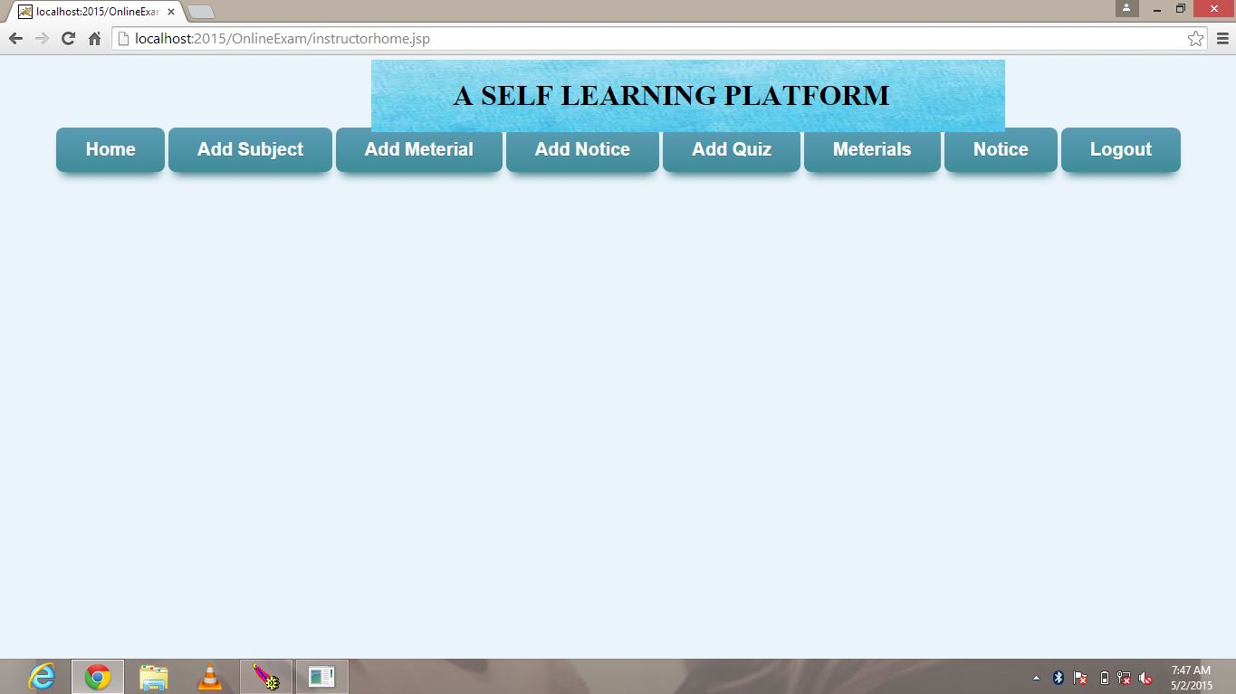
ADD MATERIAL
By selecting subject instructor can materials according to choice.
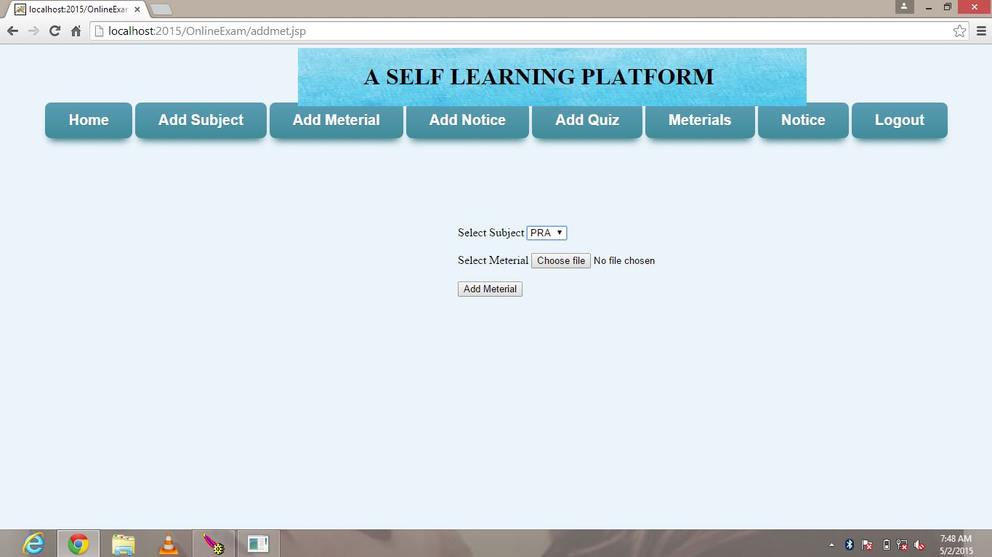

ADD NOTICE
Instructor can add notices if they want to display any information
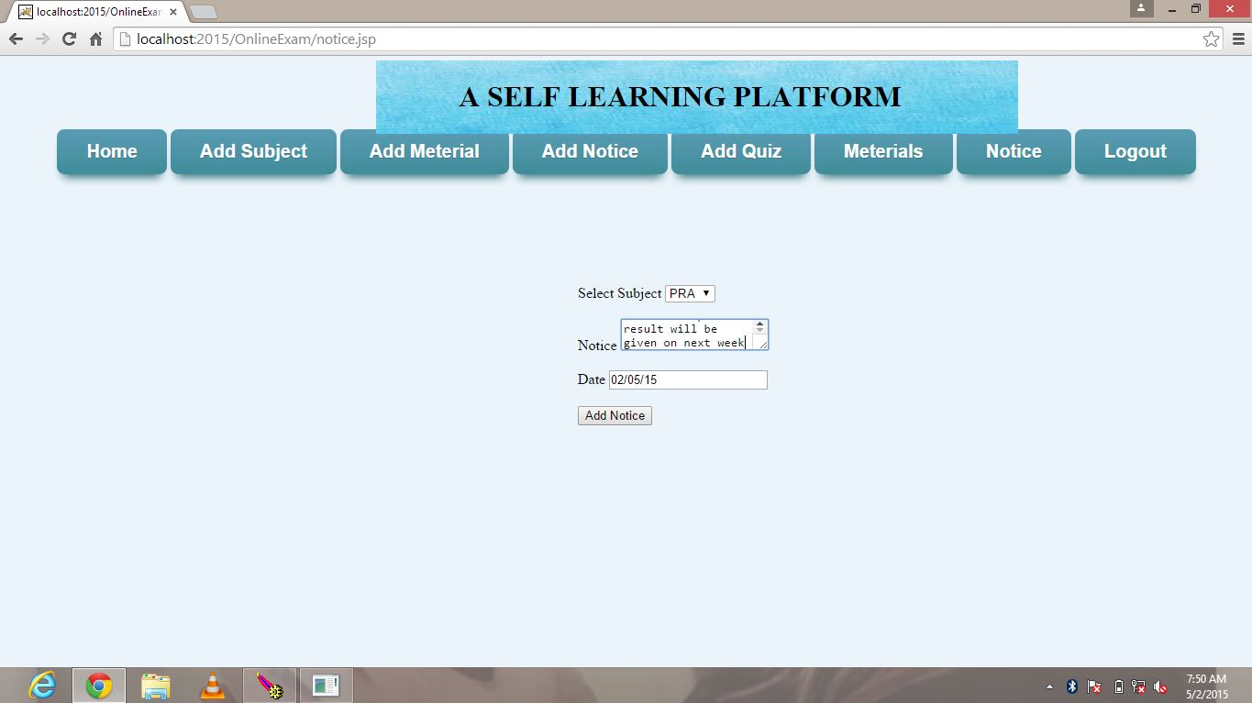
ADD QUIZ: Instructor has to make the quiz according to the choice of subject given. He has to choose the following options mode of quiz, subject, and number of questions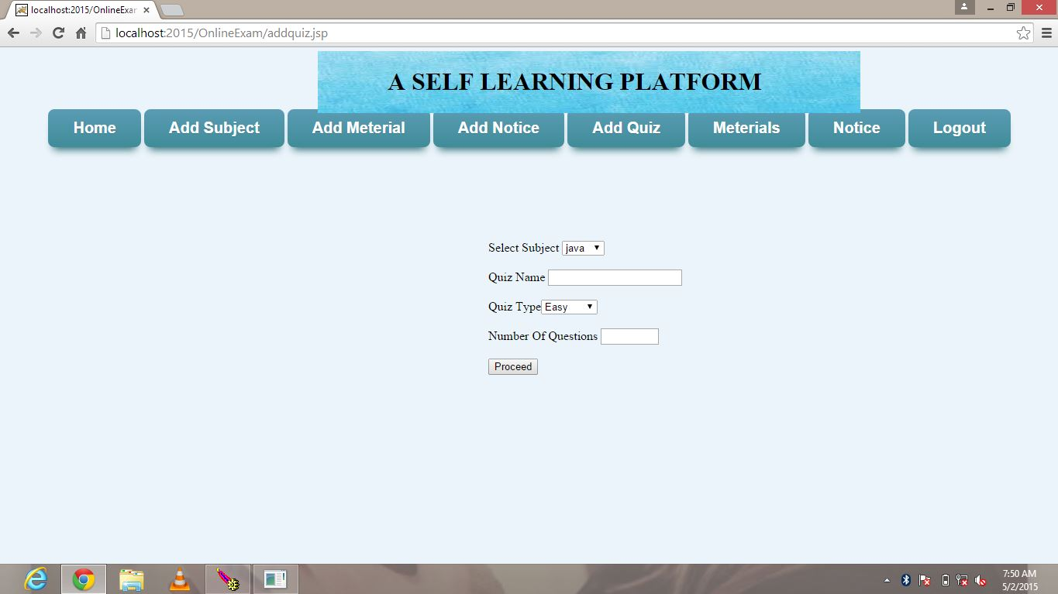

After the choosing the subject, quiz mode he need to add the questions to that quiz
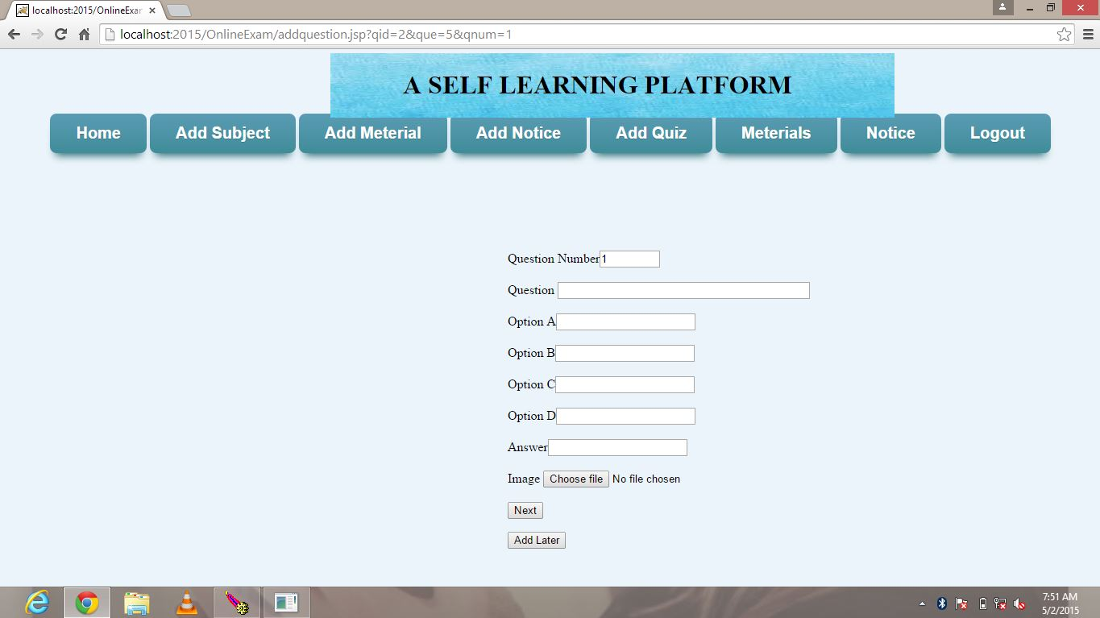
Instructor can view the material, notices to check.
If user login as Student
Student homepage
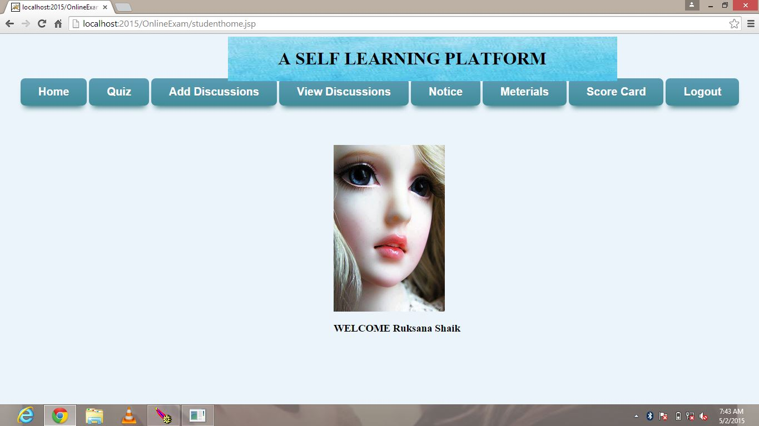

After login student choose action to perform from the given links
If he chooses quiz by selecting subject, mode of exam questions will display
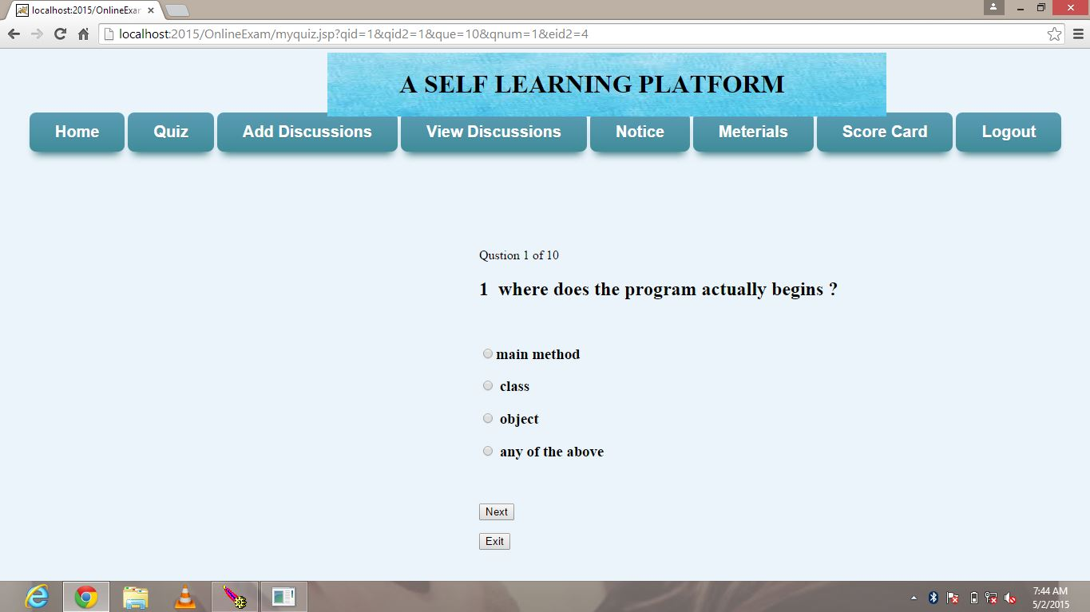
After answering all questions click on submit it will show scoreboard for the quiz finished
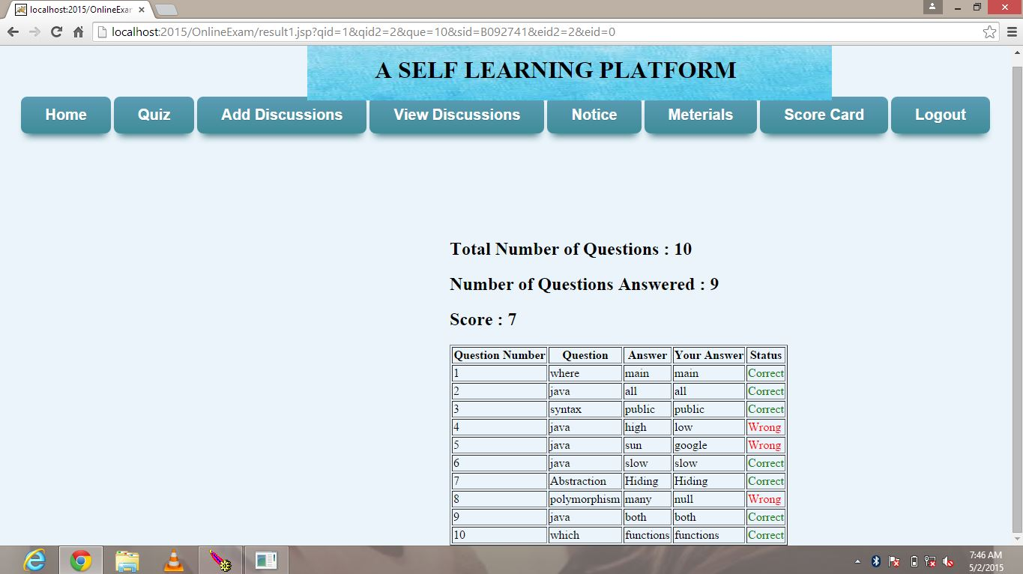

Students can post their queries get clarified by using Discussion forums
Publishing the discussion on a query
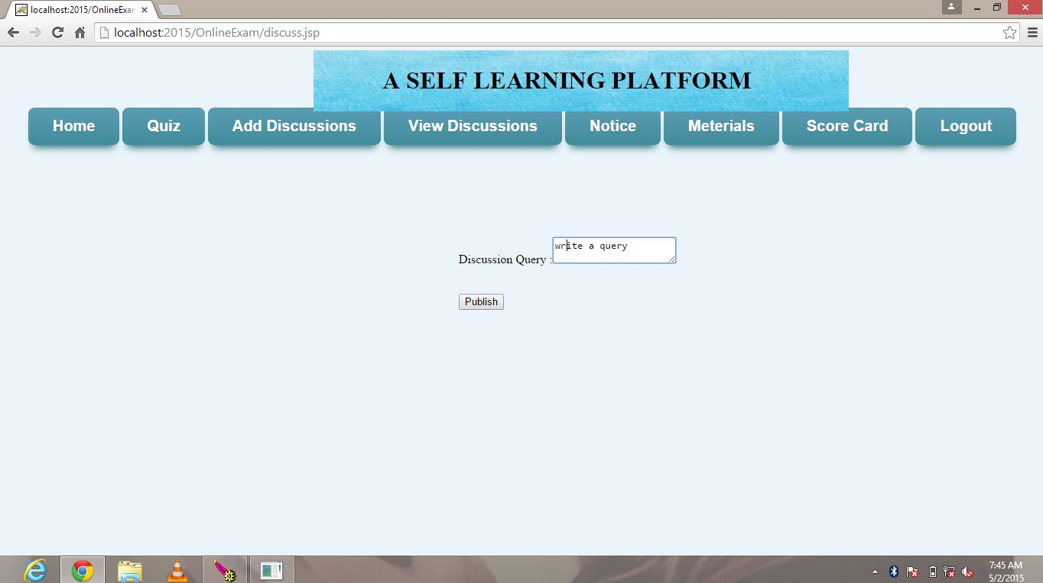
And also can comment their views for the queries
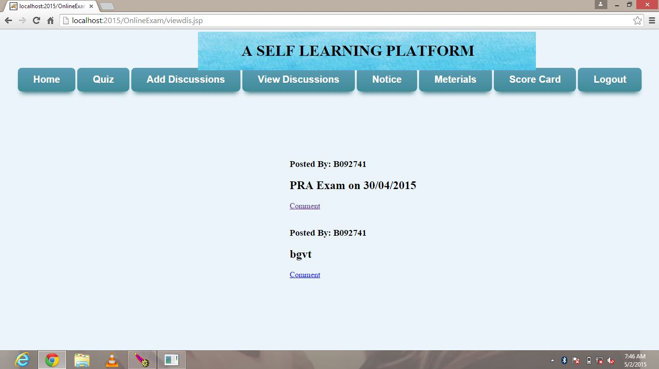
Students can also view material and can download by his choice of subject, and also can view notices posted by instructors.

5. SOFTWARE TEST DOCUMENTATION

5.1 UNIT TEST DOCUMENTATION

1. Registration module
Introduction
System Overview: This module requires the details of users to store in database, and also to take username and password for future login for website. In this page user need to enter the details in textboxes, if these details are correct after clicking on submit button he will be taken to welcome page.
Test Approach: The approach is to check valid and invalid user.
Test Plan:
Functionality:
After receiving username from the user it checks validation of the username entered by the user follows correct format or not. It also checks whether the user is valid or not.

Features to be tested:
- Check that the username should not be left blank.
- Whether it can detect an invalid user
- A unique password should be set

TEST CASES
Case registration: TestCase1

Purpose: Its purpose is to test how the registration page responds to the username without any entry i.e. null.

Inputs: No entry in username field.

Expected outputs: It will show an error message “Invalid username, Please enter the username”.

Test Procedure: Don’t enter any value in the username text field of registration page. Then click the register button.

Case registration: Test Case 2
Purpose: Its purpose is to test how the registration page responds to the password and confirm password without any entry.
Inputs: No entry in password field.
Expected Outputs It show an error message "Invalid password! Please enter any password”.
Test Procedure: Don’t enter any value in the password text field of registration page. Then click the register button.

Case registration: Test Case 3
Purpose: Its purpose is to test how the registration module responds to the email without any entry.

Inputs: No entry in email field.

Expected outputs: It shows an error message “Invalid email! Please enter your email id”.

Test Procedure: Don’t enter any value in the email text field of registration page. Then click the register button.

Case registration: Test Case 4
Purpose: Its purpose is to test how the register module responds to the Date of Birth without any entry.

Inputs: No entry in DOB field.

Expected outputs: It shows an error message “Invalid DOB! Please enter your Date of birth”.

Test Procedure: Don’t enter any value in the DOB text field of registration page. Then click the register button.

Case registration: Test Case 5
Purpose: Its purpose is to test how the registration module responds to the department without any entry.

Inputs: No entry in department field.

Expected Outputs It show an error message "Invalid! Please select department”.

Test Procedure: Don’t enter any value in the department text field of register page. Then click the register button.

2. Login module

System Overview: This module requires the details of users to check from database whether the login details exist or not. In this page user need to enter the username or login id and password entered at the time of registration. After login page user can access links.
Test Approach: The approach is to check valid and invalid user.
Test Plan:
Functionality:
After receiving username from the user it checks validation of the username entered by the user follows correct format or not. It also checks whether the user is exist or not.

Features to be tested:

- Check that the username should not be left blank whether it can detect an invalid user
- Check username and password are valid and exist in database

TEST CASES
Case Login: TestCase1

Purpose: Its purpose is to test how the login page responds to the username without any entry i.e. null.

Inputs: No entry in username field.

Expected outputs: It will show an error message “Invalid username, Please enter the username”.

Test Procedure: Don’t enter any value in the username text field of login page. Then click the login button.

Case login: Test Case 2
Purpose: Its purpose is to test how the login page responds to the password and confirm password without any entry.
Inputs: No entry in password field.
Expected Outputs: It show an error message "Invalid password! Please enter any password”.
Test Procedure: Don’t enter any value in the password text field of login page. Then click the login button.

3. INSTRUCTOR MODULE

System Overview: This module requires login from the instructor username and password. Instructor can perform add subject, add quiz, add material, add notice tasks.

Case Instructor: Test Case1
Purpose: Case1 checks the add subject page whether subject entered by the instructor valid or not.
Inputs: No entry in subject field
Expected outputs: It shows an error message “enter the subject name”.
Test procedure: Do not enter or select any subject name of subject field of add subject page. Then click on add button.

Case instructor: Test case 2
Purpose: It will check the material uploaded by instructor correct or not.
Inputs: Do not upload any file in material field
Expected Outputs: It shows error
Test procedure: Do not select any material to upload in material field then click on submit.

Case instructor: Test Case 3
Purpose: It will check the errors in add notice page.
Inputs: Instructor has to choose the subject and enter notice information.
Expected output: if the fields are empty it will error message.
Test Procedure: do not select any subject or do not enter any text in notice field then click on add notice button.

Case instructor: Test Case 4
Purpose: it will check the errors in quiz page.
Inputs: select subject, select mode, number of questions
Expected Output: if the mandatory fields are empty it will show error message
Test procedure: leave any text field as empty then click on submit quiz.

4. STUDENT MODULE

System Overview: This module requires login from the student username and password. Student can access quiz, material, view notice pages.

Case Student: Test Case1
Purpose: It checks the quiz page whether subject entered by student valid or not.
Inputs: No entry in subject field
Expected outputs: It shows an error message “enter the subject name”.
Test procedure: Do not enter or select any subject of subject field. Then click on next button.

Case Student: Test Case2
Purpose: It checks the quiz page whether mode of quiz entered by student valid or not.
Inputs: No entry in quiz mode (easy, medium, hard) field
Expected outputs: It shows an error message.
Test procedure: Do not enter or select any choice. Then click on next button.

5.2. INTEGRATION TEST DOCUMENTATION
INTRODUCTION
System Overview:
Self learning platform is a website where students and teachers can do their tasks independently. Student or instructor has to login to the site with valid username and password given at registration then only they can do their tasks. After login to the site instructor can add the material through add material page, can put the notices from add notice page. Quizzes should be added by instructor. Students can view the material and notices and they can discuss their queries from discussion page. Student can assess himself by taking quizzes. After finishing their task they can logout from website.

Test Approach
Here we are integrating all the modules registration, login, instructor module, student module to check whether these pages working or not. Our database contains some registration details of students and instructors. We have to check whether all details are correct; if correct will check whether they are working properly or not.

Test Plan
Features to be tested
- Correctness of username and password for login
- Check the details are entered without error in registration form
- Check the working with multiple users at a time by accessing form different computers
- Check whether the detailed entered by users are stored in database

TEST CASES

CASE 1: Correctness of username and password for login

Purpose: Check that the user name entered by the user is in correct format. Username and password should be unique.

Inputs: enter the registered username and password
Chandana 123 (registered)
Abcds 123(not registered)

Expected outputs: for first details it will successfully login to homepage, second input will show error asking valid details

Test procedure: Open login page and enter inputs then click on login button
CASE 2: Check the details are entered without error in registration form
Purpose: Check all fields of registration page not empty and details given are unique and valid.
Inputs: enter both valid and not valid inputs, and leave field empty
Expected outputs: for valid details it will successfully login to homepage, if fields are empty will show error asking valid details
Test procedure: Open registration page and enter inputs then click on register button

CASE 3: Check the working with multiple users at a time by accessing form different computers
Purpose: Check website can access for multiple users without any errors.

Inputs: connect to server and access from multiple computers

Expected outputs: access should be allowed and will not show errors

Test procedure: arrange more than three systems and access from one server

CASE 4: Check whether the detailed entered by users are stored in database
Purpose: Check the details in database whether all details entered by users are stored

Inputs: enter registration details

Expected outputs: if the details are wrong it will not store any details

Test procedure: enter some valid and invalid details and check in database

6.CONCLUSION

The “Self learning platform” is accessed through Internet. The user connects to Internet by means of a login and password. After those members are going to use this application, discuss and quiz part. In this system the users want to use this system should be registered then he will be allowed to use the system. Every user that they want to use this system must login with their username and password.

7.Bibliography

JSP : Java Server Pages by Peckowsky
JAVA : Java Complete Reference by Patrick Naughton
HTML : HTML Black Book by Steven Holzner
UML : Unified Modeling Language by Ivar Jacobson, Rambaugh, Grady Booch.
ORACLE : Oracle Press.

