**T06: OpenMP - Write a parallel code to perform two NxN Matrix Multiplication - Each element of the matrix is double precision number.**

**CS24M1005 – SINDHIYA R**

**Write a parallel code to perform two NxN Matrix Multiplication - Each element of the matrix is double precision number. Consider N values sufficiently larger number at least 10000.**

***Assumption: 3000 matrix size is taken as input because 10000 input matrix size took 15000 seconds for execution which is roughly 2.5hrs. Attached image for your reference.***

**  
1) Serial Code - 5 Marks**

|  |
| --- |
| #include <iostream>  #include <stdio.h>  #include <stdlib.h>  #include <time.h>  using namespace std;  #define N 3000 // Matrix size  // Function to allocate a matrix  double** allocate_matrix(int n) {  double** matrix = (double**)malloc(n * sizeof(double*));  for (int i = 0; i < n; i++) {  matrix[i] = (double*)malloc(n * sizeof(double));  }  return matrix;  }  // Function to initialize a matrix with random values  void initialize_matrix(double** matrix, int n) {  for (int i = 0; i < n; i++) {  for (int j = 0; j < n; j++) {  matrix[i][j] = (double)rand() / RAND_MAX;  }  }  }  // Serial Matrix Multiplication  void serial_matrix_mult(double** A, double** B, double** C, int n) {  for (int i = 0; i < n; i++) {  // cout<<i<< " ";  for (int j = 0; j < n; j++) {  C[i][j] = 0;  for (int k = 0; k < n; k++) {  C[i][j] += A[i][k] * B[k][j];  }  }  }  }  int main() {  double** A = allocate_matrix(N);  double** B = allocate_matrix(N);  double** C = allocate_matrix(N);  initialize_matrix(A, N);  initialize_matrix(B, N);  clock_t start = clock();  serial_matrix_mult(A, B, C, N);  clock_t end = clock();    printf("Serial Execution Time: %f seconds\n", (double)(end - start) / CLOCKS_PER_SEC);  // Free memory  for (int i = 0; i < N; i++) {  free(A[i]); free(B[i]); free(C[i]);  }  free(A); free(B); free(C);  return 0;  } |

**Output:**

**2) Parallel Code - 5 Marks**

|  |
| --- |
| #include <stdio.h>  #include <stdlib.h>  #include <omp.h>  #define N 3000 // Matrix size  // Function to allocate a matrix  double** allocate_matrix(int n) {  double** matrix = (double**)malloc(n * sizeof(double*));  for (int i = 0; i < n; i++) {  matrix[i] = (double*)malloc(n * sizeof(double));  }  return matrix;  }  // Function to initialize a matrix with random values  void initialize_matrix(double** matrix, int n) {  for (int i = 0; i < n; i++) {  for (int j = 0; j < n; j++) {  matrix[i][j] = (double)rand() / RAND_MAX;  }  }  }  // Parallel Matrix Multiplication using OpenMP  void parallel_matrix_mult(double** A, double** B, double** C, int n) {  #pragma omp parallel for collapse(2)  for (int i = 0; i < n; i++) {  for (int j = 0; j < n; j++) {  C[i][j] = 0;  for (int k = 0; k < n; k++) {  C[i][j] += A[i][k] * B[k][j];  }  }  }  }  int main() {  double** A = allocate_matrix(N);  double** B = allocate_matrix(N);  double** C = allocate_matrix(N);  initialize_matrix(A, N);  initialize_matrix(B, N);  int threads[] = {1, 2, 4, 6, 8, 10, 12, 16, 20, 32, 64};  int num_tests = sizeof(threads) / sizeof(threads[0]);  for (int t = 0; t < num_tests; t++) {  omp_set_num_threads(threads[t]);  double start = omp_get_wtime();  parallel_matrix_mult(A, B, C, N);  double end = omp_get_wtime();  printf("Parallel Execution with %d threads: %f seconds\n", threads[t], end - start);  }  // Free memory  for (int i = 0; i < N; i++) {  free(A[i]); free(B[i]); free(C[i]);  }  free(A); free(B); free(C);  return 0;  } |

**Output: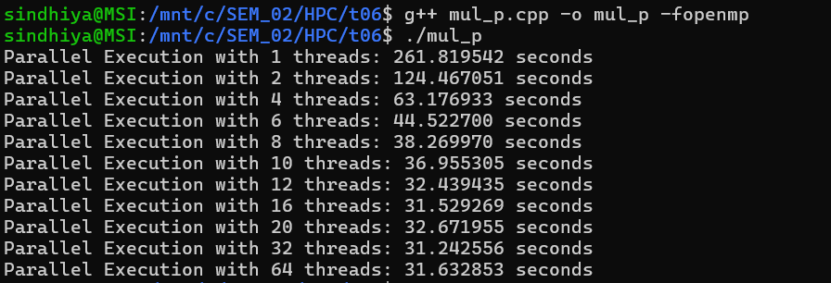  
3) Report - Thread vs Time - (run the parallel code with 1, 2, 4, 6, 8, 10, 12, 16, 20, 32, 64 Processors) - 10 Marks**

|  |  |
| --- | --- |
| Threads | Execution Time |
| 1 | 261.819542 |
| 2 | 124.467051 |
| 4 | 63.176933 |
| 6 | 44.5227 |
| 8 | 38.26997 |
| 10 | 36.955305 |
| 12 | 32.439435 |
| 16 | 31.529269 |
| 20 | 32.671955 |
| 32 | 31.242556 |
| 64 | 31.632853 |

**Observation:**

* Beyond **12 threads**, the **performance gain is minimal**, indicating a **saturation point**.
* **CPU** and **memory bandwidth bottlenecks limit** further improvement.
* After 12 threads, **increased contention for cache** and **RAM bandwidth** prevents further speedup.
* **Synchronization overhead** and **thread management** costs increase at 20+ threads, leading to no significant speedup.
* Threads beyond available **physical cores (hyperthreading)** do not contribute much to performance.

**4) Plot Speedup vs Processors - 5 Marks**

|  |  |  |
| --- | --- | --- |
| Threads | Execution Time | Speedup |
| 1 | 261.819542 | 1 |
| 2 | 124.467051 | 2.103525 |
| 4 | 63.176933 | 4.144227 |
| 6 | 44.5227 | 5.880585 |
| 8 | 38.26997 | 6.841384 |
| 10 | 36.955305 | 7.084762 |
| 12 | 32.439435 | 8.071027 |
| 16 | 31.529269 | 8.304016 |
| 20 | 32.671955 | 8.013587 |
| 32 | 31.242556 | 8.380222 |
| 64 | 31.632853 | 8.276824 |

**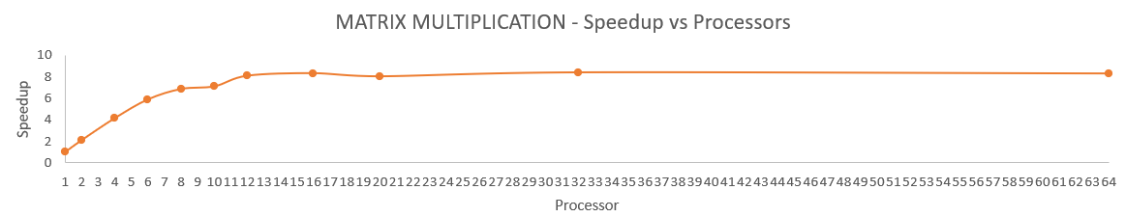  
5) Inference - 5 Marks**

**1️. Near-Linear Speedup Up to 12 Threads**

* Speedup improves significantly up to 12 threads (8.07× speedup).
* This indicates that **matrix multiplication is highly parallelizable**, benefiting from multi-threading.

**2. Performance Saturation Beyond 12 Threads**

* The improvement flattens after 12-16 threads, suggesting a hardware bottleneck.
* This is caused by memory **bandwidth limitations** and **cache conflicts**.

**3️. Memory Bandwidth Becomes the Limiting Factor**

* Beyond 12 threads, the processor struggles to fetch data from memory efficiently.
* Large matrices require high memory throughput, leading to **contention** among threads.

**4️. Synchronization and Overhead Reduce Efficiency**

* At 20+ threads, execution time fluctuates, showing diminishing returns.
* **Thread creation, scheduling, and data synchronization** introduce significant overhead.

**5️. CPU Hyperthreading Provides Minimal Gains**

* Increasing threads beyond available physical cores (16 in modern i7 CPUs) does not improve speedup.
* Hyperthreading only helps if computations involve **frequent memory stalls**.

**6️. Matrix Size Plays a Crucial Role in Parallel Performance**

* For very large matrices (N ≥ 10,000), multi-threading is highly effective.
* However, for smaller matrices, overhead dominates, making **parallelization inefficient**.

**7️. Tiling and Cache Optimization Can Improve Performance**

* Using cache-aware optimizations like tiling (**block matrix multiplication**) reduces cache misses.
* This can improve performance even when increasing threads beyond 12-16.

**8️. GPU Acceleration Would Be More Effective**

* GPUs are optimized for massively parallel operations, unlike CPUs, which suffer from thread contention.

**9️. Thread Scheduling and Load Balancing Affect Performance**

* Uneven work distribution among threads can cause some to remain idle while others work harder.
* Dynamic scheduling may improve performance in some cases.

**10. Parallel Matrix Multiplication is Memory-Bound, Not Just Compute-Bound**

* While matrix multiplication involves intense computation (O(N³)), memory access is a major bottleneck.