DIM_COUNTRY

DETAILED MAPPINGS –

OVERALL MAPPING –

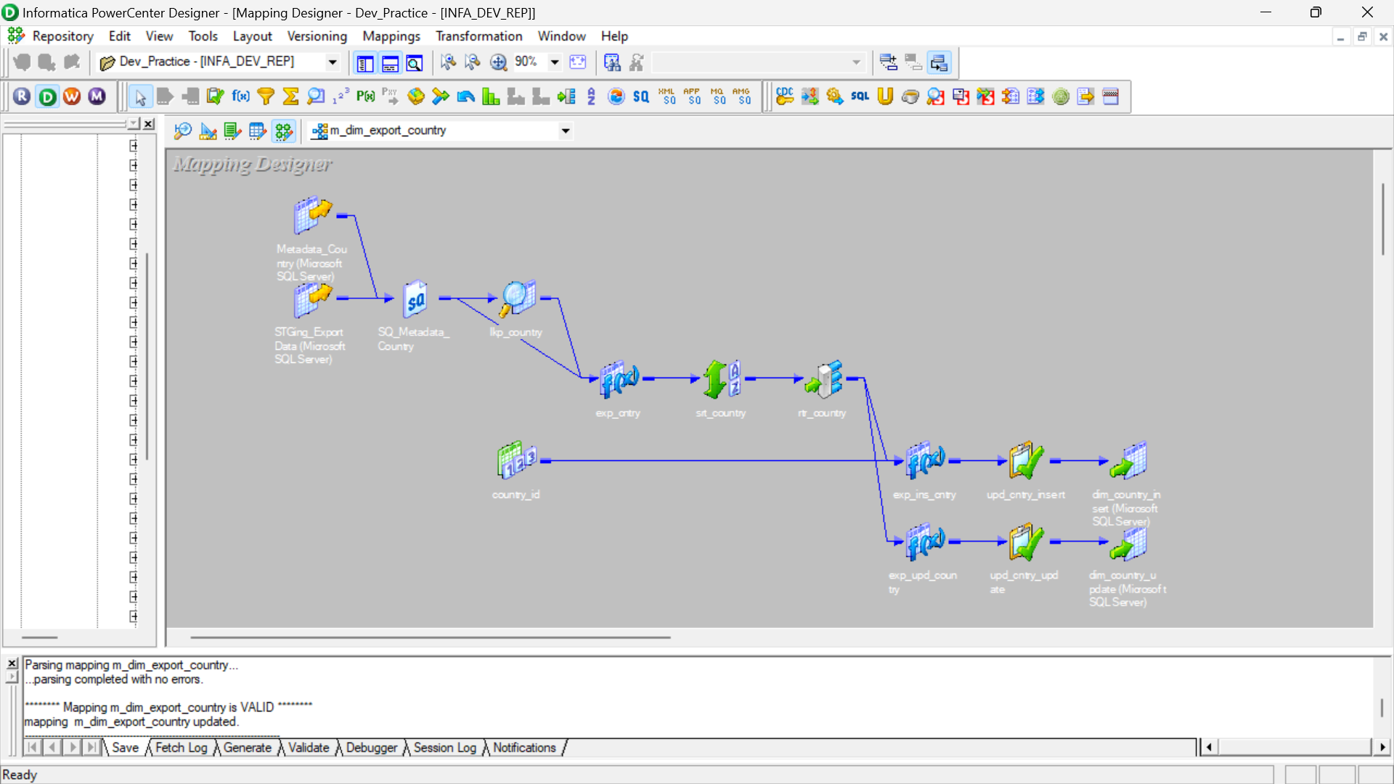

ALL ICONIC(with proper naming)

WORKFLOW-

MANAGER-

RESULT –

