DIM_INDICATOR

DETAILED MAPPING –

OVERALL MAPPING –

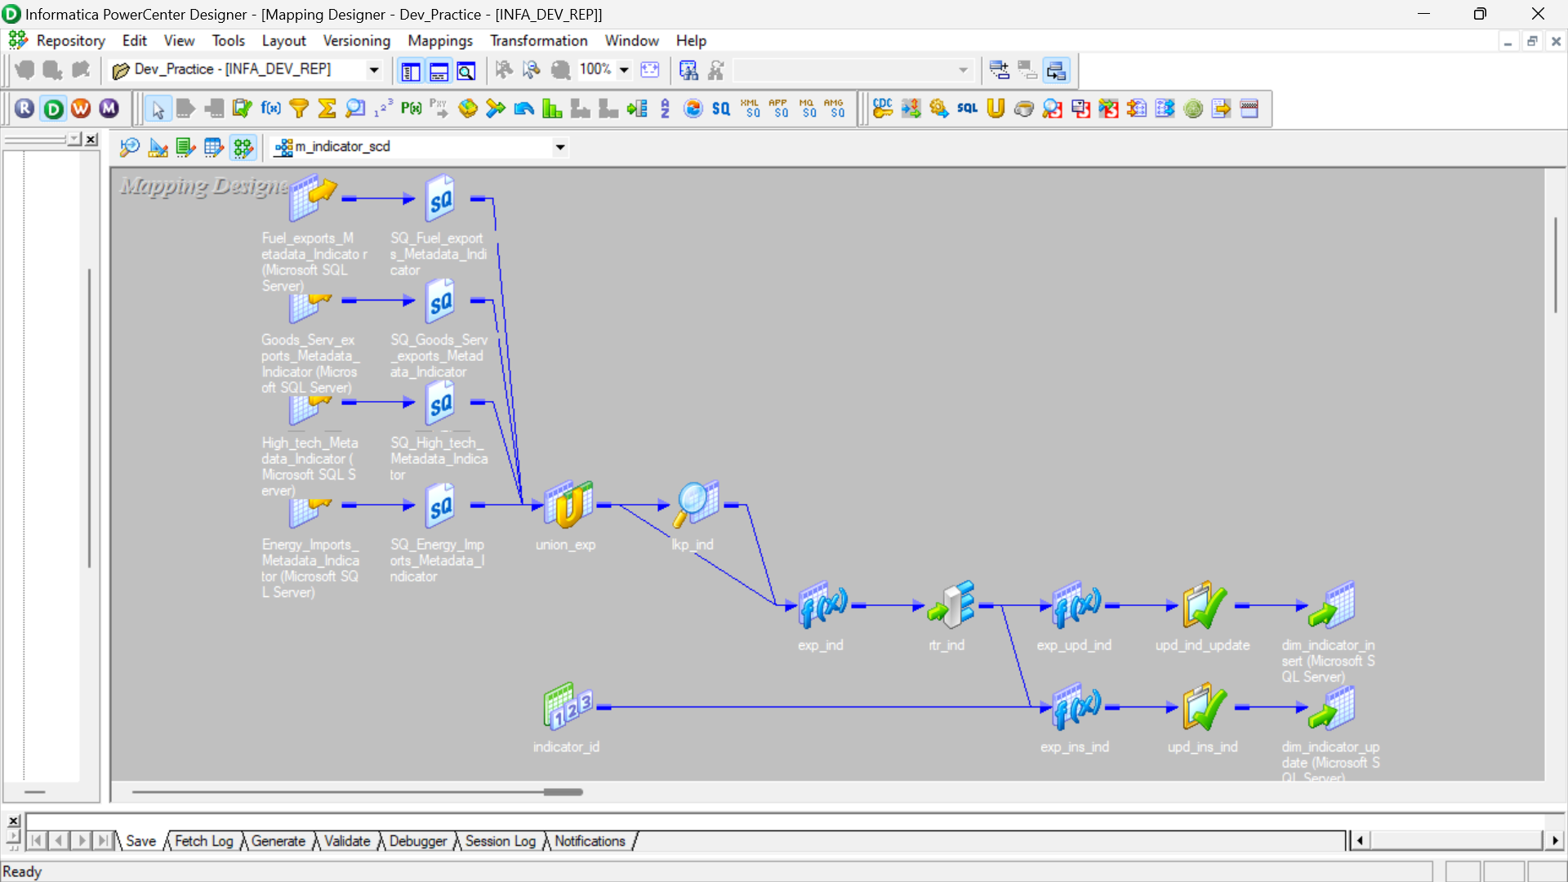

ALL ICONIC – with proper naming

WORKFLOW –

MANAGER:

RESULT –

