**1. For Each Department, Sort the Data on Manager ID and Emp_ID Desc**

○ Sort the data by Manager_id and then by Emp_id in descending order for each

department.

○ Use a Source Qualifier Transformation with a SQL Override or appropriate

transformation to implement sorting.

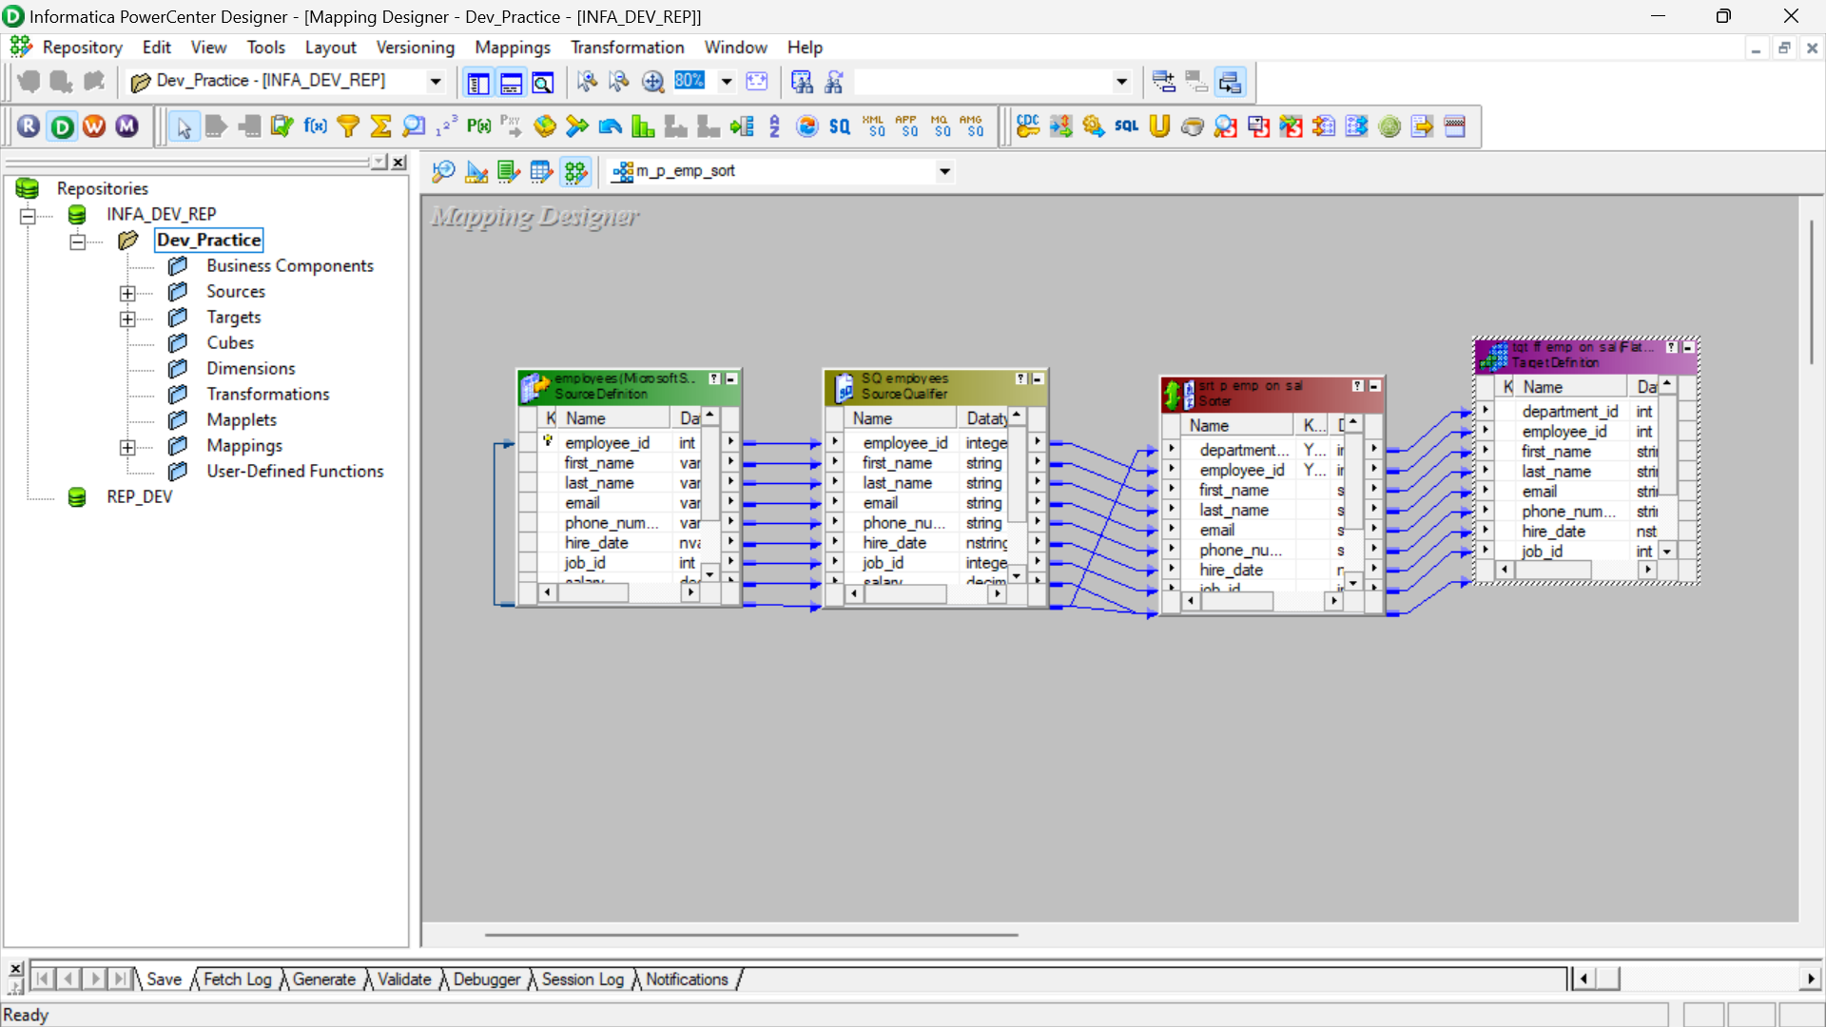

RESULT – for each department(department_id : asc) , the employee_id is sorted in descending order.

