**3. Get the Manager Name, Manager Email ID Domain, Max/Min/Avg Salary of**

**Employees Under That Manager, and Load Date**

○ Use transformations to calculate salary metrics (max, min, avg) and derive the

email domain.

○ Add the current Load Date field using an expression and load the results into a

target.

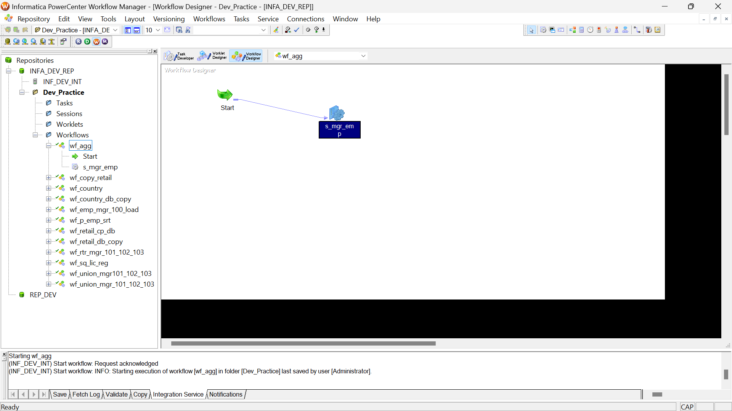

RESULT –

