DIM_EMP

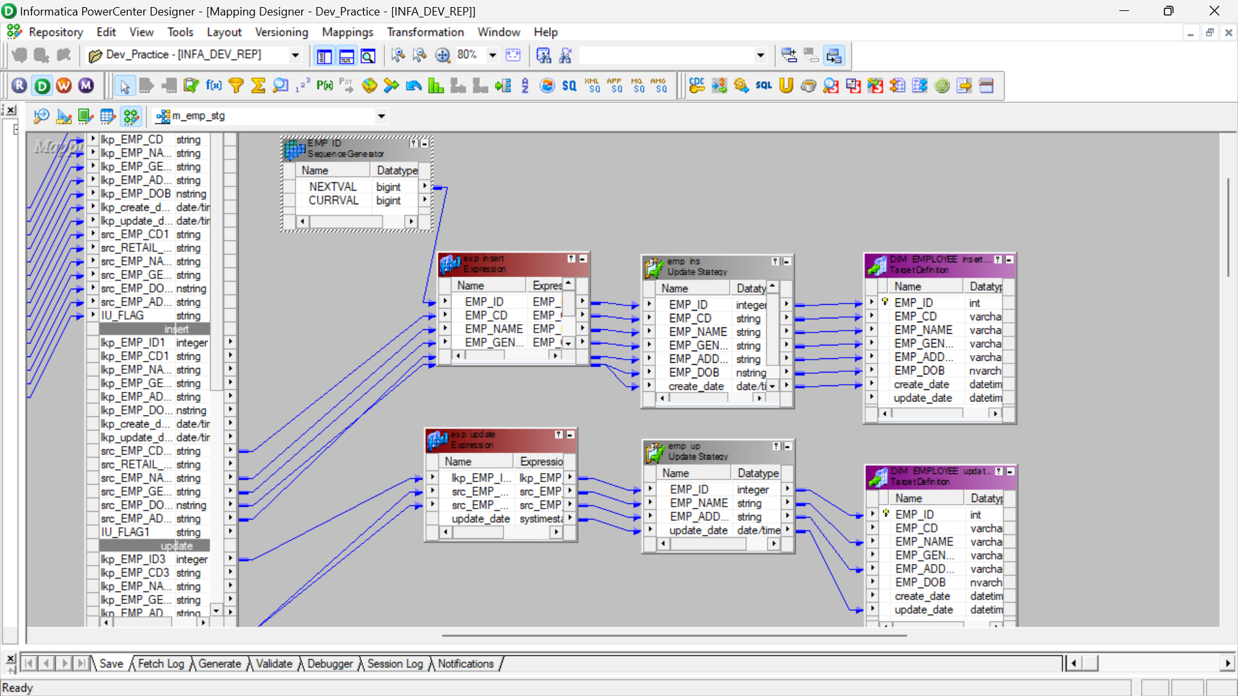

MANAGER:

OUTPUT :

