DIM_PRODUCT :

Mapping (Detailed) –

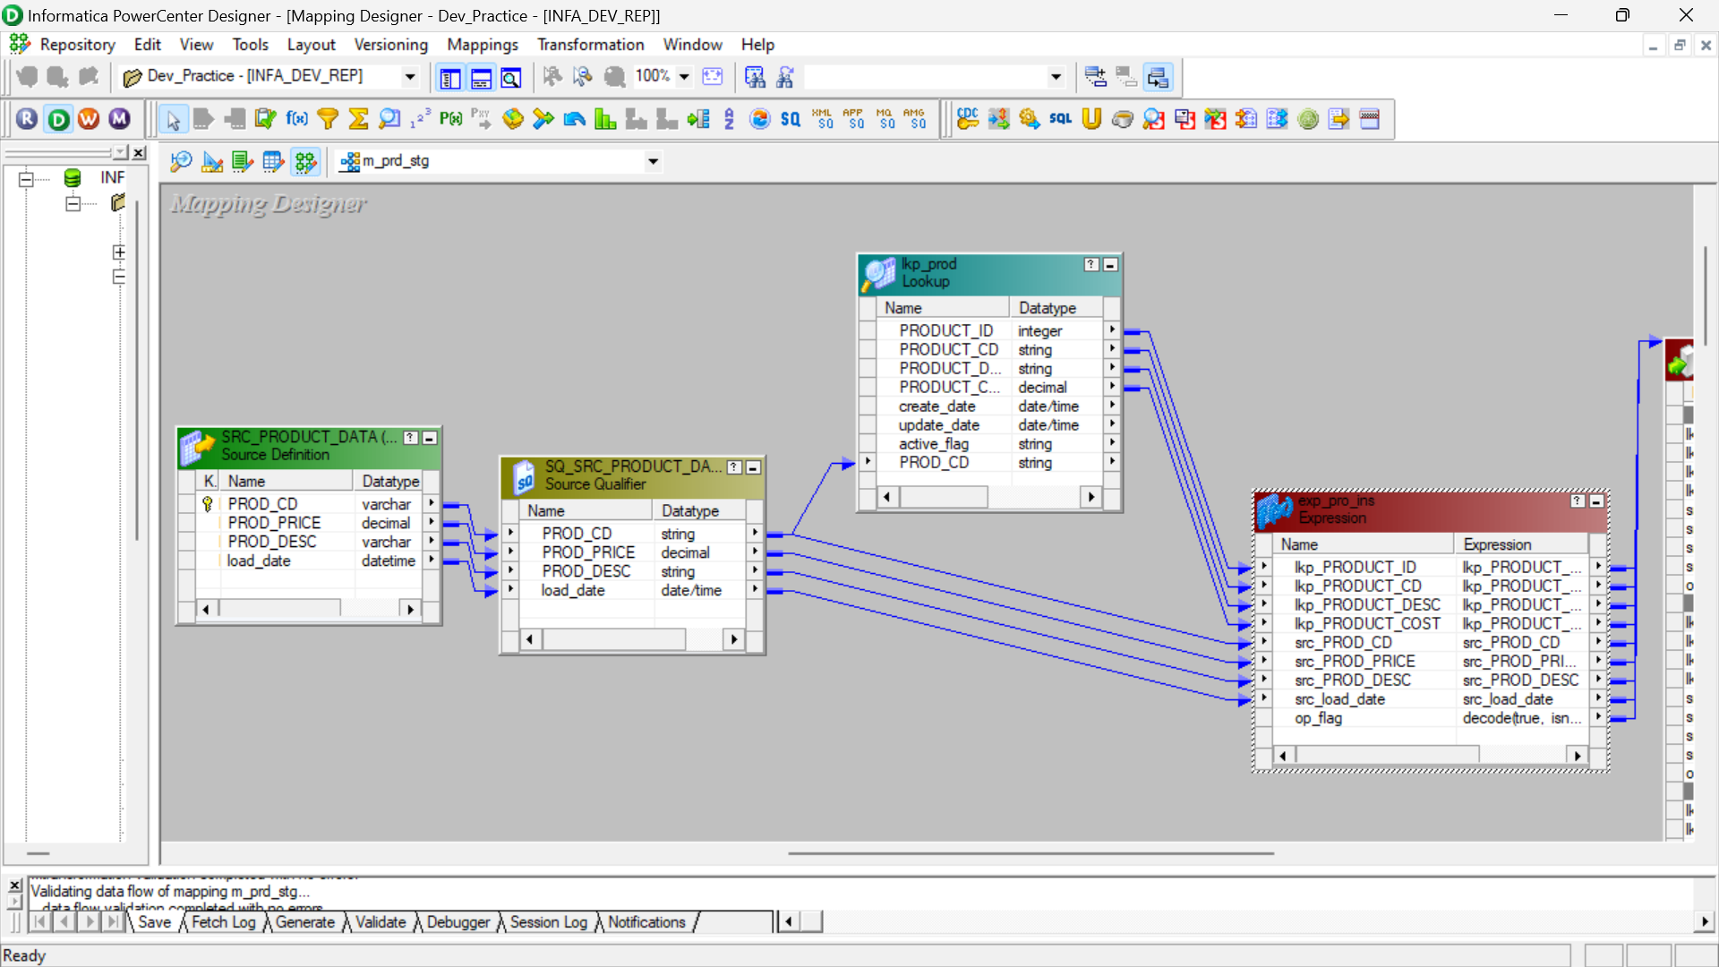

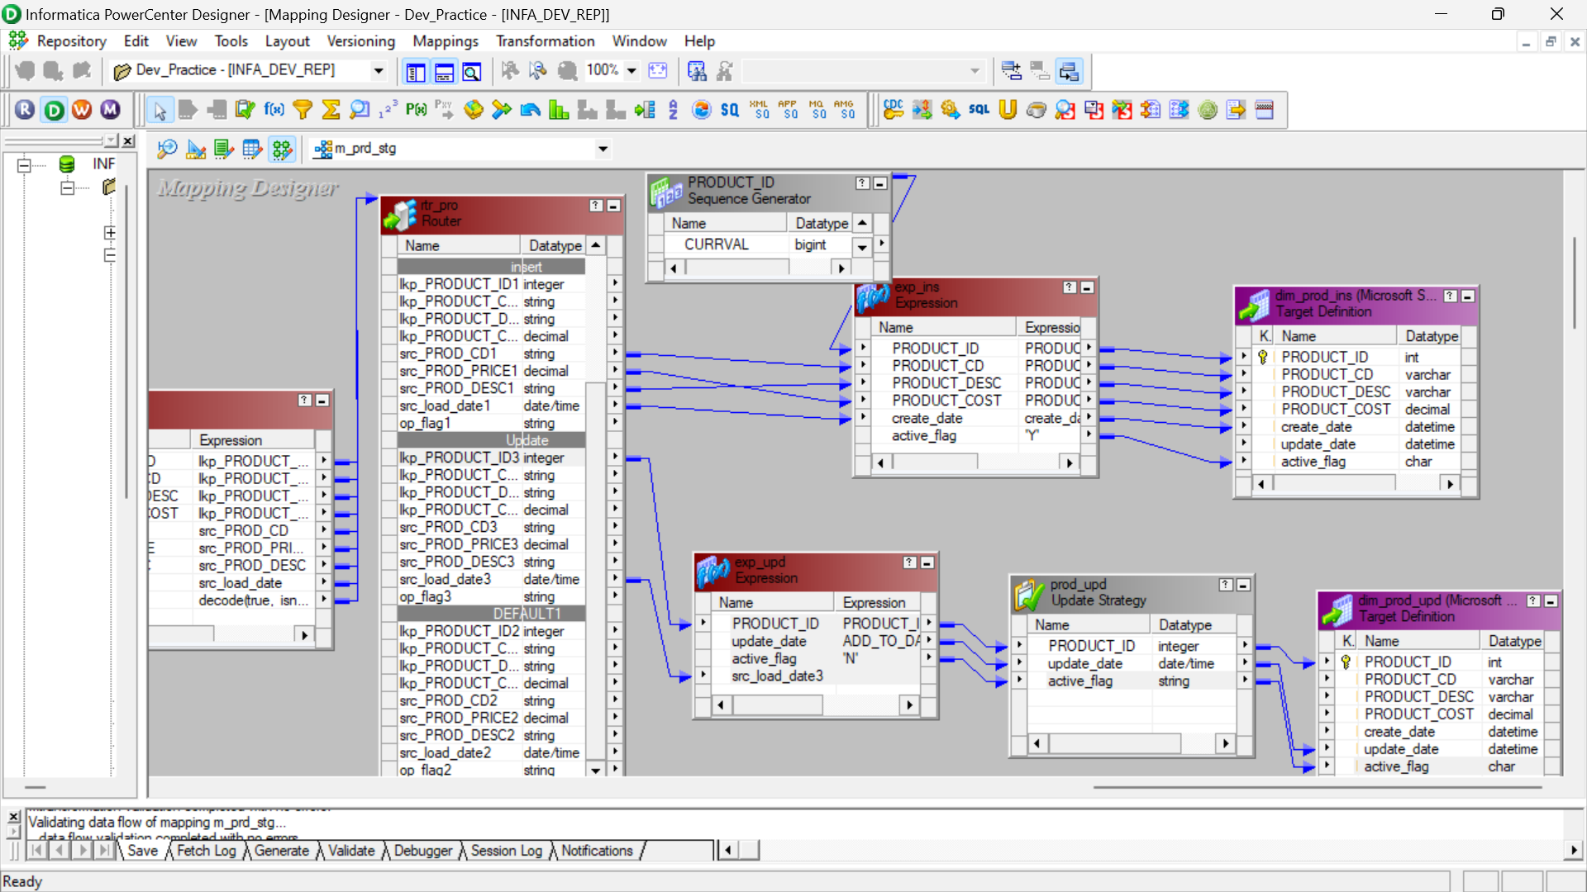

OVERALL MAPPING :

MANAGER:

OUTPUT:

