**Date:29.10.25**

**TASK:12**

**Implementation of AI CHATBOT FOR FARMERS**

**CO4, CO5 S3**

**PROBLEM STATEMENT**

**Traditional farming communities often lack instant access to expert agricultural guidance, leading to suboptimal crop yields, delayed pest/disease detection, and inefficient resource management. Existing support helplines are slow, language barriers persist, and rural farmers require accessible, real-time solutions.**

**AIM**

**To implement an AI-powered chatbot that provides Indian farmers with agricultural advice, disease identification, market price updates, and government scheme information in local languages with 24/7 accessibility.**

**OBJECTIVE**

* **Enable farmers to ask queries about crop management, pest control, and weather forecasts via chat.**
* **Provide instant advice and information using AI in their preferred language.**
* **Facilitate access to market rates and government schemes for improved farming decisions.**

**DESCRIPTION**

**The AI Chatbot leverages natural language processing to understand farmer queries and responds with actionable guidance, leveraging expert databases and real-time agricultural data. It supports multiple regional languages and integrates with market data APIs, crop disease image recognition, and government information portals.**

**ALGORITHM**

1. **Receive user input in natural language.**
2. **Analyze the query using NLP techniques.**
3. **If the query is about crops/pests, fetch information from expert databases or image recognition modules.**
4. **For market rates/schemes, call respective APIs and provide latest updates.**
5. **Respond to farmer in local language using AI-driven translation and text generation.**

**PROGRAM**

**from flask import Flask, request, jsonify**

**import random**

**app = Flask(__name__)**

**# Sample database of questions and responses**

**db = {**

**"crop recommendation": [**

**"Based on your soil type, you can grow rice, wheat, and maize.",**

**"Check soil pH and moisture levels before sowing crops."**

**],**

**"pest management": [**

**"Use neem oil spray to control common pests in crops.",**

**"For worm infestation, try biological pest control."**

**],**

**"market price": [**

**"Today's market price for tomatoes is Rs. 30/kg.",**

**"Check with your local mandi for latest price updates."**

**],**

**"government schemes": [**

**"Check PM-Kisan for direct benefit transfers to farmers.",**

**"Visit the Agriculture portal for all ongoing schemes."**

**]**

**}**

**def get_response(query):**

**query = query.lower()**

**for key in db:**

**if key in query:**

**return random.choice(db[key])**

**return "Sorry, I couldn't find information for your query. Please ask about crop recommendation, pest management, market price, or government schemes."**

**@app.route('/chatbot', methods=['POST'])**

**def chatbot():**

**data = request.get_json()**

**user_query = data.get("query", "")**

**reply = get_response(user_query)**

**return jsonify({"reply": reply})**

**if __name__ == "__main__":**

**app.run(debug=True)**

**OUTPUT**

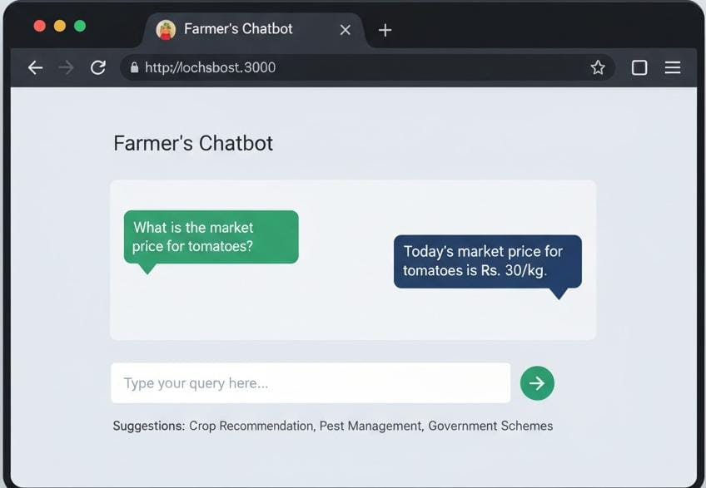

**CONCLUSION**

**Deploying an AI-powered chatbot for farmers bridges the knowledge gap, increases crop yield, and empowers rural communities with timely expert advice and resources. This solution offers scalability, multi-language support, and integration with digital agriculture initiatives.**