Create database:

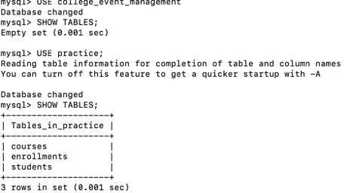
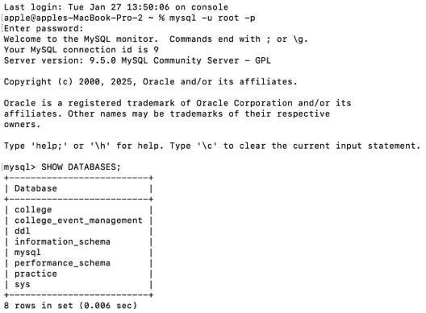

Create tables:

table courses:

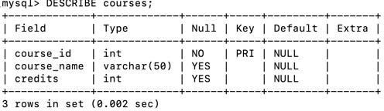

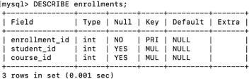
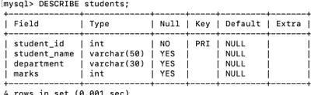
Table enrollments

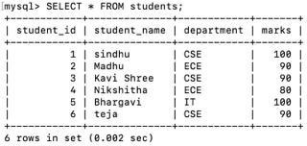
Student table values

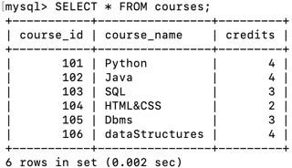
Ourses table values
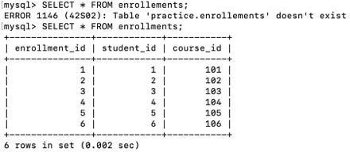

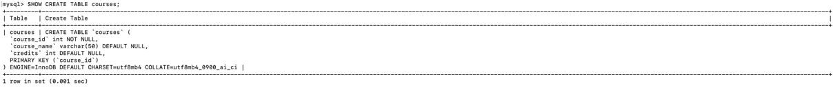
Enrollment table values
Insert into courses:

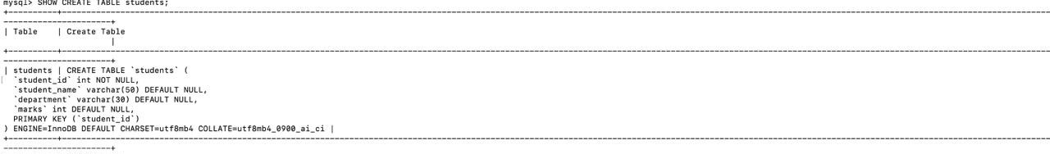

Insert into students:

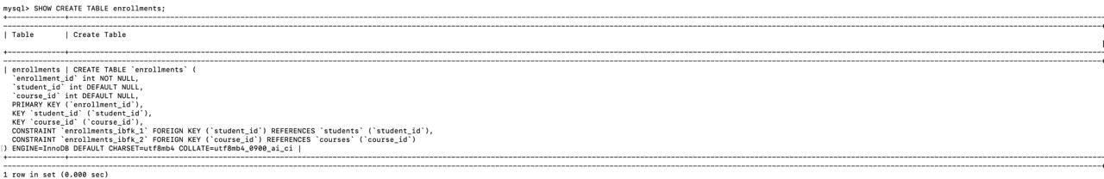
Insert into enrollments:

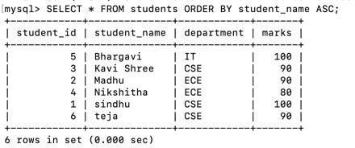
ORDER BY:

LIMIT:
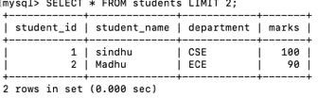

WHERE:
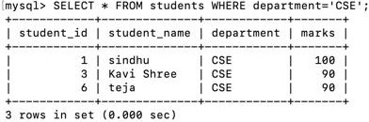
UPDATE:
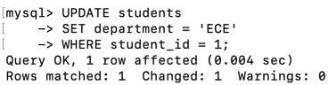

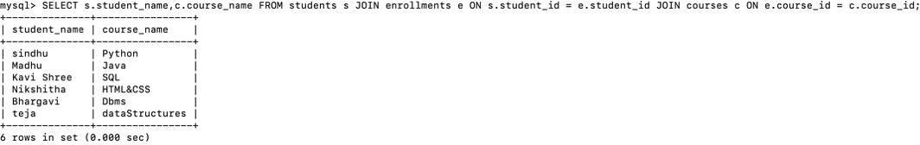
JOINS:

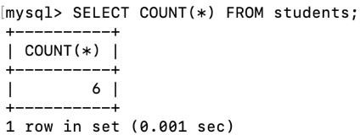
COUNT:

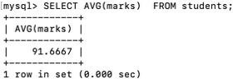

AVG:
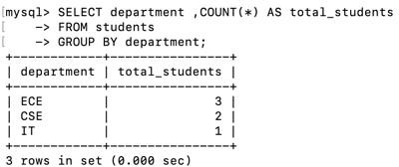
GROUP BY:

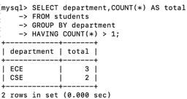

HAVING:

SUB QUERIES:

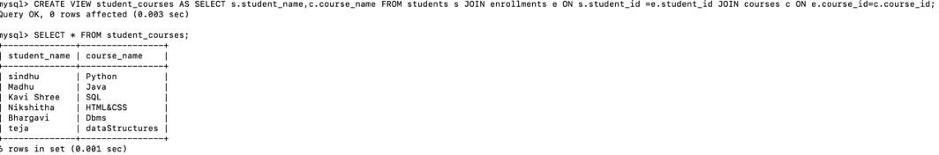
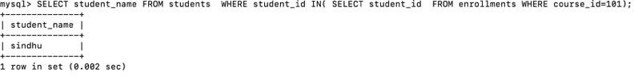

VIEW:

