FINAL PROJECT REPORT
RETAIL SALES ANALYSIS
End-to-End Data Analytics Using Excel, MySQL, Python and Power BI

Project Details | Information
Project Title | Retail Sales Analysis
Database | Capstone (MySQL)
Tools Used | MS Excel, MySQL, Python, Power BI, MS Word
Project Type | Final Project
Student Name | Sindhu C
Institute Name | Vinsup Skill Academy
Mentor Name | Varththini V
Report Date | October 2026

Executive Summary

This project develops an end-to-end retail analytics workflow to turn transactional and inventory data into useful business insights. The work follows four main phases: data preparation in Excel, relational data storage and querying in MySQL, exploratory analysis and RFM customer segmentation in Python, and interactive KPI reporting in Power BI.
The analysis focuses on sales performance over time, product and store performance, customer purchase behaviour, inventory levels, order status, and customer segments. The report documents the project workflow and describes how the resulting analysis can support retail planning and decision-making.

Table of Contents

- Introduction, Problem Statement and Objectives
- Project Architecture and Database Schema
- Phase 1 – Excel Data Cleaning and Preparation
- Phase 2 – MySQL Database Management and SQL Analysis
- Phase 3 – Python EDA and RFM Customer Segmentation
- Phase 4 – Power BI Data Model and Dashboard
- Key Business Insights and Recommendations
- Conclusion and Project Deliverables

Project at a Glance

Area | Scope
Sales | Revenue trends, monthly performance, order count and average order value
Products | Top products by sales and product-level inventory
Customers | Customer purchase behaviour and RFM segments
Operations | Order status, store performance and low-stock monitoring
Tools | Excel, MySQL, Python (Pandas), Power BI

Introduction, Problem Statement and Objectives

Introduction

Retail businesses generate data from orders, customers, products, stores, employees and inventory. Analysing these data sources together helps teams understand performance, identify operational issues and make informed decisions. This project uses a multi-tool analytics workflow to prepare, query, analyse and visualize retail data.

Problem Statement

Without a consolidated view of sales, customers and stock, a retail business may struggle to identify high-performing products and stores, understand customer repeat-purchase behaviour, monitor low inventory, and recognise changes in sales over time. The project addresses these needs by combining data preparation, SQL analysis, Python-based customer analysis and a Power BI dashboard.

Objectives

- Prepare consistent, analysis-ready datasets and validate important fields.
- Create a relational MySQL database with tables and key relationships.
- Use SQL joins, aggregations and filters to answer business questions.
- Explore data quality, distributions and customer purchase behaviour using Python.
- Calculate Recency, Frequency and Monetary (RFM) features and assign customer segments.
- Build interactive Power BI pages for sales, customers, products and operations.
- Summarise findings and recommend practical actions for retail decision-makers.

Project Scope

The project covers the retail data workflow from source-file preparation to dashboard reporting. The analysis is intended for business exploration and decision support; any recommendations should be validated against current operational context before implementation.

Project Architecture and Database Schema

Tools and Technologies

Tool | Purpose in the Project
Microsoft Excel | Inspect, clean, standardise and validate source data; prepare CSV files.
MySQL / MySQL Workbench | Create relational tables, define keys, load data and run analytical SQL queries.
Python / Jupyter Notebook | Use Pandas for extraction and EDA; calculate RFM features and customer segments.
Power BI Desktop | Create relationships, DAX measures, KPI cards, charts, slicers and report navigation.
Microsoft Word | Document methodology, results, insights and recommendations.

End-to-End Workflow

Excel data preparation → MySQL database and SQL queries → Python EDA and RFM segmentation → Power BI dashboard → Final report

Relational Dataset

The project database uses nine core retail tables. These tables describe customers, orders, order line items, products, product categories, brands, inventory, stores and staff.

Table | Role
customers | Customer profile and location information.
orders | Order header, order date, status, customer, store and staff references.
order_items | Products in each order, quantities, list prices, discounts and calculated line totals.
products | Product catalogue and links to brand and category.
brands | Brand lookup information.
categories | Product category lookup information.
stocks | Product quantities held by each store.
stores | Retail store details and locations.
staffs | Staff details and store/manager relationships.

3. Phase 1 – Excel Data Cleaning and Preparation

Data Inspection and Standardization

Excel was used as an initial preparation layer to inspect source workbooks and improve consistency before loading data into the database. Typical checks included reviewing column headers, checking duplicates, identifying blank values, and confirming that fields used for joins and analysis were consistently represented.

Data Quality Activities

- Standardise column names so that key fields are easy to identify across tables.
- Check duplicate records, especially in tables expected to have unique identifiers.
- Review missing values in fields such as phone numbers, postal codes and optional descriptive columns.
- Validate date columns and convert them to a consistent date representation where possible.
- Check order status values for consistent spelling and labels.
- Inspect quantities, prices and discounts for invalid or unexpected values.

Revenue Calculation

For order-line analysis, net line revenue can be calculated from the list price, quantity and discount. The calculation should match the actual definition used in the project data.

Metric | Formula
Net line revenue | total_price = (list_price × quantity) − discount

Output

The expected output of this phase is a set of standardized, validated data files that can be loaded into MySQL with fewer schema and data-quality issues. Add actual cleaning counts and before/after row totals if these were recorded.

Phase 2 – MySQL Database Management and SQL Analysis

Database Design

The retail tables were organised relationally, with primary keys used to identify records and foreign keys used to connect related entities. The schema supports queries that combine order headers, order items, products, customers, stores, staff and stock information.

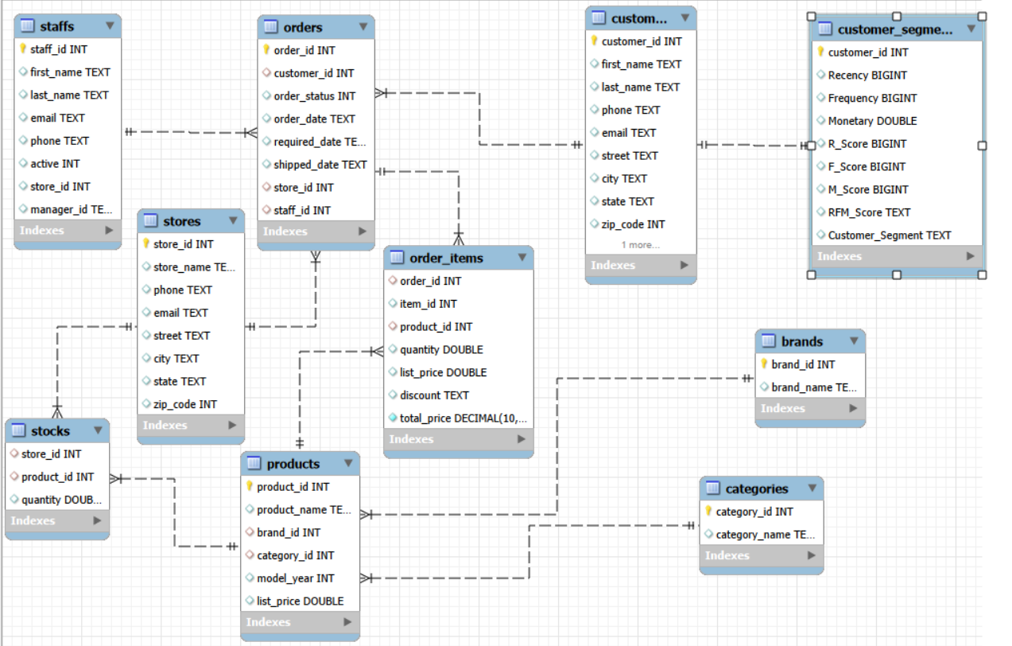

SQL Analysis Examples

A. Store-wise Sales
Join orders to order_items and stores, aggregate line revenue by store, and sort the result to identify higher-revenue branches.
SELECT s.store_name, ROUND(SUM(oi.total_price), 2) AS total_revenue
FROM orders o
JOIN order_items oi ON o.order_id = oi.order_id
JOIN stores s ON o.store_id = s.store_id
GROUP BY s.store_name
ORDER BY total_revenue DESC;

B. Low-stock Products
Filter inventory records where quantity is below the chosen threshold. This supports replenishment checks.
SELECT st.store_id, p.product_id, p.product_name, s.quantity
FROM stocks s
JOIN stores st ON s.store_id = st.store_id
JOIN products p ON p.product_id = s.product_id
WHERE s.quantity < 10;

C. Customer Segmentation Table
A customer_segments table can store the RFM values and segment labels produced in Python, making the segmentation available for downstream reporting.
CREATE TABLE customer_segments(
customer_id VARCHAR(50),
recency INT,
frequency INT,
monetary DECIMAL(12,2),
segment VARCHAR(50)
);

SQL Skills Applied

- SELECT, WHERE, ORDER BY and GROUP BY for filtering and summarising data.
- JOIN operations to combine related tables.
- Aggregate functions such as SUM, COUNT and ROUND for business metrics.
- Table creation and key definitions for relational data management.
- Inventory threshold queries and staging-table design for customer segments.

5. Phase 3 – Python EDA and RFM Customer Segmentation

Data Extraction and Libraries

Python with Pandas can read data from MySQL into DataFrames for analysis. SQLAlchemy and a MySQL connector can be used to establish the connection. Database credentials should be kept private and should not be hard-coded into a report.

Exploratory Data Analysis

- Use DataFrame methods such as info() and describe() to inspect columns, data types and distributions.
- Check missing values, duplicate records, date parsing and numerical ranges.
- Use histograms and boxplots to understand sales and quantity distributions and investigate potential outliers.
- Compare order and sales patterns by time, customer, product and store where the required fields are available.

RFM Feature Engineering
Metric | Definition
Recency (R) | Number of days since a customer's most recent order, measured against a selected snapshot date.
Frequency (F) | Number of distinct orders placed by the customer in the analysis period.
Monetary (M) | Total purchase value attributed to the customer in the analysis period.

Customer Segmentation

RFM features help distinguish customers by purchase recency, repeat activity and spending. Segment labels such as Loyal Customers, New, Needs Attention or At Risk should match the scoring or clustering logic actually used in the project.

Output

The segmentation output can be written to a MySQL customer_segments table and imported into Power BI. For reproducibility, document the snapshot date, scoring approach, segment rules and number of customers assigned to each segment.

6. Phase 4 – Power BI Data Model and Dashboard

Data Connection and Relationships

Power BI Desktop connects to the MySQL database and imports the required tables. Relationships should follow the ER diagram, using unique dimension keys and one-to-many relationships where appropriate. Validate relationship direction, data types and whether joins cause duplicated totals.

Dashboard Pages and Visuals

Report Area | Suggested Visuals / Measures
Sales Overview | Total sales, total orders, unique customers, average order value, sales by year and month.
Product Performance | Top products by sales, product/category breakdown and product-level comparisons.
Customer Analysis | Customer count or sales by RFM segment, purchase patterns and order status.
Store & Operations | Sales by store/location, order status distribution and staff/store performance where available.
Inventory Monitoring | Total stock, low-stock product count and product/store table with conditional formatting.

Example DAX Measures

Use the actual table and column names from the Power BI model. These are example patterns and may need to be adapted.
Total Sales = SUM(order_items[total_price])
Total Orders = DISTINCTCOUNT(orders[order_id])
Average Order Value = DIVIDE([Total Sales], [Total Orders])
Total Stock = SUM(stocks[quantity])
Low Stock Products = CALCULATE(DISTINCTCOUNT(products[product_id]), stocks[quantity] < 10)

Interactivity and Usability

- Add slicers for order status, product category, store and date where relevant.
- Use clear page titles, consistent number formats and descriptive visual labels.
- Provide drill-down or drill-through where it helps users explore details.
- Use navigation buttons/bookmarks consistently and test every interaction.
- Validate KPI cards against SQL totals before final submission.

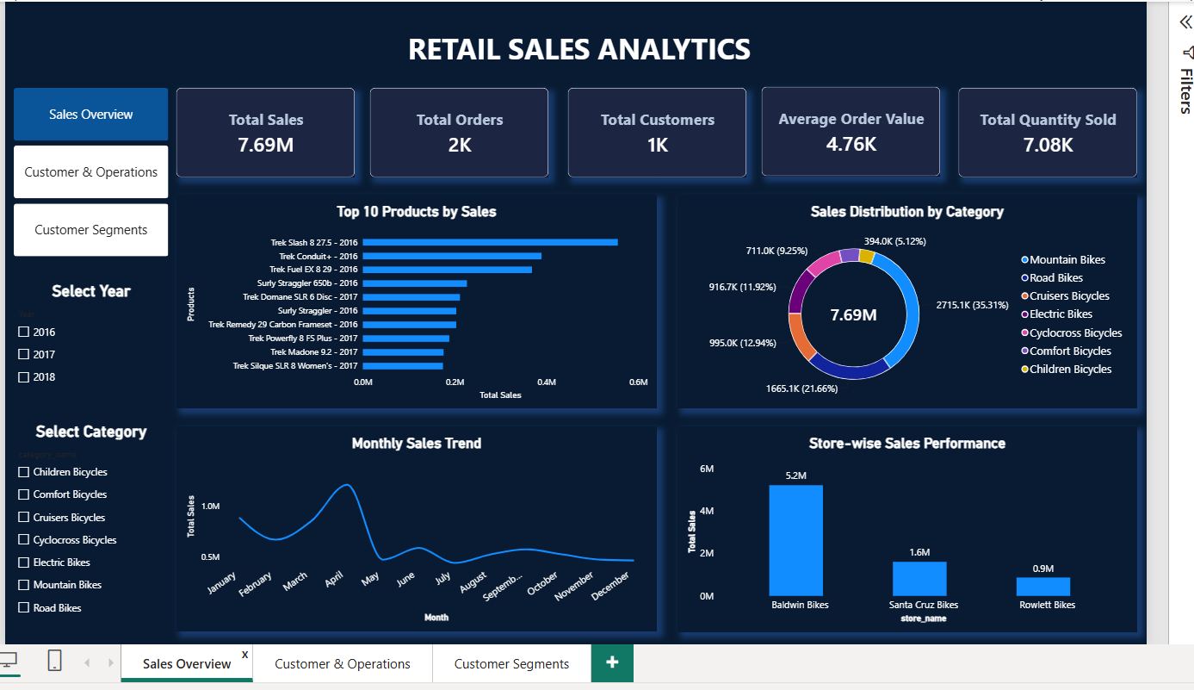

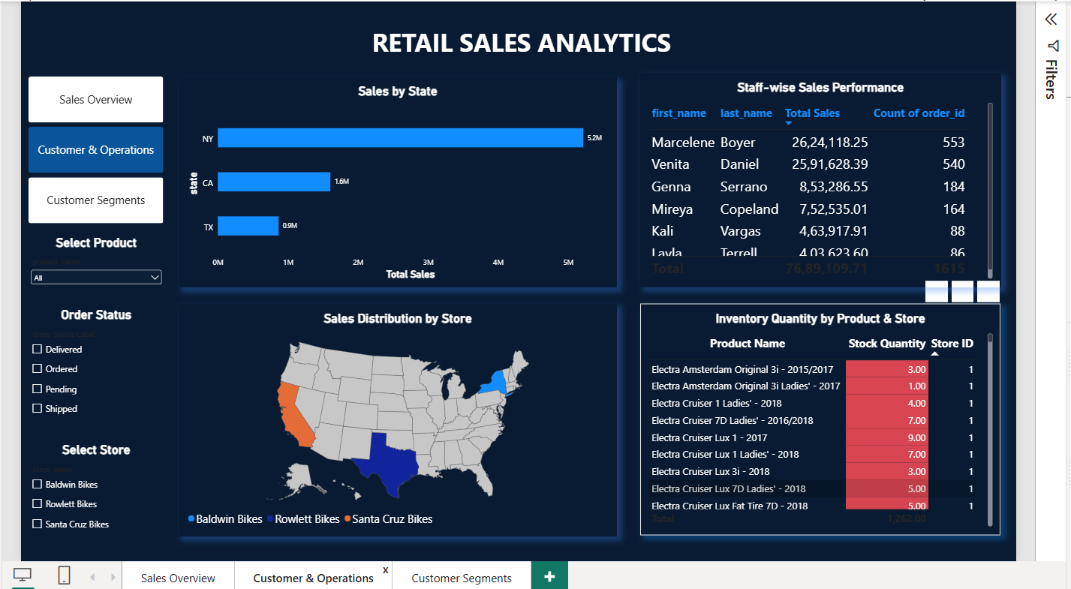

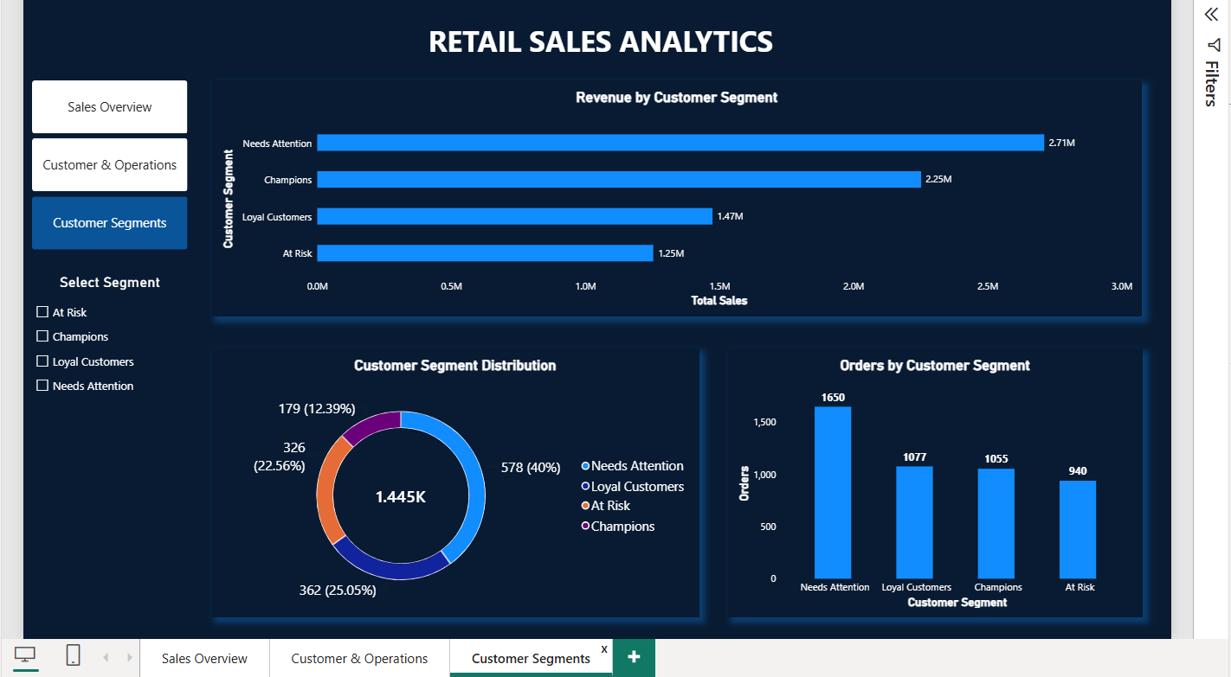

7. Key Business Insights and Recommendations

Business Questions Addressed

- How does sales performance change across years and months?
- Which products generate the highest sales value?
- How many orders and customers are represented in the report?
- Which customer groups may need retention campaigns?
- Which products or stores have stock below the replenishment threshold?
- How do order status and store/location patterns affect operational monitoring?

Project Metrics Available from Project Context

Metric | Value | Interpretation
Total orders | 1,615 | Previously reported during project work; validate against the final dashboard.
Unique customers / RFM records | 1,445 | Previously reported for RFM analysis; validate against the final model.
Total sales | 7,689,109.71 | Previously shared while checking sales totals; confirm currency and final calculation.
These values have not been independently recalculated from the PBIX file. If the final dashboard displays different validated figures, update this table to match the final report.

Recommendations

- Customer retention: use RFM segments to prioritise follow-up campaigns for inactive or at-risk customers and measure response.
- Inventory: review products below the low-stock threshold regularly and prioritise replenishment based on demand and lead time.
- Product planning: compare sales contribution by product and category before adjusting stock or promotions.
- Store performance: compare branch-level revenue and order volume while accounting for store size, operating days and local demand.
- Data quality: reconcile Power BI KPI values with SQL aggregation results and document the definitions of sales, orders and customers.
- Dashboard adoption: keep slicers intuitive, labels readable and navigation consistent.

8. Conclusion and Project Deliverables

Conclusion

The Retail Sales Analysis project demonstrates an end-to-end approach to analytics using Excel, MySQL, Python and Power BI. Excel supports data preparation, MySQL provides structured storage and query capability, Python enables exploratory analysis and RFM feature engineering, and Power BI presents the results through interactive reports.
By bringing sales, customer, product, store and inventory data into one analytical workflow, the project provides a foundation for monitoring performance, identifying potential retention opportunities and highlighting inventory that may require attention. Final business decisions should be based on validated dashboard totals and the retail organization’s current operating context.

Project Deliverables
- Prepared datasets / CSV files from the data-cleaning phase.
- MySQL database schema, relational tables and SQL analysis queries.
- Python notebook for data extraction, EDA and RFM feature engineering.
- Power BI PBIX report containing KPI cards, charts, slicers and navigation.
- Final project report documenting the workflow, analysis and recommendations.

Prepared by: Sindhu C
Institute: Vinsup Skill Academy
Mentor: Varththini V

