**KPI**

* Total Revenue

SELECT ROUND(SUM(total_price),2) AS Total_Revenue FROM pizza_sales;

* Average

SELECT ROUND(SUM(total_price)/COUNT(DISTINCT order_id), 2) AS Avg_Order_Value FROM pizza_sales;

* Total Pizzas Sold

SELECT SUM(quantity) AS Total_Pizzas_Sold FROM pizza_sales;

* Total orders placed

SELECT COUNT(DISTINCT(order_id)) AS Total_Orders_Placed FROM pizza_sales;

* Average pizzas per order

SELECT CAST(CAST(SUM(quantity) AS DECIMAL(10,2))/

CAST(COUNT(DISTINCT order_id) AS DECIMAL(10,2)) AS DECIMAL(10,2)) AS Avg_Pizzas_Per_Order

FROM pizza_sales;

**CHART ANALYSIS**

* DAILY TREND FOR TOTAL ORDERS:

SELECT DATENAME(DW, order_date) AS Order_Day, COUNT(DISTINCT order_id) AS Total_Orders

FROM pizza_sales

GROUP BY DATENAME(DW, order_date);

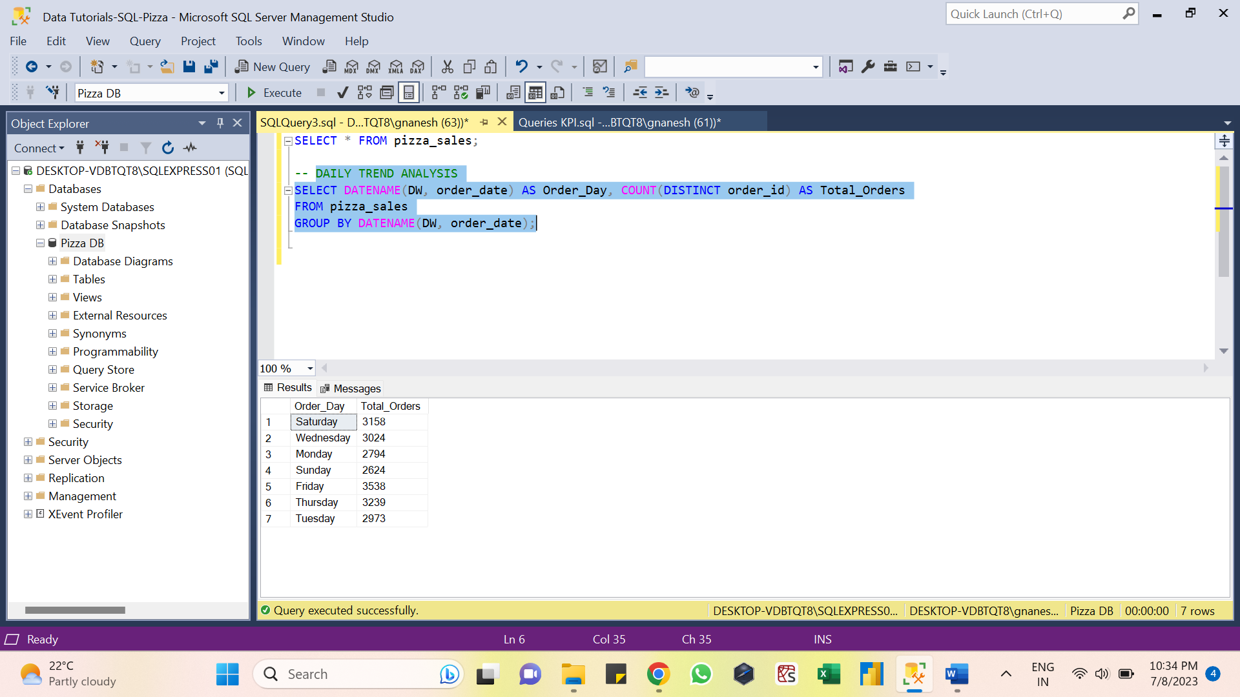

* HOURLY TREND FOR TOTAL ORDERS:

SELECT DATEPART(HOUR, order_time) AS Order_Hours, COUNT(DISTINCT order_id) AS Total_orders

FROM pizza_sales

GROUP BY DATEPART(HOUR, order_time)

ORDER BY DATEPART(HOUR, order_time);

* PERCENTAGE OF SALES BY PIZZA CATEGORY:

SELECT pizza_category, ROUND(SUM(total_price),2) AS Total_Sales, ROUND(SUM(total_price)*100/

(SELECT SUM(total_price) FROM pizza_sales WHERE MONTH(order_date) = 1),2) AS PCT

FROM pizza_sales

WHERE MONTH(order_date) = 1

GROUP BY pizza_category;

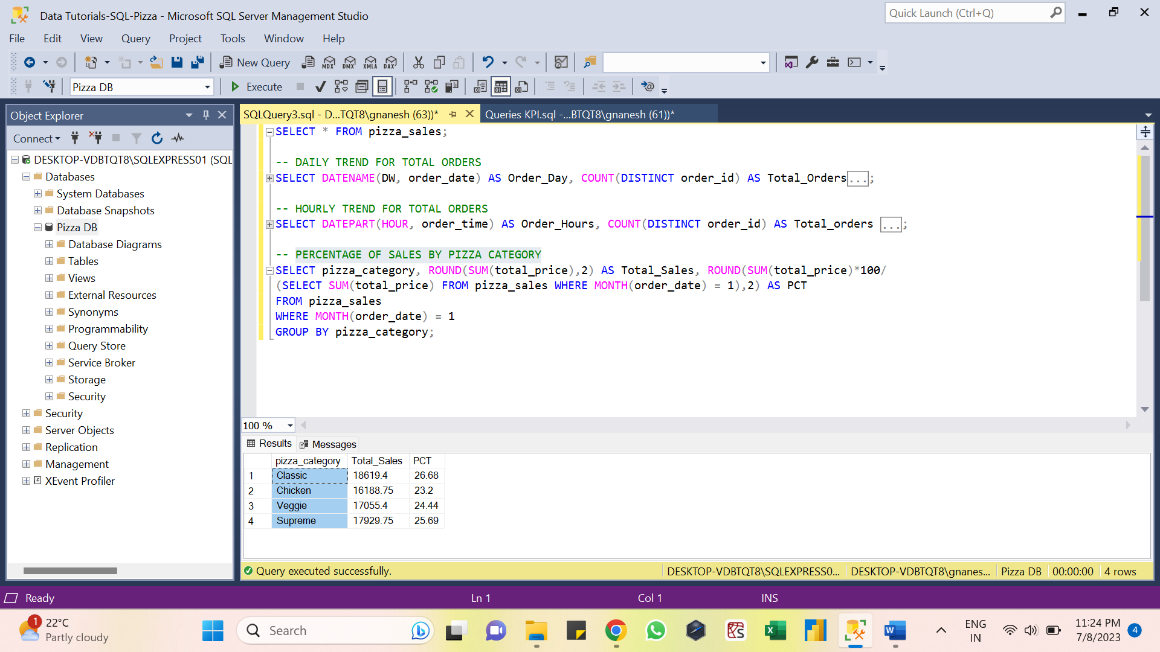

* PERCENTAGE OF SALES BY PIZZA CATEGORY:

SELECT pizza_size, ROUND(SUM(total_price),2) AS Total_Sales, ROUND(SUM(total_price)*100/

(SELECT SUM(total_price) FROM pizza_sales WHERE DATEPART(QUARTER, order_date) = 1),2) AS PCT

FROM pizza_sales

WHERE DATEPART(QUARTER, order_date) = 1

GROUP BY pizza_size

ORDER BY PCT DESC;

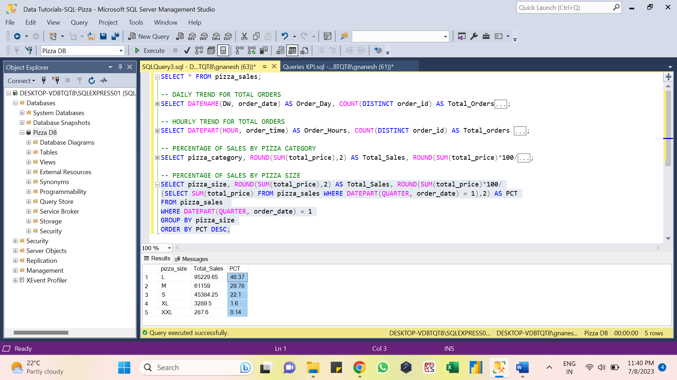

* TOP 5 BEST SELLERS BY TOTAL PIZZAS SOLD

SELECT TOP 5 pizza_name, SUM(quantity) AS Total_Pizzas_Sold

FROM pizza_sales

GROUP BY pizza_name

ORDER BY SUM(quantity) DESC;

* BOTTOM 5 WORST SELLERS BY TOTAL PIZZAS SOLD

SELECT TOP 5 pizza_name, SUM(quantity) AS Total_Pizzas_Sold

FROM pizza_sales

GROUP BY pizza_name

ORDER BY SUM(quantity) ASC;

