(c)

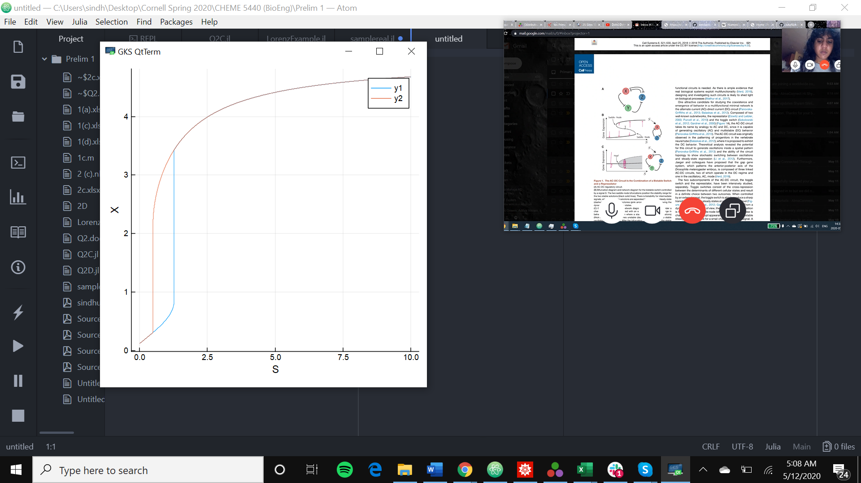

The solid black lines are qualitatively reproducible.

(d)

S = 0.2

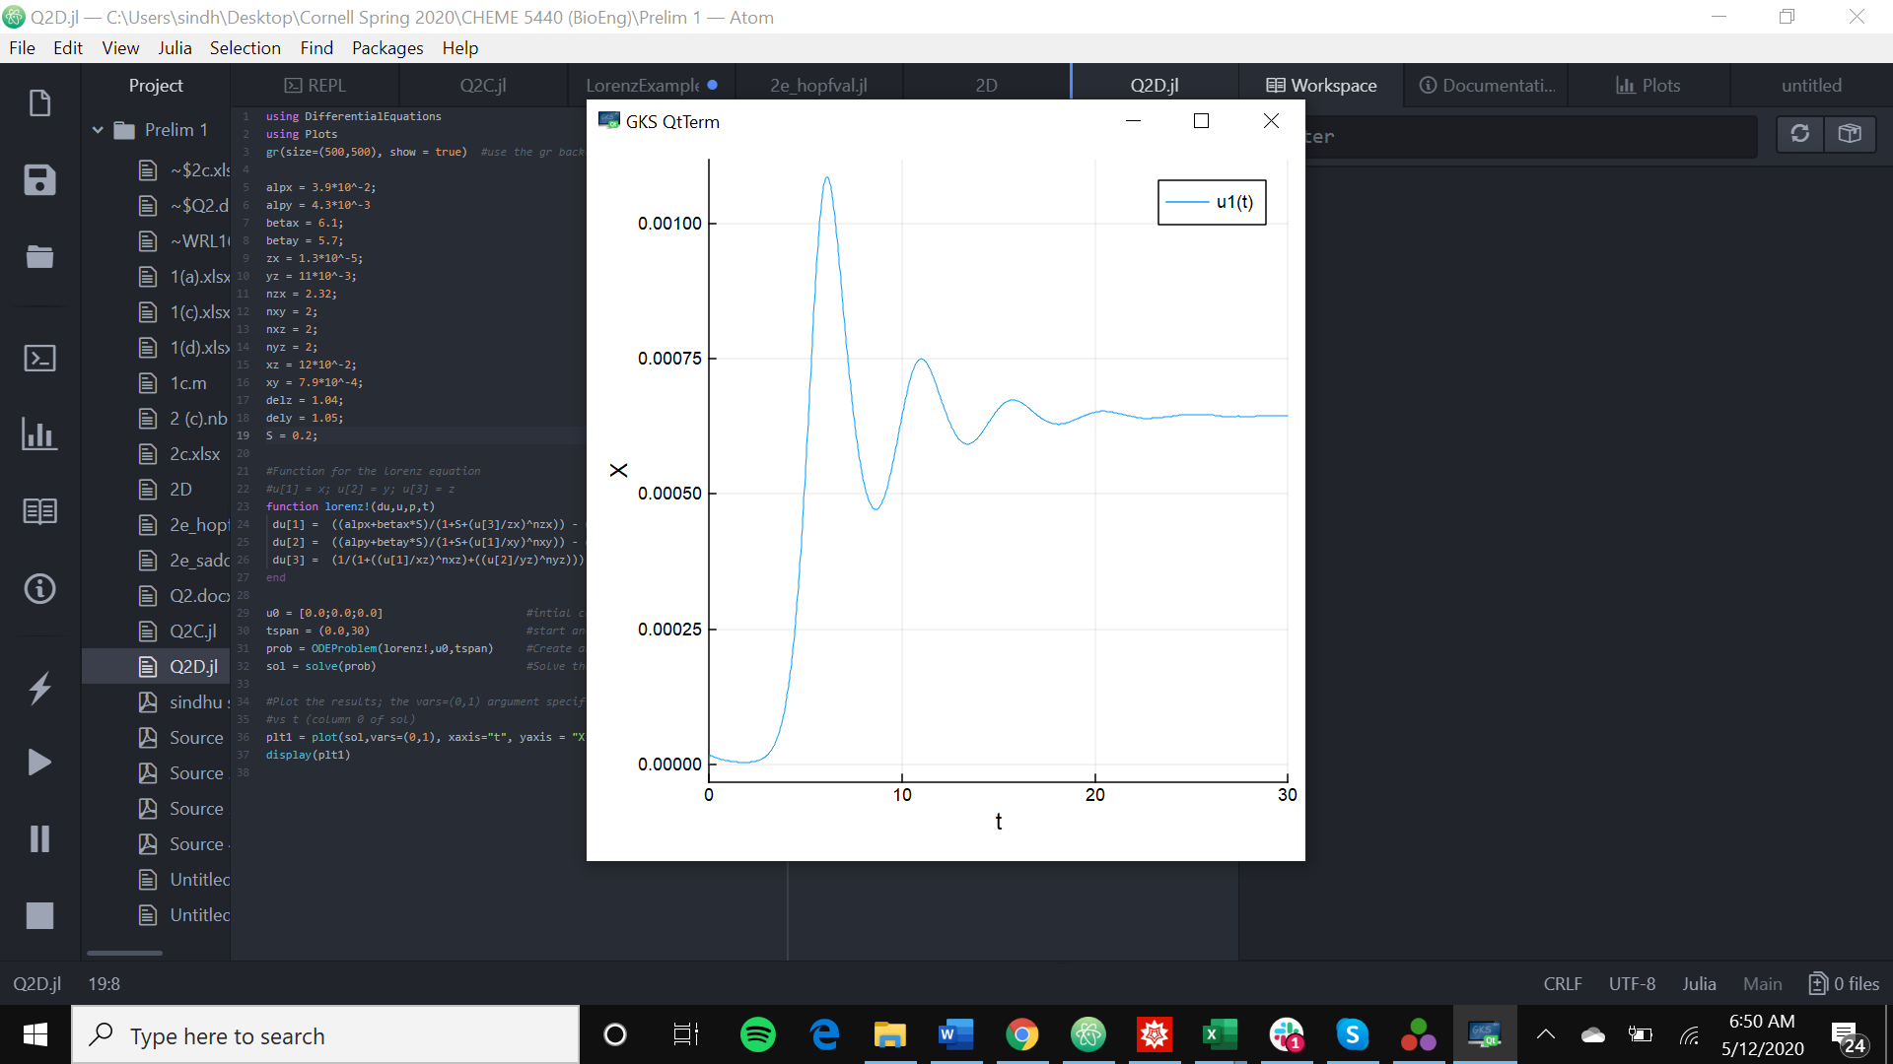

S = 10

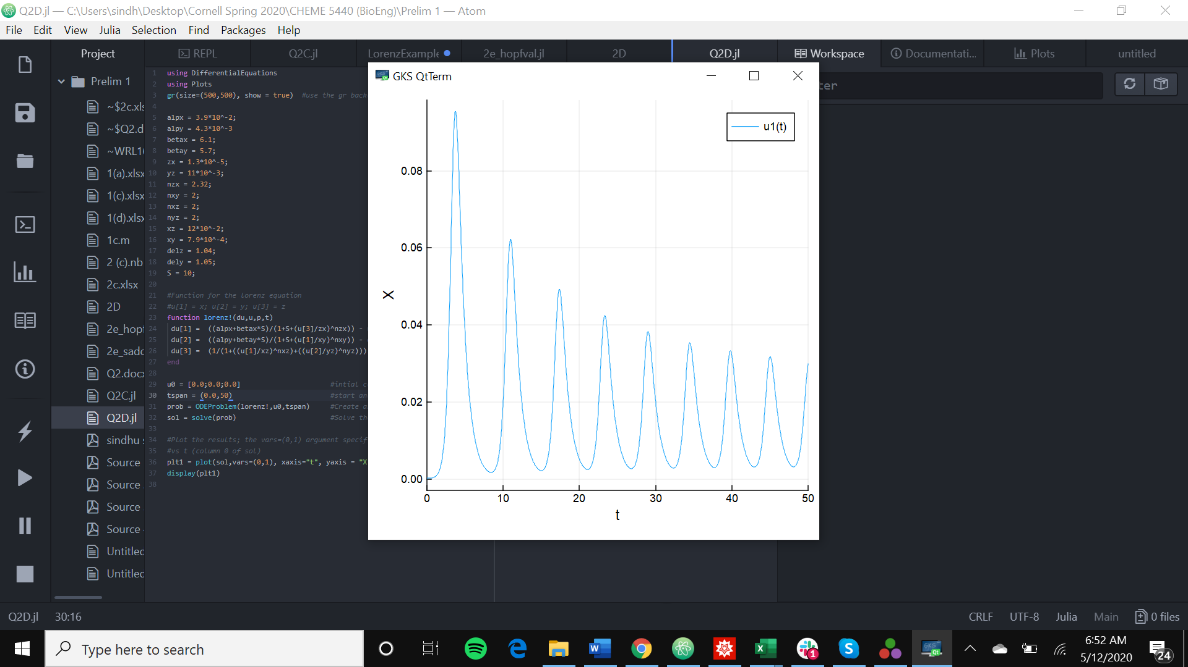

S = 100000

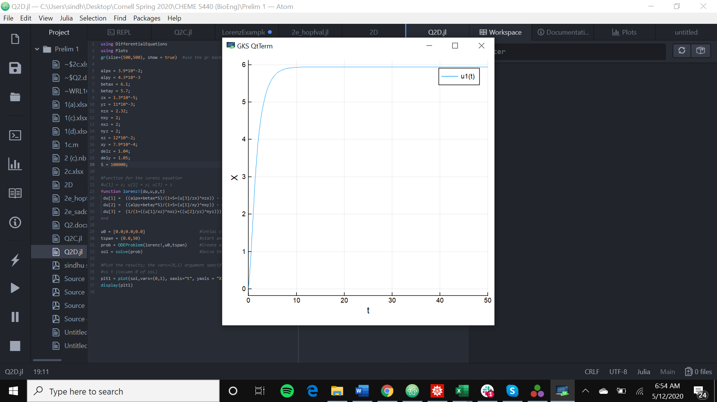

(e)

For the Hopf bifurcation occurs at approximately S = 0.5, and the Saddle bifurcation occurs at approximately S = 34,000. This can be observed in Figure 3B presented in the paper.

Instead of using a single initial value to get all the steady states, I used the steady state values from the previous step to get the values for the next step. I set my initial states to zero, and solved for the stable steady states within my function.

Hopf bifurcation – looking at the plot, the green line is 25% below steady state, the red is 25% above steady state, and the blue is at steady state. The solutions coming from below the Hopf bifurcation appear to be incoherent. When S changes from 0.5 to 100, this creates a small limit cycle around the initial steady state. The small differences between the cell initially are amplified over time.

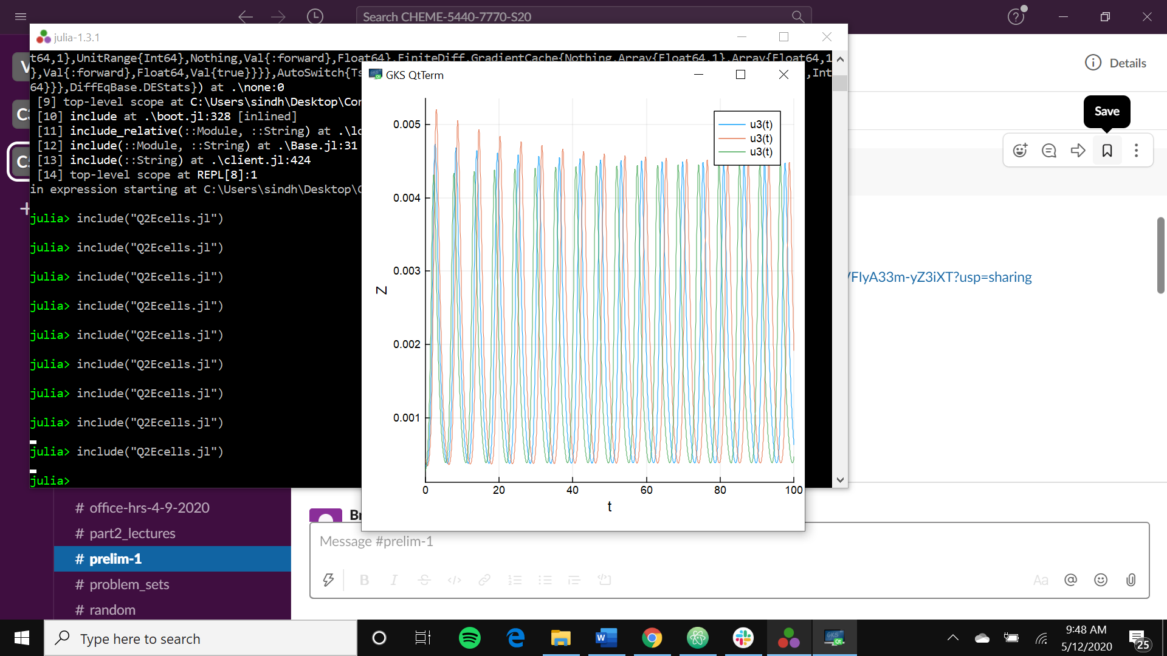

Saddle node bifurcation - looking at the plot, the green line is 25% below steady state, the red is 25% above steady state, and the blue is at steady state. The solutions coming from above the saddle appears to be coherent. This creates a large amplitude limit cycle around the initial steady state, and induces synchronous expression between cells.

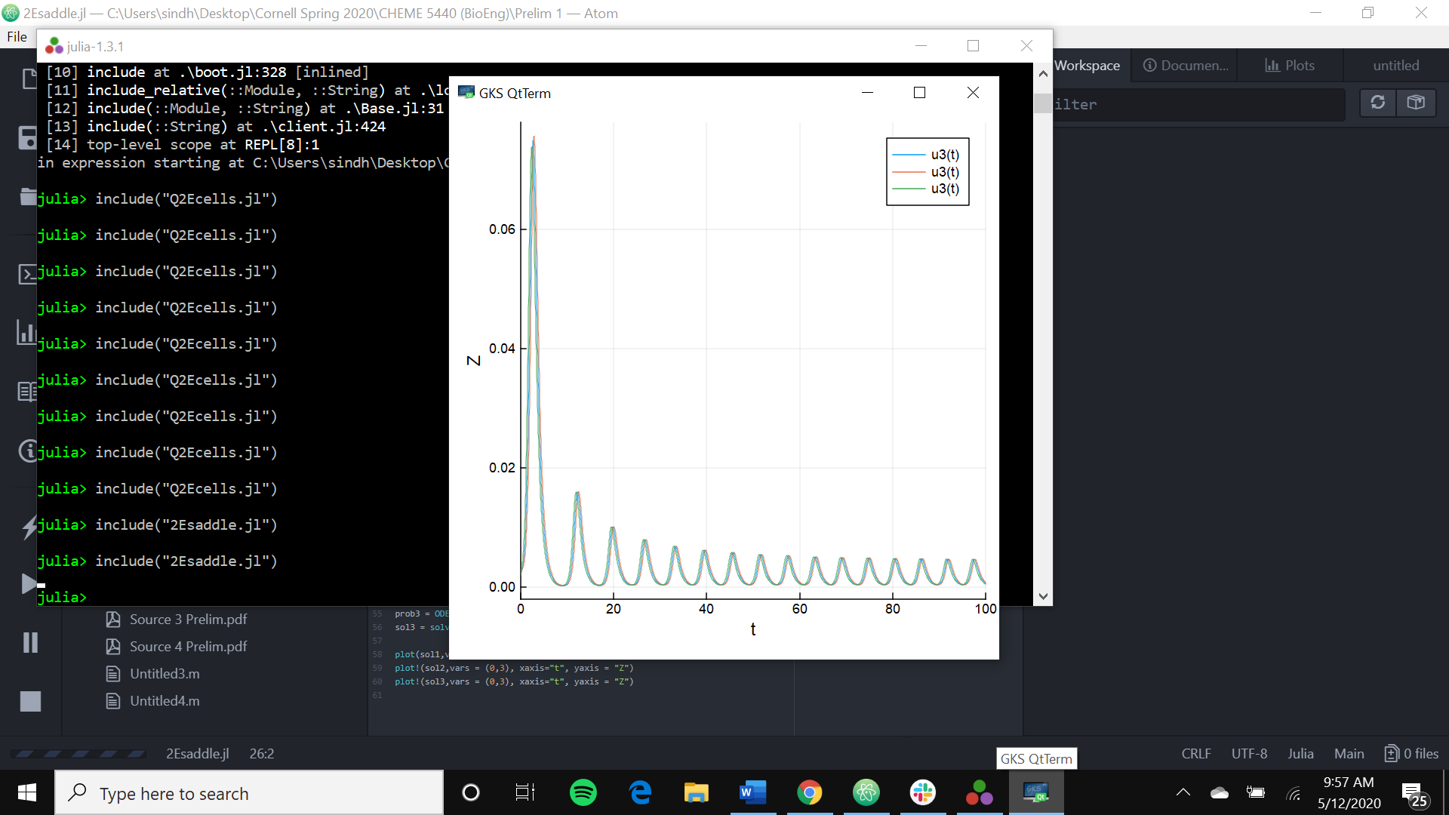

(f) Looking at the plot, a change in S from 105 to 100 does appear to produce coherent oscillation as time progresses. This is possible, given that we are using the parameters provided in the paper, and therefore indicates the paper is correct in thinking it possible.

