RidePulse — Data Architecture & Technical Documentation
Ride Demand, Supply & Surge Intelligence Dashboard
Trainer / Portfolio Submission

1. Executive Summary
RidePulse is a Power BI analytics solution for ride demand, supply, surge, revenue, driver performance and customer behavior. The model uses one central fact table and four dimensions in a star-schema design. Data is stored in Snowflake and consumed by Power BI Desktop in Import mode.
- FACT_RIDES — 1,000 ride-level records.
- DIM_DATE, DIM_CUSTOMER, DIM_DRIVER and DIM_ZONE — 10 records each.
- Snowflake database/schema: RIDE_ANALYTICS.ANALYTICS.
- Warehouse: COMPUTE_WH — X-Small, AUTO_SUSPEND=60, AUTO_RESUME=TRUE.
- Power BI connection mode: Import.
- Main pages: Executive Overview; Demand & Surge Intelligence; Driver & Customer Analytics.
- Supporting pages: Zone Tooltip and Zone Details.
- RLS role: Zone_Manager; Guindy zone filter; successfully tested.

2. Source & Technology Architecture
Component | Implementation
Source | Synthetic ride analytics dataset prepared for the portfolio project.
Storage / database | Snowflake — RIDE_ANALYTICS
Schema | ANALYTICS
Warehouse | COMPUTE_WH — X-Small; auto-suspend 60 seconds; auto-resume enabled.
BI platform | Power BI Desktop and Power BI Service
Semantic model | RidePulse
Connection mode | Import
Security | Power BI Row-Level Security

3. Snowflake Setup
Core environment setup:CREATE DATABASE IF NOT EXISTS RIDE_ANALYTICS;
CREATE SCHEMA IF NOT EXISTS RIDE_ANALYTICS.ANALYTICS;
USE DATABASE RIDE_ANALYTICS;
USE SCHEMA ANALYTICS;
CREATE WAREHOUSE IF NOT EXISTS COMPUTE_WH
WITH WAREHOUSE_SIZE='X-SMALL'
AUTO_SUSPEND=60
AUTO_RESUME=TRUE;

4. Table Inventory
Table | Role | Records | Purpose
FACT_RIDES | Fact | 1,000 | Ride-level operational and financial metrics.
DIM_DATE | Dimension | 10 | Date filtering and time analysis.
DIM_CUSTOMER | Dimension | 10 | Customer segmentation and demographics.
DIM_DRIVER | Dimension | 10 | Driver and vehicle analysis.
DIM_ZONE | Dimension | 10 | Zone-level demand, supply, surge and location analysis.

5. FACT_RIDES — Column Dictionary
Column | Power BI type | Business meaning
RIDE_ID | Whole number | Ride identifier / fact key.
DATE_ID | Whole number | FK to DIM_DATE.
CUSTOMER_ID | Whole number | FK to DIM_CUSTOMER.
DRIVER_ID | Whole number | FK to DIM_DRIVER.
ZONE_ID | Whole number | FK to DIM_ZONE.
BOOKING_TIME | Date/Time | Booking timestamp; used for hour analysis.
PICKUP_TIME | Date/Time | Pickup timestamp.
RIDE_TYPE | Text | Ride category.
DISTANCE_KM | Decimal | Trip distance in km.
DURATION_MIN | Decimal | Trip duration in minutes.
BASE_FARE | Decimal / currency | Base fare.
SURGE_MULTIPLIER | Decimal | Dynamic pricing multiplier.
DISCOUNT | Decimal / currency | Discount applied.
FARE | Decimal / currency | Ride fare.
NET_REVENUE | Decimal / currency | Revenue used in report.
DRIVER_EARNINGS | Decimal / currency | Driver earnings.
RIDE_STATUS | Text | Completed / cancelled operational status.
CANCELLATION_REASON | Text | Reason for cancellation.
PAYMENT_METHOD | Text | Payment method.
CUSTOMER_RATING | Decimal | Customer rating.
ZONE_DEMAND | Numeric | Zone demand observation.
ZONE_AVAILABLE_DRIVERS | Numeric | Available driver supply observation.
WAIT_TIME_MIN | Decimal | Wait time in minutes.

6. Dimension Column Dictionary — Confirmed Analytical Fields
The captured project evidence confirms the following dimension fields are used in the semantic model/report. The screenshots available for documentation do not expose every raw column in each 10-row dimension; therefore, unverified raw column names are intentionally not fabricated. The final submission should cross-check the full dimension inventory against Power BI Model/Data view or Snowflake DESCRIBE TABLE output.
Table | Column | Type | Usage
DIM_DATE | DATE_ID | Whole number | Relationship key
DIM_DATE | DATE | Date | Date slicer / trends
DIM_DATE | Date attributes | Text / whole number | Day, month, quarter and year analysis
DIM_CUSTOMER | CUSTOMER_ID | Whole number | Relationship key
DIM_CUSTOMER | CUSTOMER_TYPE | Text | Customer segmentation
DIM_CUSTOMER | AGE | Whole number | Age-group analysis
DIM_CUSTOMER | GENDER | Text | Demographic analysis
DIM_DRIVER | DRIVER_ID | Whole number | Relationship key
DIM_DRIVER | DRIVER_TYPE | Text | Driver segmentation
DIM_DRIVER | VEHICLE_TYPE | Text | Vehicle analysis
DIM_DRIVER | DRIVER_RATING | Decimal | Average driver rating
DIM_ZONE | ZONE_ID | Whole number | Relationship key
DIM_ZONE | ZONE_NAME | Text | Zone filtering, tooltip and drill-through

7. ER Diagram & Relationships
The semantic model is a star schema. Each dimension is on the 1-side and FACT_RIDES is on the many-side. Relationships are active and single-direction.
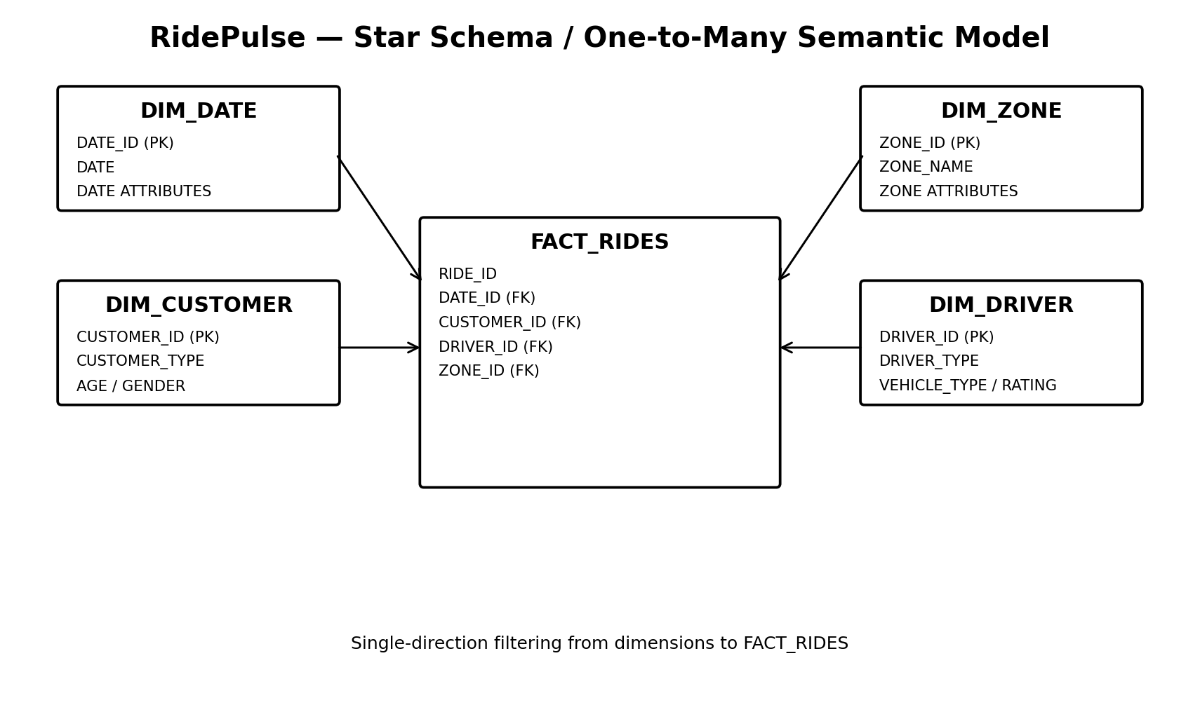
From | Cardinality | To | Filter | Status
DIM_DATE[DATE_ID] | 1 : * | FACT_RIDES[DATE_ID] | Single | Active
DIM_CUSTOMER[CUSTOMER_ID] | 1 : * | FACT_RIDES[CUSTOMER_ID] | Single | Active
DIM_DRIVER[DRIVER_ID] | 1 : * | FACT_RIDES[DRIVER_ID] | Single | Active
DIM_ZONE[ZONE_ID] | 1 : * | FACT_RIDES[ZONE_ID] | Single | Active

8. Report Architecture
Page | Purpose | Key content
Executive Overview | Management summary | KPIs, daily revenue trend, ride status, ride type, zone revenue, fare/surge trend, insights.
Demand & Surge Intelligence | Demand / supply | Demand by zone, surge by zone, available drivers, demand vs supply, wait time, hourly demand.
Driver & Customer Analytics | Performance / behavior | Driver earnings, trip distance, ratings, vehicle/driver/customer segmentation.
Zone Tooltip | Custom tooltip | Zone KPI summary: Total Rides, Net Revenue, Average Surge, Average Wait Time.
Zone Details | Drill-through | Zone KPIs plus ride status, ride type and payment method.

9. DAX Measures
Measure | DAX
Total Rides | COUNT(FACT_RIDES[RIDE_ID])
Completed Rides | CALCULATE([Total Rides], FACT_RIDES[RIDE_STATUS] = "Completed")
Cancelled Rides | CALCULATE([Total Rides], FACT_RIDES[RIDE_STATUS] = "Cancelled")
Completion Rate | DIVIDE([Completed Rides], [Total Rides])
Cancellation Rate | DIVIDE([Cancelled Rides], [Total Rides])
Gross Revenue | SUM(FACT_RIDES[FARE])
Net Revenue | SUM(FACT_RIDES[NET_REVENUE])
Average Fare | AVERAGE(FACT_RIDES[FARE])
Average Surge | AVERAGE(FACT_RIDES[SURGE_MULTIPLIER])
Average Wait Time | AVERAGE(FACT_RIDES[WAIT_TIME_MIN])
Driver Earnings | SUM(FACT_RIDES[DRIVER_EARNINGS])
Average Trip Distance | AVERAGE(FACT_RIDES[DISTANCE_KM])
Average Driver Rating | AVERAGE(DIM_DRIVER[DRIVER_RATING])
Average Customer Rating | AVERAGE(FACT_RIDES[CUSTOMER_RATING])

10. Supporting Calculations & Dynamic Parameter
- Booking Hour = HOUR(FACT_RIDES[Booking_Time])
- Booking Hour Label = FORMAT(FACT_RIDES[Booking_Time], "h AM/PM")
- Booking Hour Label is sorted by Booking Hour.
- RidePulse Metric Switch is a Power BI Field Parameter with Total Rides, Net Revenue and Average Surge.

11. DAX Strategy
- Centralize reusable business logic in measures so slicers and cross-filtering work consistently.
- Use CALCULATE for status-based KPIs.
- Use DIVIDE for ratios to handle zero denominators safely.
- Use dimensions for descriptive grouping/filtering and FACT_RIDES for transactional measures.
- Use calculated columns only where row-level classification or sorting is needed.
- Use the Field Parameter for the metric switch rather than duplicating report pages/charts.

12. Business Rules
- FACT_RIDES is the single transactional fact table.
- Dimension keys are unique on the 1-side of each relationship.
- Completed rides are identified by Ride_Status = Completed.
- Cancelled rides are identified by Ride_Status = Cancelled.
- Completion Rate = Completed Rides / Total Rides.
- Cancellation Rate = Cancelled Rides / Total Rides.
- Average Surge is the average Surge_Multiplier in the current filter context.
- Average Wait Time is measured in minutes; distance is measured in kilometres.
- Ratings use a 5-point scale.
- Currency values may be displayed in K for dashboard readability.

13. Interactive Features
Feature | Implementation
Page Navigator | Navigation across the three main report pages.
Bookmarks | Executive View and Analysis View change the Page 1 layout/visual visibility.
Dynamic Switch | Field Parameter switches Total Rides / Net Revenue / Average Surge.
Date Slicer | Changes the reporting time context.
URL | URL action included as a project requirement.
Custom Tooltip | Zone Tooltip provides zone-level KPIs.
Drill-through | Zone Details uses DIM_ZONE[ZONE_NAME].
RLS | Zone_Manager filters DIM_ZONE to Guindy.

14. RLS
Role: Zone_Manager
Filter: [ZONE_NAME] = "Guindy"
- RLS has been successfully tested.
- The active DIM_ZONE → FACT_RIDES relationship propagates the zone filter.
- For production use, assign appropriate users/groups to the role and use read/view permissions where RLS enforcement is required.

15. Refresh & Power BI Service
Item | Current documented state
Report | RidePulse
Semantic model | RidePulse
Workspace | My workspace
Snowflake credentials | Configured in Power BI Service
Scheduled refresh | Enabled
Service time zone shown | UTC
Exact scheduled clock time | Not visible in captured evidence; record the final IST time after configuration
Refresh validation | Refresh completed with a warning related to Average Driver Rating
The captured warning displayed an extra closing parenthesis in the stored Service expression. The intended measure is:
Average Driver Rating = AVERAGE(DIM_DRIVER[DRIVER_RATING])

16. Final Validation Checklist
- Three main pages are used for navigation; Tooltip and Drill-through are supporting pages.
- Page Navigator, bookmarks and Dynamic Switch work.
- Date slicer filters visuals correctly.
- Tooltip appears on zone visuals.
- Drill-through opens Zone Details and Back returns to the source page.
- RLS shows the intended Guindy zone context.
- Net Revenue and Driver Earnings use currency formatting and may display in K.
- Average Wait Time is clearly labelled in minutes.
- Average Driver Rating DAX warning is cleared in Service before final submission.
- Scheduled refresh is configured and its final IST time is recorded.
- Full dimension column inventory is cross-checked against the final Power BI/Snowflake model.

