PORTFOLIO BUSINESS CASE
E-commerce Sales, Customer Behaviour
and Profitability Analytics
Executive Business Report

Business Case | NovaCart Global
Analysis Period | 2012-2015
Dataset | Global Superstore public sample
Delivery | Python, MySQL, Excel and Power BI

DISCLOSURE
NovaCart Global is a fictional company created for this portfolio project. The report uses the public Global Superstore sample dataset and should not be presented as verified transactional data from a named real company.

Executive Summary
DECISION FOCUS
The business is growing and profitable overall, but deep discounting and loss-making products reduce the quality of that growth. Discount governance is the clearest immediate action.

$12.64M  Revenue | $1.47M  Profit | 11.61%  Profit Margin | 25,739  Orders

796  Customers | 178,312  Quantity | $491.18  Average Order Value | 4.19%  Returned-Order Rate

What the analysis found
- Revenue grew from about $2.26M in 2012 to $4.30M in 2015, while profit grew from about $248.94K to $504.17K.
- Technology was the strongest category, while Tables produced a $64.08K loss and a -8.46% margin.
- Discount bands above 20% were loss-making overall; the above-50% band produced a $412.58K loss.
- Asia Pacific led revenue, while Europe produced the highest market profit and strongest margin.
- Repeat purchasers generated 96.86% of revenue, but this should not be described as formal retention.

Immediate management priorities
- Control deep discounts with approval thresholds and expected-margin checks.
- Review loss-making products, starting with Tables and the Bottom 5 products.
- Assign country and regional profit reviews to the relevant Regional Managers.

1. Business Performance Overview
Revenue and profit increased across the four-year period. Growth was mainly volume-led: average order value decreased from about $500.32 in 2012 to $485.31 in 2015.
November and December produced the strongest revenue. However, October recorded the highest monthly margin at about 13.41%, while December margin was lower at about 10.73%.
MANAGEMENT INTERPRETATION
Peak sales periods should be evaluated using revenue, profit, margin and average order value together. High sales volume alone does not guarantee high-quality profit.

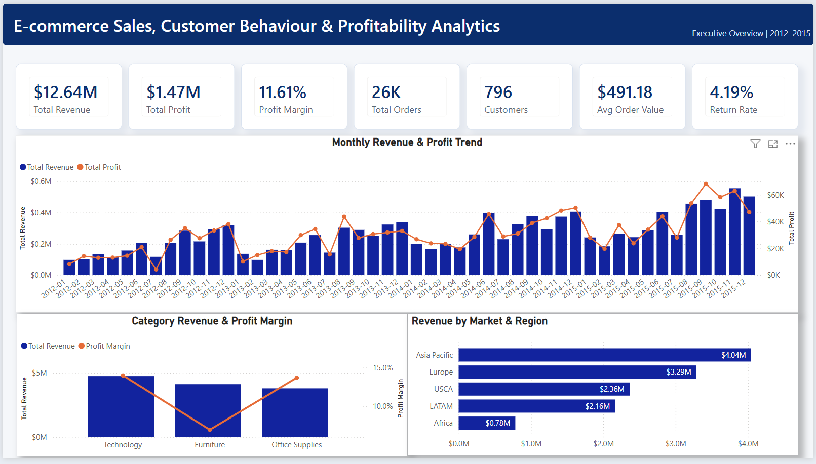
Figure 1. Power BI Executive Overview - overall KPIs, monthly trend, category performance and Market-to-Region analysis.

2. Product and Discount Risk
Issue | Validated evidence | Business meaning
Tables | $757.04K revenue; -$64.08K profit; -8.46% margin | High sales do not cover the cost and discount structure.
Loss-making products | 677 products; -$247.84K combined profit | Revenue ranking alone can hide products that destroy value.
Discounts above 20% | Loss-making in aggregate | Discount approval should include an expected-margin check.
Discounts above 50% | $371.62K revenue; -$412.58K profit; -111.02% margin | The business lost more than the revenue generated in this band.

Statistical testing supported the discount finding. Discount and line-level margin had a Spearman correlation of -0.67, while discount band and loss status had a strong association (Cramer's V: 0.84).
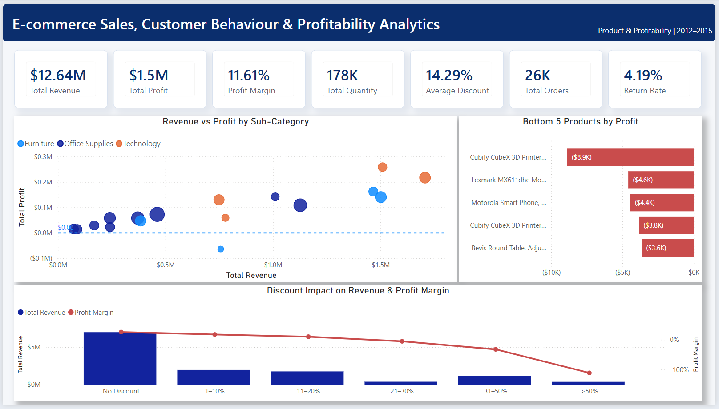
Figure 2. Product and Profitability page - sub-category performance, Bottom 5 products and discount impact.

3. Markets, Regions and Customers

Market performance
Market | Revenue | Profit | Margin | Avg. Discount
Asia Pacific | $4.04M | $403.18K | 9.97% | 18.10%
Europe | $3.29M | $449.55K | 13.68% | 9.09%
USCA | $2.36M | $304.22K | 12.87% | 15.04%
LATAM | $2.16M | $221.64K | 10.24% | 13.55%
Africa | $783.77K | $88.87K | 11.34% | 15.67%

Asia Pacific generated the most revenue, but Europe delivered the highest profit and strongest margin. Thirty-one countries were loss-making, so Market totals should be reviewed through Region and Country detail.

Customer segments
Segment | Customers | Revenue | Profit | Margin | Revenue / Customer
Consumer | 409 | $6.51M | $749.24K | 11.51% | $15.91K
Corporate | 238 | $3.82M | $441.21K | 11.54% | $16.07K
Home Office | 149 | $2.31M | $277.01K | 11.99% | $15.50K

CUSTOMER FOCUS
The At Risk RFM group represented about $2.02M in historical revenue. Reactivation should focus on past value and expected profit, not blanket discounts.

4. Customer Behaviour, Returns and Advanced Analysis
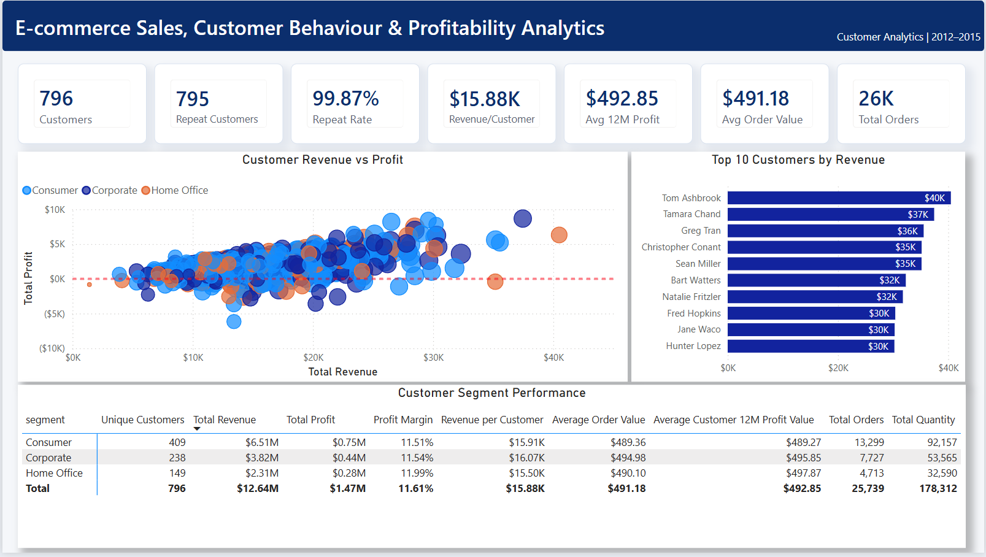
Figure 3. Customer Analytics page - customer profitability, Top 10 customers and segment performance.

Returns
The dataset contains 1,079 returned orders, equal to a 4.19% returned-order rate. USCA recorded the highest market rate at 4.47%, but market differences were small.
The above-50% discount band had a 3.73% returned-order rate, below the overall rate. This suggests returns were not the main reason for the deep-discount losses.
DATA LIMITATION
Returns are recorded at order level. Product-level findings must be described as products appearing in returned orders, not confirmed returned products.

Advanced analysis
- Furniture's product-level profitability was weaker than Office Supplies, but the discount effect was much larger than the category effect.
- Month-2 weighted customer activity was 28.19%; Month-12 activity was 38.35%. This is cohort activity, not subscription retention.
- Exact product pairs were too sparse for strong conclusions. Accessories and Phones showed a positive category-level signal across 377 orders.

5. Recommended Actions
Priority | Action | Suggested owner | Primary measure
1 | Introduce discount approval bands and expected-margin checks. | Sales, Pricing, Finance | Margin and loss by discount band
2 | Classify loss-making products as Keep, Fix or Exit; start with Tables. | Category, Procurement, Supply Chain | Negative-product loss; Tables margin
3 | Review loss-making countries through Market, Region and Country drill-down. | Regional Managers, Pricing | Loss-making countries; regional profit
4 | Reactivate high-value At Risk customers without blanket deep discounts. | CRM, Sales, Marketing | Reactivated customer profit
5 | Capture exact returned product, return reason and return cost. | Operations, Customer Service | Return rate, reason and cost

Suggested 90-day plan
Timeframe | Main actions
Days 1-30 | Approve discount rules, prepare the loss-making product list and build the At Risk customer list.
Days 31-60 | Review Tables, test pricing and cost changes, analyse loss-making countries and improve return-data capture.
Days 61-90 | Evaluate results, expand successful customer actions, test selected cross-selling ideas and assign regional follow-ups.

FIRST DECISION
Begin with discount governance. It is supported by the strongest statistical evidence and the largest directly observed loss pattern.

6. Decision Support Dashboard
The detailed Power BI page allows users to filter by Year, Market, Category and Region, review product-level profitability and connect the findings to the recommended actions.
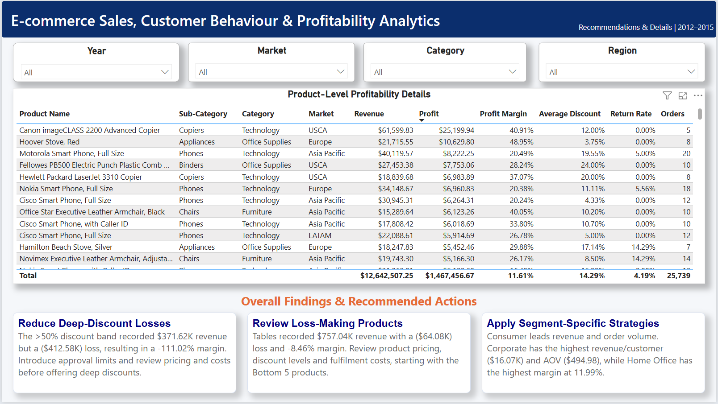
Figure 4. Recommendations and Details page - interactive product analysis and overall recommended actions.

Recommended review rhythm
- Weekly: monitor deep-discount exceptions and newly loss-making products.
- Monthly: review category, country, Region and customer profitability.
- Quarterly: reassess product Keep/Fix/Exit decisions and the impact of pricing changes.

7. Methodology and Analytical Model
The project follows an end-to-end analytics workflow. Raw data was preserved, cleaned outputs were stored separately and each analytical layer was validated before dashboard development.
Stage | Output
Python | Loading, quality audit, cleaning, EDA, statistical tests, cohort and basket analysis
MySQL 8 | Star schema and 20 business-focused SQL queries
Excel | Power Query, Data Model, PivotTables, PivotCharts, slicers and KPI formulas
Power BI | Star schema, 19 organised DAX measures and four visible dashboard pages

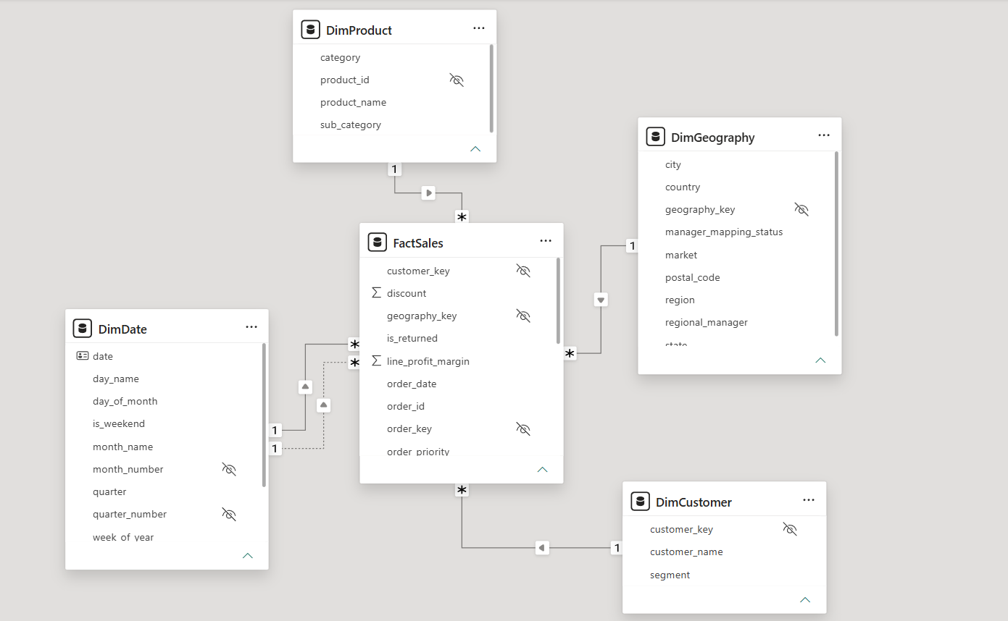
Figure 5. Power BI star schema with FactSales, DimDate, DimCustomer, DimProduct and DimGeography.
The cleaned Orders dataset contains 51,290 sales lines and 38 fields. The MySQL model contains 51,290 fact rows, 1,468 dates, 796 customers, 3,788 products and 3,856 geography records.

8. Limitations and Conclusion

Important limitations
- The project uses a public sample dataset and a fictional company scenario.
- Historical relationships do not prove direct cause and effect.
- Return information is available at order level, not individual returned-product level.
- The observed 99.87% repeat-purchase rate is not formal customer retention.
- The 12-month customer profit value is a historical proxy, not predictive lifetime value.
- Exact product-pair results were too sparse for strong basket conclusions.
- Missing postal codes were retained because they mainly belonged to non-US locations.
- Valid outliers and negative-profit transactions were retained because they are important to the business analysis.

Conclusion
NovaCart Global showed strong revenue and profit growth, but a meaningful share of sales came from low-margin or loss-making activity.
Deep discounting was the clearest risk, followed by loss-making products, Tables and unprofitable countries. Repeat customers remain important, and valuable At Risk customers provide a practical reactivation opportunity.
CLOSING MESSAGE
Future growth should be judged by profit and margin together with revenue. The existing Excel and Power BI dashboards provide the controls needed to monitor the action plan.

END OF REPORT

