**CAFETERIA MANAGEMENT SYSTEM**

*A*

*Mini Project Report*

*Submitted in partial fulfilment of the*

*Requirements for the award of the Degree of*

**BACHELOR OF ENGINEERING**

IN

**INFORMATION TECHNOLOGY**

By

**Kalthi Reddy Gayathri – 1602-19-737-013**

**Maram Sindhuja – 1602-19-737-043**



**Department of Information Technology**

**Vasavi College of Engineering (Autonomous)**

**(Affiliated to Osmania University)**

**Ibrahimbagh, Hyderabad-31**

**2020**

**Vasavi College of Engineering (Autonomous)**

**(Affiliated to Osmania University)**

**Hyderabad-500 031**

**Department of Information Technology**



**DECLARATION BY THE CANDIDATE**

              We, **Kalthi Reddy Gayathri and Maram Sindhuja ,**bearing hall ticket numbers, **1602-19-737-013 and 1602-19-737-043**, hereby declare that the project report entitled **”CAFETERIA MANAGEMENT SYSTEM”**Department of Information Technology, Vasavi College of Engineering, Hyderabad, is submitted in partial fulfilment of the requirement for the award of the degree of **Bachelor of Engineering** in **Information Technology**

               This is a record of bonafide work carried out by us and the results embodied in this project report have not been submitted to any other university or institute for the award of any other degree or diploma.

**Kalthi Reddy Gayathri**

**1602-19-737-013**

**Maram Sindhuja**

**1602-19-737-043**

**B.Leelavathy** **Mr.Ram Mohan Rao**

(Faculty In-Charge)                  (Head,Dept of IT)

**TABLE OF CONTENT**

|  |  |  |
| --- | --- | --- |
| S.No | Content | Page |
| 1. | Cover sheet | 1 |
| 2. | Declaration | 2 |
| 3. | Acknowledgement | 4 |
| 4. | Abstract | 5 |
| 5. | Introduction | 6 |
| 6. | Technology | 8 |
| 7. | Proposed work | 9 |
| 8. | Results | 71 |
| 9. | Additional learning | 80 |
| 10. | Discussion and Future work | 81 |
| 11. | References | 82 |

**ACKNOWLEDGMENT**

We would like to express our special thanks of gratitude to our principal sir **“Dr. S.V.Ramana”** and HOD sir **“Dr. K. Ram Mohan Rao”.**

It is our privilege to express our sincere regards to our class coordinator, “**B.Leelavathy”** madamfor her valuable advices and suggestions from time to time and for always supporting us.

We take this opportunity to thank all our lecturers who have directly or indirectly helped our project. We pay our respects and love to our parents and all other family members and friends for their love and encouragement throughout our career. Last but not the least we express our thanks to our friends for their cooperation and support.

**ABSTRACT**

Cafeteria management system is a simple application which is designed for the purpose of calculating total bill of a customer in a café. This system elaborates basic concept of storing and generating ordered item’s details. This application is secured with a password, so that the admin can login at any time and can maintain the records of everything that happens in a café. This application will have an account for every customer. The features of this application are displaying menu of the food items, orders placed by the customers, details of the customers, a mini quiz (to entertain the customers and to give discounts) and calculation of the total bill. The source code of this application is written only in c language using structures, files etc and can be compiled using GCC or turbo compiler. This is a user-friendly application.

**INTRODUCTION**

Cafeteria management system will able to provide fast services to their customers by using their records which has been saved previously. However new records can be added any time whenever any customers visited to their canteen shop. To identify the customers, each customer can choose a unique reference id and during data entering process all their basic information’s will be added into the file.

1. Main modules in Cafeteria Management System
2. Admin
3. Customer
4. Create account
5. View account
6. Edit account
7. Delete account
8. Display menu
9. Display total bill
10. Quiz
11. Pay bill

1. Aim of the project

To create a C language based application for the project **Cafeteria Management System** which takes the values like customerId, customer name, customer mobile number, customer address, admin userId and password. These entities are used for basic use for the customer.

**TECHNOLOGY**

**Hardware Requirements:**

* Operating system: windows XP or higher versions
* Memory: minimum 2GB RAM is required

**Software Requirements:**

* C-compiler (GCC)
* Language: C

**PROPOSED WORK**

1. Design
2. Use Case Diagram

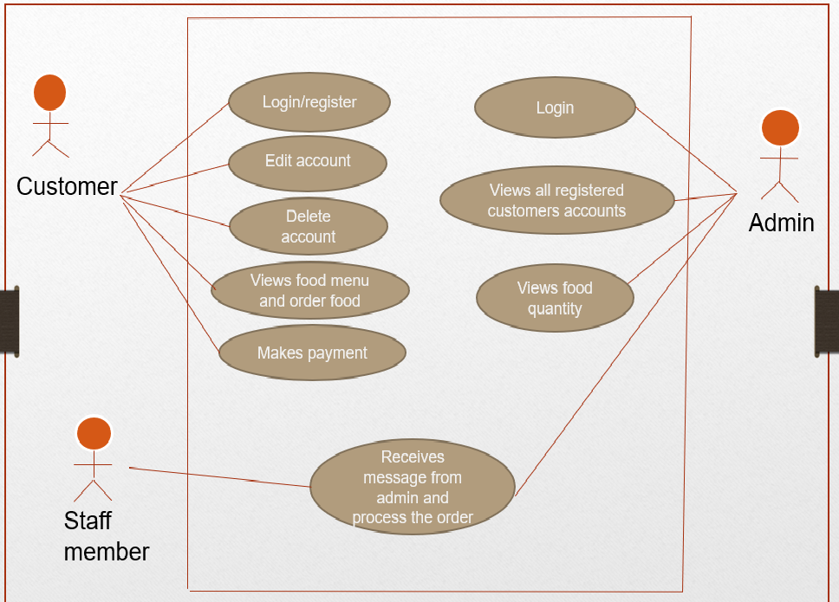

1. Flowchart

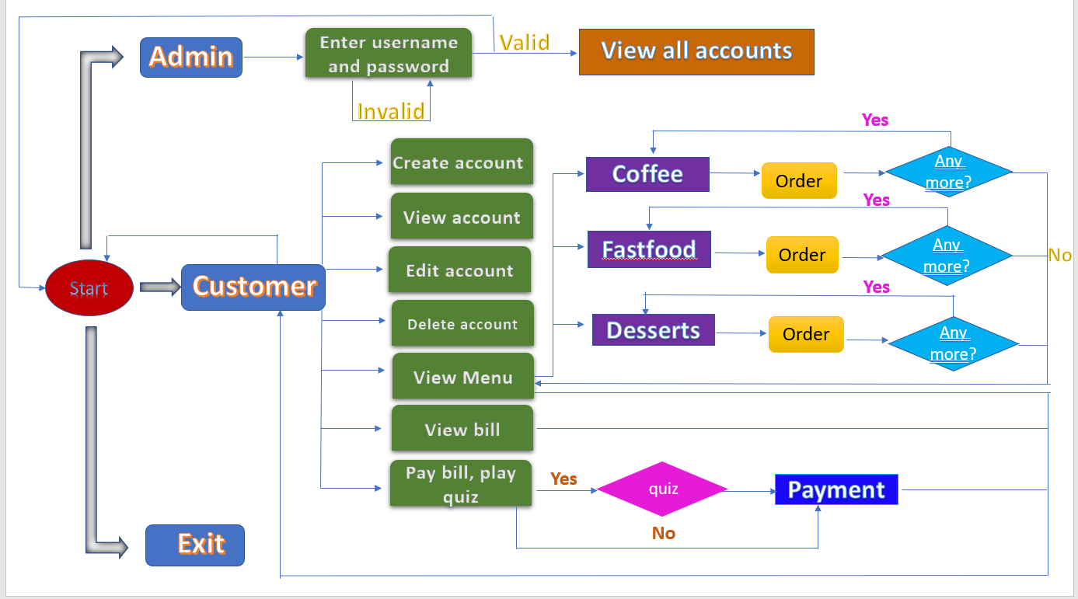

1. Implementation
2. Description of main modules/classes/components

**Below is the module to print headmessage**

void headMessage(const char *message)

{

system("cls");

system("color 0B");

getch();

printf("\n\t\t\t\t\t#################################################################");

getch();

printf("\n\t\t\t\t\t############ ############");

getch();

printf("\n\t\t\t\t\t############ Cafeteria Management System ############");

getch();

printf("\n\t\t\t\t\t############ ############");

getch(); printf("\n\t\t\t\t\t#################################################################");

getch();

printf("\n\t\t\t\t\t-----------------------------------------------------------------\n");

printMessage(message);

printf("\n\t\t\t\t\t-----------------------------------------------------------------\n");

}

**Below is the module for displaying admin menu**

void admin()

{

system("cls");

system("color 0E");

int choice;

int k,a = 0,i = 0;

char p;

char checkuname[13];

char checkpword[13];

char username[13] = "miniproject";

char password[13] = "cafeteria";

do{

printf("\n\t\t\t\t\t\xB2\xB2\xB2\xB2\xB2\xB2\xB2\xB2\xB2\xB2\xB2\xB2\xB2\xB2\xB2\xB2\xB2\xB2 LOGIN FORM \xB2\xB2\xB2\xB2\xB2\xB2\xB2\xB2\xB2\xB2\xB2\xB2\xB2\xB2\xB2\xB2\xB2\xB2\n\n");

printf("\t\t\t\t\t Enter username: ");

scanf("%s",&checkuname);

printf("\n\t\t\t\t\t Enter password: ");

p = 0;

while(p!=13)

{

p = getch();

if(p!=13 && p!=9)

{

printf("*");

checkpword[i]=p;

i++;

}

}

checkpword[i]='\0';

int z = strcmp(checkuname,username);

int x = strcmp(checkpword,password);

if( !z && !x)

{

printf("\n\n\t\t\t\t\t WELCOME! LOGIN SUCCESSFUL");

getch();

goto opt;

break;

}

else

{

printf("\n\n\t\t\t\t\t SORRY! LOGIN UNSUCCESSFUL");

a++;

getch();

system("cls");

}

}while(a<3);

if(a>=3)

{

system("cls");

system("color oC");

printf("\n\n\n\n\n\n\t\t\t\t\t\t SORRY YOU HAVE ENTERED WRONG DETAILS FOR THREE TIMES!!!\n\n");

exit(1);

}

opt:{

system("cls");

if(a<3)

{

system("color 09");

printf("\n\n\n\n\n\t\t\t\t\t\t 1. View all accounts \n");

printf("\t\t\t\t\t\t 2. Back to home \n\n");

printf("\t\t\t\t\t\t Enter your choice : ");

scanf("%d",&choice);

switch(choice)

{

case 1 : viewAllAccounts();break;

default :

printf("\n\t\t\t\t\t\t Press any key to continue...");

getch();

system("cls");

break;

}

}//end of if block

}//end of opt

}

**Below is the module to view all accounts**

void viewAllAccounts()

{

system("cls");

system("color 03");

FILE *fp;

struct customer c;

fp=fopen("customerInfo.txt","r");

printf("\n\t\t\t\t\t==============================================================\n");

printf("\t\t\t\t\t\t\tAll Customer Details");

printf("\n\t\t\t\t\t==============================================================\n");

while(1)

{

fread(&c,sizeof(c),1,fp);

if(feof(fp))

break;

printf("\n\t\t\t\t\tCustomerID :%d",c.customerID);

printf("\n\t\t\t\t\tName :%s",c.name);

printf("\n\t\t\t\t\tPhone :%s",c.phone);

printf("\n\t\t\t\t\tAddress :%s",c.address);

printf("\n\t\t\t\t\tAmount last paid :%.2f\n",c.amount);

}

printf("\t\t\t\t\t==============================================================\n\n");

getch();

system("cls");

fclose(fp);

}

**Below is the module to display customer menu**

void Customer()

{

system("cls");

system("color 0D");

int choice;

system("cls");

printf("\n\n\n\n\t\t\t\t\t\t 1.Create account");

printf("\n\t\t\t\t\t\t 2.view account");

printf("\n\t\t\t\t\t\t 3.Edit account");

printf("\n\t\t\t\t\t\t 4.Delete account");

printf("\n\t\t\t\t\t\t 5.View Menu to order food");

printf("\n\t\t\t\t\t\t 6.Display bill");

printf("\n\t\t\t\t\t\t 7.Pay bill");

printf("\n\t\t\t\t\t\t 8.Back to home\n");

printf("\n\t\t\t\t\t\t Enter your choice : ");

scanf("%d",&choice);

switch(choice)

{

case 1 : add_account();break;

case 2 : view_account();break;

case 3 : edit_account();break;

case 4 : delete_account();break;

case 5 : Menu_display();break;

case 6 : DisplayBill();break;

case 7 : PayBill();break;

case 8 : system("cls");

break;

default : printf("\n\n\t\t\t\t\t\t Invalid input\n");

printf("\t\t\t\t\t\t Press any key to continue...");

getch();

break;

}

}

**Below is the module to check for a valid name**

int isNameValid(const char *name)

{

int validName = 1;

int len = 0;

int index = 0;

len = strlen(name);

for(index =0; index <len ; ++index)

{

if(!(isalpha(name[index])))

{

if(!(isspace(name[index])))

{

validName = 0;

break;

}

else

break;

}

}

return validName;

}

**Below is the module to check for a valid mobile number**

int isValidNumber(const char *number)

{

int validNumber = 1;

int len = strlen(number);

int num = atoi(number);

if(num != 0)

{

if(len == 10)

return validNumber;

else

{

validNumber = 0;

return validNumber;

}

}

else

{

validNumber = 0;

return validNumber;

}

}

**Below is the module to create an account**

void add_account()

{

system("cls");

system("color 02");

FILE *fp;

char y[20];

struct customer c1;

int id,status = 0;

fflush(stdin);

printf("\n\n\n\t\t\t\t\t\t Do you want to create an account? [Y/N]:");

while(toupper(getche())=='Y'){

getchar();

fp=fopen("customerInfo.txt","a");

add_check(y);

c1.customerID = atoi(y);

do{

printf("\n\t\t\t\t\t\tEnter your Name :");

gets(c1.name);

status = isNameValid(c1.name);

if (!status)

{

printf("\n\t\t\t\t\t\t\tName contains an invalid character. Please enter again...\n");

getch();

}

}while(!status);

status = 0;

do{

printf("\n\t\t\t\t\t\tEnter your phone number:");

gets(c1.phone);

status = isValidNumber(c1.phone);

if(!status)

{

printf("\n\t\t\t\t\t\t\t\tMobile number is in invalid format.Please enter again...\n");

}

}while(!status);

printf("\n\t\t\t\t\t\tEnter your Address :");

gets(c1.address);

c1.amount=0;

printf("\n\n\n\t\t\t\xB2\xB2\xB2\xB2\xB2\xB2\xB2\xB2\xB2\xB2\xB2\xB2\xB2\xB2\xB2\xB2\xB2\xB2\xB2\xB2\xB2\xB2\xB2\xB2\xB2 YOUR ACCOUNT IS CREATED SUCCESSFULLY \xB2\xB2\xB2\xB2\xB2\xB2\xB2\xB2\xB2\xB2\xB2\xB2\xB2\xB2\xB2\xB2\xB2\xB2\xB2\xB2\xB2\xB2\xB2\xB2\xB2\n");

getch();

system("cls");

fwrite(&c1,sizeof(c1),1,fp);

fclose(fp);

}

}

**Below is the module to check for existing reference Id**

void add_check(char y[])

{

int flag;

FILE *fp;

struct customer c;

int status = 0;

fp = fopen("customerInfo.txt","r");

while(1)

{

flag = 1;

rewind(fp);

printf("\n\n\t\t\t\xB2\xB2\xB2\xB2\xB2\xB2\xB2\xB2\xB2\xB2\xB2\xB2\xB2\xB2\xB2\xB2\xB2\xB2\xB2\xB2\xB2\xB2\xB2\xB2\xB2 Creating Your Account.......... \xB2\xB2\xB2\xB2\xB2\xB2\xB2\xB2\xB2\xB2\xB2\xB2\xB2\xB2\xB2\xB2\xB2\xB2\xB2\xB2\xB2\xB2\xB2\xB2\xB2\xB2\xB2\n\n");

printf("\n\t\t\t\t\t\tEnter a reference id :");

gets(y);

while(fread(&c,sizeof(c),1,fp)==1)

{

if(atoi(y) == c.customerID)

{

flag = 0;

printf("\n\t\t\tSorry it seems this reference id already exists.... Press any key to enter a differnet id ..\n");

getch();

system("cls");

getch();

break;

}

}

if(flag == 1)

break;

}

fclose(fp);

}

**Below is the code to view account**

void view_account()

{

system("cls");

system("color 03");

FILE *fp;

struct customer c;

int id,found=0;

fp=fopen("customerInfo.txt","r");

printf("\n\n\n\n\n\n");

printf("\n\t\t\t\t\t\tEnter your reference ID to view your account:");

scanf("%d",&id);

while(1)

{

fread(&c,sizeof(c),1,fp);

if(feof(fp))

break;

if(c.customerID==id)

{

found=1;

printf("\n\n\n\n\n\n");

printf("\n\t\t\t\t\t\t =============================================\n");

printf("\t\t\t\t\t\t\t\tCustomer Details of %d",c.customerID);

printf("\n\t\t\t\t\t\t =============================================\n");

printf("\n\t\t\t\t\t\t Name : %s",c.name);

printf("\n\t\t\t\t\t\t Phone Number : %s",c.phone);

printf("\n\t\t\t\t\t\t Address : %s",c.address);

printf("\n\t\t\t\t\t\t Amount last paid : %.2f",c.amount);

printf("\n\t\t\t\t\t\t =============================================\n");

getch();

system("cls");

}

}

if(found==0)

{

printf("\n\n\t\t\t\t\t\t Sorry no record found");

getch();

system("cls");

}

fclose(fp);

}

**Below is the code to edit account**

void edit_account()

{

system("cls");

system("color 09");

FILE *fp,*fp1;

struct customer c1;

int id,found=0,status=0;

char name[20];

char Name[20],Mobile[12],Addr[200];

fp=fopen("customerInfo.txt","r");

fp1=fopen("temp.txt","w");

printf("\n\n\n\n\n\n\t\t\t\t\t\tEnter your reference id to edit:");

scanf("%d",&id);

fflush(stdin);

printf("\n\t\t\t\t\t\tEnter your name :");

gets(name);

system("cls");

while(1)

{

fread(&c1,sizeof(c1),1,fp);

if(feof(fp))

break;

if(c1.customerID==id && (strcmp(c1.name,name) == 0))

{

found=1;

printf("\n\t\t\t\t\t\t =================================================\n");

printf("\t\t\t\t\t\t\t\tCustomer Details of %d",c1.customerID);

printf("\n\t\t\t\t\t\t =================================================\n");

printf("\n\t\t\t\t\t\t Name : %s",c1.name);

printf("\n\t\t\t\t\t\t Phone Number : %s",c1.phone);

printf("\n\t\t\t\t\t\t Address : %s",c1.address);

printf("\n\t\t\t\t\t\t Amount paid last : %.2f",c1.amount);

printf("\n\t\t\t\t\t\t =================================================\n");

strcpy(Name,c1.name);

strcpy(Mobile,c1.phone);

strcpy(Addr,c1.address);

printf("\n\n\t\t\t\t\t\t Do you want to edit your account ? [Y/N] ");

if(toupper(getche()) == 'Y'){

system("cls");

printf("\n\n\n\n\n");

printf("\n\t\t\t \xB2\xB2\xB2\xB2\xB2\xB2\xB2\xB2\xB2\xB2\xB2\xB2\xB2\xB2\xB2\xB2\xB2\xB2\xB2\xB2\xB2\xB2\xB2\xB2\xB2 Edit Your Account....... \xB2\xB2\xB2\xB2\xB2\xB2\xB2\xB2\xB2\xB2\xB2\xB2\xB2\xB2\xB2\xB2\xB2\xB2\xB2\xB2\xB2\xB2\xB2\xB2\xB2\n\n");

fflush(stdin);

do{

printf("\n\t\t\t\t\t\tEnter your Name :");

gets(c1.name);

status = isNameValid(c1.name);

if (!status)

{

printf("\n\t\t\t\t\tName contains an invalid character. Please enter again...\n");

getch();

}

}while(!status);

status = 0;

do{

printf("\n\t\t\t\t\t\tEnter your phone number:");

gets(c1.phone);

status = isValidNumber(c1.phone);

if(!status)

{

printf("\n\t\t\t\t\t\t\t\tMobile number is in invalid format.Please enter again...\n");

}

}while(!status);

printf("\n\t\t\t\t\t\tEnter your address :");

scanf("%s",c1.address);

printf("\n\t\t\t \xB2\xB2\xB2\xB2\xB2\xB2\xB2\xB2\xB2\xB2\xB2\xB2\xB2\xB2\xB2\xB2\xB2\xB2\xB2\xB2 Account edited successfully \xB2\xB2\xB2\xB2\xB2\xB2\xB2\xB2\xB2\xB2\xB2\xB2\xB2\xB2\xB2\xB2\xB2\xB2\xB2\xB2\xB2\xB2\xB2\xB2\xB2\xB2\xB2");

getch();

system("cls");

fwrite(&c1,sizeof(c1),1,fp1);

}

else

{

fwrite(&c1,sizeof(c1),1,fp1);

getch();

system("cls");

}

}

else

{

fwrite(&c1,sizeof(c1),1,fp1);

getch();

system("cls");

}

}

fclose(fp);

fclose(fp1);

if(found==0){

printf("\n\n\n\n\n\n\n\t\t\t\t\t\t Sorry record not found\n\n");

getch();

system("cls");

}

else

{

fp=fopen("customerInfo.txt","w");

fp1=fopen("temp.txt","r");

while(1)

{

fread(&c1,sizeof(c1),1,fp1);

if(feof(fp1))

break;

fwrite(&c1,sizeof(c1),1,fp);

}

}

fclose(fp);

fclose(fp1);

}

**Below is the code to delete an account**

void delete_account()

{

system("cls");

system("color 08");

FILE *fp,*fp1;

struct customer c1;

int id,found=0;

char name[20];

fp=fopen("customerInfo.txt","r");

fp1=fopen("temp.txt","w");

printf("\n\n\n\n\t\t\t\t\t Enter your reference id to delete your account:");

scanf("%d",&id);

fflush(stdin);

while(1)

{

fread(&c1,sizeof(c1),1,fp);

if(feof(fp))

break;

if(c1.customerID==id)

{

found=1;

printf("\n\n\n\t\t\t\t\xB2\xB2\xB2\xB2\xB2\xB2\xB2\xB2\xB2\xB2\xB2\xB2\xB2\xB2\xB2\xB2\xB2\xB2\xB2\xB2 Account deleted successfully..... \xB2\xB2\xB2\xB2\xB2\xB2\xB2\xB2\xB2\xB2\xB2\xB2\xB2\xB2\xB2\xB2\xB2\xB2\xB2\xB2\n");

getch();

system("cls");

}

else

{

fwrite(&c1,sizeof(c1),1,fp1);

}

}

fclose(fp);

fclose(fp1);

if(found==0)

printf("\n\t\t\t\t\t\tSorry record not found\n\n");

else

{

fp=fopen("customerInfo.txt","w");

fp1=fopen("temp.txt","r");

while(1)

{

fread(&c1,sizeof(c1),1,fp1);

if(feof(fp1))

break;

fwrite(&c1,sizeof(c1),1,fp);

}

}

fclose(fp);

fclose(fp1);

}

**Below is the module to display bill**

void DisplayBill()

{

system("cls");

system("color 0D");

if(ref != 1 || totalbill == 0)

{

printf("\n\n\n\t\t\t\t\t\t It seems you have not yet ordered !!!!!!!\n");

getch();

system("cls");

}

else{

printf("\n\t\t\t\t\t\t \xB2\xB2\xB2\xB2\xB2\xB2\xB2\xB2\xB2\xB2\xB2\xB2\xB2\xB2\xB2\xB2\xB2\xB2\xB2\xB2\xB2\xB2\xB2\xB2\xB2\xB2 YOUR BILL \xB2\xB2\xB2\xB2\xB2\xB2\xB2\xB2\xB2\xB2\xB2\xB2\xB2\xB2\xB2\xB2\xB2\xB2\xB2\xB2\xB2\xB2\xB2\xB2\xB2\xB2\xB2\xB2\xB2\xB2\xB2\n\n");

printf("\n\t\t\t\t\t ===============================================================================\n");

printf("\t\t\t\t\t Item Unit price Quantity Total price ");

printf("\n\t\t\t\t\t ===============================================================================\n");

char c;

FILE *fp=fopen("bill.txt","r");

while((c=getc(fp))!=EOF)

{

putchar(c);

}

fclose(fp);

printf("\n\t\t\t\t\t ===============================================================================\n");

printf("\t\t\t\t\t Total amount is Rs.%.2f/-",totalbill);

printf("\n\t\t\t\t\t ===============================================================================\n");

getch();

system("cls");

}

}

**Below is the module for paying bill**

void PayBill()

{

system("cls");

system("color 09");

FILE *fp,*fp1;

struct customer c1;

char name[20];

int id,found=0;

fp=fopen("customerInfo.txt","r");

fp1=fopen("temp.txt","w");

printf("\n\n\n\n\n\t\t\t\t\t\tEnter the your id to pay bill:");

scanf("%d",&id);

fflush(stdin);

printf("\n\t\t\t\t\t\tEnter your name : ");

gets(name);

fflush(stdin);

while(1)

{

fread(&c1,sizeof(c1),1,fp);

if(feof(fp))

break;

if(c1.customerID==id && (strcmp(c1.name,name) == 0))

{

found=1;

c1.amount=0;

if(totalbill != 0){

printf("\n\n\t\t\t\t\t\t Your total bill is %.2f",totalbill);

printf("\n\n\t\t\t\t Play the quiz and get upto 10%c discount !!! (Press y/Y to play the quiz)\n\t\t\t\t\t\t\t Press any other key to continue \n",37);

fflush(stdin);

//scanf("%c",&option);

if(toupper(getch()) == 'Y')

{

int dis = quiz();

float Bill = totalbill;

float discount = (dis*Bill)/100;

totalbill = Bill - discount;

system("cls");

printf("\n\t\t\t\t\t\t Your total bill after discount is %.2f",totalbill);

printf("\n\t\t\t\t\t\t Enter bill amount:");

scanf("%f",&c1.amount);

fwrite(&c1,sizeof(c1),1,fp1);

printf("\n\t\t\t\t\t\t You have paid successfully.....\n");

getch();

system("cls");

totalbill = 0;

}

else

{ system("cls");

printf("\n\t\t\t\t\t\t Enter bill amount:");

scanf("%f",&c1.amount);

fwrite(&c1,sizeof(c1),1,fp1);

printf("\n\t\t\t\t\t\t You have paid successfully.....\n");

getch();

system("cls");

totalbill = 0;

}

}

else

{

fwrite(&c1,sizeof(c1),1,fp1);

printf("\n\n\t\t\t\t\t\t It seems you have not yet ordered.....\n");

getch();

system("cls");

}

}

else

{

fwrite(&c1,sizeof(c1),1,fp1);

}

}

fclose(fp);

fclose(fp1);

if(found==0){

printf("\n\t\t\t\t\t\t Sorry record not found\n\n");

getch();

system("cls");

}

else

{

fp=fopen("customerInfo.txt","w");

fp1=fopen("temp.txt","r");

while(1)

{

fread(&c1,sizeof(c1),1,fp1);

if(feof(fp1))

break;

fwrite(&c1,sizeof(c1),1,fp);

}

}

fclose(fp);

fclose(fp1);

}

**Below is the module to display quiz**

int quiz()

{

system("cls");

system("color 03");

char c;

int score = 0;

int lower = 1;

int upper = 20;

srand(time(0));

int i=0;

printf("\n\n\n\n\n\n\n\n\n\n\n\n\t\t\t\t\t \xB2\xB2\xB2\xB2\xB2\xB2\xB2\xB2\xB2\xB2\xB2\xB2\xB2\xB2\xB2\xB2\xB2\xB2\xB2\xB2 QUIZ \xB2\xB2\xB2\xB2\xB2\xB2\xB2\xB2\xB2\xB2\xB2\xB2\xB2\xB2\xB2\xB2\xB2\xB2\xB2\xB2\xB2\xB2\xB2\xB2\xB2\xB2\xB2\xB2\xB2\xB2");

getch();

while(i<5)

{

int choice = (rand()%(upper-lower+1)) + lower;

switch(choice)

{

case 1 : system("cls");

printf("\n\t\t\t\tIn which US state is coffee grown commercially?\n");

printf("\t\t\t\ta. California \t\t b. Florida\n\t\t\t\tc. Hawaii \t \t d. Montana\n");

printf("\t\t\t\tEnter your answer : ");

fflush(stdin);

scanf("%c",&c);

score = score + points(choice,c);

break;

case 2 : system("cls");

printf("\n\t\t\t\tWhich coffee is also known as Cat Poop Coffee?\n");

printf("\t\t\t\ta. Luwak \t\t b. Espresso\n\t\t\t\tc. Cafe Cubano \t\t d. Caramel Macchiato\n");

printf("\t\t\t\tEnter your answer : ");

fflush(stdin);

scanf("%c",&c);

score = score + points(choice,c);

break;

case 3 : system("cls");

printf("\n\t\t\t\tWhere did the tres leches cake originate?\n");

printf("\t\t\t\ta. Australia \t \t b. Mexico\n\t\t\t\tc. Russia \t \t d. New Zealand\n");

printf("\t\t\t\tEnter your answer : ");

fflush(stdin);

scanf("%c",&c);

score = score + points(choice,c);

break;

case 4 : system("cls");

printf("\n\t\t\t\tWhat country is known for this torched dessert called creme brulee?\n");

printf("\t\t\t\ta. South Africa \t\t\t b. Russia\n\t\t\t\tc. Australia\t \t d. France\n");

printf("\t\t\t\tEnter your answer : ");

fflush(stdin);

scanf("%c",&c);

score = score + points(choice,c);

break;

case 5 : system("cls");

printf("\n\t\t\t\tOn an average how many donuts are made per year in US?\n");

printf("\t\t\t\ta. 70 million \t b. 1 million\n\t\t\t\tc. 10 billion \t d. 5 billion\n");

printf("\t\t\t\tEnter your answer : ");

fflush(stdin);

scanf("%c",&c);

score = score + points(choice,c);

break;

case 6 : system("cls");

printf("\n\t\t\t\tWhere did the first commercial pizza originate?\n");

printf("\t\t\t\ta. US\t\t b. Italy\n\t\t\t\tc. China \t d. Russia\n");

printf("\t\t\t\tEnter your answer : ");

fflush(stdin);

scanf("%c",&c);

score = score + points(choice,c);

break;

case 7 : system("cls");

printf("\n\t\t\t\tWhich month is celebrated as the National Pizza month in America?\n");

printf("\t\t\t\ta. December \t b. January\n\t\t\t\tc. October \t d. April\n");

printf("\t\t\t\tEnter your answer : ");

fflush(stdin);

scanf("%c",&c);

score = score + points(choice,c);

break;

case 8 : system("cls");

printf("\n\t\t\t\tWhere were the French Fries first invented?\n");

printf("\t\t\t\ta. Belgium \t b. France\n\t\t\t\tc. Australia \t d. Italy\n");

printf("\t\t\t\tEnter your answer : ");

fflush(stdin);

scanf("%c",&c);

score = score + points(choice,c);

break;

case 9 : system("cls");

printf("\n\t\t\t\tWhen is National Latte day celebrated?\n");

printf("\t\t\t\ta. January 10th \t b.November 29th\n\t\t\t\tc. April 15th \t d. October 7th\n");

printf("\t\t\t\tEnter your answer : ");

fflush(stdin);

scanf("%c",&c);

score = score + points(choice,c);

break;

case 10 : system("cls");

printf("\n\t\t\t\tOn an average how many sandwiches are eaten by the people in the US?\n");

printf("\t\t\t\ta. 70 billion \t b. 300 million\n\t\t\t\tc. 30 billion \t d. 6 million\n");

printf("\t\t\t\tEnter your answer : ");

fflush(stdin);

scanf("%c",&c);

score = score + points(choice,c);

break;

case 11 : system("cls");

printf("\n\t\t\t\tWhich city consumes most ice cream per year?\n");

printf("\t\t\t\ta. Los Angeles\t b. New York\n\t\t\t\tc. Bagheria \t d. Rome\n");

printf("\t\t\t\tEnter your answer : ");

fflush(stdin);

scanf("%c",&c);

score = score + points(choice,c);

break;

case 12 : system("cls");

printf("\n\t\t\t\tHow much pasta is produced by Italy per year?\n");

printf("\t\t\t\ta. 100300 tons \t b. 68110 tons\n\t\t\t\tc. 1432990 tons \t d. None\n");

printf("\t\t\t\tEnter your answer : ");

fflush(stdin);

scanf("%c",&c);

score = score + points(choice,c);

break;

case 13 : system("cls");

printf("\n\t\t\t\tCoffee was discovered in?\n");

printf("\t\t\t\ta. 750 AD \t b. 800 AD\n\t\t\t\tc. 900 AD \t d. 960 AD\n");

printf("\t\t\t\tEnter your answer : ");

fflush(stdin);

scanf("%c",&c);

score = score + points(choice,c);

break;

case 14 : system("cls");

printf("\n\t\t\t\tHow many Big Macs are sold per year in US?\n");

printf("\t\t\t\ta. 500 million \t b. 100 million\n\t\t\t\tc. 50 million \t d. 120 million\n");

printf("\t\t\t\tEnter your answer : ");

fflush(stdin);

scanf("%c",&c);

score = score + points(choice,c);

break;

case 15 : system("cls");

printf("\n\t\t\t\tHow many calories does one slice of Black Forest Cake have?\n");

printf("\t\t\t\ta. 120 \t b. 299\n\t\t\t\tc. 610 \t d. 441\n");

printf("\t\t\t\tEnter your answer : ");

fflush(stdin);

scanf("%c",&c);

score = score + points(choice,c);

break;

case 16 : system("cls");

printf("\n\t\t\t\tHow many types of coffee exists?\n");

printf("\t\t\t\ta.22 \t b. 9\n\t\t\t\tc.12 \t d. 20\n");

printf("\t\t\t\tEnter your answer : ");

fflush(stdin);

scanf("%c",&c);

score = score + points(choice,c);

break;

case 17 : system("cls");

printf("\n\t\t\t\tModern commercial American cream cheese was developed in?\n");

printf("\t\t\t\ta. 1900 \t b. 1872\n\t\t\t\tc. 2000 \t d. 1720\n");

printf("\t\t\t\tEnter your answer : ");

fflush(stdin);

scanf("%c",&c);

score = score + points(choice,c);

break;

case 18 : system("cls");

printf("\n\t\t\t\tWhich dessert given has most calories?\n");

printf("\t\t\t\ta. Puff Pastry \t b. Cheesecake\n\t\t\t\tc. Tiramisu \t d. Treacle tart\n");

printf("\t\t\t\tEnter your answer : ");

fflush(stdin);

scanf("%c",&c);

score = score + points(choice,c);

break;

case 19 : system("cls");

printf("\n\t\t\t\tWhich pasta is also known as mixed sauce pasta?\n");

printf("\t\t\t\ta. Red sauce pasta \t b. White sauce pasta\n\t\t\t\tc. Pink sauce pasta \t d. None\n");

printf("\t\t\t\tEnter your answer : ");

fflush(stdin);

scanf("%c",&c);

score = score + points(choice,c);

break;

case 20 : system("cls");

printf("\n\t\t\t\tWhich milkshake is the most popular?\n");

printf("\t\t\t\ta. Peanut Butter Milkshakes \t b. Mint Chocolate Milkshakes\n\t\t\t\tc. Venilla Berry Milkshakes \t d. Cookies and Cream Milkshakes\n");

printf("\t\t\t\tEnter your answer : ");

fflush(stdin);

scanf("%c",&c);

score = score + points(choice,c);

break;

default : break;

}

i++;

}

return (score*2);

}

**Below is the module to check for correct answers of the quiz**

int points(int ch,char ans)

{

if(ans>='a' && ans<='d')

{

if(ch == 1)

{

if(ans == 'c')

{

printf("\t\t\t\tCorrect answer !! You have got a point\n");

getch();

return 1;

}

else

{

printf("\n\t\t\t\tWrong answer...\n");

getch();

return 0;

}

}

else if(ch == 2)

{

if(ans == 'a')

{

printf("\t\t\t\tCorrect answer !! You have got a point\n");

getch();

return 1;

}

else

{

printf("\n\t\t\t\tWrong answer...\n");

getch();

return 0;

}

}

else if(ch == 3)

{

if(ans == 'b')

{

printf("\t\t\t\tCorrect answer !! You have got a point\n");

getch();

return 1;

}

else

{

printf("\n\t\t\t\tWrong answer...\n");

getch();

return 0;

}

}

else if(ch == 4)

{

if(ans == 'd')

{

printf("\t\t\t\tCorrect answer !! You have got a point\n");

getch();

return 1;

}

else

{

printf("\n\t\t\t\tWrong answer...\n");

getch();

return 0;

}

}

else if(ch == 5)

{

if(ans == 'c')

{

printf("\t\t\t\tCorrect answer !! You have got a point\n");

getch();

return 1;

}

else

{

printf("\n\t\t\t\tWrong answer...\n");

getch();

return 0;

}

}

else if(ch == 6)

{

if(ans == 'b')

{

printf("\t\t\t\tCorrect answer !! You have got a point\n");

getch();

return 1;

}

else

{

printf("\n\t\t\t\tWrong answer...\n");

getch();

return 0;

}

}

else if(ch == 7)

{

if(ans == 'c')

{

printf("\t\t\t\tCorrect answer !! You have got a point\n");

getch();

return 1;

}

else

{

printf("\n\t\t\t\tWrong answer...\n");

getch();

return 0;

}

}

else if(ch == 8)

{

if(ans == 'a')

{

printf("\t\t\t\tCorrect answer !! You have got a point\n");

getch();

return 1;

}

else

{

printf("\n\t\t\t\tWrong answer...\n");

getch();

return 0;

}

}

else if(ch == 9)

{

if(ans == 'd')

{

printf("\t\t\t\tCorrect answer !! You have got a point\n");

getch();

return 1;

}

else

{

printf("\n\t\t\t\tWrong answer...\n");

getch();

return 0;

}

}

else if(ch == 10)

{

if(ans == 'b')

{

printf("\t\t\t\tCorrect answer !! You have got a point\n");

getch();

return 1;

}

else

{

printf("\n\t\t\t\tWrong answer...\n");

getch();

return 0;

}

}

else if(ch == 11)

{

if(ans == 'a')

{

printf("\t\t\t\tCorrect answer !! You have got a point\n");

getch();

return 1;

}

else

{

printf("\n\t\t\t\tWrong answer...\n");

getch();

return 0;

}

}

else if(ch == 12)

{

if(ans == 'c')

{

printf("\t\t\t\tCorrect answer !! You have got a point\n");

getch();

return 1;

}

else

{

printf("\n\t\t\t\tWrong answer...\n");

getch();

return 0;

}

}

else if(ch == 13)

{

if(ans == 'b')

{

printf("\t\t\t\tCorrect answer !! You have got a point\n");

getch();

return 1;

}

else

{

printf("\n\t\t\t\tWrong answer...\n");

getch();

return 0;

}

}

else if(ch == 14)

{

if(ans == 'a')

{

printf("\t\t\t\tCorrect answer !! You have got a point\n");

getch();

return 1;

}

else

{

printf("\n\t\t\t\tWrong answer...\n");

getch();

return 0;

}

}

else if(ch == 15)

{

if(ans == 'd')

{

printf("\t\t\t\tCorrect answer !! You have got a point\n");

getch();

return 1;

}

else

{

printf("\n\t\t\t\tWrong answer...\n");

getch();

return 0;

}

}

else if(ch == 16)

{

if(ans == 'c')

{

printf("\t\t\t\tCorrect answer !! You have got a point\n");

getch();

return 1;

}

else

{

printf("\n\t\t\t\tWrong answer...\n");

getch();

return 0;

}

}

else if(ch == 17)

{

if(ans == 'b')

{

printf("\t\t\t\tCorrect answer !! You have got a point\n");

getch();

return 1;

}

else

{

printf("\n\t\t\t\tWrong answer...\n");

getch();

return 0;

}

}

else if(ch == 18)

{

if(ans == 'a')

{

printf("\t\t\t\tCorrect answer !! You have got a point\n");

getch();

return 1;

}

else

{

printf("\n\t\t\t\tWrong answer...\n");

getch();

return 0;

}

}

else if(ch == 19)

{

if(ans == 'c')

{

printf("\t\t\t\tCorrect answer !! You have got a point\n");

getch();

return 1;

}

else

{

printf("\n\t\t\t\tWrong answer...\n");

getch();

return 0;

}

}

else if(ch == 20)

{

if(ans == 'd')

{

printf("\t\t\t\tCorrect answer !! You have got a point\n");

getch();

return 1;

}

else

{

printf("\n\t\t\t\tWrong answer...\n");

getch();

return 0;

}

}

else{

printf("\t\t\t\tWrong choice\n");

getch();

}

}

else{

printf("\n\t\t\t\twrong Choice entered\n");

getch();

}

}

**Below is the module to display menu**

void Menu_display()

{

system("cls");

system("color 01");

FILE *FP=fopen("bill.txt","w");

while(1)

{

system("cls");

printf("\n\t\t\t\t\t\t \xB2\xB2\xB2\xB2\xB2\xB2\xB2\xB2\xB2\xB2\xB2\xB2\xB2\xB2\xB2\xB2\xB2\xB2\xB2\xB2 FOOD MENU \xB2\xB2\xB2\xB2\xB2\xB2\xB2\xB2\xB2\xB2\xB2\xB2\xB2\xB2\xB2\xB2\xB2\xB2\xB2\xB2\n");

printf("\n\n\t\t\t\t\t\t --------------- Food Categories --------------- \n\n");

printf("\t\t\t\t\t\t 1.Coffee\n\t\t\t\t\t\t 2.FastFood\n\t\t\t\t\t\t 3.Desserts\n\t\t\t\t\t\t 4.Back go home\n");

int n;

printf("\n\t\t\t\t\t\t Enter your choice:");

scanf("%d",&n);

switch(n)

{

case 1:Coffee();break;

case 2:FastFood();break;

case 3:Desserts();break;

case 4:break;

default:printf("\n\t\t\t\t\t Invalid");

printf("\n\t\t\t\t\t Enter any key to continue..");

getch();

break;

}

if(n==4){

Customer();

break;

}

}

fclose(FP);

}

**Below is the code to display coffee menu**

void Coffee()

{

system("cls");

system("color 0D");

char ch;

ref = 1;

FILE *fp2=fopen("bill.txt","a");

do{

printf("\n\t\t\t\t\t\t \xB2\xB2\xB2\xB2\xB2\xB2\xB2\xB2\xB2\xB2\xB2\xB2\xB2\xB2\xB2\xB2\xB2\xB2\xB2\xB2 Coffee menu \xB2\xB2\xB2\xB2\xB2\xB2\xB2\xB2\xB2\xB2\xB2\xB2\xB2\xB2\xB2\xB2\xB2\xB2\xB2\xB2\n\n");

printf("\t\t\t\t\t\t 1.Cappuccino Rs.40/-\n");

printf("\t\t\t\t\t\t 2.Espresso Rs.40/-\n");

printf("\t\t\t\t\t\t 3.Latte Rs.40/-\n");

printf("\t\t\t\t\t\t 4.Mocha Rs.50/-\n");

printf("\t\t\t\t\t\t 5.Americano Rs.40/-\n");

printf("\t\t\t\t\t\t 6.cold coffee Rs.30/-\n");

int n;

printf("\n\t\t\t\t\t\t Enter your choice 1-6:");

scanf("%d",&n);

switch(n)

{

int a;

float totalPrice=0;

case 1:printf("\t\t\t\t\t\t one Cappuccino costs Rs.40/-\n");

printf("\t\t\t\t\t\t enter quantity:");

scanf("%d",&a);

totalPrice=40*a;

fprintf(fp2,"\t\t\t\t\t %s\t\t\t%s\t\t %d\t\t%s%.2f%s\n","Cappuccino","Rs.40/-",a,"Rs.",totalPrice,"/-");

totalbill+=a*40;break;

case 2:printf("\t\t\t\t\t\t one Espresso costs Rs.40/-\n");

printf("\t\t\t\t\t\t enter quantity:");

scanf("%d",&a);

totalPrice=40*a;

fprintf(fp2,"\t\t\t\t\t %s\t\t\t%s\t\t %d\t\t%s%.2f%s\n","Espresso","Rs.40/-",a,"Rs.",totalPrice,"/-");

totalbill+=a*40;break;

case 3:printf("\t\t\t\t\t\t one Latte costs Rs.40/-\n");

printf("\t\t\t\t\t\t enter quantity:");

scanf("%d",&a);

totalPrice=40*a;

fprintf(fp2,"\t\t\t\t\t %s\t\t\t%s\t\t %d\t\t%s%.2f%s\n","Latte","Rs.40/-",a,"Rs.",totalPrice,"/-");

totalbill+=40;break;

case 4:printf("\t\t\t\t\t\t one Mocha costs Rs.50/-\n");

printf("\t\t\t\t\t\t enter quantity:");

scanf("%d",&a);

totalPrice=50*a;

fprintf(fp2,"\t\t\t\t\t %s\t\t\t%s\t\t %d\t\t%s%.2f%s\n","Mocha","Rs.50/-",a,"Rs.",totalPrice,"/-");

totalbill+=a*50;break;

case 5:printf("\t\t\t\t\t\t one Americano costs Rs.40/-\n");

printf("\t\t\t\t\t\t enter quantity:");

scanf("%d",&a);

totalPrice=40*a;

fprintf(fp2,"\t\t\t\t\t %s\t\t\t%s\t\t %d\t\t%s%.2f%s\n","Americano","Rs.40/-",a,"Rs.",totalPrice,"/-");

totalbill+=a*40;break;

case 6:printf("\t\t\t\t\t\t one Cold coffee costs Rs.30/-\n");

printf("\t\t\t\t\t\t enter quantity:");

scanf("%d",&a);

totalPrice=30*a;

fprintf(fp2,"\t\t\t\t\t %s\t\t\t%s\t\t %d\t\t%s%.2f%s\n","Cold coffee","Rs.30/-",a,"Rs.",totalPrice,"/-");

totalbill+=a*30;break;

default:printf("sorry your choice is invalid\n");

}

printf("\n\t\t\t\t\t\t Do you want to order anything else from Coffee section [Y/N]:");

scanf(" %c",&ch);

system("cls");

}while(toupper(ch) == 'Y');

fclose(fp2);

}

**Below is the code to display fastfood menu**

void FastFood()

{

system("cls");

system("color 02");

char ch;

ref = 1;

FILE *fp1=fopen("bill.txt","a");

do{

printf("\n\t\t\t\t\t\t \xB2\xB2\xB2\xB2\xB2\xB2\xB2\xB2\xB2\xB2\xB2\xB2\xB2\xB2\xB2\xB2\xB2\xB2\xB2\xB2 FastFood menu \xB2\xB2\xB2\xB2\xB2\xB2\xB2\xB2\xB2\xB2\xB2\xB2\xB2\xB2\xB2\xB2\xB2\xB2\xB2\xB2\n\n");

printf("\t\t\t\t\t\t 1.veg pizza Rs.50/-\n");

printf("\t\t\t\t\t\t 2.chicken pizza Rs.60/-\n");

printf("\t\t\t\t\t\t 3.veg burger Rs.40/-\n");

printf("\t\t\t\t\t\t 4.chicken burger Rs.50/-\n");

printf("\t\t\t\t\t\t 5.white sauce pasta Rs.30/-\n");

printf("\t\t\t\t\t\t 6.red sauce pasta Rs.30/-\n");

printf("\t\t\t\t\t\t 7.pink sauce pasta Rs.30/-\n");

printf("\t\t\t\t\t\t 8.French fries Rs.40/-\n");

printf("\t\t\t\t\t\t 9.Masala fries Rs.50/-\n");

printf("\t\t\t\t\t\t 10.veg sandwich Rs.20/-\n");

printf("\t\t\t\t\t\t 11.chicken sandwich Rs.30/-\n");

int n;

printf("\n\t\t\t\t\t\t Enter your choice 1-11:");

scanf("%d",&n);

switch(n)

{

int a;

float totalPrice=0;

case 1:printf("\t\t\t\t\t\t One veg pizza costs Rs.50/-\n");

printf("\t\t\t\t\t\t Enter quantity:");

scanf("%d",&a);

totalPrice=50*a;

fprintf(fp1,"\t\t\t\t\t %s\t\t\t%s\t\t %d\t\t%s%.2f%s\n","Veg pizza","Rs.50/-",a,"Rs.",totalPrice,"/-");

totalbill+=a*50;break;

case 2:printf("\t\t\t\t\t\t one chicken pizza costs Rs.60/-\n");

printf("\t\t\t\t\t\t Enter quantity:");

scanf("%d",&a);

totalPrice=60*a;

fprintf(fp1,"\t\t\t\t\t %s\t\t%s\t\t %d\t\t%s%.2f%s\n","Chicken pizza","Rs.60/-",a,"Rs.",totalPrice,"/-");

totalbill+=a*60;break;

case 3:printf("\t\t\t\t\t\t one veg burger costs Rs.40/-\n");

printf("\t\t\t\t\t\t enter quantity:");

scanf("%d",&a);

totalPrice=40*a;

fprintf(fp1,"\t\t\t\t\t %s\t\t\t%s\t\t %d\t\t%s%.2f%s\n","Veg Burger","Rs.40/-",a,"Rs.",totalPrice,"/-");

totalbill+=40;break;

case 4:printf("\t\t\t\t\t\t one chicken burger costs Rs.50/-\n");

printf("\t\t\t\t\t\t enter quantity:");

scanf("%d",&a);

totalPrice=50*a;

fprintf(fp1,"\t\t\t\t\t %s\t\t%s\t\t %d\t\t%s%.2f%s\n","Chicken Burger","Rs.50/-",a,"Rs.",totalPrice,"/-");

totalbill+=a*50;break;

case 5:printf("\t\t\t\t\t\t one white sauce pasta costs Rs.30/-\n");

printf("\t\t\t\t\t\t enter quantity:");

scanf("%d",&a);

totalPrice=30*a;

fprintf(fp1,"\t\t\t\t\t %s\t\t%s\t\t %d\t\t%s%.2f%s\n","White Sauce Pasta","Rs.30/-",a,"Rs.",totalPrice,"/-");

totalbill+=a*30;break;

case 6:printf("\t\t\t\t\t\t one red sauce pasta costs Rs.30/-\n");

printf("\t\t\t\t\t\t enter quantity:");

scanf("%d",&a);

totalPrice=30*a;

fprintf(fp1,"\t\t\t\t\t %s\t\t%s\t\t %d\t\t%s%.2f%s\n","Red Sauce Pasta","Rs.30/-",a,"Rs.",totalPrice,"/-");

totalbill+=a*30;break;

case 7:printf("\t\t\t\t\t\t one pink sauce pasta costs Rs.30/-\n");

printf("\t\t\t\t\t\t enter quantity:");

scanf("%d",&a);

totalPrice=30*a;

fprintf(fp1,"\t\t\t\t\t %s\t\t%s\t\t %d\t\t%s%.2f%s\n","Pink Sauce Pasta","Rs.30/-",a,"Rs.",totalPrice,"/-");

totalbill+=a*30;break;

case 8:printf("\t\t\t\t\t\t one French fries costs Rs.40/-\n");

printf("\t\t\t\t\t\t enter quantity:");

scanf("%d",&a);

totalPrice=40*a;

fprintf(fp1,"\t\t\t\t\t %s\t\t%s\t\t %d\t\t%s%.2f%s\n","French Fries","Rs.30/-",a,"Rs.",totalPrice,"/-");

totalbill+=a*40;break;

case 9:printf("\t\t\t\t\t\t one Masala fries costs Rs.50/-\n");

printf("\t\t\t\t\t\t enter quantity:");

scanf("%d",&a);

totalPrice=50*a;

fprintf(fp1,"\t\t\t\t\t %s\t\t%s\t\t %d\t\t%s%.2f%s\n","Masala Fries","Rs.50/-",a,"Rs.",totalPrice,"/-");

totalbill+=a*50;break;

case 10:printf("\t\t\t\t\t\t one veg sandwich costs Rs.20/-\n");

printf("\t\t\t\t\t\t enter quantity:");

scanf("%d",&a);

totalPrice=20*a;

fprintf(fp1,"\t\t\t\t\t %s\t\t%s\t\t %d\t\t%s%.2f%s\n","Veg Sandwich","Rs.20/-",a,"Rs.",totalPrice,"/-");

totalbill+=a*20;break;

case 11:printf("\t\t\t\t\t\t one chicken sandwich costs Rs.30/-\n");

printf("\t\t\t\t\t\t enter quantity:");

scanf("%d",&a);

totalPrice=30*a;

fprintf(fp1,"\t\t\t\t\t %s\t\t%s\t\t %d\t\t%s%.2f%s\n","Chicken Sandwich","Rs.30/-",a,"Rs.",totalPrice,"/-");

totalbill+=a*30;break;

default:printf("\t\t\t\t\t\t sorry your choice is invalid\n");

}

printf("\n\t\t\t\t\t\t Do you want to order anything else from fastfood [Y/N]:");

scanf(" %c",&ch);

system("cls");

}while(toupper(ch) == 'Y');

fclose(fp1);

}

**Below is the module to display desserts menu**

void Desserts()

{

system("cls");

system("color 0B");

char ch;

ref = 1;

FILE *fp3=fopen("bill.txt","a");

do{

printf("\n\t\t\t\t\t\t \xB2\xB2\xB2\xB2\xB2\xB2\xB2\xB2\xB2\xB2\xB2\xB2\xB2\xB2\xB2\xB2\xB2\xB2\xB2\xB2 Desserts menu \xB2\xB2\xB2\xB2\xB2\xB2\xB2\xB2\xB2\xB2\xB2\xB2\xB2\xB2\xB2\xB2\xB2\xB2\xB2\xB2\n\n");

printf("\t\t\t\t\t\t 1.Choco lava cake Rs.90/-\n");

printf("\t\t\t\t\t\t 2.Brownies with icecream Rs.80/-\n");

printf("\t\t\t\t\t\t 3.chocolate mousse cake Rs.60/-\n");

printf("\t\t\t\t\t\t 4.Classic donuts Rs.50/-\n");

printf("\t\t\t\t\t\t 5.Black forest pastry Rs.40/-\n");

printf("\t\t\t\t\t\t 6.Blueberry cheesecake Rs.50/-\n");

printf("\t\t\t\t\t\t 7.Chocochip icecream Rs.70/-\n");

printf("\t\t\t\t\t\t 8.Oreo milkshake Rs.60/-\n");

int n;

printf("\n\t\t\t\t\t\t Enter your choice 1-8:");

scanf("%d",&n);

switch(n)

{

int a;

float totalPrice=0;

case 1:printf("\t\t\t\t\t\t one Choco lava cake costs Rs.90/-\n");

printf("\t\t\t\t\t\t enter quantity:");

scanf("%d",&a);

totalPrice=90*a;

fprintf(fp3,"\t\t\t\t\t %s\t\t%s\t\t %d\t\t%s%.2f%s\n","Choco lava Cake","Rs.90/-",a,"Rs.",totalPrice,"/-");

totalbill+=a*90;break;

case 2:printf("\t\t\t\t\t\t one Brownies with icecream costs Rs.80/-\n");

printf("\t\t\t\t\t\t enter quantity:");

scanf("%d",&a);

totalPrice=80*a;

fprintf(fp3,"\t\t\t\t\t %s\t%s\t\t %d\t\t%s%.2f%s\n","Brownies with icecream","Rs.80/-",a,"Rs.",totalPrice,"/-");

totalbill+=a*80;break;

case 3:printf("\t\t\t\t\t\t one piece of chocolate mousse cake Rs.60/- \n");

printf("\t\t\t\t\t\t enter quantity:");

scanf("%d",&a);

totalPrice=60*a;

fprintf(fp3,"\t\t\t\t\t %s\t%s\t\t %d\t\t%s%.2f%s\n","Chocolate mousse cake","Rs.60/-",a,"Rs.",totalPrice,"/-");

totalbill+=60;break;

case 4:printf("\t\t\t\t\t\t one Classic donut costs Rs.50/-\n");

printf("\t\t\t\t\t\t enter quantity:");

scanf("%d",&a);

totalPrice=50*a;

fprintf(fp3,"\t\t\t\t\t %s\t\t%s\t\t %d\t\t%s%.2f%s\n","Classic donut","Rs.50/-",a,"Rs.",totalPrice,"/-");

totalbill+=a*50;break;

case 5:printf("\t\t\t\t\t\t one Black forest pastry costs Rs.40/-\n");

printf("\t\t\t\t\t\t enter quantity:");

scanf("%d",&a);

totalPrice=40*a;

fprintf(fp3,"\t\t\t\t\t %s\t\t%s\t\t %d\t\t%s%.2f%s\n","Black forest pastry","Rs.40/-",a,"Rs.",totalPrice,"/-");

totalbill+=a*40;break;

case 6:printf("\t\t\t\t\t\t one piece of blueberry cheesecake costs Rs.50/- \n");

printf("\t\t\t\t\t\t enter quantity:");

scanf("%d",&a);

totalPrice=50*a;

fprintf(fp3,"\t\t\t\t\t %s\t%s\t\t %d\t\t%s%.2f%s\n","Blueberry cheesecake","Rs.50/-",a,"Rs.",totalPrice,"/-");

totalbill+=a*50;break;

case 7:printf("\t\t\t\t\t\t one chocochip icecream costs Rs.70/-\n");

printf("\t\t\t\t\t\t enter quantity:");

scanf("%d",&a);

totalPrice=70*a;

fprintf(fp3,"\t\t\t\t\t %s\t\t%s\t\t %d\t\t%s%.2f%s\n","Chocochip icecream","Rs.70/-",a,"Rs.",totalPrice,"/-");

totalbill+=a*70;break;

case 8:printf("\t\t\t\t\t\t one Oreo milkshake costs Rs.60/-\n");

printf("\t\t\t\t\t\t enter quantity:");

scanf("%d",&a);

totalPrice=60*a;

fprintf(fp3,"\t\t\t\t\t %s\t\t%s\t\t %d\t\t%s%.2f%s\n","Oreo milkshake","Rs.60/-",a,"Rs.",totalPrice,"/-");

totalbill+=a*60;break;

default:printf("\n\t\t\t\t\t\t sorry your choice is invalid\n");

}

printf("\n\t\t\t\t\t\t Do you want to order anything else from Desserts section [Y/N]:");

scanf(" %c",&ch);

system("cls");

}while(toupper(ch) == 'Y');

fclose(fp3);

}

**Below is the module to display thankyou message**

void thankyou_message()

{

outputcursorposition(20, 15);

Sleep(150);

printf(" ==================\n");

outputcursorposition(20, 16);

printf(" || \n");

outputcursorposition(20, 17);

printf(" || \n");

outputcursorposition(20, 18);

printf(" || \n");

outputcursorposition(20, 19);

printf(" || \n");

outputcursorposition(20, 20);

printf(" || \n");

outputcursorposition(20, 21);

printf(" || \n");

outputcursorposition(20, 22);

printf(" || \n");

outputcursorposition(20, 23);

printf(" || \n");

outputcursorposition(40, 15);

Sleep(150);

printf(" || ||\n");

outputcursorposition(40, 16);

printf(" || ||\n");

outputcursorposition(40, 17);

printf(" || ||\n");

outputcursorposition(40, 18);

printf(" || ||\n");

outputcursorposition(40, 19);

printf(" || =========== ||\n");

outputcursorposition(40, 20);

printf(" || ||\n");

outputcursorposition(40, 21);

printf(" || ||\n");

outputcursorposition(40, 22);

printf(" || ||\n");

outputcursorposition(40, 23);

printf(" || ||\n");

outputcursorposition(61, 15);

Sleep(150);

printf(" ============\n");

outputcursorposition(61, 16);

printf(" || ||\n");

outputcursorposition(61, 17);

printf(" || ||\n");

outputcursorposition(61, 18);

printf(" || ||\n");

outputcursorposition(61, 19);

printf(" ||============||\n");

outputcursorposition(61, 20);

printf(" || ||\n");

outputcursorposition(61, 21);

printf(" || ||\n");

outputcursorposition(61, 22);

printf(" || ||\n");

outputcursorposition(61, 23);

printf(" || ||\n");

outputcursorposition(81, 15);

Sleep(150);

printf(" || \\\\ ||\n");

outputcursorposition(81, 16);

printf(" || \\\\ ||\n");

outputcursorposition(81, 17);

printf(" || \\\\ ||\n");

outputcursorposition(81, 18);

printf(" || \\\\ ||\n");

outputcursorposition(81, 19);

printf(" || \\\\ ||\n");

outputcursorposition(81, 20);

printf(" || \\\\ ||\n");

outputcursorposition(81, 21);

printf(" || \\\\ ||\n");

outputcursorposition(81, 22);

printf(" || \\\\ ||\n");

outputcursorposition(81, 23);

printf(" || \\\\ ||\n");

outputcursorposition(101, 15);

Sleep(150);

printf(" || //\n");

outputcursorposition(101, 16);

printf(" || //\n");

outputcursorposition(101, 17);

printf(" || //\n");

outputcursorposition(101, 18);

printf(" || //\n");

outputcursorposition(101, 19);

printf(" || //\n");

outputcursorposition(101, 20);

printf(" || \\\\\n");

outputcursorposition(101, 21);

printf(" || \\\\\n");

outputcursorposition(101, 22);

printf(" || \\\\\n");

outputcursorposition(101, 23);

printf(" || \\\\\n");

outputcursorposition(120, 15);

Sleep(150);

printf(" || ||\n");

outputcursorposition(120, 16);

printf(" || ||\n");

outputcursorposition(120, 17);

printf(" || ||\n");

outputcursorposition(120, 18);

printf(" || ||\n");

outputcursorposition(120, 19);

printf(" || ||\n");

outputcursorposition(120, 20);

printf(" || ||\n");

outputcursorposition(120, 21);

printf(" || ||\n");

outputcursorposition(120, 22);

printf(" || ||\n");

outputcursorposition(120, 23);

printf(" =============\n");

outputcursorposition(120, 42);

getch();

system("cls");

}

1. Github links

* <https://github.com/gayathri0124/C-project>
* <https://github.com/sindhuja8520/C_miniproject>

C. Testing

1. 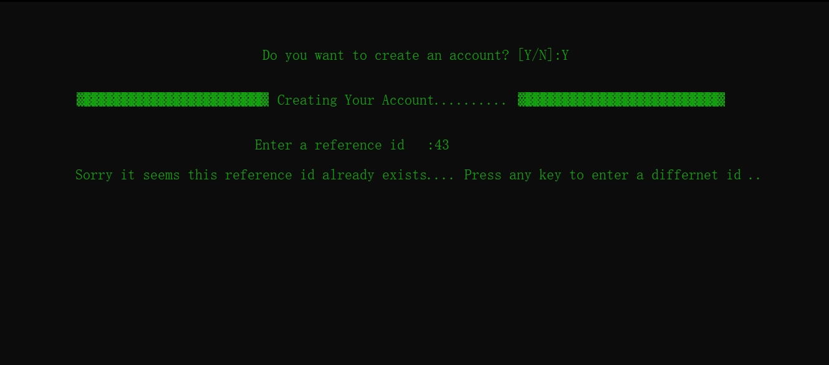

2. 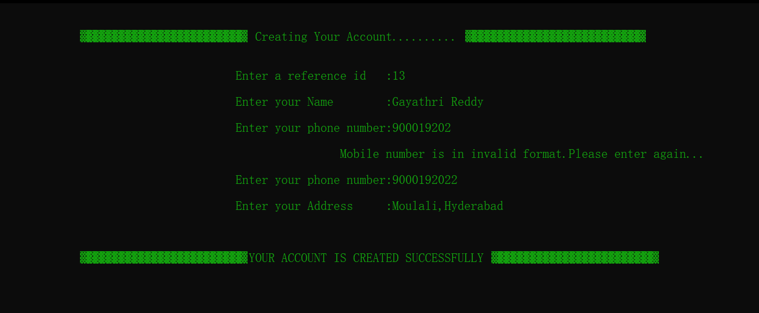

3.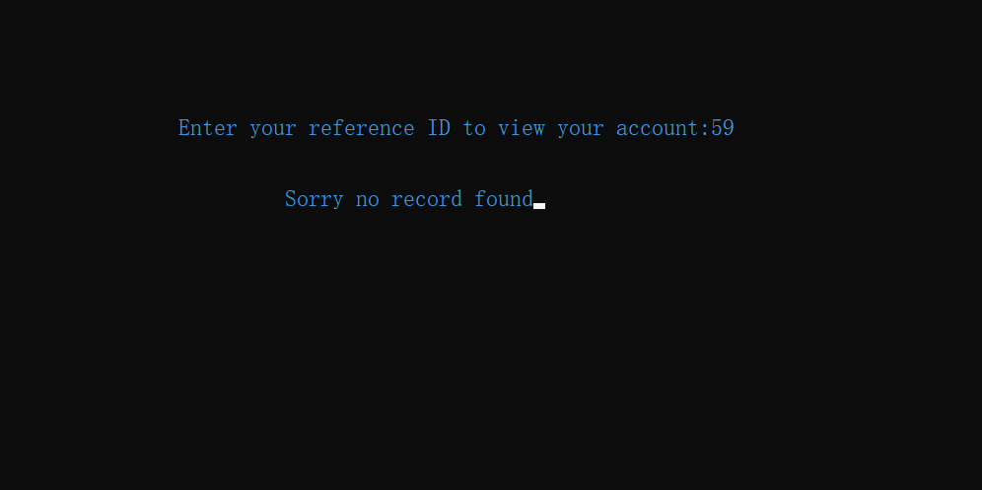

4.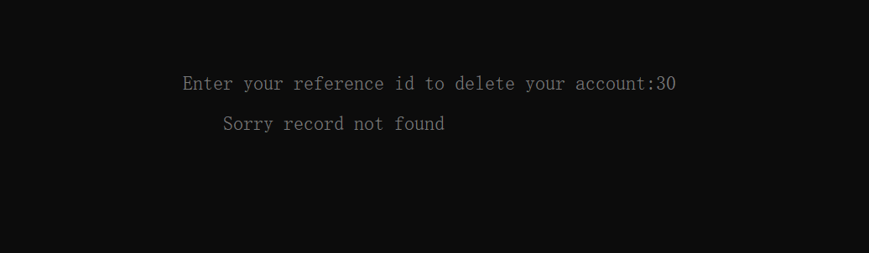

5.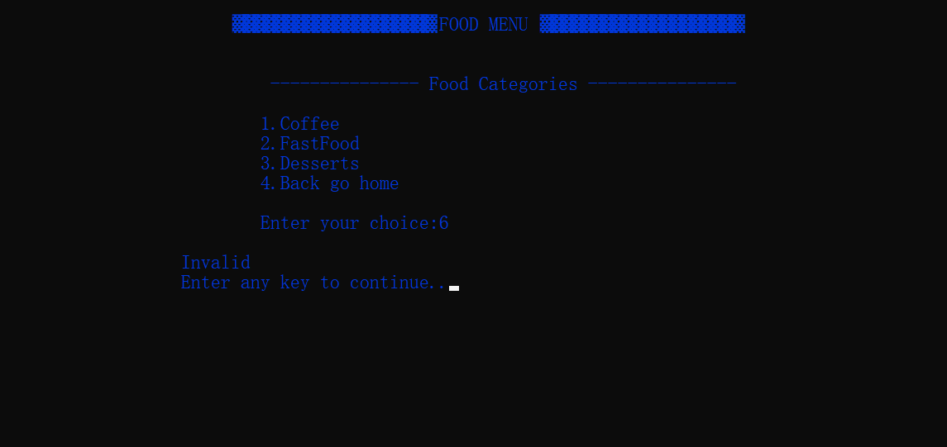

6.

7.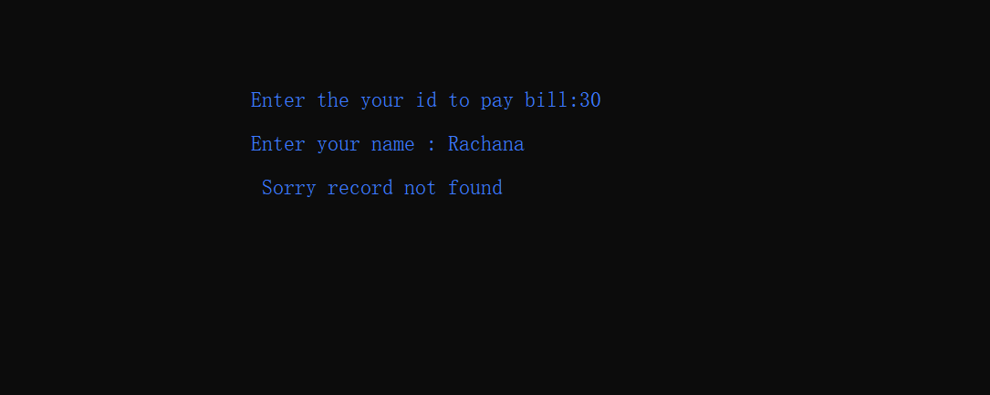

8. 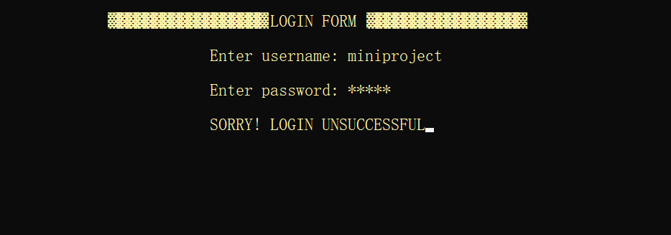

9.

**Results :**

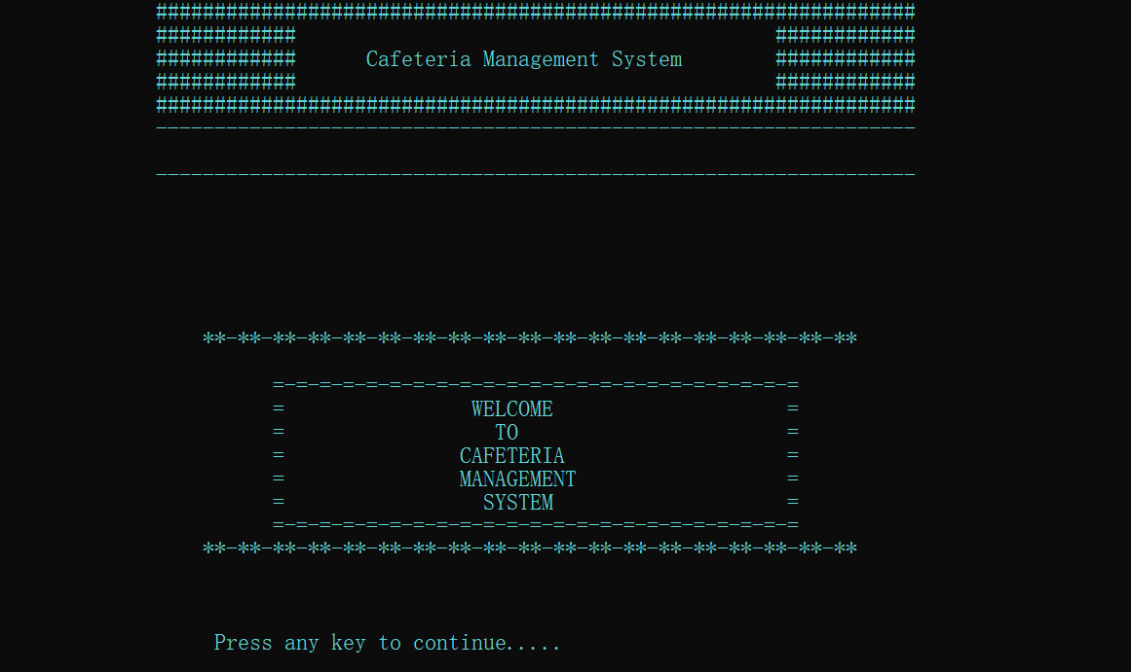

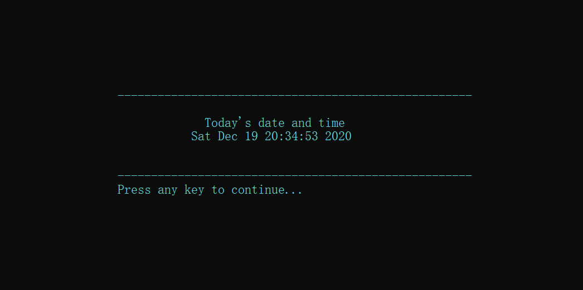

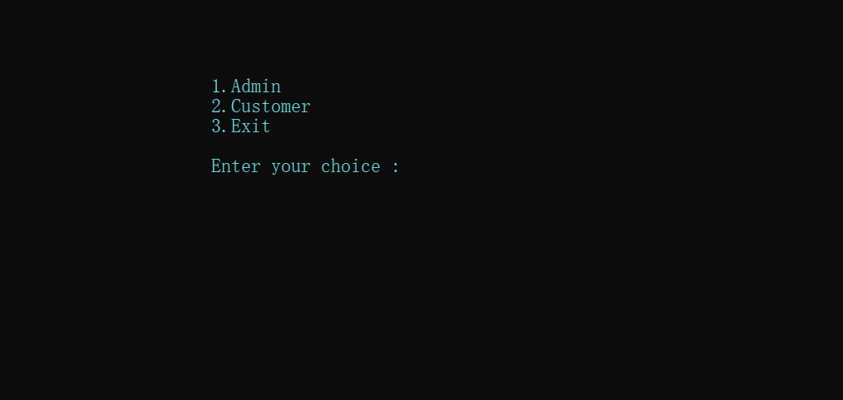

Customer Menu

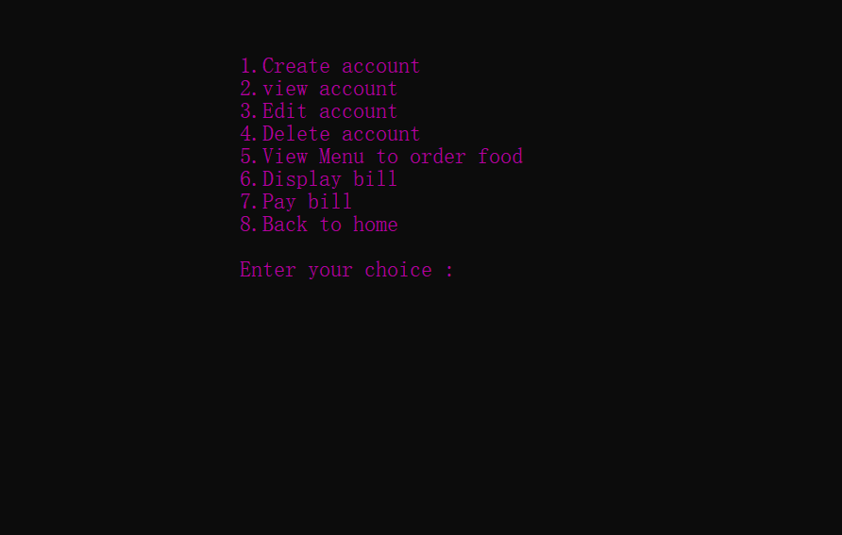

Creating a new account

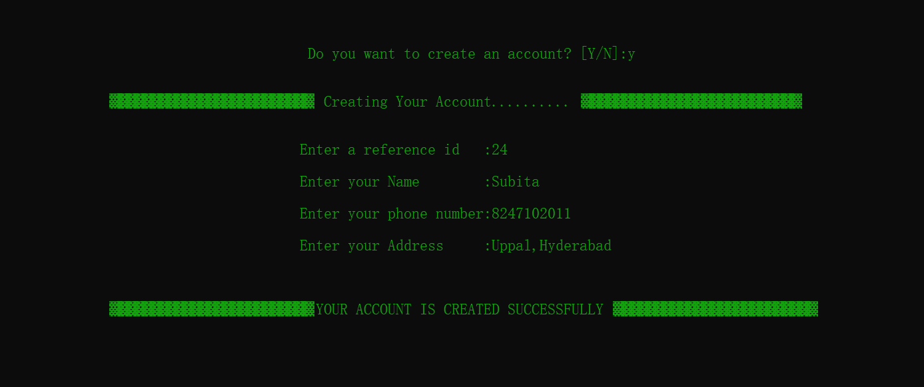

Viewing account

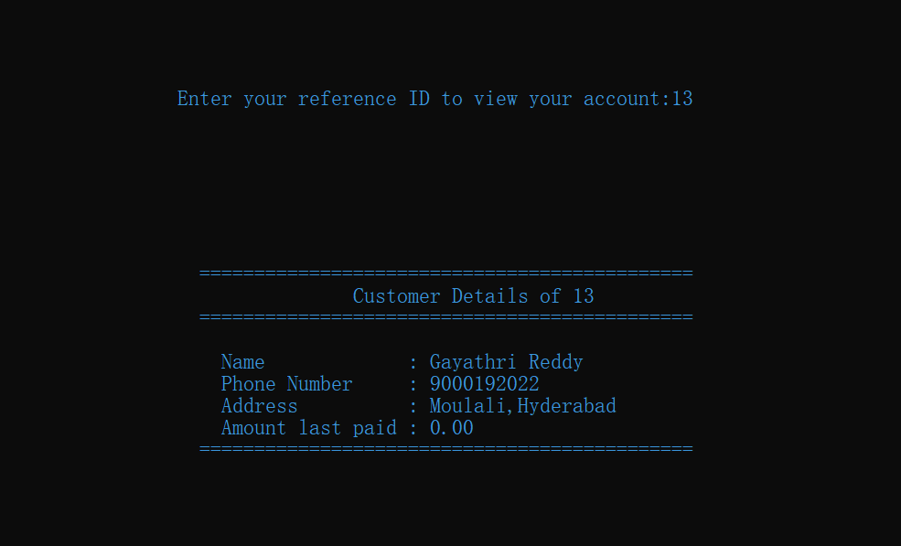

Editing account

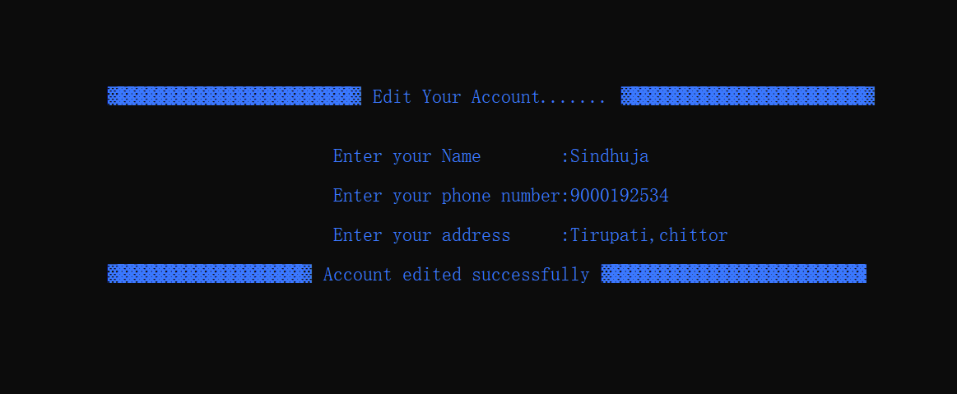

Deleting account

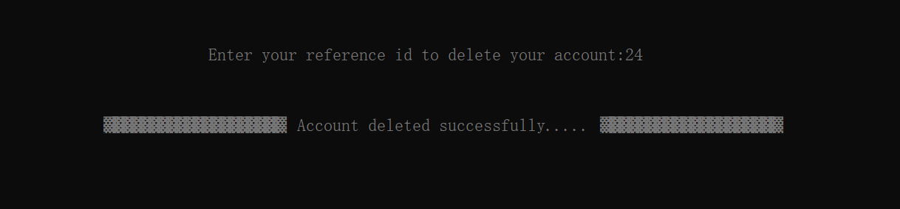

Admin menu

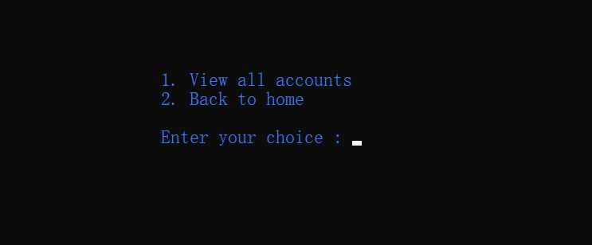

Viewing all accounts

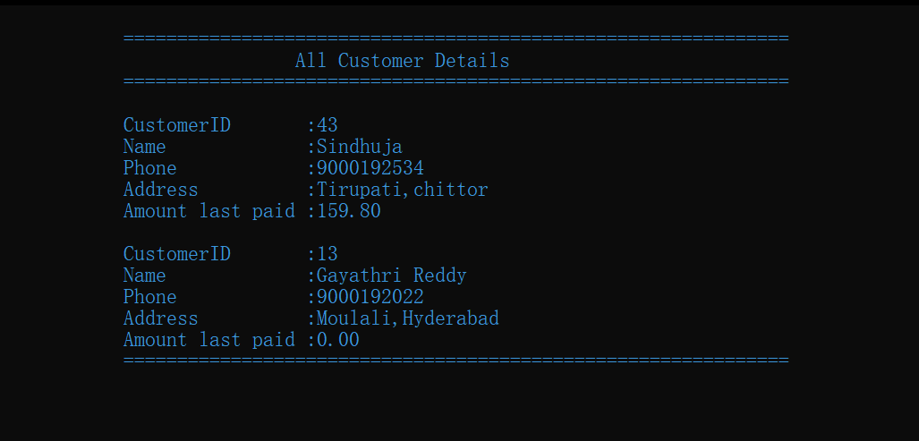

Food menu

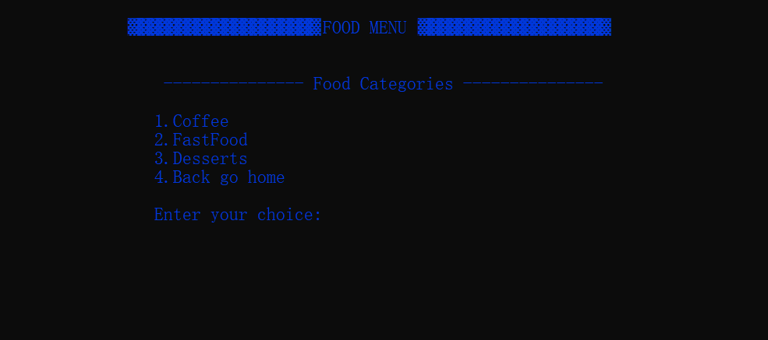

Coffee menu

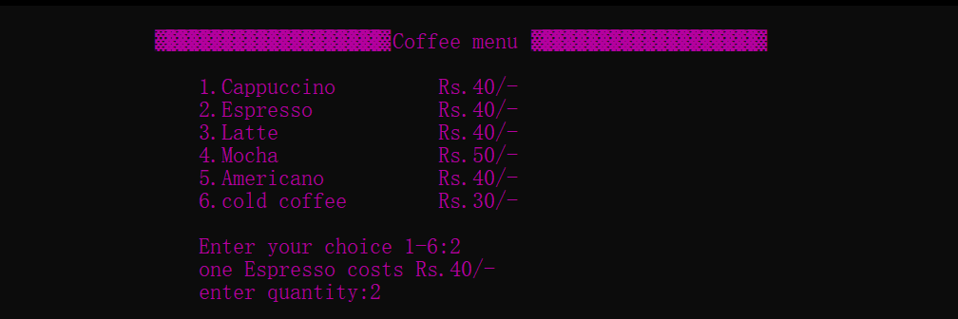

Fastfood menu

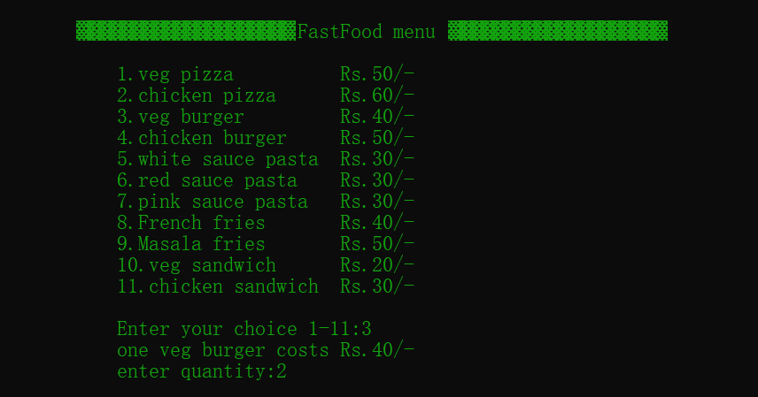

Desserts menu

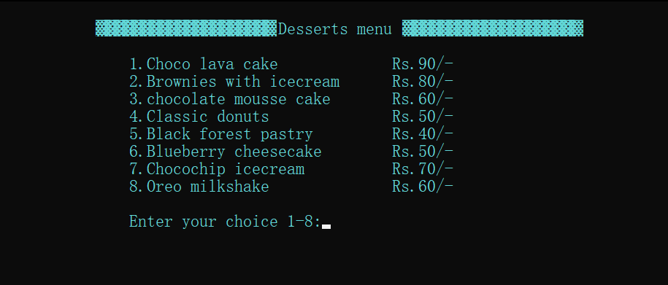

Display bill

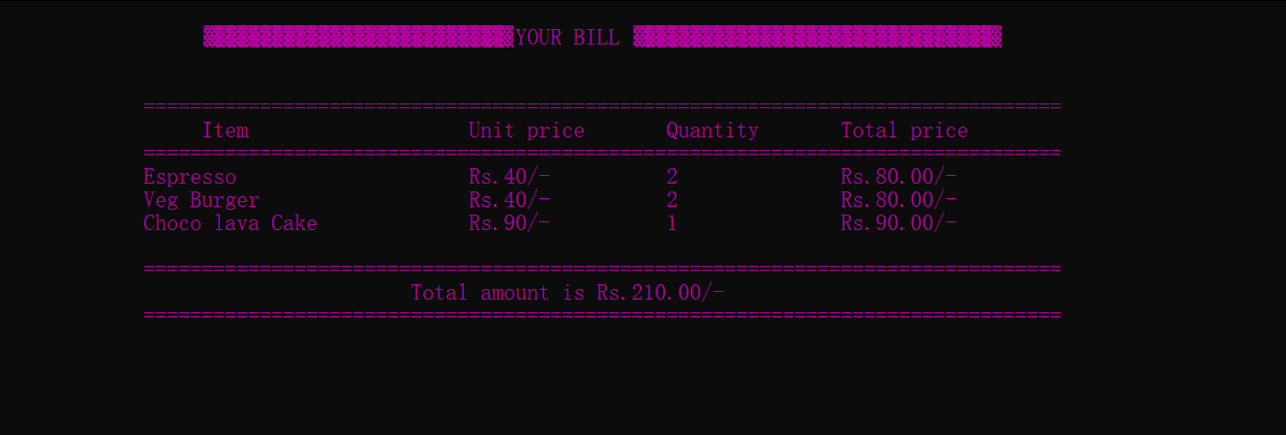

Pay bill

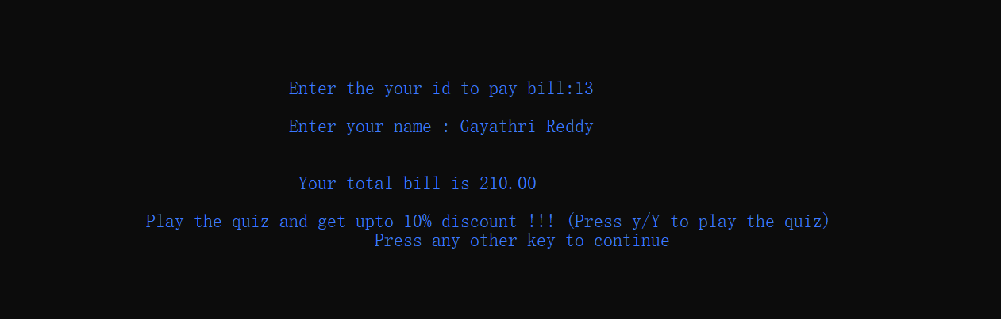

Quiz [Displays 5 questions]

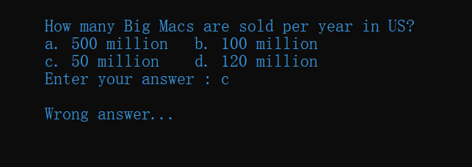

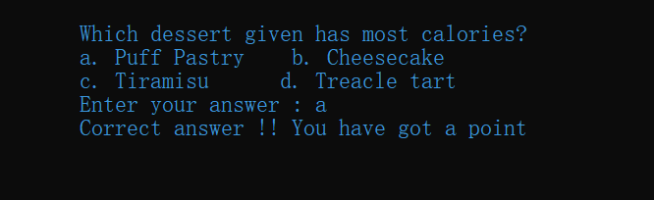

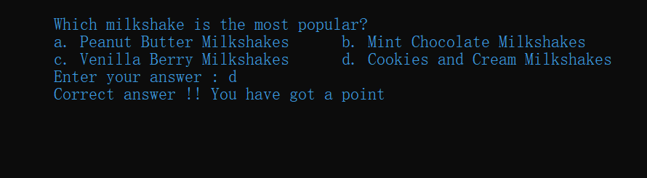

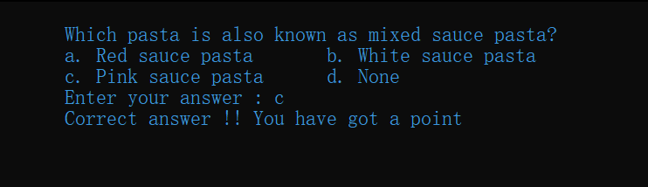

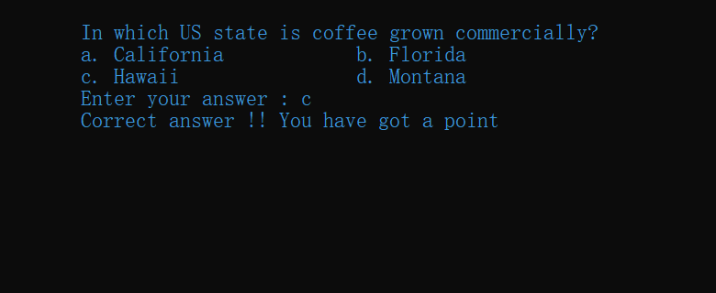

Payment conformation

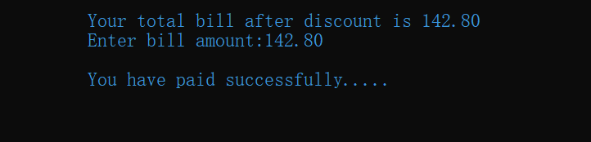

Thankyou message

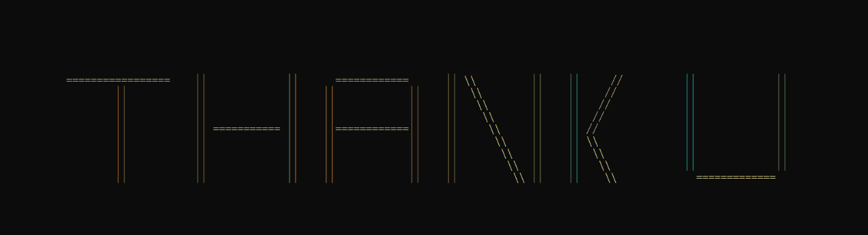

**ADDITIONAL LEARNING**

In addition to the learning that we have gained from the concepts of files, structures etc earlier, we have now understood the functionality of <time.h> library and <windows.h> library.

* We have understood how to display the current time and how to generate random questions in our quiz using <time.h> library.
* We have also understood how to change the font, background color, how to clear the console and moving the cursor position using <windows.h> library.

**DISCUSSION AND FUTURE WORK**

In future, this application can be further developed by adding Graphical User Interface (GUI) to display bill, display food icons (to make the application more attractive), for creating account etc using JAVA language.

Also socket programming will be included for payment verification process (by either sending One Time Password i.e., OTP to registered mail Id or registered mobile number).

**REFERENCES**

<https://www.javatpoint.com/file-handling-in-c>

<https://www.geeksforgeeks.org/readwrite-structure-file-c/>

<https://www.tutorialspoint.com/c_standard_library/time_h.htm>