Data Visualization Techniques

SINDHUJA HARIHARAN

Contents

Charts 2

1. Top Selling Areas 2
2. Top 5 Selling Streets per Area 2
3. Top 5 Selling Properties by Street 2
4. Most held properties by area 3
5. Sales for the most held property 3
6. Per SqFt rate by Area 4
7. Avg Tax by Area 4
8. Tax changes over the years 4
9. Per SqFt rate by Area 5
10. Avg Tax by Area 5
11. Tax changes over the years 5
12. Avg Sale per number of rooms 6
13. Yearly Average sales 6
14. Sale Favourablility by Area 7
15. Bargain percentage for Buyer 7
16. Trend in Average Price over the years 9
17. Trend in Sale by RC 9

Story concept 10

Insights and Findings 10

Tableau Public – Assignment link 10

# Charts:

1. **Top Selling Areas:** This chart lists down the sum of sales that has happened across the Areas.
2. **Top 5 selling Streets per Area:** This chart lists down the top 5 contributing streets in a particular area. When placed on to a dashboard, this chart uses the previous chart to filter the top selling streets with respect to Areas
3. **Top 5 Selling Properties by Street:** This chart lists down the top 5 contributing Properties in a particular Street. When placed on to a dashboard, this chart uses the previous charts to filter the top selling Properties with respect to Streets and Areas. 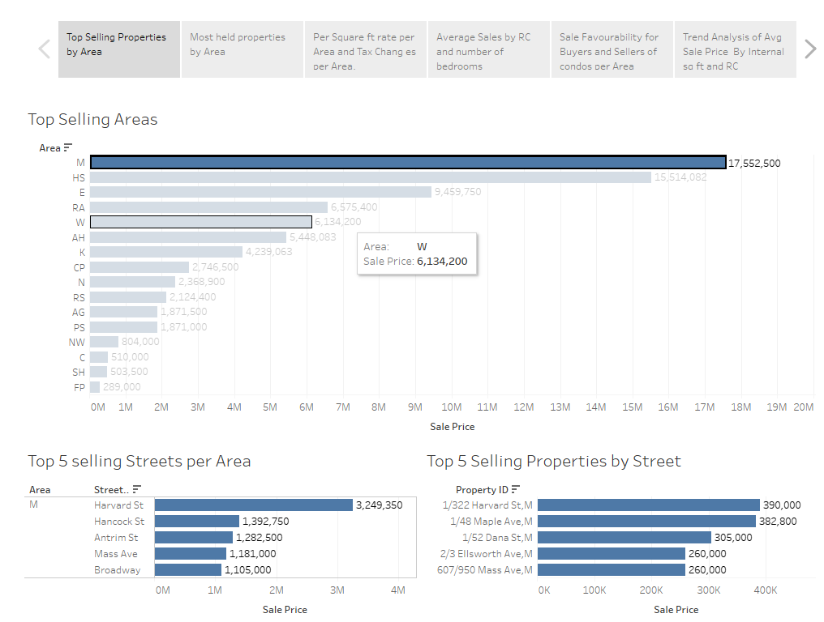

For instance, the above dashboard filters out top 5 properties in “M” Area and their corresponding Sale prices

1. **Most held properties By Area:** The idea behind this chart is to find out the properties (in each area) which have been held for the longest period of time by the Seller.
   1. *No of days held = [Close Date]-[First Date]:* This formula accounts for finding the maximum no of days until the Sale happened.
   2. *Rank No Of Days Held = RANK(sum([No of days held])) :* This formula Ranks the properties by the above calculated field.
   3. *[Rank No Of Days Held]<=[Top n] :* This formula is to filter out the top ‘n’ most held properties by area
2. **Sales for the most held property:** This chart shows the Sale Price for the most held property, selected from the above chart 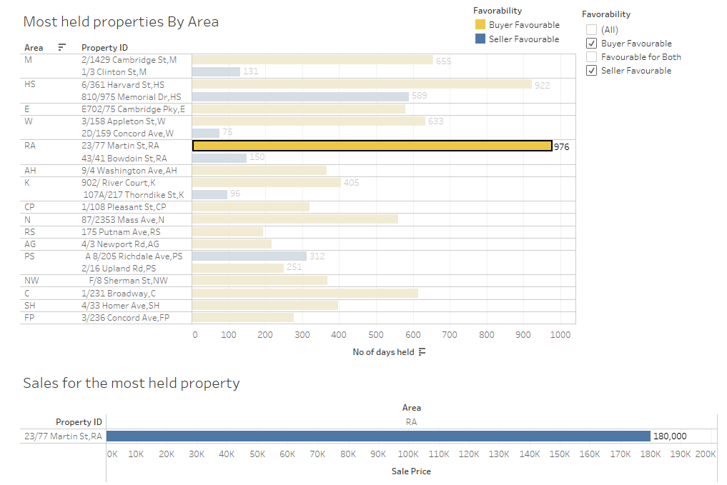

The above chart for example, the most Held property in “RA” area is “23/77 Martin St, RA”. The Property has been held for a total of 976 days and finally was sold at 180,000 USD.

1. **Per Sqft Rate by Area:** This chart lists down the average per square feet rates for condos in specific areas
2. **Avg Tax by Area:** This chart shows the average tax collected in a specific area. In a dashboard, the above chart can be used as a filter to find out average tax rates specific to an area.
3. **Tax changes over the years:**  This chart analyses the change/trend in property tax over a duration of four years (1990 – 1994). For better understanding, I have set a threshold of 1500 USD to differentiate using colours. <1500 USD will appear in Green. > 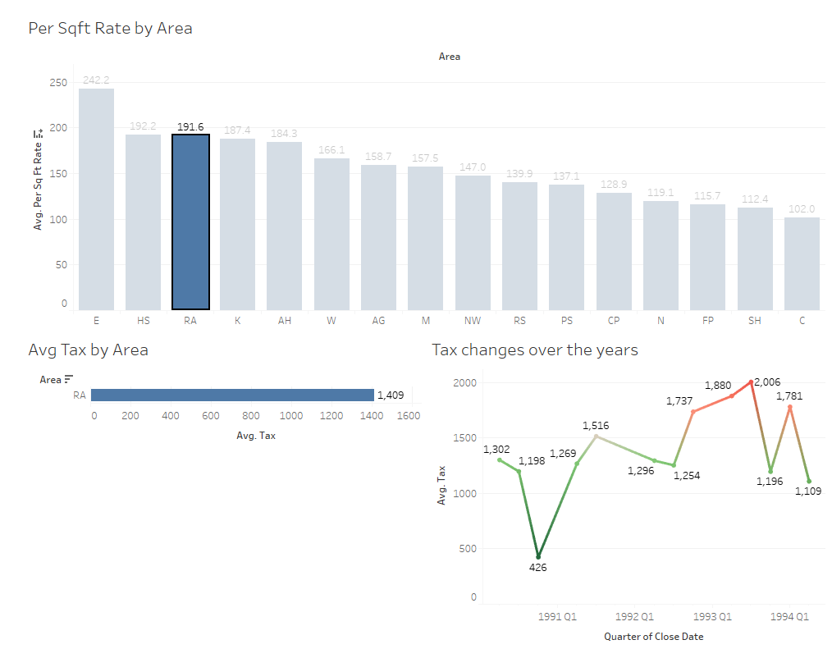

In the above dashboard, Avg tax rate for area “RA” is 1409 USD. The tax rate has touched a peak of 2006 USD in Q3 1994.

1. **Per Sqft Rate by Area:** This chart lists down the average per square feet rates for condos in specific areas
2. **Avg condo Fee by Area:** This chart shows the average condo fee collected in a specific area. In a dashboard, the above chart can be used as a filter to find out average condo fee rates specific to an area.
3. **Condo fee changes over the years:**  This chart analyses the change/trend in condo fee over a duration of four years (1990 – 1994). For better understanding, any condo fee over a value of 235, will show up in red, indicating that the value is higher than usual. 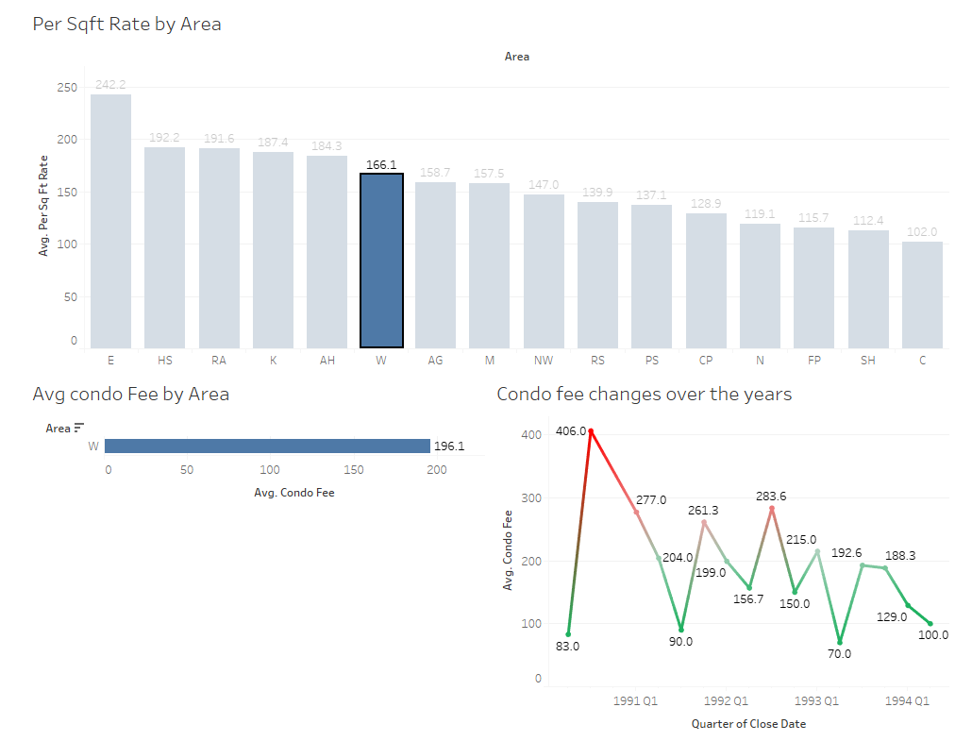
4. **Avg Sale per number of rooms:** This chart describes the average sales across areas, per number of rooms in the property being sold in that area.
5. **Yearly Avg Sales by number of rooms:** Thischartexplains yearly average sales in the five years 1990, 1994, with respect to the number of rooms available in the property.
   1. This chart filters the data by condo being a “Residential” property/ “Residential and commercial” property

Another filter is applied to filter out data based on the number bedrooms in the property 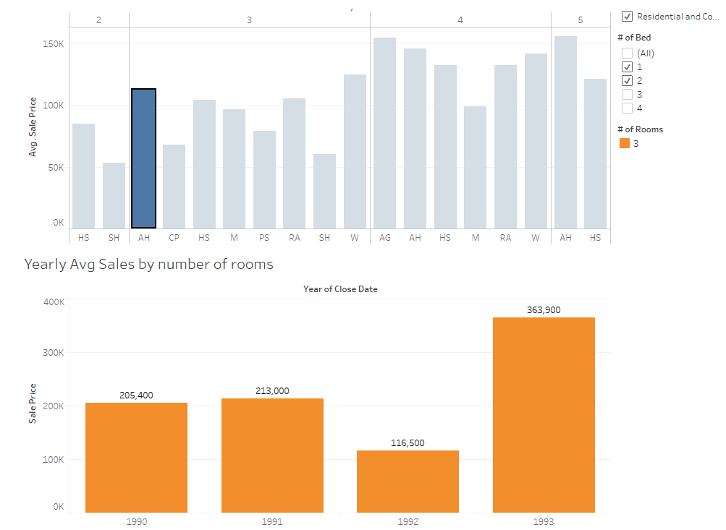

This chart explains the average sale price in the four years for all residential and commercial property sales in area “AH”, which have totally 3 rooms.

1. **Sale Favourability:** A Sale is favourable to the buyer, if the difference between the “buyer-quoted” price and the actual “Sale Price” is less.

A Sale is favourable to the Seller, if the difference between the “Seller-quoted” price and the actual “Sale Price” is less.

**Sale Favourability by Area:** This chart explains how many sales in a specified area are “Buyer- Favourable” and “Seller-Favourable”. This chart also shows us the average Sale Price for each area.

**Favourablity:**

IF [Price that Buyer paid]>[Price the seller came down by] THEN

"Seller Favourable"

ELSEIF [Price the seller came down by]>[Price that Buyer paid] THEN

"Buyer Favourable"

ELSEIF [Price the seller came down by]=[Price that Buyer paid] THEN

"Favourable for Both"

END

1. **Bargain Percentage for Buyer:** “Bargain Percentage” is the percentage to which the Seller has come down from his initial quote price to complete his sale.
   1. **Bargain Percentage:** ABS(([Max Price Difffor the sale]*100)/[First Price])
   2. Where “[Max Price Difffor the sale]” = [First Price] - [Sale Price]

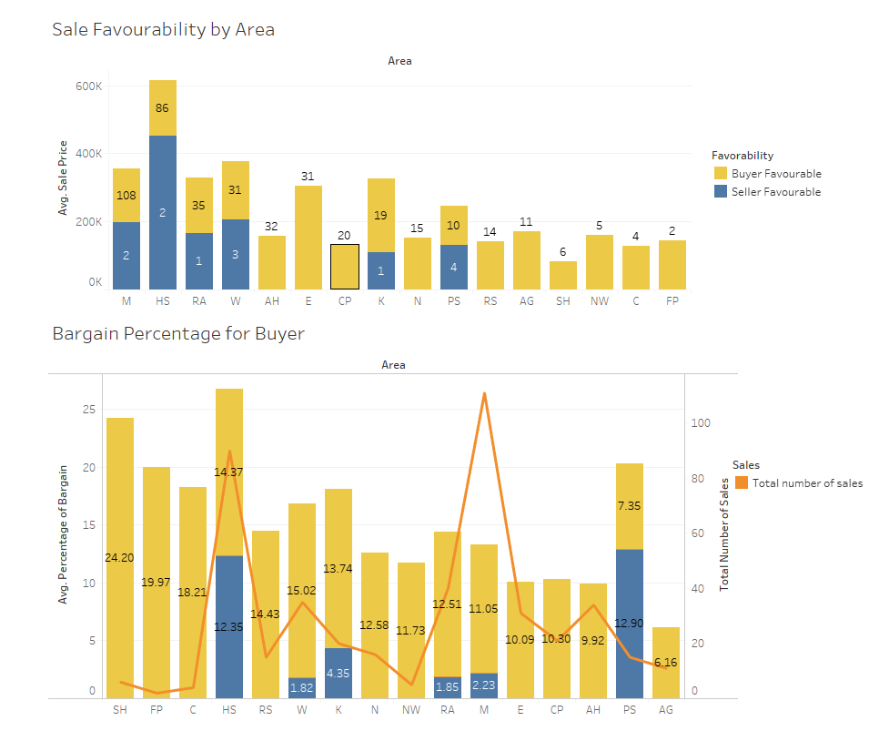

1. **Trend in Avg Sale Price over the years:** This chart talks about how the Average sale andd the interior sqft change with respect to sale price has coexisted over the years.
2. **Trend in Sales by RC:** This chart explains the trend in sales with respect to “Residential” or “Residential and commercial” properties over the past years. 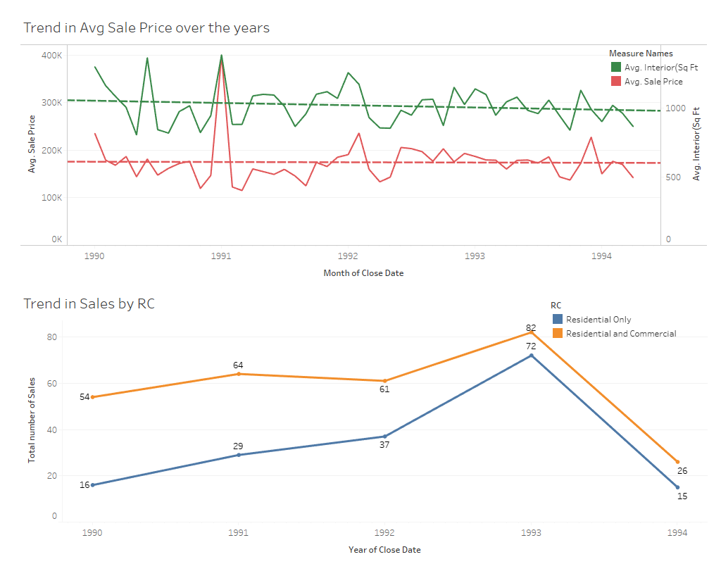

**Story concept:**

**Insights and Findings:** The charts anddashboards answers/clarifies the following business insights that the data presents.

1. What are the premium properties overall in Boston and premium properties in each location?
2. What is the Sale price of the most held property, in both "Buyer-favourable" and "Seller-favourable" categories?
3. What is the most profitable bargain percentage for the buyer if he decides to buy a condo in a specific area?
4. Which year/quarter most number of sales has happened.
5. The trend in average sale price and interior square ft rate bring fairly steady, the sales in the year "1993" has peaked with "154" in Q3 1994. During the same period, the average condo fee and average property Tax has also increased reasonably.

**Tableau Public – Assignment link:**

Please find the tableau public workbook for the assignment in the below link.

<https://public.tableau.com/profile/sindhuja.hariharan#!/vizhome/Trial_187/BostonCondoDataSet?publish=yes>