**INTRODUCTION:**

Wearable biosensors have drawn a lot of attention from the research community and the industry during the last decade as it is pointed out by the numerous and yearly increasing corresponding research and development efforts. As healthcare costs are increasing and the world population is ageing there has been a need to monitor a patient’s health status while he is out of the hospital in his personal environment. To address this demand a variety of system prototypes and commercial products have been produced in the course of recent years, which aim at providing real-time feedback information about one's health condition, either to the user himself or to a medical center or straight to a supervising professional physician, while being able to alert the individual in case of possible imminent health threatening conditions. In addition to that, wearable biosensors constitute a new means to address the issues of managing and monitoring chronic diseases, elderly people, postoperative rehabilitation patients, and persons with special abilities.

**TYPES OF BIOSENSORS**

1. **Calorimetric biosensor** -They measure change in temperature due to either release (exothermic) or absorption (endothermic) of heat. Ex.Temperature biosensors.
2. **Amperometric biosensor**- They measure current (flow of electrons) arising during a reaction. Ex . Glucose biosensor.
3. **Pulse oximetry biosensor**- They measure the oxygen saturation of haemoglobin in blood. Ex. pulse oximetry device.
4. **Potentiometric biosensor** -They measure potential difference arising during a redox reaction. Ex .Urea biosensor.
5. **Optical biosensors**-They measure the light arising from action of enzymes. Ex.detection of bacteria.

**WEARABLE TECHNOLOGIES FOR DIFFERENT BODY PARTS:**

1. **Head-**The head is the uppermost part of the body and includes the forehead, ears, eyes, nose, and mouth. The wearable health-tracking devices for the head comprise mainly glasses, goggles, contact lenses, hats, headbands, hearing aids, earrings, earphones, and patches. Modern smart glasses can be considered as wearable computers, and they are embedded with several sensors, such as gyroscopes, accelerometers, pressure sensors, image sensors, and microphones. They can be operated using voice commands through a user interface. Hats, helmets, and headbands can be also embedded with wearable sensors. Other than activity monitoring, wearables worn on the head can be used to measure brain activity. For example, SmartCap, introduced by SmartCap Technologies (Australia) (70) is a fatigue monitoring system that measures brainwave signals for the risk of microsleep, which is an unintended/uncontrolled sleep for a duration of 5–10 s.
2. **FOOT, ARM, LEG-** Wearable devices worn on the arm, leg, and foot are mostly accessories such as smart watches, bracelets , rings , arm bands , and wristbands that can monitor physiological parameters such as body temperature and heart rate , UV exposure levels , and daily activities. Smart socks and sleeves for injury prevention are a few of the wearable accessories worn on the foot or leg. Smart socks, provide 3D dynamic measurement of pressure distribution over the entire foot while a patient is walking. This foot pressure distribution serves as valuable data for orthopedic shoemakers in fabricating custom shoes for diabetic foot syndrome.
3. **TORSO-** The torso is the central part of the body in which most of the organs are housed. Suits, belts, are some examples of wearable technologies worn on the torso. Some examples of wearable technologies worn as a suit include pajamas for electrocardiogram measurement in babies , baby glove swaddles for temperature sensing , smart jackets for monitoring the physiological parameters of newborn infants , military uniforms with a wearable computer to continuously monitor military personnel and protect them, e.g., from environmental threats , and swimsuits with a UV sensor
4. **INGESTIBLE AND IMPLANTABLE WEARABLES-** Ingestible pills, introduced by Proteus Digital Health (Redwood City, CA), are smart pills for monitoring the precise time at which medicine is taken. When the smart pill reaches the stomach, it is powered up with the chemical reaction with the stomach fluid and sends an ingestion time signal to the patch worn on the body. This patch not only communicates with the smart pill but also monitors heart rate, blood pressure, pH, and temperature.

**Literature survey:**

* **K. Ikeda, M. Saito, M. Yamashita. K. Shimizu, G. Matsumoto, Development of a ring-type vital sign telemeter, Biotelemetry** (1991)-As the population of aged people increases, close and continuous monitoring becomes more important to establish the right dose and timing of medication. A couple of compact, continuous monitoring device have been developed However, these devices have not been widely accepted due to lack of comfort for wearers.
* **J.C. Veraart, H.A.M. Neumann, J.P. Welch pulse oximetry: instrumentation and clinical application (1994**)- This continuous monitoring system can provide unique and useful information for preventive diagnosis in which long-term trends and signal patterns are more important. The ring sensor is completely wireless and miniaturized so that the patient can wear the device comfortably 24 hours a day.
* **R. Paradiso, G. Loriga. and N. Taccini, “A wearable health care system based on knitted integral sensors.. IEEE Trans*.* lnf Technol. Biomed****vol. 9. no. 3. pp. 337-344. Sep. 2005-** The Wearable Health Care System (WEALTHY) project. part of the fifth framework program of the European Commission and completed in 2005, has developed a wearable garment, covering the whole upper body and worn under normal clothing, capable of recording biomechanical variables and physiologic cal signals.
* **M. Di Rienzo, F. Rizzo, G. Parati, G. Brambilla, M. Ferratini, and   
  P. Castiglioni, “MagiC system: A new textile-based wearable device for biological signal monitoring applicability in daily life and clinical setting.”in Proc. 27th Ann. int. IEEE EMBS Conf,2005,pp. 7167.7169**- Magic developed by researchers in Milan, Italy, is a washable sensorized vest including fully woven textile sensors for ECG and respiration rate monitoring and a portable electronic board, which evaluates the wearer's motion level and is responsible for signal preprocessing and data transmission through Bluetooth to a local PC or PDA.

**METHODOLOGY:**

**CONCEPT OF RING SENSOR**

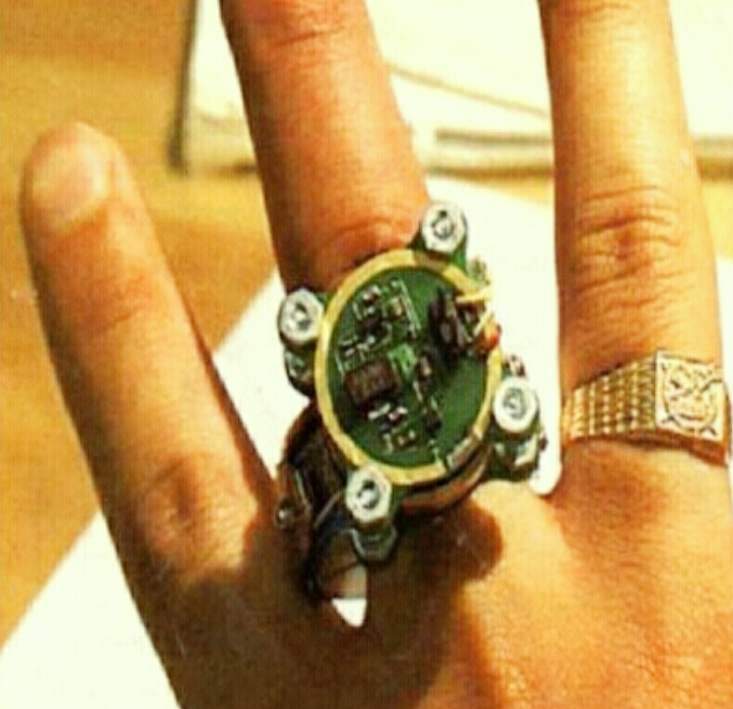

A finger ring is a unique form of wearable sensors, and probably the only thing that the majority of people will accept to wear at all times. To monitor a patient 24 hours a day continually, a miniaturized sensor in a ring is a rational design choice. Other personal ornaments and portable instruments, such as ear rings and wrist watches, are not continually worn in daily living. when taking a shower, for example, people remove wrist watches. Bathrooms, however, are one of the most dangerous places in the home. More than 10,000 people, mostly hypertensions and the elderly, die in bathrooms every year. Miniature ring sensors provide a promising approach to guarantee the monitoring of a patient at all times also, a ring configuration provides the anatomical advantage of having transparent skin and tissue at the finger compared with other part of the body so that it is feasible to monitor arterial blood flow at the finger base using an optoelectric sensor. Subsequently, a variety of simple cardiac and circulatory disorders may be detected by monitoring arterial blood flow at the finger base.

**Block diagram of ring sensor**

LED

PHOTODIODE

SAMPLE AND HOLD

CPU

WIRELESS TRANSMITTER

**PRINCIPLE OF RING SENSOR (PULSE OXIMETER)**

The principle of pulse oximetry is based on the differential absorption characteristics of oxygenated and the de-oxygenated hemoglobin. Oxygenated hemoglobin absorbs more infrared light and allows more red light to pass through. Where as Deoxygenated hemoglobin absorbs more red light and allowing more infrared light to pass through.

**WORKING OF RING SENSOR (PULSE OXIMETER)**

The ring sensor consists of a ring with LEDs and a photodiode, a four-layer printed circuit board (PCB) for signal processing, another four-layer PCB for wireless transmission, and two batteries. The signal processing and the wireless transmission were separated to reduce severe interference between the two functions. Two batteries are sandwiched between the two PCBs to supply the power to the two circuits. It has been found that the two circuits have to be powered separately to eliminate signal interference. I/Oconnections are distributed on the edge of the boards, providing the connections for power supplies, LEDs and programming. Four screws are used in the four ears on the boards to provide mechanical fixtures for the boards. All the circuitry on the boards are protected by optical epoxy after fabrication and debugging.

* **PHOTODIODE AND LED**

One red LED and two infrared LEDs are used as the light sources. The peak wavelength of the red LED is 660nm, and that of the infrared LEDs is 940 nm. The photodiode has the peak wavelength of 940 nrn and the spectral sensitivity ranges from 500 to 1000 nm, which meets our needs. The voltage drop of the red LED is 1.6 V and that of the infrared LEDs is 1.2 V, and two infrared LEDs are connected in serial.

* **SAMPLE AND HOLD CIRCUIT**

Since one photodiode is shared by two channels of signal conditioner, the sample-and-hold circuit is necessary to hold the right signal for a brief moment. The two LEDs are alternatively lit and the two bilateral switches are also in synchronization with the LEDs. When the red LED is on, the bilateral switch of the first channel is turned on to make the signal flow into the first channel. When the infrared LED is on, the switch on the second channel is turned on and the signal is held by the sample-and-hold circuit. With these sampling-and-hold channels, the single photodiode can generate two wave forms from the different LEDs at the same time.

* **CPU**

The CPU on the board controls all the operations of the ring from scheduling LEDs to digitally converting acquired analog signals to formatting the signals in an RS-232 form for transmission. Since the CPU is one of the major components of power consumption, it has to be chosen carefully. For this purpose, we chose a PIC16C711 from Microchip. This CPU has two channels of embedded A/D converter, and 8 channels of digital I/O line, a satisfactory baud rate for the RS-232 generator, which will result in more power consumption.

* **RF TRANSMITTER**

The piecewise constant waves generated at the LED circuit are converted to digital signals by an 8-bit A/D converter and transmitted through an RF wave by the microprocessor. The transmitter is simply an ON/OFF transmitter. In other words, it transmits signal when the input is high, and does not transmit anything when the input is low, hence, the power is consumed only when 1he input is high. We can save the power by reducing 1he width of the ‘1’ bit, which will happen when we use a higher baud rate.

**SMART SHIRT**

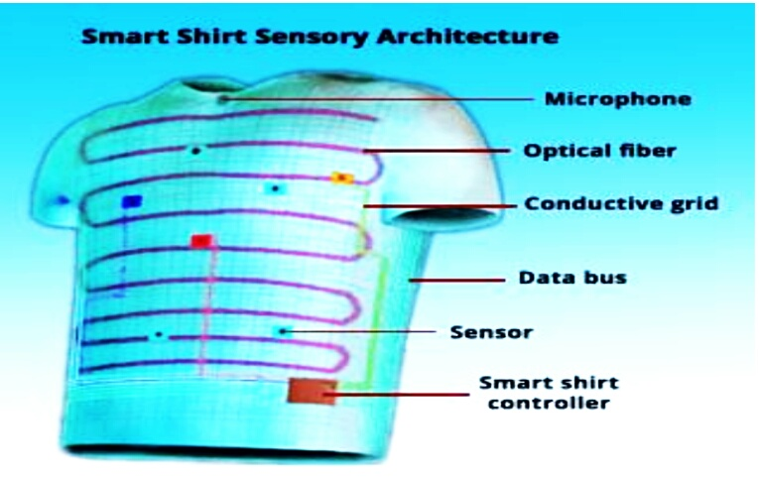

Smart shirt developed at Georgia tech which represents the first attempt at relying an unobtrusive, mobile and easy to use vital signs monitoring system; presents the key applications of the smart shirt technology along with its impact on the practice of medicine: and covers key opportunities to create the next generation of truly “adaptive and responsive” medical systems. Research on the design and development of a smart shirt fort a combat casualty care has led to the realization of the world's first wearable motherboard or an “intelligent” garment for the 2l century. The Georgia tech wearable motherboard (GTWM) uses optical fibers to detect bullet wounds and special sensors and interconnects to monitor the body vital signs during combat conditions. This GTWM (smart shirt) provides an extremely versatile framework for the incorporation of sensing, monitoring and information processing devices. The principal advantage of smart shirt is that it provides for the first time a very systematic way of monitoring the vital signs of humans in an unobtrusive manner.

**REQUIREMENTS OF SMART SHIRT**

Casualties are associated with combat and sometimes are inevitable. Since medical resources are limited in a combat scenario, there is critical need to make optimum use of the available resources to minimize the loss of human life, which has value that is priceless. In a significant departure from the past, the loss of even a single soldier in a war can alter the nations engagement strategy making it all the important to save lives. Similarly on the civilian side, the population is aging and the cost of the health care delivery is expected to increase at a rate faster than it is today. With the decreasing number of doctors in rural areas, the doctor/patient ratio is in certain instances reaching unacceptable levels for ensuring a basic sense of security when they leave the hospital because they feel “cutoff. from the continuous watch and care they received in the hospital. This degree of uncertainty can greatly influence their postoperative recovery. Therefore there is a need to continuously monitor such patients and give them the added peace of mind so that the positive psychological impact will speedup the recovery process.

Mentally ill patients need to be monitored on a regular basis to gain a better understanding of the relationship between their vital signs and their behavioral patterns so that their treatments can be suitably modified. Such medical monitoring of individuals is critical for the successful practice of telemedicine that is becoming economically viable in the context of advancements in computing and telecommunication, likewise continuous monitoring of astronauts in space, of athletes during practice sessions and in competition, of law enforcement personnel and combat soldiers in the line of duty are all extremely important.

**ARCHITECTURE**

The GTWM was woven into a single -piece garment (an undershirt) on a weaving machine to fit a 38-40” chest. The plastic optical fiber (POF) is spirally integrated into the structure during the fabric production process without any discontinuities at the armhole or the segms using a novel modification in the weaving process.

An interconnection technology was developed to transmit information from (and to) sensors mounted at any location on the body thus creating a flexible “bus" structure. T-connectors -similar to “button clips” used in clothing are attached to the fibers that serve as a data bus to carry the information from the sensors (eg: ECG sensors) on the body.   
The sensors will plug into these connectors and at the other end similar Tc connector will be used to transmit their information for monitoring equipment or DARPS (Defense Advanced Research Projects Agency) personnel status monitor By making the sensors detachable from the garments, the versatility I\of the Georgia Tech Smart Shirt has been significantly enhanced Since shapes and sizesof humans will be different, sensors can he positioned on the right locations for all users and without any constraints being imposed by the smart shirt can be truly “customized”. Moreover the smart shirt can be laundered without any damage to the sensors themselves.

The interconnection technology has been used to integrate sensors for monitoring the following vital signs: temperature, heart rate and respiration rate .In addition a microphone has been attached to transmit the weavers voice data to monitoring locations. Other sensors can be easily integrated into the structure. The flexible data bus integrated into the stricture transmits the information from the suite of the sensors to the multifunction processor known as the Smart shirt controller. This controller in turn processes the signals and transmit them wirelessly to desired locations (eg : doctor's office, hospital, battlefield). The bus also serves to transmit information to the sensors (and hence the weaver) from the external sources, thus making the smart shirt a valuable information infrastructure.

A combat soldier sensor to his body, pulls the smart shirt on, and attaches the sensors to the smart shirt. The smart shirt functions like a motherboard, with plastic optical fibers and other special fibers woven throughout the actual fabric of the shirt. To pinpoint the exact location of a bullet penetration, a “signal” is sent from one end of the plastic optical fiber to a receiver at the other end. The emitter and the receiver are connected to a Personal Status Monitor (psm) worn at the hip level by the soldier. If the light from the emitter does not reach the receiver inside the PSM, it signifies that the smart shirt has been penetrated (i.e.: the soldier has been shot). The signal bounces back to the PSM forum the point of penetration, helping the medical personnel pinpoint the exact location the solider wounds.

The soldiers vital signs -heart rate, temperature, respiration rate etc. are monitored in two ways: through the sensors integrated into the T-shirt: and through the sensors on the soldier's body, both of which are connected to the PSM. Information on the soldiers wound and the condition is immediately transmitted electronically from the PSM to a medical triage unit somewhere near the battlefield. The triage unit them dispatches the approximate medical personnel to the scene .The Georgia tech smart shirt can help a physician determine the extent of a soldiers injuries based on the strength of his heart beat and respiratory rate. This information is vital for accessing who needs assistance first during the so-called “Golden hour” in which there are numerous casualties.

**PARAMETERS OF WEARABLE DEVICES**

* **Measurement of Heart Rate**

The heart is a biomechanical organ, pumping blood around the vascular system to supply nutrients and remove waste products from other organs. Heart rate is dependent on the level physical activity , but can also be dependent on sleep, anxiety , stress , illness, and drugs . Therefore, heart rate is a physiological indicator of health state Typical heart rates at rest are 40 - 60 bpm for trained athletes to 60 - 100 bpm for children more than 10 years old and adults . Heart rates during intense exercise may reach 200 bpm. In general, heart rate detection relies on the transduction of mechanical, electrical, optical, or acoustic signals associated with the mechanical beating of the heart, or from the resulting pulsatile hemodynamic flow . Heart rate can be detected manually by sensing the mechanical pulsations of an artery near the surface of the body (e.g. radial or carotid) under slight pressure from the index and middle fingers. The electrical activity of the heart muscle can be detected by electrodes attached to the chest (electrocardiogram, ECG). Pulsatile blood flow gives rise to changes in the impedance of tissue that can be measured using a variation of the 4-electrode resistance method, with electrodes usually located at the neck and waist (impedance cardiogram, ICG). The acoustic signal associated with the beating heart and pulsatile flow can be detected with a stethoscope or ultrasound sensor.

* **MEASUREMENT OF RESPIRATORY RATE:** Respiratory Inductance Plethysmography (RIP) Plethysmography systems detect expansion and contraction of the chest and abdomen. Sensors usually consist of two bands, each containing a wire loop, one placed around the chest and one around the abdomen . The wire in the loop is zigzagged to allow changes in length during expansion and contraction. RIP measures changes in the magnetic field induced in the wire loop resulting from the expansion and contraction associated with inhalation and exhalation . The AC current in the loop generates a magnetic field that is dependent on the cross-sectional area defined by the chest or abdomen. The changes in the cross-sectional area of the loop result in a frequency shift of the signal that is proportional to the cross-sectional area . The sum of the signal from the two bands is calibrated against a known gas volume. Variations of RIP include elastomeric plethysmography and impedance plethysmography both of which can yield high accuracy.
* **Wearable Sensors for Temperature Measurement:**  Most wearable devices for skin or surface temperature measurement are thermistor-based, which have high sensitivity at ambient temperatures. These devices can be attached to the wrist, forehead, chest, feet, fingers, ears or other peripheral points on the body . Infrared thermopile sensors are used to measure temperature at the tympanic membrane in devices that are worn on the ear . Other methods include smart capsules that transmit temperature data while in the gastrointestinal system . Although remote monitoring is beyond the scope of this review, smart phone-based infrared cameras can be used to estimate temperature. Surface temperature reflects heat exchange with the environment and hence is dependent on-air temperature, air flow, altitude and barometric pressure, and exposure to sunlight, and blood flow . Surface temperature has been used to monitor athletic performance , fatigue , emotional state , ovulation cycle , and sleep states .
* **Emotional Health State** :There is increasing awareness that emotion, affect, and mood are important contributors to the overall health state of an individual . Emotions are brief, consistent, verbal, physiological, behavioral, and neural responses to internal and/or external events that may manifest as depression, anxiety, stress, fatigue, sleep disorders, drowsiness, loss of appetite, changes in activity and sleep patterns. Chemical analysis (e.g. cortisol, prolactin, HGH, ACTH, and lactate) of saliva and blood are widely used to measure stress and other factors . Physical assessment of emotion has largely focused on eye blinking and pupil dilation .

**ADVANTAGES:**

1. **Rapid continuous monitoring-**advancement in sensor technologies have resulted in wearable devices that are commercially available for monitoring patients vital sign on continual basis.
2. **Easy to use**-since it comes in many different wearable forms it becomes easy for the individual to choose the required and comfortable wearable device as per his requirement.
3. **Reducing hospitalization fee-**these devices reduce the need to continuously visit the hospitals and hence it helps to save money from the hospital fees.
4. **Accurate results**-these device have a real time monitoring system and hence any change can be immediately reported thus the chances of errors becomes very less.

**DISADVANTAGES:**

1. Initial cost is high.
2. Battery life is less.
3. Limited number of physiological parameters can be monitored.

**APPLICATIONS**

1. **Prevention of bedsore by smart clothing-** scientists have designed smart clothing thatcan assess the level of blood flow, oxygen, and nutrients required for different parts of the body. This clothing is equipped with a set of sensors that apply mild shocks to specific parts of body when needed in order to increase the blood flow to that part: as a result, the risk of bedsore will greatly reduce.
2. **helmets for treatment of depression**- Danish researchers have designed a helmet that helps to reactive parts involved in depression and rapid recovery of patients by transmission of weak electrical pulses to the brain.
3. **Smart clothing for premature babies** -Annually, 15 million babies are born premature in the world. More than one million of this population die or suffer physical and psychological complications due to the loss of body water. Polish researchers have succeeded in designing smart clothing to be worm by premature babies. This clothing is composed of two layers: one layer is ordinary fabric and the other is a membrane that prevents excessive sweating in the baby.
4. **Smart socks-** Researchers have revealed smart socks that allow parents to check their infants’ health using a mobile application. These smart socks are called Owlet and can send the child’ heart rate, oxygen level, skin temperature, sleep quality, and sleep position to parents smartphones . According to manufacturers this technology can check child’s daily health and can help to identify sudden infant death syndrome.

**Future scope:**

* Every person is uniquely different, and various factors affect personal health (e.g. family medical history, genetics, and diet); therefore, personal calibration of devices and machine learning-based analysis of data that are tailored for individuals are required for more accurate and relevant monitoring of the health status of the patient using wearable sensors.
* The durability and robustness of wearable sensors also require further improvement. Wearable sensors should be capable of operating under different conditions, such as in humid or wet environments and warm temperature. This would allow continuous parameter monitoring without losing performance during such activities as swimming, showering, or sunbathing while in use.

**Conclusion:**

* It is anticipated that the personalized smart rings, shirt and watches will bring personalized and affordable healthcare monitoring to the population at large scale.
* Advanced technologies such as the smart shirt have at partial to dramatically alter its landscape of healthcare delivery and at practice of medicine as we know them today. It is leading to the realization of “Affordable Healthcare, Any place, Anytime, Anyone”.

**REFERENCES:**

1. H.Harry Asada “mobile monitoring with wearable ppg sensors ”JEEEengineering in medicine and biologymagazine vol22 pp- 28-39 may/june 2003.   
2. Park and Jayaraman “enhancing the quality of life through wearable technology” IEEE engineering in medicine and biology magazine,vol 22, pp-41-48 may/june 2003.   
3. Handbook of biomedical instrumentation Khandpur pp- 138,233,238 .  
4. R. Neuman “biomedical sensors ” handbook of biomedical instrumentation pp-725-755.   
5.http://www.smartshirt.gatech.edu.  
6. http://www.wearables.gatech.edu.