Functional Requirement Document

**Project Overview**

|  |  |  |  |  |
| --- | --- | --- | --- | --- |
| Project Name | Identify Courses | | | |
| Name of product | https://www.coursera.org/in | | | |
| Product Description | Web application is designed for E-Learning. | | | |
| Project Description | To perform functional and GUI testing. | | | |
| Project Type | Automation Testing | | | |
| Project Duration | Start Date | 11-05-2021 | End Date | 27-05-2021 |

**Contents:**

**1. Introduction 3 1.1 Purpose 3**

**1.2 Intended Audience 3**

**2. Functional Requirements 3**

**2.1 Home Page 3**

**2.1.1 Search Box 4**

**2.1.2 Explore 4**

**2.1.3 Join For Free 5**

**2.2 Web Development Courses 5**

**2.2.1 Language Selection 5**

**2.2.2 Level Selection 6**

**2.3 Language Learning 6**

**2.3.1All Languages count 6**

**2.3.2 Each Level count 7**

**2.4 Form Filling 7**

**2.4.1 For Enterprise 8**

**2.4.2 For Campus 8**

**2.4.3 Get Started 9**

**1. Introduction:**

The function requirement document is a complete description of the features **Home Page, Web Development Courses, Language Learning, Form Filling.**

This document also describes the user interaction and the response of the website.

**1.1 Purpose:**

The purpose of the document is to give the functional requirements for the ‘coursera.org’ website. This document will help the audience for to understand the behavior of the website for development.

**1.2 Intended Audience:**

* Business Unit (BU) Person
* Academy Coach
* Technical Trainer
* Project Team

**2. Functional Requirements:**

* When the user types the URL https://www.coursera.org/in, it should navigate to the Home Page of the “coursera” website.

**2.1 Home Page:**

* Search Box
* Web Development Courses
* Language learning
* For Enterprise
* Top of the Home Page contains search box with the logo of the web application.
* Top left of the Home Page also contains For Explore button which displays Goals and Subjects.
* Top right of the Home Page contains Join For Free button which the use can login using their mail-id and password.

**2.1.1 Search Box**



**2.1.2 Explore**



**2.1.3 Join For Free**



**2.2 Web Development Courses**

* Search for web development courses
* In Language dropdown “English” must be selected.
* In Level dropdown “Beginner” must be selected.

**2.2.1 Language Selection**

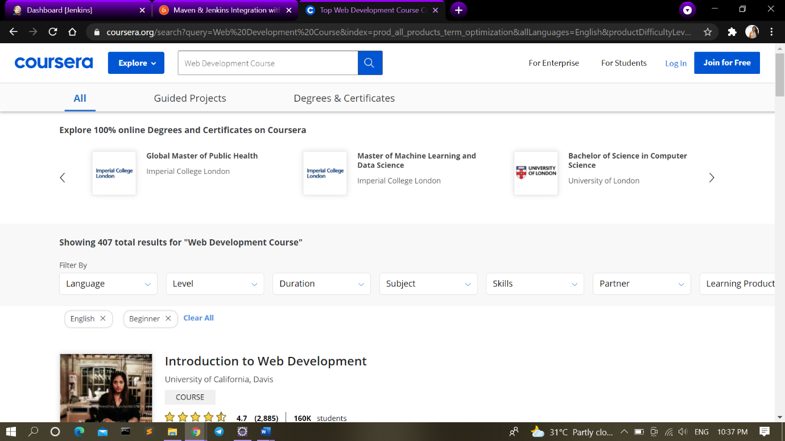

**2.2.2 Level Selection**



**2.3 Language Learning**

* Search for Language Learning
* In Language dropdown ,Extract all languages count.
* In Level dropdown , Extract all levels count.

**2.3.1All Languages count**

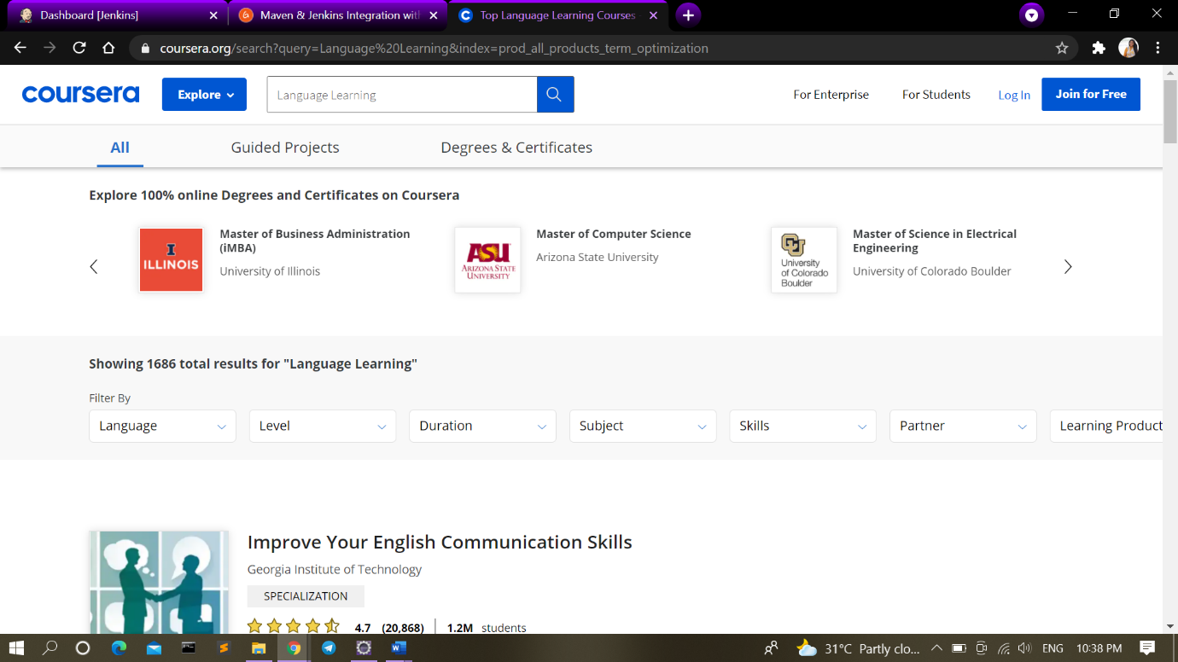

**2.3.2 Each Level count**

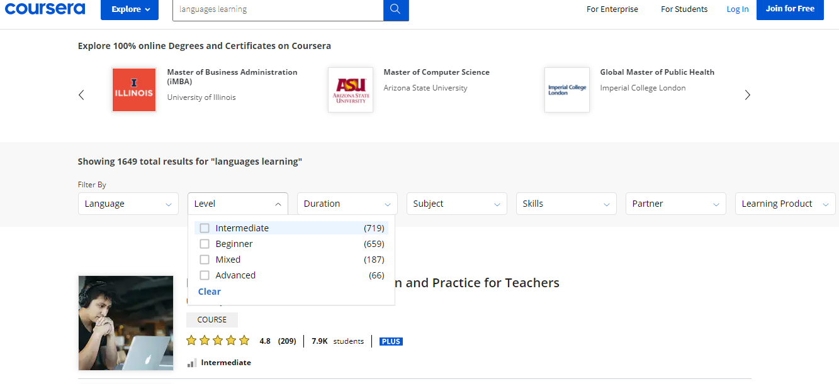

**2.4 Form Filling**

**2.4.1 For Enterprise**

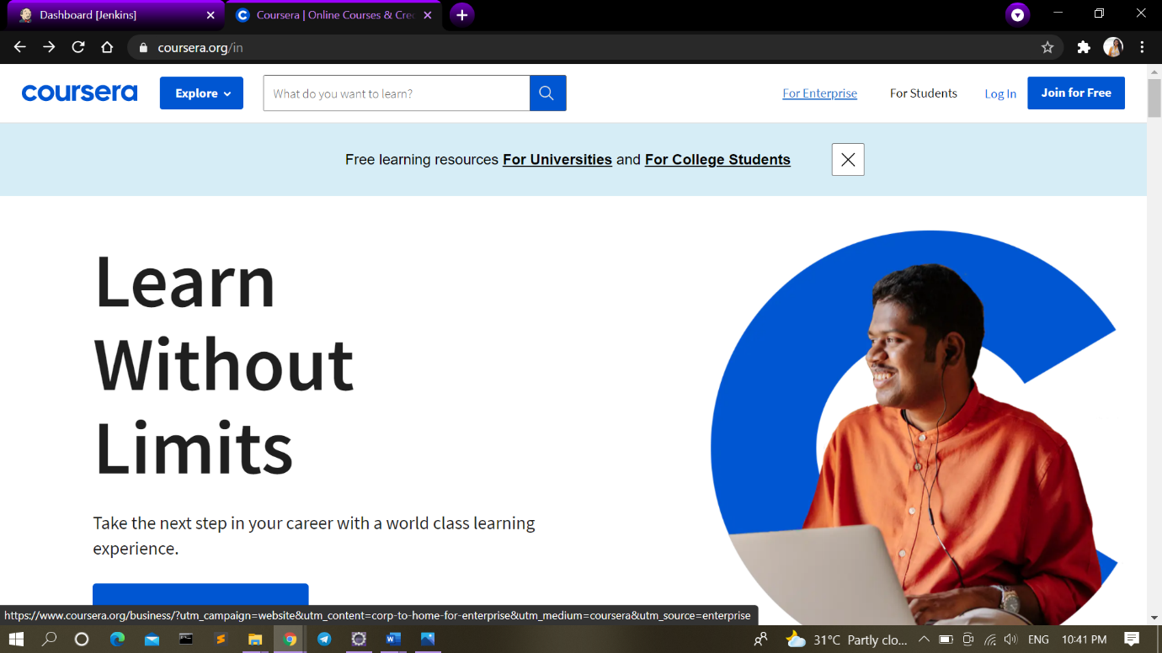

**2.4.2 For Campus**

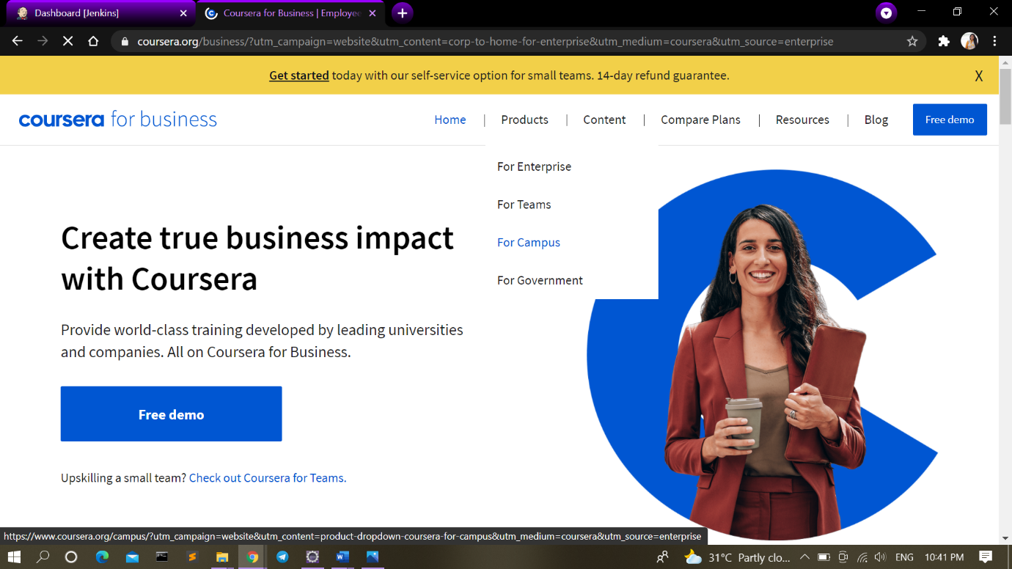

**2.4.3 Get Started**



