WEEK 2 TASK REPORT
Data Visualization and Insight Communication Using R
Exploring Trends and Patterns in Netflix Movies and TV Shows

Submitted as part of Week 2 Task

1. Introduction
Data visualization helps transform raw data into meaningful and understandable information. This project analyzes a Netflix Movies and TV Shows dataset using R and the ggplot2 library. The objective is to identify important patterns, distributions, trends, and relationships through different types of charts. The visualizations are accompanied by explanations so that the findings can be understood by both technical and non-technical audiences.

2. Objectives
- To explore a publicly available Netflix Movies and TV Shows dataset.
- To inspect and prepare the data for visualization.
- To create multiple types of visualizations using R and ggplot2.
- To identify trends, patterns, distributions, and relationships in the dataset.
- To communicate insights clearly using graphs and written interpretation.

3. Dataset Overview
The Netflix dataset contains information about movies and television shows available in the catalog. Important variables include content type, title, country, release year, rating, and duration. For this visualization task, the main variables analyzed were type, release_year, and duration.
Key variables:
- type – identifies whether a title is a Movie or TV Show.
- release_year – indicates the year in which the title was released.
- duration – gives movie duration in minutes or TV show duration in seasons.

4. Tools and Technologies Used
- R Programming Language
- RStudio
- ggplot2 library
- Base R functions for data preparation

5. Data Preparation
The dataset was imported into R and inspected before visualization. Missing values and duplicate records were checked. For the movie-duration analysis, only Movie records were selected and the duration values were converted into numerical minutes. Rows with non-numeric duration values were excluded only from the duration-specific analysis.
netflix <- read.csv("netflix_titles.csv")
colSums(is.na(netflix))
sum(duplicated(netflix))
movie_data <- subset(netflix, type == "Movie")
movie_data$duration_min <- as.numeric(
gsub(" min", "", movie_data$duration)
)
movie_duration <- movie_data[!is.na(movie_data$duration_min), ]

6. Visualization 1 – Distribution of Movies and TV Shows
A bar chart was selected to compare the number of Movies and TV Shows in the Netflix dataset. Bar charts are effective for comparing categorical groups because the difference in their counts can be understood immediately.
library(ggplot2)
ggplot(netflix, aes(x = type)) +
geom_bar() +
labs(
title = "Distribution of Movies and TV Shows on Netflix",
x = "Content Type",
y = "Number of Titles"
) +
theme_minimal()
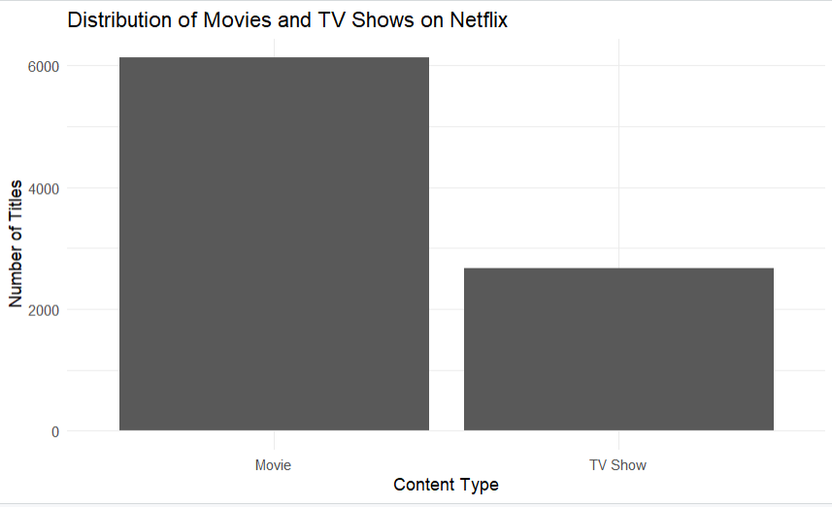
Interpretation: The visualization clearly shows that Movies make up a substantially larger portion of the Netflix dataset than TV Shows. The movie count is above 6,000, while the number of TV Shows is around 2,600. This indicates that the catalog represented in this dataset is dominated by movie content.

7. Visualization 2 – Number of Netflix Titles by Release Year
A line chart was used to study how the number of titles varies across release years. A line chart is appropriate because release year is an ordered time-related variable, making long-term changes easier to identify.
yearly_content <- as.data.frame(table(netflix$release_year))
names(yearly_content) <-
c("release_year", "number_of_titles")
yearly_content$release_year <-
as.numeric(as.character(yearly_content$release_year))
ggplot(yearly_content,
aes(x = release_year, y = number_of_titles)) +
geom_line() +
labs(
title = "Number of Netflix Titles by Release Year",
x = "Release Year",
y = "Number of Titles"
) +
theme_minimal()
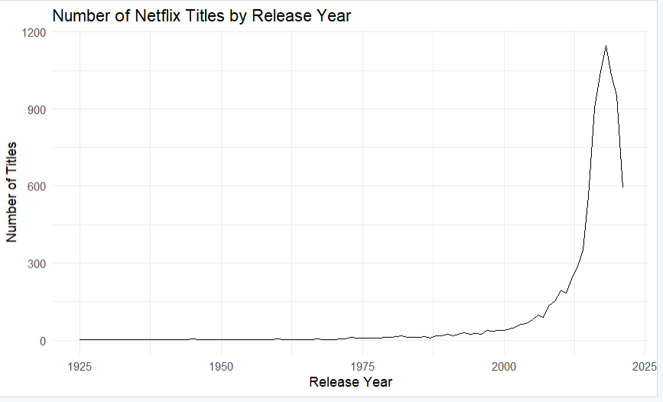
Interpretation: The graph shows very low numbers of titles for earlier release years, followed by gradual growth and then a sharp increase after the 2000s. The number of titles reaches its highest point during the late 2010s before declining in the most recent years shown. It is important to note that release_year represents the title's original release year, not necessarily the year it was added to Netflix.

8. Visualization 3 – Distribution of Movie Durations
A histogram was selected to examine the distribution of movie duration. Histograms are useful for numerical data because they group values into intervals and reveal where observations are concentrated.
ggplot(movie_duration, aes(x = duration_min)) +
geom_histogram(binwidth = 10) +
labs(
title = "Distribution of Movie Durations on Netflix",
x = "Duration (Minutes)",
y = "Number of Movies"
) +
theme_minimal()
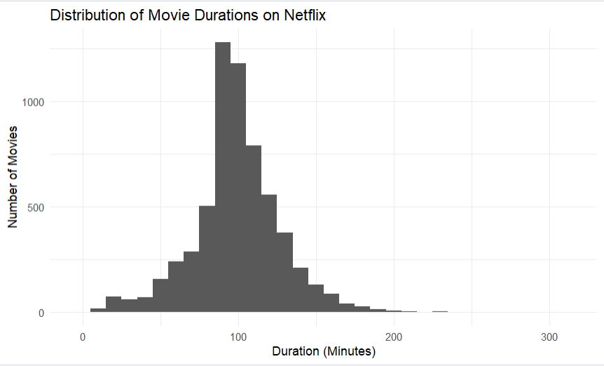
Interpretation: Most movies are concentrated approximately between 80 and 120 minutes, with the highest concentration close to the 90–100 minute range. The number of movies decreases as duration becomes very short or very long. A small number of unusually long movies can also be observed, producing a right-skewed distribution.

9. Visualization 4 – Relationship Between Release Year and Movie Duration
A scatter plot was used to investigate the relationship between movie release year and movie duration. Each point represents one movie. Scatter plots are suitable for exploring possible relationships, clusters, and unusual observations between two numerical variables.
ggplot(movie_duration,
aes(x = release_year, y = duration_min)) +
geom_point(alpha = 0.4) +
labs(
title = "Relationship Between Release Year and Movie Duration",
x = "Release Year",
y = "Movie Duration (Minutes)"
) +
theme_minimal()
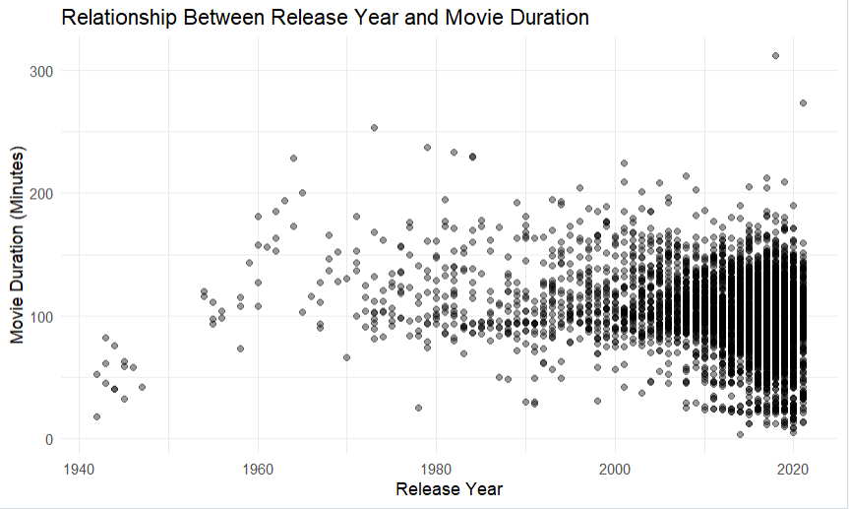
Interpretation: Most observations are concentrated between approximately 80 and 150 minutes, especially in recent release years where the number of data points is much higher. A few unusually long movies above 200 minutes are visible as outliers. The scatter plot does not show a clear strong linear relationship between release year and movie duration, suggesting that movie length does not consistently increase or decrease over time.

10. Overall Key Findings
- Movies are considerably more common than TV Shows in the dataset.
- The number of titles represented by release year increases strongly after the 2000s and peaks during the late 2010s.
- Most movies have durations concentrated roughly between 80 and 120 minutes.
- Very short and very long movies occur less frequently than movies with standard durations.
- There is no clear strong linear relationship between movie release year and movie duration.
- The visualizations demonstrate how different chart types can communicate different aspects of the same dataset.

11. Limitations
- The dataset represents a snapshot and may not reflect future changes to the Netflix catalog.
- Release year should not be confused with the date on which Netflix added the title.
- The duration analysis was limited to movies because TV Shows use seasons rather than minutes.
- A scatter plot can show visual patterns but cannot by itself establish causation.

12. Conclusion
This project demonstrated the use of R and ggplot2 for effective data visualization and insight communication. Four different visualization types—a bar chart, line chart, histogram, and scatter plot—were used to explore the Netflix dataset from different perspectives. The analysis revealed the dominance of movies over TV Shows, major changes in the distribution of titles across release years, a strong concentration of standard movie durations, and no clear strong relationship between release year and movie duration. Overall, the project shows how suitable visualization choices can make patterns in a dataset easier to understand and communicate.

