ECLASSIFIEDS
1. INTRODUCTION & OBJECTIVES
This is a leading Classifieds website. This website provides a different kinds of facilities to the users like Education, Rental, Real estate, Situations vacant, Sunday cinema, Wheels used cars, Matrimonial, Mailing, Job Searching facility.
Another important reason for the popularity of Internet Users is the advent of Online Job opportunities, Matrimonial and Rental. Now the people are able to do search without wasting their precious time. This make searching flexible.
As online job searching is a popular way for getting jobs easily, we are implementing it. This project report includes Resume posting, Searching of jobs, Posting of jobs and searching of Resumes.
As Online matrimonial is a popular way for searching suitable bride and bridegroom and posting your bio-data.
As Online rental is a popular way of searching for the apartments and rooms available for monthly rental. This module gives you brief idea about rooms available and area where it is located.

The Functionalities provided by the System as follows:
1.Education: This module provides information like Admissions into different courses of different colleges, Fees information, Last date to submit application forms and Results of different courses like 10th class, Intermediate, Degree, MBA, MCA and BE.
2.Rental: This module provides information about rented houses like what is the rent of house, facilities provided by the house, addresses for contacting.
3.Real Estate: Application should provide information about location, Area details and cost of land in acres/yards.
4.Situations Vacant: This module will give the information about situations vacant in different companies, so that users can apply.
5.Sunday Cinema: This will provides the information about Movies, which are running in the city. Users can book their tickets online.
6.Wheels-Used Cars: This module will give the detailed information about used cars, which are going to sell.
7.Matrimonial: In this module users can search for matching based on their requirement. Once user enters his matching requirement system will fetch and display the matched results.
8.Searching Facility: This interface acts like a search engine. Based on the key entered by the user engine will searches for results, if there is any matching with the key application should display the results.
9.Administration: Administrator will maintain the site. Administrator will have facilities to give necessary inputs to the site.

2. LITERATURE SURVEY
2.1 IDENTIFICATION OF NEED

2.1.1 Business Impacts:
It will reduce the amount of time spent by the employees of the company and also provides a convenient and efficient means of reaching to persons using cutting-edge- technologies. The main goal is targeting towards smooth internal communication and functioning for the customers along with other useful information.

2.2.2 Expected Results:
1.Time and cost saving to reach to people
2.Time saving for persons of remote places for their product search and also provides the convenience of searching for products anywhere at any point of time.

2.2.3 Business Requirement:

1.Searching Capability:
For users convenience, they should able to search for desired information using different criteria thus allowing them to find what they are looking for in the shortest possible time. This saves the users’ time and makes search convenient.
2.Information and Payment Details :
The users of the website should be able to create their address details and payment details before making the confirmation. There should also be a restriction for payment to either credit card type or debt card type.
3.Ease of Use:
E-Classifieds screen need to be designed and organized for easier, more intuitive access to selecting their choices in different type of class and also for other aspects of the website like any type of searching online booking for cinema etc.

4.Event Logging:
Significant System events (e.g. Logons any failure activity) must be logged and time stamped so that the system admin/web master is able to monitor system updated and usage.
5.Automate Work/Information Flow:
To minimize redundant effort and to enhance user experience the workflow on the website should be automated. Users are taken through a sequence of screens in a logical manner while they are on the website looking for searching information.
6.Linking with partner websites:
Provision should be made to enable the website to link to other website from the homepage and also from other deeper lying pages within the website.
7.Security:
E-Classifieds deals with a lot of proprietary information for its users, which are confidential. It is therefore imperative to provide a means through which information can be kept confidential. This is also ensures that the data that is put into the system maintains its integrity because malicious or unauthorized individual will not have access to alter them.

2.2 PRELIMINARY INVESTIGATIOMThe project has been divided into nine modules based on the functionalities.
1.Education:
This module provides information like Admissions into different courses of different colleges, Fees Information, Last Date to submit application forms.To view details about courses offered by different collages, first user has to select the university, Then he has to selects the college, Then application has to display the set ofcourses offered by that college and details about the course like what is the fee to join that course, and application has to display the applications issued dates.

It will display Results of different courses like 10th class, Intermediate, Degree, MBA, MCA and BE. To get the results first user has to select Education link, Then he has to select the Results link, Then he has to select the University, Then he has to give the hall ticket number, if this number is valid then display the result else display the error message.

2.Rental:
This module provides information about rented houses like what is the rent of house, facilities provided by the house, addresses for contacting.To get the rented houses details first user has to select the RENTAL option from the site then he has to give the city (Hyderabad or Chennai), then he has to give the location details and then user has to enter the Rent Range. Based on these Factors our application has to display Rented house details, description about the house and contact person details.

3.Real Estate:
Application provides information about Land details and location, Area details and cost of land in acres/yards.To get the Real Estate details first user has to select the Real Estate option from the site then he has to give the city (Hyd or Chennai), then he has to give the location details and then user has to enter the Range of Land costs. Based on these Factors our application has to display Real Estate information, description about the Land and contact person details.

4.Situation Vacant:
This module will give the information about situations vacant in different companies, so that users can apply.To get the information about situations in different companies first user has to select the situation vacant option, which is provided by the site. After that, take

- Qualification of the user
- Experience of the user
- Skill Set of the user
- Location of the Job

Based on these four factors our application has to search for Job and it has to give details about the job (What is the company, location of the company, Last date for applying, contact person details and mail id for applying to that job.

5.Sunday Cinema:
This will provide the information about Movies, which are running in the city.
To get the movie details which are running in different theaters first user has to select this Sunday cinema option from the site. User can search movies details in two ways.

- Search move based on Language:
To search the move if user chooses movie language then our application has to display the movie names based on the language and it has to display the theater information like address, phone number, timings of that theater and also information about the movie like hero of the movie etc.

- Search move based on Theater Name:
To search the move if user chooses Theater name then our application has to display the movie names based on the Theater name and it has to display the theater information like address, phone number, timings of that theater and also information about the movie like hero of the movie etc.
6.Wheela Used Cars:
This module will give the detailed information about used cars, which are going to sell.
When user selects this option our application has to display the set of existed used cars details and contact person details.To search the car details first user has to take the option of wheels-used cars, and he has to give

  - Car type (Maruthi or Santro or Ford)
  - Range of cost
Based on these two factors application has to display the results.

7.Matrimonial:
In this module users can search for matching based on their requirement. Once user enters his matching requirement system will fetch and display the matched results.The Matrimonial module is used to post their bio-data, search for bride, and bridegrooms. The Flow Chart is represented in the above figure.
This module consists of the following functionalities:
1.Post Bio-data:
The post bio-data facility enables the users to wish to be placed in the firm to enter their personal details in a form, which is provided. These details are collected form all the users who are willing to search for bride and bridegrooms. The details is collected and stored in the database. The Flow Chart is represented in the below figure.

2.Search Brides and Bridegrooms:
The Search for Bride and Bridegrooms facility is used by the user, who are looking out for a perfect bride and bridegrooms. To search Brides or Bridegrooms first user has to give the following information that is

- Sex
- Country
- Religion
- Education
Based on this information our application has to search for matching.
8.Search Facility:
This interface acts like a search engine. Based on the key entered by the user engine will searches for results, if there is any matching with the key application should display the results.
9.Administration:
Administrator will maintain the site. Administrator will have facilities to give necessary inputs to the site.

2.3 FEASIBILITY STUDY
All projects are feasible – given unlimited resources and infinite time! Unfortunately, the development of computer-based system or product is more likely plagued by a scarcity of resources and difficult delivery dates. It is both necessary and prudent to evaluate the feasibility of a project at the earliest possible time. Months or years of effort, thousands or millions of dollars, and untold professional embarrassment can be averted if an ill-conceived system is recognized early in the definition phase.
Feasibility and risk analysis are related in many ways. If project risk is great the feasibility of producing quality software is reduced. During product engineering, however, we concentrate our attention on four primary areas of interest:
2.3.1 Technical Feasibility:
This application in going to be used in an Internet environment called www (World Wide Web). So, it is necessary to use a technology that is capable of providing the networking facility to the application. This application as also able to work on distributed environment. Application on developed with J2EE (Java 2 Enterprise Edition platform) Technology. One major advantage in application is platform neutral. We can deploy and used it in any operating system.
GUI is developed using HTML.to capture the information from the customer. HTML is used to display the content on the browser. It uses TCP/IP protocol. It is an interpreted language. It is very easy to develop a page/document using HTML some RAD (Rapid Application Development) tools are provided to quickly design/develop our application. So many objects such as button, text fields, and text area etc are providing to capture the information from the customer.
We can use this application in any OS. They can have their own security and transactional advantages. But are the responsible for selecting suitable and secured OS, which is suitable to our application.
The back-end Oracle 8i and front-end application are platform independent. So we can port this enterprise application in any environment. Both are having their individual configuration to get better performance and backup issues.

2.3.2 Economical Feasibility:
In present system customer need to go to biller’s place to pay the bill. So he/she needs to spend some time to complete this protocol. It is time consuming process some times customer not able to spend that much of time. In such case needs to pay some additional payment to the biller for late payment.
If it is developed in electronic payment system, He can pay the bill from any where in the world. No need to travel to pay the bills. For doing this process electronically have to spend some time.

2.3.3 Operational Feasibility:
In our application front end is developed using GUI. So it is very easy to the customer to enter the necessary information. But customer has some knowledge on using web applications before going to use our application.

2.4 SOFTWARE ENGINEERING PARADIGIM APPLIED

2.4.1 Design Specification:
Design of software involves conceiving planning out and specifying the externally observable characteristics of the software product. We have data design, architectural design and user interface design in the design process. These are explained in the following section. The goals of design process it to provide a blue print for implementation, testing, and maintenance activities.

2.4.2 Data Design:
The primary activity during data design is to select logical representations of data objects identified during requirement analysis and software analysis. A data dictionary explicitly on the elements of the data structure. A data dictionary should be established and used to define both data and program design.
2.4.3 Design Methodology:
The two basic modern design strategies employed in software design are:
- Top Down Design2.
- Bottom Up Design
Top Down Design is basically a decomposition process, which focuses on the flow of control. At later stages it concern itself with the code production. The first step is to study the overall aspects of the tasks at hand and to break it into a number of independent modules. The second step is to break each one of these modules further into independent sub-modules. The process is repeated one to obtain modules, which are small enough to group mentally and to code in a straightforward manner. One important feature is that at each level the details of the design at the lower level are hidden. Only the necessary data and control that must be called back and forth over the interface are defined.
In a bottom-up design one first identifies and investigates parts of design that are most difficult and necessary designed decision are made the reminder of the design is tailored to fit around the design already chose for crucial part. It vaguely represents a synthesis process explained in previous section.
One storage point of the top-down method is that it postpones details of the decision until the last stage of the decision. It allows making small design changes when the design is half way through. There is danger that the specifications will be incompatible and this will not be discovered until late in the design process. By contrast the bottom-up strategy first focuses on the crucial part so that feasibility of the design is tested at early stage.
In mixing top-down and bottom-up design it often appears that we start in the middle of the problem and work our way both up and down there. In a complex problem, it is often difficult to decide how to modularize the various procedures in such cases one might consider a list of system inputs and decide what functions are necessary to process these inputs. This is called back to front design. Similarly one can start with the required outputs and work backwards evolving so called front-back design. We have applied both the top down and bottom up approach in our design approach.

2.4.4 Database Design:
Databases are normally implemented by using a package called a Data Base Management System (DBMS). Each particular DBMS has somewhat unique characteristics, and so such, general techniques for the design of database are limited. One of the most useful methods of analyzing the data required by the system for the data dictionary has developed from research into relational database, particularly the work of E.F.Codd. This method of analyzing data is called “Normalization”. Unnormalized data are converted into normalized data by three stages. Each stage has a procedure to follow.

2.4.5 Normalization:
The first stage is normalization is to reduce the data to its first normal form, by removing repeating items showing them as separate records but including in them the key fields of the original record.
The next stage of reduction to the second normal form is to check that the record, which one is first normal form, all the items in each record are entirely dependent on the key of the record. If a data item is not dependent on the key of the record, but on the other data item, then it is removed with its key to form another record. This is done until each record contains data items, which are entirely dependent on the key of their record.
The final stage of the analysis, the reduction of third normal form involves examining each record, which one is in second normal form to see whether any items are mutually dependent. If there are any item there are removed to a separate record leaving one of the items behind in the original record and using that as the key in the newly created record.

2.4.6 Business Modeling:
The information flow among business function is modeled in a way that answers the following questions: what information drives the business process? What information is generated? What generate it? Where does the information go? Who process it?

2.4.7 Data Modeling:
The information flow defined as a process of the business modeling is refined into a set of data objects that are needed to support the business. The characteristics (called attributes) of each object are identified and relationships between these objects are defined.

2.4.8 Process Modeling:
The data objects defined in the data-modeling phase are transformed to achieve the information flow necessary to implement a business function. Processing description are created for addition, modifying, deleting, or retrieving a data object.

The Linear Sequential Model:
The linear sequential model for software engineering some times called the “classic model” or the “water fall model,” the linear sequential suggests a systematic, sequential approach to software development that begins at eth system level and process through analysis, design, coding, testing, and maintenance.
The linear sequential model is the oldest and the most widely used paradigm for software engineering. Modeled after the conventional engineering cycle, the linear sequential model encompasses the following activities:

1) System/Information Engineering and Modeling:

- Because software is always part of a larger system (or business), work begins by establishing requirements for all system elements and then allocating some subset of these requirements to software. This system view is essential when software must interface with other elements such as hardware, people, and databases.

- System engineering and analysis encompasses requirements gathering at the system level with a small amount of top-level analysis and design. Information engineering encompasses requirements gathering at the strategic business level and at the strategic business level and at the business area level.

2) Software Requirement Analysis
The requirements gathering process is intensified and focused specifically on software. To understand the nature of the programs to be built, the software Engineer must under stand the information domain for the software, as well as required function, behavior, performance, and inter facing. Requirements for the both the system and the software are documented and reviewed with the customer.

3) Design:
Software design is actually a multi step process that focuses on four distinct attributes of a program: data structure, software architecture, interface representations, and procedural detail. The design process translates requirements into a representation of the software that can be assessed for quality before code generation begins. Like requirements the design is documented and becomes part of the software configuration.

4) Code Generation:
The design must be translated into a machine-readable form. The code generation step performs this task. If design is performed in a detailed manner, code generation can be accomplished mechanistically.

5) Testing:
Once code has been generated, program testing process focuses on the logical internals of the software, assuring that all statements have been tested, and on the functional externals that is, conducting tests to uncover errors and ensure that defined input will produce actual results that agree with required results.

6) Maintenance:
Software will undoubtedly undergo change after it is delivered to the customer. Change will occur because errors have been encountered, because the software must be adapted to accommodate changes in its external environment (e.g., a change required because of a new operating system or peripheral devices), or because the customer requires functional or performance enhancement. Software maintenance reapplies each of the preceding phases to an existing program rather than a new one

3. SOFTWARE AND HARDWARE SPECIFICATIONS
Online Banking System is a network-based application. When we talk about hardware and software, we have to mention requirements on both the Client and Server part.
    - Internet connection with 33.6 KBPS Modem.
    - Pentium 2.77 GHz. 40 GB HDD, 512 MB RAM (Server).
    - Any P.C with Windows compatibility, 64 MB RAM (Client).
    - JDK 1.4 Enterprise Edition (J2EE)
    - Weblogic version 7.0.
    - Enterprise Java Beans
    - JDBC/ODBC drivers installed.
    - Functional Java enabled browser.
    - Data Base (Oracle).
    - Operating System (Windows).
3.1 INTERNET TERMINOLOGY
Java and Internet:
The Internet helped catapult Java to the forefront of programming and Java in turn has had a profound effect on the Internet. The reason is simple: Java expands the universe of objects that can move about freely in cyberspace. In a network, there are two broad categories of objects transmitted between the Server and your Personal Computer: passive information and dynamic, active programs like an object that can be transmitted to your computer, which is a dynamic, self-executing program. Such a program would be an active agent ton the client computer, yet the server would initiate it. As desirable as dynamic, networked programs are, they also present serious problems in the areas of security and portability. Prior to Java cyberspace was effectively closed to half the entities that now live there. Java addresses these concerns and doing so, has opened the door to an exiting a new form of program.
The rise of server-side Java applications is one of the latest and most exciting trends in Java programming. It was first hyped as a language for developing elaborate client-side web content in the form of applets. Now, Java is coming into its own as a language ideally suited for server-side development. Businesses in particular have been quick to recognize Java’s potential on the server-Java is inherently suited for large client/server applications. The cross platform nature of Java is extremely useful for organizations that have a heterogeneous collection of servers running various flavors of the Unix of Windows operating systems. Java’s modern, object-oriented, memory-protected design allows developers to cut development cycles and increase reliability. In addition, Java’s built-in support for networking and enterprise API provides access to legacy data, easing the transition from older client/server systems
Java Servlets are a key component of server-side java development. A Servlets is a small, plug gable extension to a server that enhances the server’s functionality. Servlets allow developers to extend and customize and Java enabled server a web server, a mail server, an application server, or any custom server with a hitherto unknown degree of portability, flexibility and ease.

3.2 JAVA SERVER PAGE(JSP)
Java Server Pages is a simple, yet powerful technology for creating and maintaining dynamic-content web pages. Based on the Java programming language, Java Server Pages offers proven portability, open standards, and a mature re-usable component model.
1.Portability:
Java Server Pages files can be run on any web server or web-enabled application server that provides support for them. Dubbed the JSP engine, this support involves recognition, translation and management of the Java Server Pages lifecycle and its interaction with associated components.
The JSP engine for a particular server might be built-in or might be provided through a 3rd –party add-on. As long as the server on which you plan to execute the Java Server Pages supports the same specification level as that to which the file was written, no change should be necessary as you move your files from server to server. Note, however, that instructions for the setup and configuration of the files may differ between files.

2.Composition:
It was mentioned earlier that the Java Server Pages architecture could include reusable Java components. The architecture also allows for the embedding of a scripting language directly into the Java Server Pages file. The components current supported include Java Beans and Serves. As the default scripting language, Java Server Pages use the Java Programming language. This means that scripting on the server side can take advantage of the full set of capabilities that the Java programming language offers.

3.Processing:
A Java Server Pages file is essentially an HTML document with JSP scripting or tags. It may have associated components in the form of class, .jar, or .ser files- -or it may not. The use of components is not required.
The Java Server Pages file has a .jsp extension to identify it to the server as a Java Server Pages file. Before the page is served, the Java Server Pages syntax is parsed and processed into a servlet on the server side. The servlet that is generated, outputs real content in straight HTML for responding to the customer. Because it is standard HTML, the dynamically generated response looks no different to the customer browser than a static response.
4.Access Models:
A Java Server Pages file may be accessed in at least two different ways: A client request comes directly into a Java Server Page.

Browser

Bean

JSP
Request
Response

Fig 3.1: Client Request into JSP
In this scenario, suppose the page accessed reusable Java Bean components that perform particular well-defined computations like accessing a database. The result of the Bean’s computations, called result sets is stored within the Bean as properties. The page uses such Beans to generate dynamic content and present it back to the client. A request comes through a servlet.

3.3 SERVLET

Browser

Bean

JSP
Request
Response
Result Bean
JDBC
Database

Fig 3.2: Handling the response to client
The servlet generates the dynamic content. To handle the response to the client, the servlet creates a Bean and stores the dynamic content (sometimes called the result set) in the Bean. The servlet then invokes a Java Server Page that will present the content along with the Bean containing the generated from the servlet.
There are two APIs to support this model of request processing using Java Server Pages. One API facilitates passing context between the invoking servlet and the Java Server Page. The other API lets the invoking servlet specify which Java Server Page to use.
In both of the above cases, the page could also contain any valid Java code. The Java Server Pages architecture separation of content from presentation- -it does not mandate it.
JDBC requires that the SQL statements be passed as Strings to Java methods. For example, our application might present a menu of database tasks from which to choose. After a task is selected, the application presents prompts and blanks for filling information needed to carry out the selected task. With the requested input typed in, the application then automatically invokes the necessary commands.
In this project we have implemented three-tier model, commands are sent to a “middle tier” of services, which then send SQL statements to the database. The database process the SQL statements and sends the results back to the middle tier, which then sends them to the user. JDBC is important to allow database access from a Java middle tier.

3.4 WHAT IS JDBCTM?
JDBCTM is a JavaTM API for executing SQL statements. (As a point of interest, JDBC is a trademarked name and is not an acronym; nevertheless, JDBC is often thought of as standing for "Java Database Connectivity".) It consists of a set of classes and interfaces written in the Java programming language. JDBC provides a standard API for tool/database developers and makes it possible to write database applications using a pure Java API.
Using JDBC, it is easy to send SQL statements to virtually any relational database. In other words, with the JDBC API, it isn't necessary to write one program to access a Sybase database, another program to access an Oracle database, another program to access an Informix database, and so on. One can write a single program using the JDBC API, and the program will be able to send SQL statements to the appropriate database. And, with an application written in the Java programming language, one also doesn't have to worry about writing different applications to run on different platforms. The combination of Java and JDBC lets a programmer write it once and run it anywhere
. Java being robust, secure, easy to use, easy to understand, and automatically downloadable on a network, is an excellent language basis for database applications. What is needed is a way for Java applications to talk to a variety of different databases. JDBC is the mechanism for doing this.
JDBC extends what can be done in Java. For example, with Java and the JDBC API, it is possible to publish a web page containing an applet that uses information obtained from a remote database. Or an enterprise can use JDBC to connect all its employees (even if they are using a conglomeration of Windows, Macintosh, and UNIX machines) to one or more internal databases via an intranet. With more and more programmers using the Java programming language, the need for easy database access from Java is continuing to grow.

MIS managers like the combination of Java and JDBC because it makes disseminating information easy and economical. Businesses can continue to use their installed databases and access information easily even if it is stored on different database management systems. Development time for new applications is short. Installation and version control are greatly simplified. A programmer can write an application or an update once, put it on the server, and everybody has access to the latest version. And for businesses selling information services, Java and JDBC offer a better way of getting out information updates to external customers.

Connection:
A connection object represents a connection with a database. A connection session includes the SQL statements that are executed and the results that are returned over the connection. A single application can have one or more connections with a single database, or it can have connections with many different databases.

Opening Connection:
The standard way to establish a connection with a database is to call the method DriverManager.getConnection. This method takes a string containing a URL. The Driver Manager class, referred to a the JDBC management layer, attempts to locate a driver than can connect to the database represented Driver classes, and when the method get Connection is called, it checks with each driver in the list until it finds one that can connect uses this URL to actually establish the connection.
<Sub protocol>-usually the driver or the database connectivity mechanism, which may be supported by one or more drivers. A prominent example of a sub protocol name is “oracle”, which has been reserved for URLs that specify “thin”-style data source names.
<Sub name>- a way to identify the database. The sub names can vary, depending on the sub protocol, and it can have a sub name with any internal syntax the driver writer chooses. The point of a sub name is to give enough information to locate the database.

Sending Statement:
Once a connection is established, it is used to pass SQL statements to its underlying database. JDBC does not put any restrictions on the kinds of SQL statements that can be sent; this provides a great deal of flexibility, allowing the use of database-specific statements or even non-SQL statements. It requires, however, that the user be responsible for making sure that the underlying database can process the SQL statements being sent and suffer the consequences if it cannot.

Driver Manager:
The Driver Manager class is the management layer of JDBC, working between the user and the drivers. It keeps track of the drivers that are available and handles establishing a connection between a database and the appropriate driver. It addition, the driver manager class attends to things like driver login time limits and the printing of log and tracing messages. The only method in this class that a general programmer needs to use directly is DriverManager.getConnection. As its name implies, this method establishes a connection to a database.

A JAVA2 Platform, Enterprise Edition Deployment

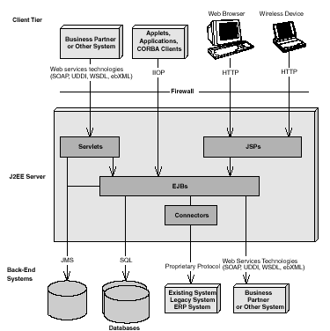

Fig 3.3: JAVA2 Platform,Enterprise,Edition Deployment

Acquiring a reference to a home object
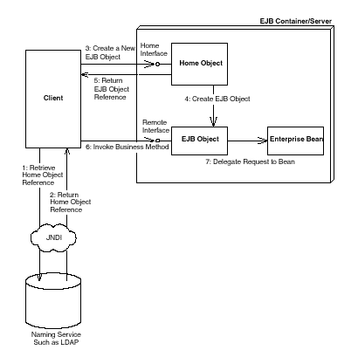

Fig 3.4:Acquiring a reference to a home object

Life cycle of a Stateful Session Bean(SFSB):
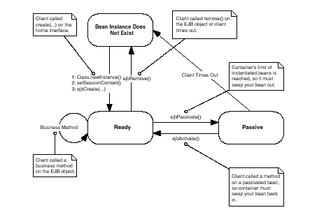

Fig 3.5: Life cycle of a Stateful Session Bean
3.4 ORACLE 8i:
Introduction To Oracle:
Any programing environment used to create containers, to manage human data, in the conceptualization as a Data Management System. Traditionally, the block of human data being managed is called a Database. Hence, in very simple terms, these programming environments can the conceptualized as Database Management Systems, in short DBM systems.
All Databases Management Systems (that is, Oracle is DBMS) allow users to create containers for data stories and management. These containers are called ‘cells’. The minimum information that has to be given to Oracle for a suitable container to be constructed, which can hold free from human data is
1. The cell name
2. The cell length
Another name that programming environments use for a ‘Cell’ is ‘Field’. These can the conceptualized as follows.
Basic DataBase Concepts:
A database is a corporate collection of data with some inherent meaning, designed, built and populated with data for a specific purpose. A database stores data that is useful to us. This data is only a part of the entire data available in the world around us.
To be able to successfully design and maintain databases we have to do the following:

1.Identify which part of the world’s data is of interest to us.
2.Identify what specific objects in that part of the world’s data are of interest to us
3.Identify a relationship between the objects.
Hence the objects, their attributes and the relationship between them that are of interest to us are still owed in the database that is designed, built and populated with data for a specific purpose.

Characteristics of Database Management System:

- It represents a complex relationship between data.
- Keeps a tight control of debtor redundancy.
- Enforces user-defined rules to ensure integrity of table data.
- Has a centralized data dictionary for the storage of information pertaining to data and its manipulation.
- Ensures that data can be shared across applications.
- Enforces data access authorization has automatic, intelligent backup and recovery procedures for data.
- Have different interfaces via which users can manipulate data.
Relational Database Management System:
A relational database management system uses only its relational capabilities to manage the information stored in its databases.
Information Representation:
All information stored in a relational database is represented only by data item values, which are stored in the tables that make up the database. Associations between data items are not logically represented in any other way, such as the use of pointers from one table to the other.
Logical Accessibility:
Every data item value stored in relational database is accessible by stating the nature of the table it is stored in, the name of the column under which it is stored and the value of the primary key that defines the row in which it is stored.
Representation of Null values:
The database management system has a consistent method for representing null values. For example, null values for numeric data must be distinct from zero or any other numeric and for the character data it must be different from a string of blanks or any other character value.
Catalogue Facilities:
The logical description of the relation database is represented in the same manner as ordinary data. This is done so that the facilities of the relation database management system itself can be used to maintain database description.

Data Language:
The relational database management system may support many types of languages for describing data and accessing the database. However, there must be at least one language that uses ordinary character strings to support the definition of data, the definition of views, the manipulation of data, constraints on data integrity, information concerning authorization and the boundaries for recovery of units.
View updatability:
Any view that can be defined using combination of basic tables, that are theoretically updateable, these capital of being updated by the relational database management system.
Insert,update and delete:
Any operand that describes the results of a single retrieval operation is capable of being applied to an insert update or delete operation as well.
Physical Data Independence:
Changes made to physical storage representation or access methods do not require changes to be made to application programmers.
Logical Data Independence:
Changes made to tables, that do not modify any data stored in that table, do not require changes to be made to application programmers.
Integrity Constraints:
Constraints that apply to entity integrity and referential integrity are specifiable by the data language implemented by the database management system and not by the statements coded into the application program.
Database Distribution
The data language implemented by the relation database management system supports the ability to distribute the database without requiring changes to be made to application programmers. This facility must be provided in the data language, whether or not the database management system itself supports distributed databases.
Non-Subversion:
If the relational database management system supports facilities that allow application programmers to operate on the tables a row at a time, an application programmer using this type access is prevented from by passing entity integrity or referential integrity constraints that are defined for the database.

4. ANALYSIS AND DESIGN
4.1 SYSTEM DESIGN
Database Design
1.Univers_det Table
univid number(3) primary key
univname varchar2(20)
univlocation varchar2(20)
univaddress varchar2(20)
webaddress varchar2(20));

2.collage_det table

collageid number(3) primary key
univid varchar2(20)
collagename varchar2(20)
collagelocation varchar2(20)
collageaddress varchar2(20)
webaddress varchar2(20)
aboutcollage varchar2(20)
establisheddate varchar2(12)

3.course_det table

courseid number(3) primary key
collageid varchar2(20)
coursename varchar2(20)
noofseat varchar2(20)
durationofcourse number(3)
feedetail number(10,2)
courcestartdate varchar2(20)

4.stu_det Table

hallticketno Varchar2(10) primary key
univid varchar2(20)
collageid varchar2(20)
courseid varchar2(20))

5.stu_sem_det Table

serialno number(5) primary key
hallticketno varchar2(20)
semno number(5)
samesterstatus varchar2(20)

6.stu_mark_det Table

serialno number(5) primary key
hallticketno varchar2(20)
semno number(5)
sub1 number(3)
sub2 number(3)
sub3 number(3)
sub4 number(3)
sub5 number(3)
Lab1 number(3)
Lab2 number(3)
projectwork varchar2(20)
total number(3)
result varchar2(10)

7.sunday_cinema Table

theetorno number(2) primary key
theatename varchar2(20)
location varchar2(20)
address varchar2(20)
moviename varchar2(20)
movielanguage varchar2(20)
showtime1 varchar2(20)
showtime2 varchar2(20)
showtime3 varchar2(20)
showtime4 varchar2(20)
phoneno number(10)
hero varchar2(20)
movietype varchar2(20)

8.matrimonial_det table

Name varchar2(20)
Age number(3)
mailid varchar2(20) primary key
gender varchar2(20)
religion varchar2(20)
martialstatus varchar2(20)
dob varchar2(20)
height number(82)
occupation varchar2(20)
nameofres varchar2(20)
country varchar2(20)
eduqual varchar2(20)
contactumber number(10);
9. Renatls

houseno varchar2(20) primary key
ownersname varchar2(30)
facilities varchar2(30)
location varchar2(30)
address varchar2(30)
rent number(10,2)
adavance number(10,2)
city varchar2(30)
contactno number(10)

10. Real Estate

flotno varchar2(20) primary key
ownersname varchar2(30)
facilities varchar2(30)
location varchar2(30)
address varchar2(30)
landacrs number(10,2)
city varchar2(30)
contassno number

11. Wheels_used cars

carcode varchar2(20) primary key
carmodel varchar2(30)
costofcar number(10,2)
usedsofor varchar2(20)
contactper varchar2(30)
contactno number
contactaddress varchar2(30)
discription varchar2(30)

13. Adminclassified

username varchar2(20)
password varchar2(20)

12. Situation vacant

job_code number(15) Primary key
job_name varchar2(20)
quali_req varchar2(30)
skill_req varchar2(30)
resp_req varchar2(40)
exp_req number(5)
vac_open number(4)
dby varchar2(40)
don varchar2(20)
lastdate varchar2(20)
status varchar2(20)
location varchar2(20)

6. 2 DATA FLOW DIAGRAMS
DFDs For Eclassified:

1. ZERO LEVEL DFD

User
E-CLASSIFIED
Administrator
Result

Fig 4.1 : Zero level DFD

2. DFD LEVEL 1

E-CLASSIFIED
Education
Rental
Administration
Real Estate
Situation Vacant
Sunday Cinema
Wheels Used Car
Matrimonial
Searching Facility

Fig 4.2: Level one DFD

3. DFD FOR ADMINISTRATION

ADMINISTRATION
Rentals Details
Education
Matrimonial Details
Cars Details
D
Movies Details
Situation Vacant
Real Estate
Store Details
In Database

Fig 4.3: Administration DFD

4. DFD FOR EDUCATION

Results Info
College Info
EDUCATION
University Details
College Details
Results Details
University Info

Fig 4.4: Education DFD
5. DFD RENTALS

RENTALS
Rented House Details
Search for Rented House
Display Results
Rented House Info

Fig 4.5: Rentals DFD

6. REAL ESTATE DFD

Real Estate Info
REAL ESTATE
Real Estate Details
Search for Real Estate
Display Real Estate Details

Fig 4.6: Real Estate DFD

7. SITUATION VACANT

Situation Vacant
Info
SITUATION VACANT
Situation Vacant Details
Give the Profile
Display Jobs Based on Profiles

Fig 4.7: Situation Vacant DFD

8. SUNDAY CINEMA DFD
SUNDAY CINEMA
Theater Info Movie Info
Search Movie
Display Movie Details
Theater Movie Info

Fig 4.8: Sunday Cinema DFD
9. WHEELS USED CARS DFD

WHEELS USED CARS
Car Details
Search for a Car
Display Car Details
Car Info

Fig 4.9: Wheels used cars DFD

10. MATRIMONIAL DFD

Store Profile
MATRIMONIAL
Add Profile
Search for Match
Update Profile
Update Profile
Display Match Details

Fig 4.10: Matrimonial DFD

11. SEARCH FACILITY

Search
Key
SEARCH
Display Search
Details

Fig 4.11: Search Facility DFD

5. CODE EFFICIENCY
5.1 Measures of Code Efficiency:
The code is designed with the following characteristics in mind.

- Uniqueness:
The code structure must ensure that only one value of the code with a single meaning is correctly applied to a give entity or attribute.

- Expandability:
The code structure are designed for in a way that it must allow for growth of it’s set of entities or attributes, thus providing sufficient space for the entry of new items with in each classification.

- Conciseness:
The code requires the fewest possible number of positions to include and define each item.

- Uniform size and format:
Uniform size and format is highly desirable in mechanized data processing system. The addition of prefixes and suffixes to the root code should not be allowed especially as it is incompatible with the uniqueness requirement.

- Simplicity:
The codes are designed in a simple manner to understand and simple to apply.

- Versatility:
The code allows modifying easily to reflect necessary changes in conditions, characteristics and relationship of the encoded entities. Such changes must result in a corresponding change in the code or coding structure.

- Sortability: Reports are most valuable for user efficiency when sorted and presented in a predetermined format or order. Although data must be sorted and collaged, the representative code for the date does not need to be in a sortable form if it can be correlated with another code that is sortable.

- Stability:
Codes that do not require to be frequently updated also promote use efficiency. Individual code assignments for a given entity should be made with a minimal likelihood of change either in the specific code or in the entire coding structure.

- Meaningfulness:
Code is meaningful. Code value should reflect the characteristics of the coded entities, such as mnemonic features unless such a procedures results in inconsistency and inflexibility.

- Operatability:
The code is adequate for present and anticipated data processing both for machine and human use. Care is taken to minimize the clerical effort and computer time required for continuing the operation.

6. OPTIMIZATION OF CODE
6.1 Introduction:
A good program is not the one that solves the intended problem alone but the one that does it efficiently. An ideal compiler should produce target code that is as good as can be written by hand crafted meticulously to run on the target machine in the most efficient manner both in terms of time of execution and memory requirements. The reality however is that this goal is achieved only in limited, cases and that too with difficulty. Nonetheless, the code produced by straight forward compiling algorithms can often be made more space and time efficient. This is accomplished by applying transformations on the produced code. These transformations aiming at optimization of compiled code are known as code optimization and compilers that apply code improving transformations are called optimizing compilers.
The optimization may be machine dependent or machine independent. A machine independent optimization is a set of program transformations that improve the target code without taking into consideration any properties of the target machine. Machine dependent optimizations, such as register allocation and utilization of special machine instruction sequences, on the other hand, depend on the target machine.
The overall performance of a program can be effectively improved if we can identify the frequently executed parts of a program and then make these parts as efficient as much as possible. According to Pareto principle, most programs spend ninety per cent of their execution time in ten percent of the code. While the actual percentages may vary, it is often the case that a small fraction of a program accounts for most of the running time. Profiling the run-time execution of a program on representative input data accurately identifies the heavily traveled regions of a program. Unfortunately, a compiler does not have the benefit of sample input data, so it must make best guess as to where the program hot spots are.
In practice, the program's inner loops are good candidates for improvement. In a language that emphasizes control constructs like while and for statements, the loops may be evident from the syntax of the program; in general, a process called contra/flow analysis identifies loops in the flow graph of a program.

The best technique for deciding what transformations are worthwhile to put into a compiler is to collect statistics about the source programs and evaluate the benefit of a given set of optimizations on a representative sample of real source programs.

Organization for an Optimizing Compiler:
There are often levels at which a program can be improved algorithm level, source program level, intermediate level or target level. Since the techniques needed to analyze and transform a program do not change significantly with the level, this chapter concentrates on the transformation of intermediate code using the organization shown below:

Code
Optimizer
Control
Flow
Analysis
Data
Flow
Analysis

Transformations
Front end
Code
Optimizer
In the code optimizer programs are represented by flow graphs, in which edges indicate the flow of control and nodes represent basic blocks. Unless otherwise specified a program means a single procedure.

6.2 Sources of Optimization:
Let us see some of the most useful code-improving transformations. If looking only at can perform it the statements in a basic block are called local otherwise, it is called global. Many transformations can be performed at both the local and global levels. Local transformations are usually performed first.

Function Preserving Transformation:
There are a number of ways in which a compiler can improve a program without changing the function it computes. Common sub-expression elimination, copy propagation, dead code elimination, and constant folding are common examples of such function-preserving transformations.
Frequently, a program will include several calculations of the same value, such as an offset in an array. The programmer cannot avoid some of these duplicate calculations because they lie below the level of detail accessible within the source language.

Common Sub-Expression:
An occurrence of an expression E is called a common sub-expression if E was previously computed, and the values of variables in E have not changed since the previous computation. We can avoid recomputing the expression if we can use the previously computed value. Removing such command sub-expressions may optimize the code.

Copy propagation:
The idea behind the copy-propagation transformation is to use g for f, wherever possible after the copy statement f: =g.

Dead-Code:
A variable is live at a point in a program if its value can be used subsequently; otherwise, it is dead at that point. A related idea is dead or useless code, statements that compute values that never get used. While the programmer is unlikely to introduce any dead code intentionally, it may appear as the result of previous transformations. Deducing at compile time that the value of an expression is a constant and using the constant instead is known as constant folding.

6.3 Loop Optimizations:
Loops are very important place for optimizations where programs tend to spend the bulk of their time. rf we decrease the number of instructions in an inner loop, even if we increase the amount of code outside that loop, the running time of a program may be improved considerably. Three important techniques for loop optimization are - code motion, which moves code outside a loop; induction-variable elimination, which we apply to eliminate loop indices from the inner loops; and reduction in strength, which replaces an expensive operation by a cheaper one, such as a multiplication by an addition. Some of the loop optimization techniques are discussed below:
Code motion is an important modification that decreases the amount of code in a loop. It takes an expression and transforms it yielding the same result independent of the number of times a loop is executed (i.e. a loop-invariant computation) and places the expression before the loop. The assumption made here is that an entry for the loop exists. For instance, evaluation of aaa is a loop-invariant computation in the following while-statement:
While (i < = aaa)
Code motion will transform it into the following equivalent statements:
ttt = aaa;
While (i < = ttt)
Clearly the code motion technique has reduced the number of computations in this form.

Induction Variables And Reduction In Strength
Code motion may not be applicable to all the situations. Loops are usually processed from inside to outside. For example, consider the following loops:
Note that the values of j and t2 remain in lock step; every time the value of j decreases by 1, that of t2 decreases by 5 because 5* j is assigned to t2. Such identifiers are called induction variables.
By the process of induction variable elimination in a loop, it may be possible to get rid of all but one when more than one induction variables are present.

6.4 Basic Blocks Optimization:

Many of the structure-preserving transformations can be implemented by constructing a directed-cyclic-graph (DAG) for a basic block. There is a node in the DAG for each of the initial values of the variables appearing in the basic block, and there is a node n associated with each statement s within the block. The children of n are those nodes corresponding to statements that are the last definitions prior to s of the operands used by s. Node n is labeled by the operator applied at s, and also attached to n is the list of variables for which it is the definition within the block. We also note those nodes, if any, whose are live on exit from the block; these are the output nodes.

7.TESTING AND IMPLEMENTATION
In the text boxes like name, address etc., only alphabets and number could be entered thus if the operator by mistake enters other special characters, it would not be entered.In the text boxes like age, telephone number only numbers could be entered.
If the users do not fill any of the fields, which could not be empty, a message would be displayed asking to enter the required parameters.
When a user starts the applications, a login form will be displayed prompting to enter the username and password, if even any one of them is not matched with the details stored in the database, the user will be warned to re-enter the correct details.
While entering the details of new customer, the customer number which cannot be null value will be automatically generated which is one greater than the highest number existing previously.
When the details of one customer are modified even if one parameter is missed a message will be displayed asking to enter complete details.

7.1 SOFTWARE TESTING TECHNIQUES
Software testing is a critical element of software quality assurance and represents the ultimate review of specification, designing and coding.

Testing objectives
- Testing is process of executing a program with the intent of finding an error.
- A good test case design is one that has a probability of finding an as yet undiscovered error.
- A successful test is one that uncovers an as yet undiscovered error.
These above objectives imply a dramatic change in view port.
Testing cannot show the absence of defects, it can only show that software errors are present.
Testcase Design:
Any engineering product can be tested in one of two ways:

White Box Testing: This testing is also called as glass box testing. In this testing, by knowing the specified function that a product has been designed to perform test can be conducted that demonstrates each function is fully operation at the same time searching for errors in each function. It is a test case design method that uses the control structure of the procedural design to derive test cases. Basis path testing is a white box testing.
Basis Path Testing:
- Flow graph notation
- Cyclomatic Complexity
- Deriving test cases
- Graph matrices

Control Structure Testing:
- Condition testing
- Data flow testing
- Loop testing

Black Box Testing:
In this testing by knowing the internal operation of a product, tests can be conducted to ensure that “ all gears mesh”, that is the internal operation performs according to specification and all internal components have been adequately exercised. It fundamentally focuses on the functional requirements of the software.
The steps involved in black box test case design are:
- Graph based testing methods
- Equivalence partitioning
- Boundary value analysis
- Comparison testing

7.2 SOFTWARE TESTING STRATAGIES
A software testing strategy provides a road map for the software developer. Testing is a set of activities that can be planned in advance and conducted systematically. For this reason a template for software testing a set of steps into which we can place specific test case design methods should be defined for software engineering process. Any software testing strategy should have the following characteristics:

- Testing begins at the module level and works “outward” toward the integration of the entire computer based system.
- Different testing techniques are appropriate at different points in time.
- The developer of the software and an independent test group conducts testing.
- Testing and Debugging are different activities but debugging must be accommodated in any testing strategy.

1.Unit Testing: Unit testing focuses verification efforts in smallest unit of software design (module).

- Unit test considerations
- Unit test procedures

2.Integration Testing: Integration testing is a systematic technique for constructing the program structure while conducting tests to uncover errors associated with interfacing. There are two types of integration testing:
1. Top-Down Integration:
Top down integration is an incremental approach to construction of program structures. Modules are integrated by moving down wards throw the control hierarchy beginning with the main control module.
2.Bottom-Up Integration:
Bottom up integration as its name implies, begins construction and testing with automatic modules.

Regression Testing:
In this contest of an integration test strategy, regression testing is the re execution of some subset of test that have already been conducted to ensure that changes have not propagate unintended side effects.

7.3 Validation Testing:
At the culmination of integration testing, software is completely assembled as a package; interfacing errors have been uncovered and corrected, and a final series of software tests – validation testing may begin. Validation can be fined in many ways, but a simple definition is that validation succeeds when software functions in a manner that can be reasonably expected by the customer.
Reasonable expectation is defined in the software requirement specification – a document that describes all user-visible attributes of the software. The specification contains a section titled “Validation Criteria”. Information contained in that section forms the basis for a validation testing approach.

Validation Test Criteria:
Software validation is achieved through a series of black-box tests that demonstrate conformity with requirement. A test plan outlines the classes of tests to be conducted, and a test procedure defines specific test cases that will be used in an attempt to uncover errors in conformity with requirements. Both the plan and procedure are designed to ensure that all functional requirements are satisfied; all performance requirements are achieved; documentation is correct and human-engineered; and other requirements are met.
After each validation test case has been conducted, one of two possible conditions exist: (1) The function or performance characteristics conform to specification and are accepted, or (2) a deviation from specification is uncovered and a deficiency list is created. Deviation or error discovered at this stage in a project can rarely be corrected prior to scheduled completion. It is often necessary to negotiate with the customer to establish a method for resolving deficiencies.

Configuration Review:
An important element of the validation process is a configuration review. The intent of the review is to ensure that all elements of the software configuration have been properly developed, are catalogued, and have the necessary detail to support the maintenance phase of the software life cycle. The configuration review sometimes called an audit.

7.4 ALPHA AND BETA TESTING
It is virtually impossible for a software developer to foresee how the customer will really use a program. Instructions for use may be misinterpreted; strange combination of data may be regularly used; and output that seemed clear to the tester may be unintelligible to a user in the field.
When custom software is built for one customer, a series of acceptance tests are conducted to enable the customer to validate all requirements. Conducted by the end user rather than the system developer, an acceptance test can range from an informal “test drive” to a planned and systematically executed series of tests. In fact, acceptance testing can be conducted over a period of weeks or months, thereby uncovering cumulative errors that might degrade the system over time.
If software is developed as a product to be used by many customers, it is impractical to perform formal acceptance tests with each one. Most software product builders use a process called alpha and beta testing to uncover errors that only the end user seems able to find.
A customer conducts the alpha test at the developer’s site. The software is used in a natural setting with the developer “looking over the shoulder” of the user and recording errors and usage problems. Alpha tests are conducted in controlled environment.
The beta test is conducted at one or more customer sites by the end user of the software. Unlike alpha testing, the developer is generally not present. Therefore, the beta test is a “live” application of the software in an environment that cannot be controlled by the developer. The customer records all problems that are encountered during beta testing and reports these to the developer at regular intervals. As a result of problems reported during bets test, the software developer makes modification and then prepares for release of the software product to the entire customer base.

7.5 IMPLEMENTATION
Implementation is the process of having systems personnel check out and put new equipment into use, train users, install the new application depending on the size of the organization that will be involved in using the application and the risk associated with its use, systems developers may choose to test the operation in only one area of the firm, say in one department or with only one or two persons. Sometimes they will run the old and new systems together to compare the results. In still other situation, developers will stop using the old system one-day and begin using the new one the next. As we will see, each implementation strategy has its merits, depending on the business situation in which it is considered. Regardless of the implementation strategy used, developers strive to ensure that the system’s initial use in trouble-free.
Once installed, applications are often used for many years. However, both the organization and the users will change, and the environment will be different over weeks and months. Therefore, the application will undoubtedly have to be maintained; modifications and changes will be made to the software, files, or procedures to meet emerging user requirements. Since organization systems and the business environment undergo continual change, the information systems should keep pace. In this sense, implementation is ongoing process.
Evaluation of the system is performed to identify its strengths and weakness. The actual evaluation can occur along any of the following dimensions.
Operational Evaluation: assessment of the manner in which the system functions, including ease of use, response time, suitability of information formats, overall reliability, and level of utilization.
Organization Impact: Identification and measurement of benefits to the organization in such areas as financial concerns operational efficiency, and competitive impact. Includes impact on internal and external information flows.
User Manager Assessment: Evaluation of the attitudes of senior and user mangers within the organization, as well as end-users.
Development Performance: Evaluation of the development process in accordance with such yardsticks as overall development time and effort, conformance to budgets and standards, and other project management criteria. Includes assessment of development methods and tools.
Unfortunately system evaluation does not always receive the attention it merits. Where properly managed however, it provides a great deal of information that can improve the effectiveness of subsequent application efforts.
8. SYSTEM SECURITY MEASURES
Security in software engineering a broad topic. This script limits its scope to defining and discussing software security, software reliability, developer responsibility, and user responsibility
.
8.1 COMPUTER SYSTEM ENGINEERING
Software security applies information security principles to software development. Information security is commonly defined as "the protection of information systems against unauthorized access to or modification of information, whether in storage, processing or transit, and against the denial of service to authorized users of the provision of service to unauthorized users, including those measures necessary to detect, document, and counter such threats."
Many questions regarding security are related to the software life cycle itself. In particular, the security of code and software processes must be considered during the design and development phase. In addition, security must be preserved during operation and maintenance to ensure the integrity of a piece of software.
The mass of security functionality employed by today's networked world, might deceive us into believing that our jobs as secure system designers are already done. However, computers and networks are incredibly insecure. The lack of security stems from two fundamental problems. Systems, which are theoretically secure, may not be secure in practice. Furthermore, systems are increasingly complex; complexity provides more opportunities for attacks. It is much easier to prove that a system is insecure than to demonstrate that one is secure to prove insecurity, one simply exploits certain system vulnerability. On the other hand, proving a system secure requires demonstrating that all possible exploits can be defended against (a very daunting, if not impossible, task).

8.2 GOOD PRACTICE
Security requires more managing and mitigating risk than it does technology. When developing software one must first determine the risks of a particular application. For example, today's typical web site may be subject to a variety of risks, ranging from defacement, to distributed denial of service (DDoS, described in detail later) attacks, to transactions with the wrong party.
Once the risks are identified, identifying appropriate security measures becomes tractable. In particular, when defining requirements, it is important to consider how the application will be used, who will be using the application, etc. With that knowledge, one can decide whether or not to support complex features like auditing, accounting, no repudiation, etc.
Another potentially important issue is how to support naming. The rise of distributed systems has made naming increasingly important. Naming is typically handled by rendezvous: a principal exporting a name advertises it somewhere, and someone wishing to use that name searches for it (phone books and directories are examples). For example, in a system such as a resource discovery system, both the resources and the individuals using those resources must be named. Often there are tradeoffs with respect to naming: while naming can provide a level of indirection, it also can create additional problems if the names are not stable. Names can allow principals to play different roles in a particular system, which can also be useful.
9. COST ESTIMATION OF THE PROJECT
For a given set of requirements it is desirable to know how much it will cost to develop the software to satisfy the given requirements, and how much time development will take. These estimates are needed before development is initiated. The primary reason for cost and schedule estimation is to enable the client or developer to perform a cost-benefit analysis and for project monitoring and control. Automation more practical use of these estimates is in bidding for software projects, where the developers must give cost estimates, to a potential client for the development contract.
For a software development project, detailed and accurate cost and schedule estimates are essential prerequisites for managing the project. Otherwise, even simple questions like “is the project late”, “are there cost overruns” and “when is the project likely to complete” cannot be answered. Cost and schedule estimates are also required to determine the staffing level for a project during different phases. It can be safely said that cost and schedule estimates are fundamental to any form of project management and generally always required for a project.
Cost in a project is due to the requirements for software, hardware, and human resources. Hardware resources are such things as the computer time, terminal time, and memory required for the project, whereas software resources include the tools and compilers needed during development. The bulk of the cost of software development is due to the human resources needed, and most cost estimation procedures focus on this aspect. Most cost estimates are determined in terms of person-months (PM). By properly including the “Overheads” (i.e. the cost of hardware, software, office space etc,) in the dollar cost of the person-month, besides including the direct cost of the person-month, most costs for a project can be incorporated by using PM as the basic measure.
Estimates can be based in subjective opinion of some person or determined through the user of models. Though there are approaches to structure the opinions of persons for achieving a consensus on the cost estimate it is generally accepted that it is important to have a more scientific approach to estimate though the user of models.

Uncertainities in Cost Estimation:
One can perform cost estimation at any point in the software life circle. As the cost of the project depends on the nature and characteristics of the project, at any point, the accuracy of the estimate will depend on the among or reliable information we have about the final product. Clearly, when the product is delivered, the cost can be accurately determined, as all the data about the project and the resources spent be fully known by then. This is cost estimation with complete knowledge about be fully known by then. This is cost estimation with complete knowledge about the project. On the other extreme is the point when the project is being initiated or during the feasibility study.

10.REULTS
1. Home Page:

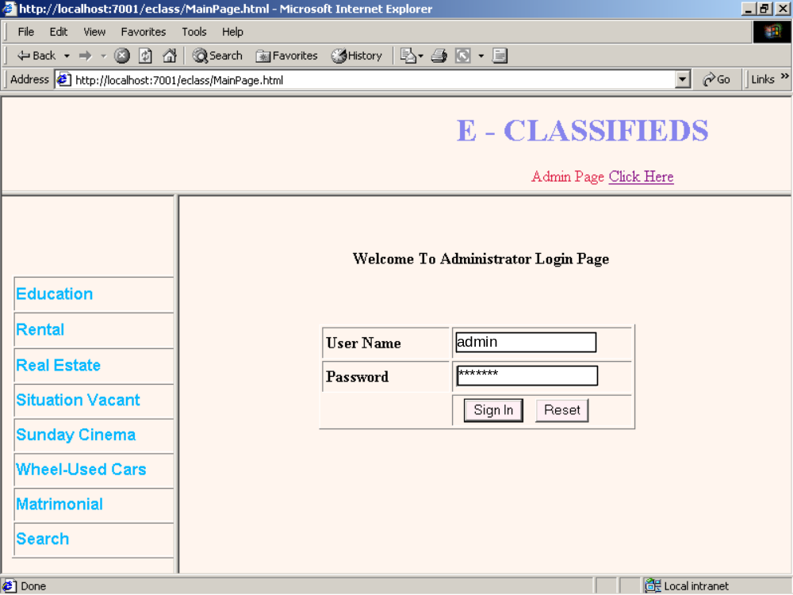
Screen 10.1:Home Page
The above page is the admin login page .Admin is the owner of the website.Admin have the permissions to add and remove data

2. Admin Page:

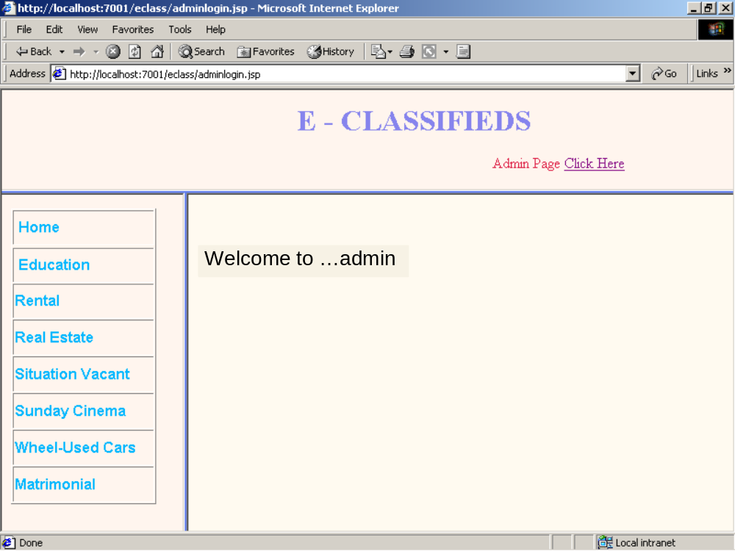

Screen 10.2: Admin page

Admin have to login with the username and password.Admin home page will be displayed after the validations are performed.

3. University Registration Page:

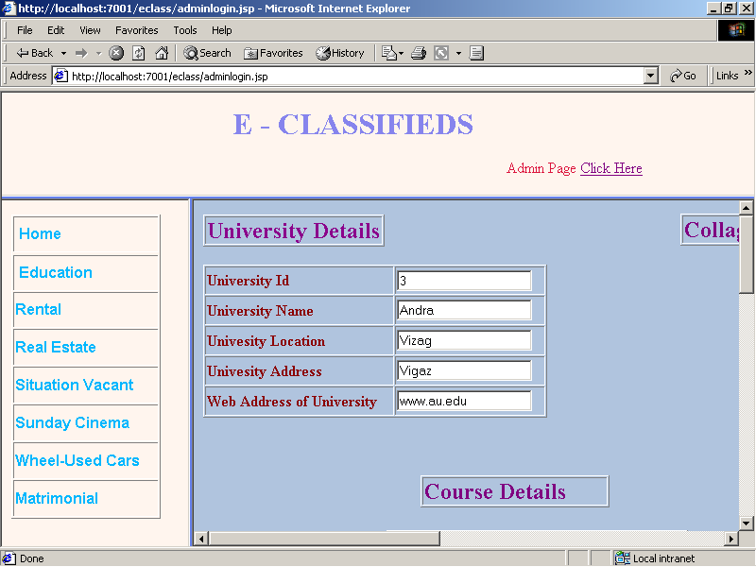

Screen 10.3: University Registration Page

we can update the information of the universities by selecting the education module and update the information regarding university,college and course

4. Rental Module Page:

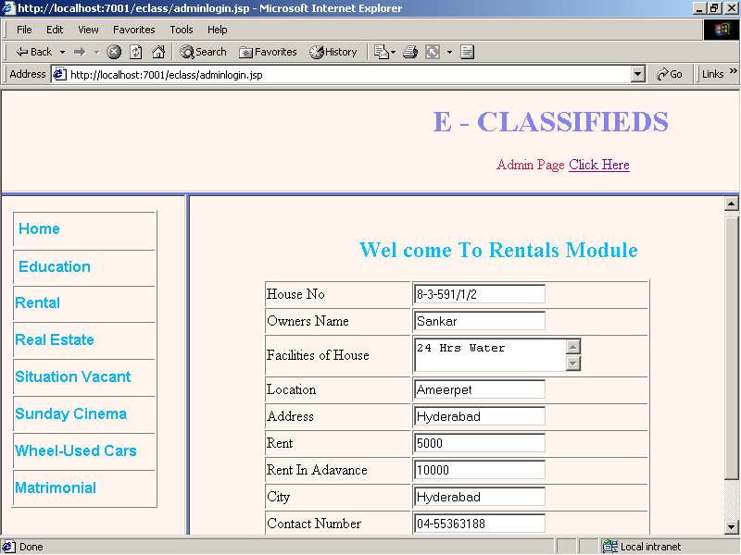

5. Matrimonial Module Page:

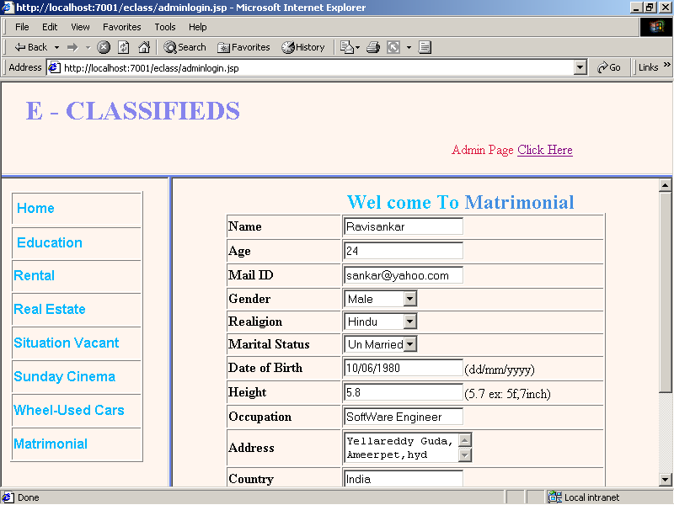

6. Eclassifieds Home Page:

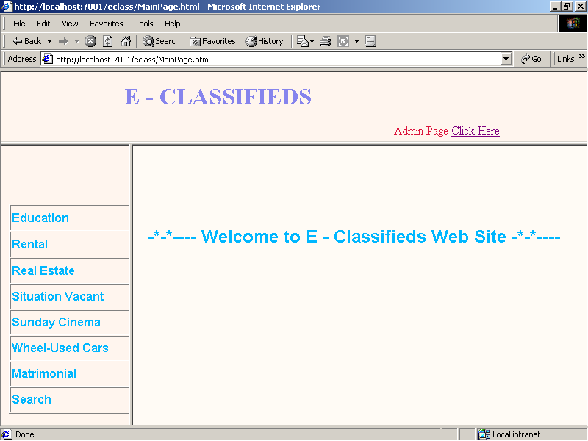

7. Education module Page:

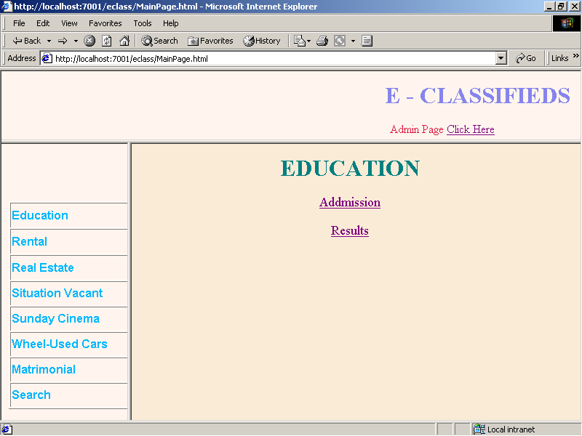

8. Universities Details Display page:

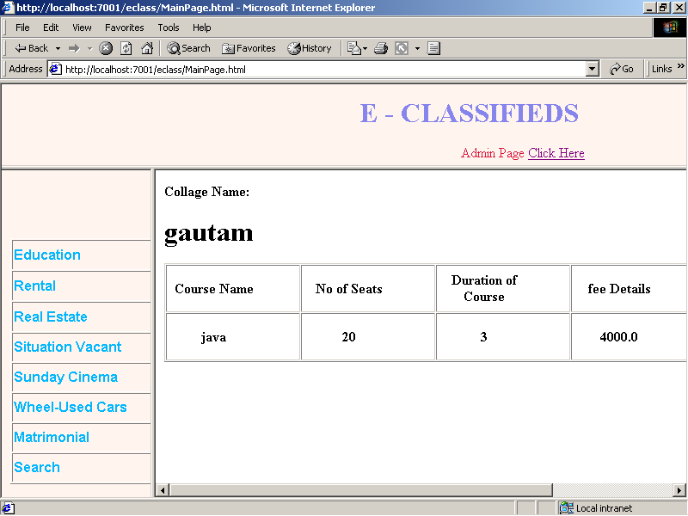

9. Results Display Page:

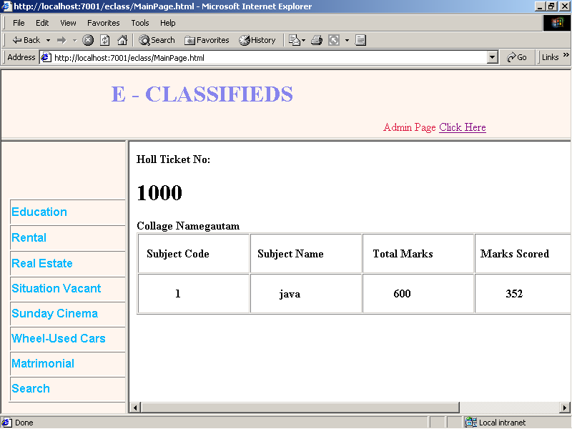

10. Real Estate Module Page:

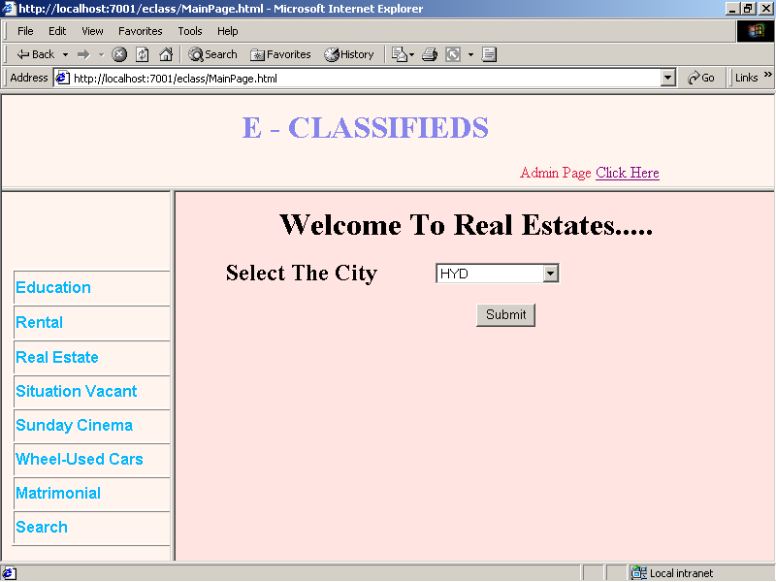

11. Selecting the location in Real Estate Module Page:

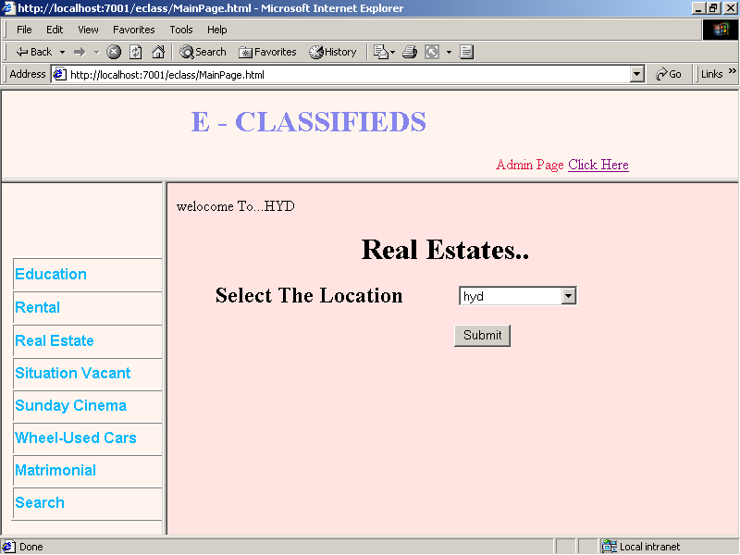

12. Displaying the Real Estate Details:

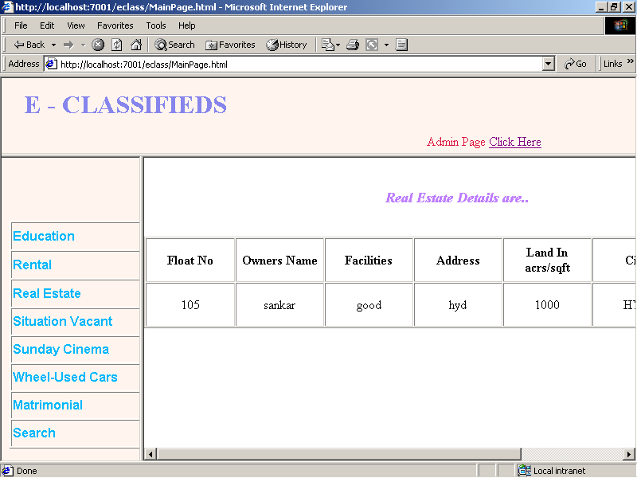

13. Displaying the details of Situation Vaccancy :

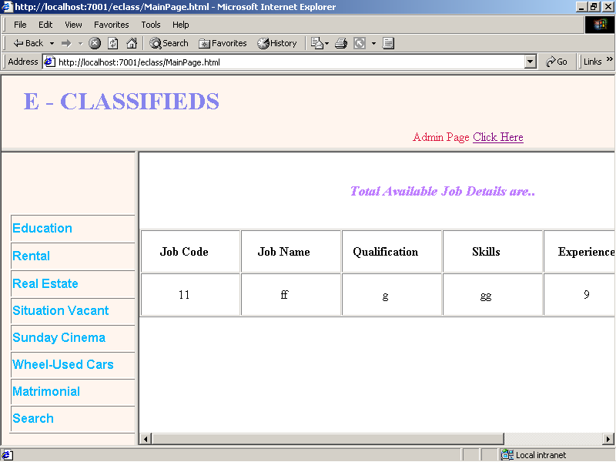

14. Displaying Sunday Cinema Module:

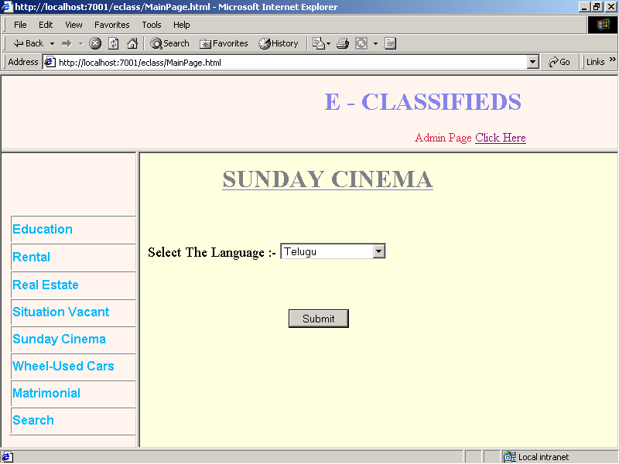

15. Displaying the details of Sunday Cinema:

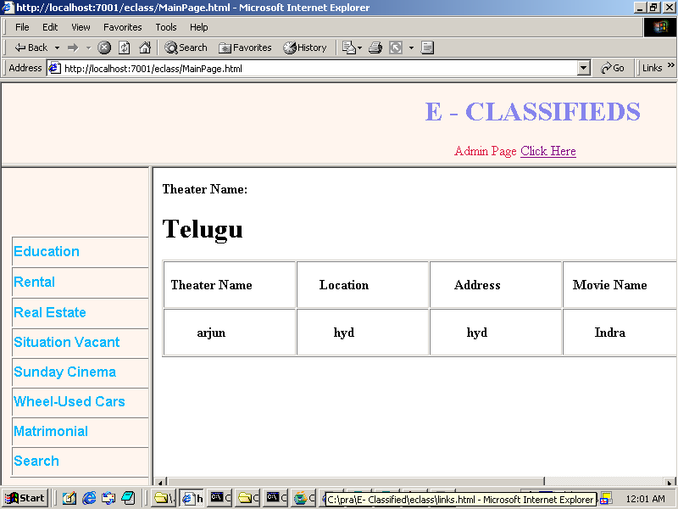

16. Matrimonail Module Home Page and Selecting the Country:

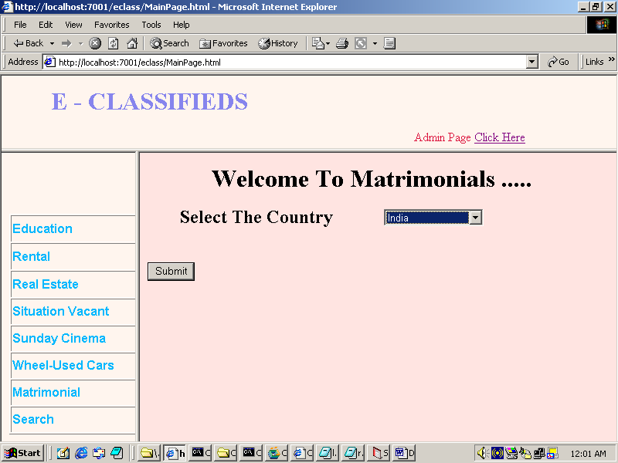

17. Displaying the available information of the Real Estate Module:

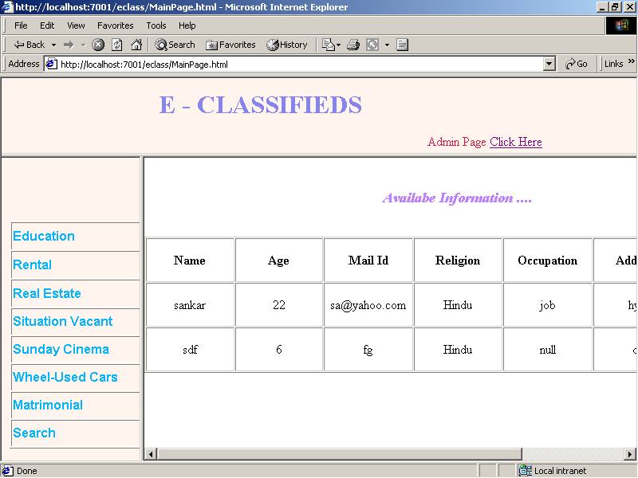

11. PERT CHART & GANTT CHART
Pert Chart:
Program Evaluation Review Technique, PERT can be both a cost and a time management system. PERT is organized by events and activities or tasks. PERT has several advantages over bar charts and is likely to be used with more complex projects. One advantage of PERT is that it is scheduling device that also shows graphically which tasks must be completed before others are begun.
Also, by displaying the various task paths, PERT enables the calculation of a critical path. Each path consists of combinations of tasks, which must be completed. PERT controls time and cost during the project and also facilitates finding the right balance between completing a project on time and completing it within the budget.

PERT CHART

25 JUN 2004

10 JUL 2004

ANALYSIS

I/O DESIGN
INTEGRATION AND TESTING

FINISH

START

WRITE MANUAL

CODING
01 JUL 2004
10 JUL 2004

10 JUL 2004
10 AUG 2004

15 AUG 2004

Gantt Chart(Bar Chart):
A Bar Chart is perhaps the simplest form of formal project management. The bar chart is also known as Gantt Chart. It is used almost exclusively for scheduling purposes and therefore controls only the time of projects.
Gantt Charts are a project control technique that can be used for several purposes, including scheduling, budgeting and resource planning. A Gantt Chart is a Bar Chart, with each bar representing an activity. The bars are drawn against a time line. The length of each bar is proportional to the length of time planned for the activity.

GANTT CHART

JUN 25,04 JULY1,04 JULY15,04 AUG10,04 AUG25,04

ANALYSIS
I /O DESIGN
CODING
WRITE MANUAL

START
INTEGRATION
AND
TESTING

SLACK TIME, i.e., the LATEST TIME by which a task must be finished

White part of the bar shows the length of time each task is estimated to take
12. FUTURE SCOPE OF THE APPLICATION
The Cyber Shopping can be further developed into a separate, automated system with the following enhancements:

- Help file can be included. The system, as of now, does not support any help facility for the users of the system. A help menu can be provided with a special function key and help command in the main page itself. Help can be either introduced as a separate window, a reference to a printed manual or as one or two line suggestion produced in a fixed screen location.

- The system can use typed commands, as they were once the most common mode of communication with the system. The typed command can be provided through control sequence or function keys or typed word.

- A training module can be included in the system. This module can be used to train the users of the system about the systems usage. The training module can be in the form of a HTML file describing different commands usage and the overall function of the system. This would be a handy tool for the developer to train the HR department people.
13. BIBLIOGRAPHY

The following books and manuals provided a lot of help to us in making this project a reality.
JAVA COMPLETE REFERENCE
PATRICK NAUGHTON,
HERBERT SCHILDT
JAVA HOW TO PROGRAM
DEITERL & DEITEL
JAVA UNLEASHED
JDBC DATABASE ACCESS WITH JAVA
GRAHAM AMELTON,
RICK CATTEL,
MATDENE FISHER.
SERVLET PROGRAMMING
O’RELLY
SOFTWARE ENGINEERING
R. E. FAIRELY
SOFTWARE ENGINEERING
PRESSMAN
AN INTEGRATED APPROACH TO SOFTWARE
ENGINNERING
PANKAJ JALOTE
NAROSA PUBLISING HOUSE
FUNDAMENTALS OF DATABASE SYSTEMS
ELMASRI & NAVATHE
ADDISON WESLY
LEARN SQL IN 21 DAYS
TECH MEDIA
SQL, PL/SQL
IVAN BAYROSS
BPB PUBLICATIONS

SYSTEM ANALYSIS AND DESIGN
ELIAS M AWAD
GALGOTIA
J2EE 2ND EDITION
WROX PRESS

