UNIT I
Computer system overview-basic elements, Instruction execution, operating system overview-objectives and functions, Evolution of OS. Process description and control - process states, process description, process control; Process and threads, Types of Threads.

Computer System Overview
- An operating system(OS) exploits the hardware resources of one or more processors to provide a set of services to system users.
- The OS also manages secondary memory and I/O (input/output) devices on behalf of its users.
Basic Elements
- At a top level of any computer architecture, a computer is supposed to have a processor, memory and some I/O components, with one or more quantities of each type.
- These components are interrelated and connected in a way to achieve the major function of the computer, which is to execute programs. So, there are four key structural elements of any computer. These are:
- Processor: It controls the processes within the computer and carries out its data processing functions. When there is only one processor available, it is in combination termed as the central processing unit (CPU), which you must be familiar with.
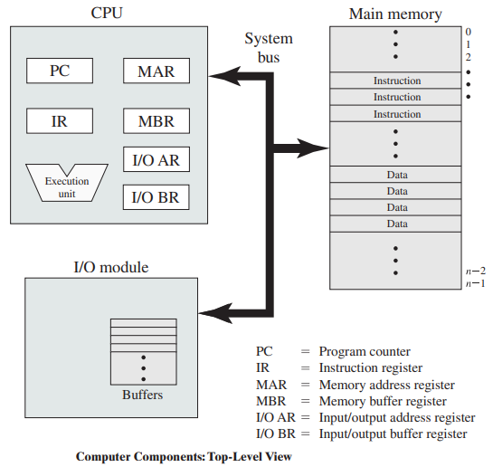
- Main memory: It stores data and programs within it. This memory is typically volatile and is also called primary memory. This is because when the computer is shut down, the contents that are within the memory gets lost. In contrast, the contents of disk memory are kept hold of even when the computer system is turned off which you call as shutting down of Operating system or computer. Main memory is also termed as real memory.
- I/O modules: This moves the data within the computer to its peripheral external environment. The external environment supposed to have a variety of devices, including secondary memory devices (e.g., pen drives, CDs, etc.), communications equipment (such as LAN cable), terminals, etc.
- System bus: It provides communication between processors, main memory, and I/O modules.
Instruction Execution:
- Memory consists of a large array of words or bytes, each with its own address.
- The CPU fetches instructions from memory according to the value of the program counter.
- These instructions may cause additional loading from and storing to specific memory addresses. A typical instruction-execution cycle, for example, first fetches an instruction from memory.
- The instruction is then decoded and may cause operands to be fetched from memory.

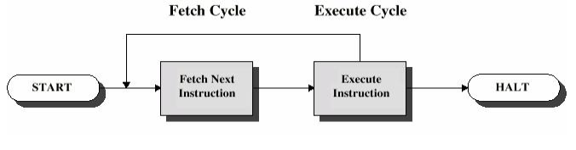
- After the instruction has been executed on the operands, results may be stored back in memory.
- The memory units see shortly a stream of memory addresses; it does not know how they are generated (by the instruction counter, indexing, indirection, literal addresses, and so on) or what they are for (instructions or data).
- Accordingly, we can ignore a program generates a memory address. We are interested only in the sequence of memory addresses generated by the running program.

The following is a summary of the six steps used to execute a single instruction.
Step 1: Fetch instruction.
Step 2: Decode instruction and Fetch Operands.
Step 3: Perform ALU operation.
Step 4: Access memory.
Step 5: Write back result to register file.
Step 6: Update the PC.
Operating System Overview

OS Introduction
- An Operating System (OS) acts as an interface connecting a computer user with the hardware of the computer.
- An operating system falls under the category of system software that performs all the fundamental tasks like file management, memory handling, process management, handling the input/output, and governing and managing the peripheral devices like disk drives, networking hardware, printers, etc.
- An operating system is a program that acts as an intermediate part between a user of a computer and the computer hardware and controls the execution of all kinds of programs.
- An operating system is the program that, after being initially loaded into the computer by a boot program, manages all the other programs in a computer.

Objectives of OS:
1.Convenience: An OS makes a computer more convenient to use.
2.Efficiency: An OS allows the computer system resources to be used in an efficient manner.
3.Ability to evolve: An OS should be constructed in such a way as to permit the effective development, testing, and introduction of new system functions without interfering with service.
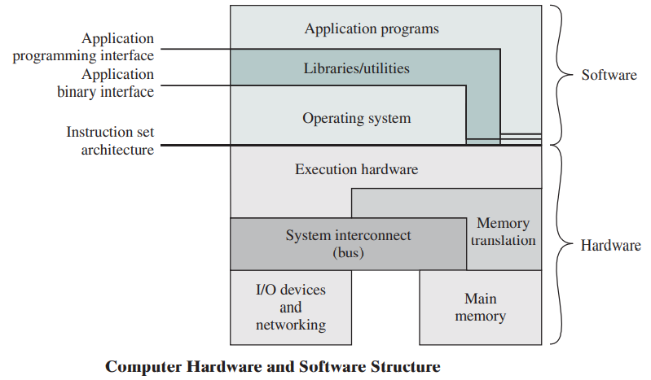

Functions of an operating System are as follows:
1. Memory Management:
- Memory management refers to management of Primary Memory or Main Memory.
- An Operating System does the following activities for memory management: OS Keeps tracks of primary memory, i.e., what part of it are in use by whom, what part are not in use.
- In multi-programming, the OS decides which process will get memory when and how much.
- OS allocates the memory when a process requests it to do so. It de-allocates the memory when a process no longer needs it or has been terminated.
2. Processor Management:
- In multi-programming environment, the OS decides which process gets the processor when and for how much time.
- This function is called process scheduling.
- An Operating System does the following activities for processor management: OS keeps tracks of processor and status of process.
- OS allocates the processor (CPU) to a process.It de-allocates processor when a process is no longer required.
3. Device Management:
- An Operating System manages device communication via their respective drivers.
- It does the following activities for device management: Keeps tracks of all devices.
- The program responsible for this task is known as the I/O controller.
- Decides which process gets the device when and for how much time. OS allocates the device in the most efficient way.
- It de-allocates devices in most efficient way.
4. File Management:
- A file system is normally organized into directories for easy navigation and usage. These directories may contain files and other directions.
- An Operating System does the following activities for file management: Keeps track of information, location, uses, status etc. The collective facilities are often known as file system.
- OS Decides who gets the resources.
- It allocates the resources and also de-allocates the resources when not in need.
5. Security:
- OS prevents unauthorized access to programs and data.
- For shared or public systems, the OS controls access to the system as a whole and to specific system resources.

6. Control over system performance:
OS will collect usage statistics for various resources and monitor performance parameters such as response time, Recording delays between request for a service and response from the system.
7. Job accounting:
- OS Keeps track of time and resources used by various jobs and users.
- On any system, this information is useful in anticipating the need for future enhancements and in tuning the system to improve performance and can be used for job accounting purposes.
8. Error detection & Response:
- A variety of errors can occur while a computer system is running.
- These include internal and external hardware errors, such as a memory error, or a device failure or malfunction; and various software errors.
- In each case, the OS must provide a response that clears the error condition with the least impact on running applications.
- The response may range from ending the program that caused the error, to retrying the operation, to simply reporting the error to the application, Production of dumps, traces, error messages, and other debugging and error detecting aids.
9. Booting the computer:
- Booting is the process of starting or restarting the computer. If computer is switched off completely and then turned on then it is cold booting.
- If computer is restarted then it is warm booting.
- Booting of the computer is done by OS.
10. Coordination between other software and users:
An OS enables coordination of hardware components, coordination and assignment of compilers, interpreters, assemblers and other software to the various users of the computer systems.

Evolution of Operating System
- Evolution of Operating system started from serial to batch, and gradually to multiprogramming, time sharing, parallel and distributed systems.  - Evolutions of Operating system have completely brought delight changes in the human computing world.  - Now, it can process several operations in a very short period depending upon the type of operating system. | 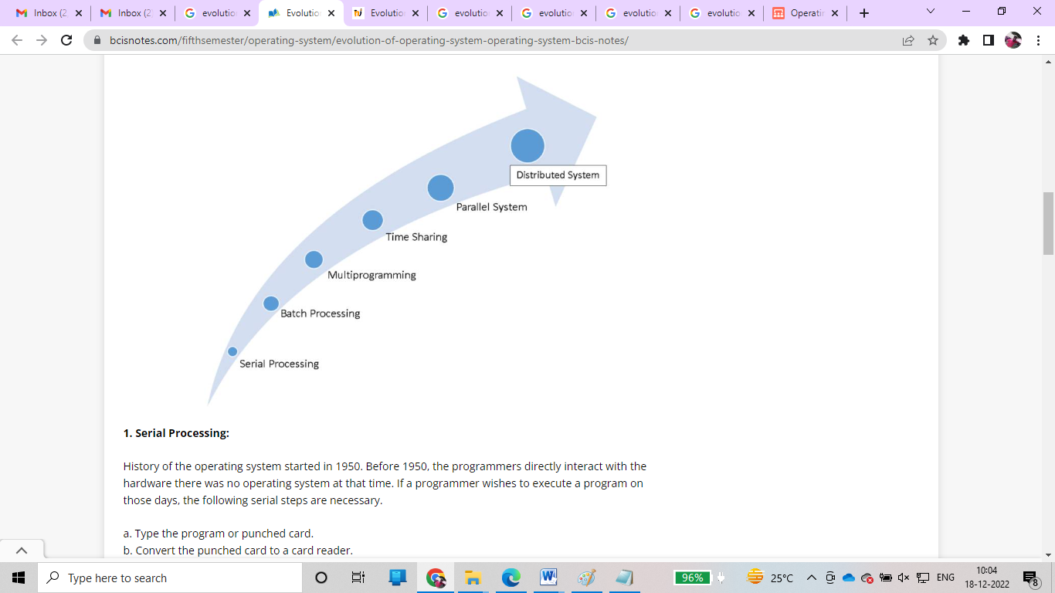
1. Serial Processing:
- History of the operating system started in 1950. Before 1950, the programmers directly interact with the hardware there was no operating system at that time.
- If a programmer wishes to execute a program on those days, the following serial steps are necessary.
- Type the program or punched card.
- Convert the punched card to a card reader.
- submit to the computing machine, is there any errors, the error was indicated by the lights.
- The programmer examined the register and main memory to identify the cause of an error
- Take outputs on the printers.
- Then the programmer ready for the next program.
2. Batch Processing:
- Before 1960, it is difficult to execute a program using a computer because of the computer located in three different rooms, one room for the card reader, one room for executing the program and another room for printing the result.
- The user/machine operator runs between three rooms to complete a job. We can solve this problem by using batch processing.
- In batch processing technique, the same type of jobs batch together and execute at a time.
- The carrier carries the group of jobs at a time from one room to another. Therefore, the programmer need not run between these three rooms several times.
3. Multiprogramming:
- Multiprogramming is a technique to execute the number of programs simultaneously by a single processor.
- In multiprogramming, a number of processes reside in main memory at a time.
The OS(Operating System) picks and begins to execute one of the jobs in main memory.
Advantages:
- Can get efficient memory utilization.
- CPU is never idle so the performance of CPU will increase.
- The throughput of CPU may also increase.
4. Time-sharing
- Time-sharing or multitasking is a logical extension of multiprogramming.
- Multiple jobs are executed by the CPU switching between them.
- The CPU scheduler selects a job from the ready queue and switches the CPU to that job.
- When the time slot expires, the CPU switches from this job to another.
5. Parallel system
- There is a trend multiprocessor system, such system have more than one processor in close communication, sharing the computer bus, the clock, and sometimes memory and peripheral devices.
- These systems are referred to as “Tightly Coupled” system. Then the system is called a parallel system. In the parallel system, a number of processors are executing there job in parallel.
Advantages:
- It increases the throughput.
- By increasing the number of processors(CPU), to get more work done in a shorter period of time.
6. Distributed system
- In a distributed operating system, the processors cannot share a memory or a clock, each processor has its own local memory.
- The processor communicates with one another through various communication lines, such as high-speed buses. These systems are referred to as “Loosely Coupled” systems.

Process Description and Control

Process
- Process is the execution of a program that performs the actions specified in that program.
- It can be defined as an execution unit where a program runs.
- The OS helps you to create, schedule, and terminates the processes which is used by CPU.
- A process created by the main process is called a child process.
- Process operations can be easily controlled with the help of PCB(Process Control Block). You can consider it as the brain of the process, which contains all the crucial information related to processing like process id, priority, state, CPU registers, etc.

Process Management
- Process management involves various tasks like creation, scheduling, termination of processes, and a dead lock.
- Process is a program that is under execution, which is an important part of modern-day operating systems.
- The OS must allocate resources that enable processes to share and exchange information. It also protects the resources of each process from other methods and allows synchronization among processes.
- It is the job of OS to manage all the running processes of the system. It handles operations by performing tasks like process scheduling and such as resource allocation.
Process Architecture
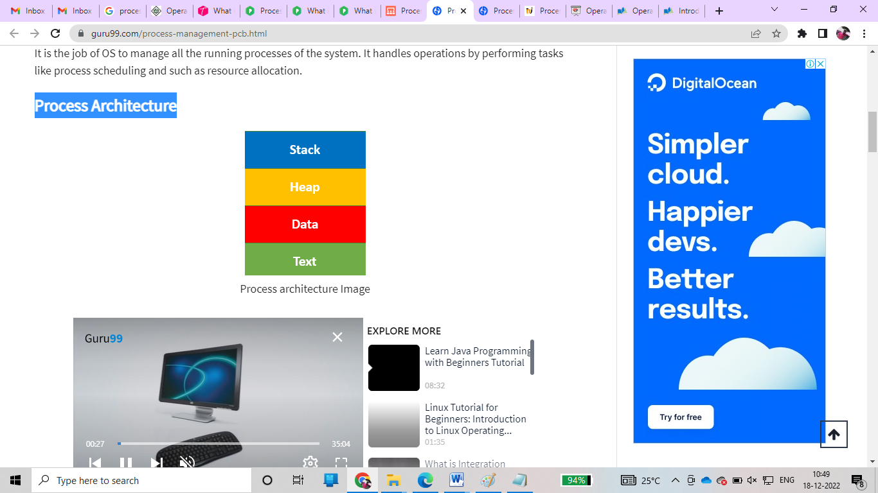
Here, is an Architecture diagram of the Process
- Stack: The Stack stores temporary data like function parameters, returns addresses, and local variables.
- Heap Allocates memory, which may be processed during its run time.
- Data: It contains the variable.
- Text:
Text Section includes the current activity, which is represented by the value of the Program Counter.

Process Control Blocks
- PCB stands for Process Control Block. It is a data structure that is maintained by the Operating System for every process.
- The PCB should be identified by an integer Process ID (PID).
- It helps you to store all the information required to keep track of all the running processes.
- It is also accountable for storing the contents of processor registers.
- These are saved when the process moves from the running state and then returns back to it.
- The information is quickly updated in the PCB by the OS as soon as the process makes the state transition.
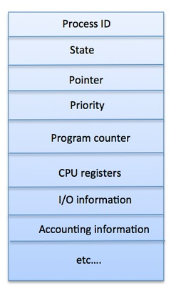
This basically is an unique integer ID for a particular process being carried out. The PCB keeps the track of this and other relevant information related to any process.
The following are kept track of by the PCB –
- Process ID or PID – Unique Integer Id for each process in any stage of execution.
- Process Stage – The state any process currently is in, like Ready, wait, exit etc
- Process Privileges – The special access to different resources to the memory or devices the process has.
- Pointer – Pointer location to the parent process.
- Program Counter – It will always have the address of the next instruction in line of the processes
- CPU Registers – Before the execution of the program the CPU registered where the process needs to be stored at.
- Scheduling Information – There are different scheduling algorithms for a process based on which they will be selected in priority. This section contains all the information about the scheduling.
- Memory Management Information – The operating system will use a lot of memory and it needs to know information like – page table, memory limits, Segment table to execute different programs MIM has all the information about this.
- Accounting Information – As the name suggest it will contain all the information about the time process took, Execution ID, Limits etc.
- I/O Status – The list of all the information of I/O the process can use.
Process States
- A process state is a condition of the process at a specific instant of time.
- It also defines the current position of the process.
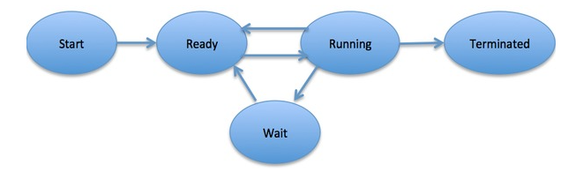
There are mainly seven stages of a process which are:
- New: The new process is created when a specific program calls from secondary memory/ hard disk to primary memory/ RAM a
- Ready: In a ready state, the process should be loaded into the primary memory, which is ready for execution.
- Waiting: The process is waiting for the allocation of CPU time and other resources for execution.
- Executing: The process is an execution state.
- Blocked: It is a time interval when a process is waiting for an event like I/O operations to complete.
- Suspended: Suspended state defines the time when a process is ready for execution but has not been placed in the ready queue by OS.
- Terminated: Terminated state specifies the time when a process is terminated
After completing every step, all the resources are used by a process, and memory becomes free.

Process Description
- The OS controls events with in the computer system.
- It schedules and dispatches processes for execution by the processor, allocates resources to processes, and responds to requests by user processes for basic services.
- Fundamentally, we can think of the OS as that entity manages the use of system resources by processes.
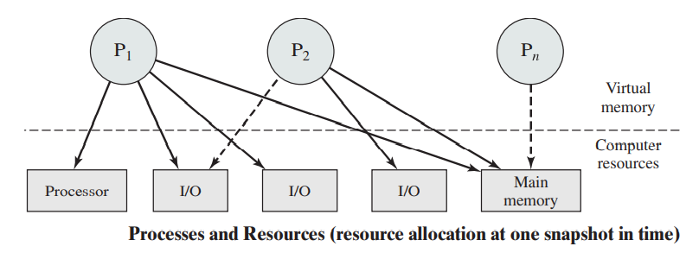
Memory tables:
- Memory table are used to keep track of both main(real) and secondary (virtual) memory.
- Some of main memory is reserved for use by the OS; the remainder is available for use by processes.
- Processes are maintained on secondary memory using some sort of virtual memory or simple swapping mechanism. The memory tables must include the following information:
- The allocation of main memory to processes
- The allocation of secondary memory to processes
- Any protection attributes of blocks of main or virtual memory, such as which processes may access certain shared memory regions.
- Any information needed to manage virtual memory.
I/O tables:
- I/O tables are used by the OS to manage the I/O devices and channels of the computer system.
- At any given time, an I/O device may be available or assigned to a particular process.
File Tables:
It provides information about the existence of files, their location on secondary memory, their current status, and other attributes.
Process tables:
The OS must maintain process tables to manage processes.
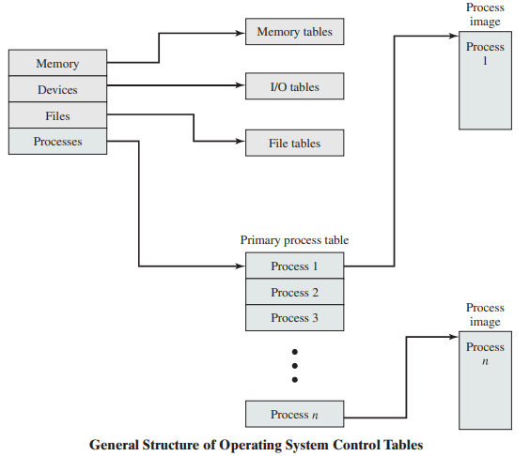

Process Control:
- The mode of processor execution normally associated with the OS and that normally associated with user programs.
- Most processors support at least two modes of execution.
- The less-privileged mode is often referred to as the user mode, because user programs typically would execute in this mode. The more privileged mode is referred to as the system mode, control mode or kernel mode.
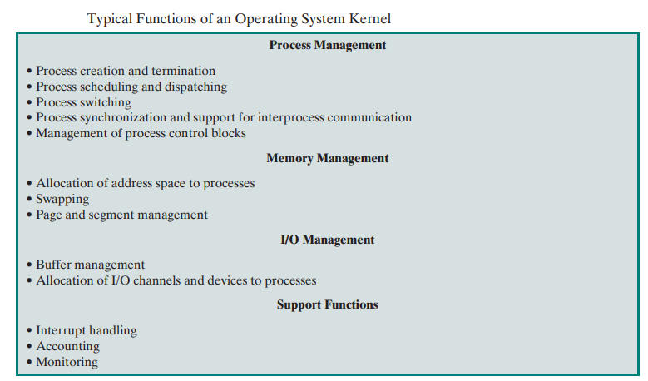

Process and Thread
A process is an instance of a program that is being executed. When we run a program, it does not execute directly. It takes some time to follow all the steps required to execute the program, and following these execution steps is known as a process.
A process can create other processes to perform multiple tasks at a time; the created processes are known as clone or child process, and the main process is known as the parent process. Each process contains its own memory space and does not share it with the other processes. It is known as the active entity. A typical process remains in the below form in memory.

How do Processes work?
When we start executing the program, the processor begins to process it. It takes the following steps:
- Firstly, the program is loaded into the computer's memory in binary code after translation.
- A program requires memory and other OS resources to run it. The resources such that registers, program counter, and a stack, and these resources are provided by the OS.
- A register can have an instruction, a storage address, or other data that is required by the process.
- The program counter maintains the track of the program sequence.
- The stack has information on the active subroutines of a computer program.
- A program may have different instances of it, and each instance of the running program is known as the individual process.

Features of Process
- Each time we create a process, we need to make a separate system call for each process to the OS. The fork() function creates the process.
- Each process exists within its own address or memory space.
- Each process is independent and treated as an isolated process by the OS.
- Processes need IPC (Inter-process Communication) in order to communicate with each other.
- A proper synchronization between processes is not required.

What is Thread?
A thread is the subset of a process and is also known as the lightweight process. A process can have more than one thread, and these threads are managed independently by the scheduler. All the threads within one process are interrelated to each other. Threads have some common information, such as data segment, code segment, files, etc., that is shared to their peer threads. But contains its own registers, stack, and counter.
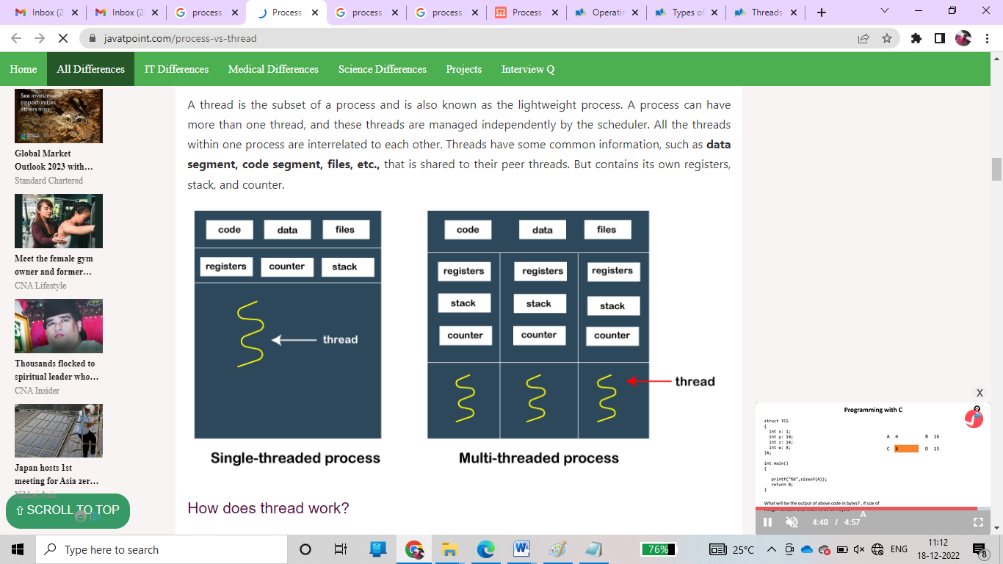

How does thread work?
As we have discussed that a thread is a subprocess or an execution unit within a process. A process can contain a single thread to multiple threads. A thread works as follows:
- When a process starts, OS assigns the memory and resources to it. Each thread within a process shares the memory and resources of that process only.
- Threads are mainly used to improve the processing of an application. In reality, only a single thread is executed at a time, but due to fast context switching between threads gives an illusion that threads are running parallelly.
- If a single thread executes in a process, it is known as a single-threaded And if multiple threads execute simultaneously, then it is known as multithreading.

Types of Threads
There are two types of threads, which are:
1. User Level Thread
- As the name suggests, the user-level threads are only managed by users, and the kernel does not have its information.
- These are faster, easy to create and manage.
- The kernel takes all these threads as a single process and handles them as one process only.
- The user-level threads are implemented by user-level libraries, not by the system calls.
2. Kernel-Level Thread
- The kernel-level threads are handled by the Operating system and managed by its kernel.
- These threads are slower than user-level threads because context information is managed by the kernel.
- To create and implement a kernel-level thread, we need to make a system call.

Features of Thread
- Threads share data, memory, resources, files, etc., with their peer threads within a process.
- One system call is capable of creating more than one thread.
- Each thread has its own stack and register.
- Threads can directly communicate with each other as they share the same address space.
- Threads need to be synchronized in order to avoid unexpected scenarios.

Key Differences Between Process and Thread
- A process is independent and does not contained within another process, whereas all threads are logically contained within a process.
- Processes are heavily weighted, whereas threads are light-weighted.
- A process can exist individually as it contains its own memory and other resources, whereas a thread cannot have its individual existence.
- A proper synchronization between processes is not required. In contrast, threads need to be synchronized in order to avoid unexpected scenarios.
- Processes can communicate with each other using inter-process communication only; in contrast, threads can directly communicate with each other as they share the same address space.
Process | Thread
A process is an instance of a program that is being executed or processed. | Thread is a segment of a process or a lightweight process that is managed by the scheduler independently.
Processes are independent of each other and hence don't share a memory or other resources. | Threads are interdependent and share memory.
Each process is treated as a new process by the operating system. | The operating system takes all the user-level threads as a single process.
If one process gets blocked by the operating system, then the other process can continue the execution. | If any user-level thread gets blocked, all of its peer threads also get blocked because OS takes all of them as a single process.
Context switching between two processes takes much time as they are heavy compared to thread. | Context switching between the threads is fast because they are very lightweight.
The data segment and code segment of each process are independent of the other. | Threads share data segment and code segment with their peer threads; hence are the same for other threads also.
The operating system takes more time to terminate a process. | Threads can be terminated in very little time.
New process creation is more time taking as each new process takes all the resources. | A thread needs less time for creation.
Differences Between Process and Thread

