**Assignment 2: Introduction to Git & GitHub**

**Course:** BIA 4650 — Data Management & Security in the Cloud **Points:** 20 — **Due Date: September 22nd, 2025**

# Part 1: Create a Local Repository (2 points)

# Part 2: Add Assignment Files (2 points)

# Part 3: Stage and Commit (3 points)

# Part 4: Create a GitHub Repository and Connect Remote (3 points)

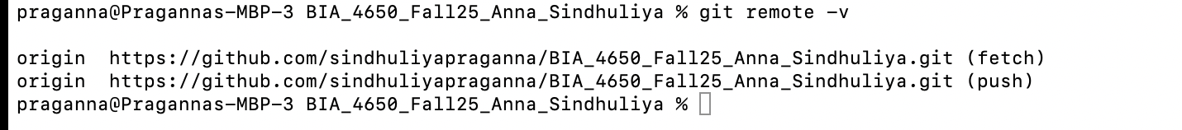

# Part 5: Clear Cache Memory (1 point)

# 

# Part 6: Generate Personal Access Token (3 points)

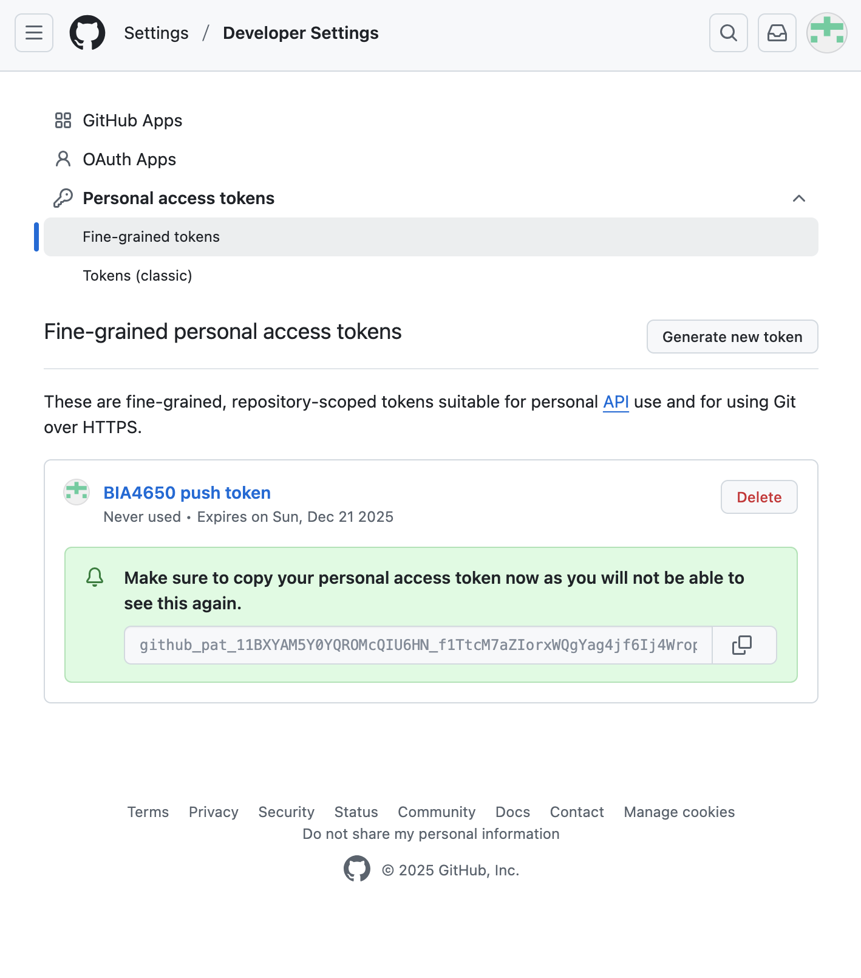

# Part 7: Authenticate and Push (4 points)

# Part 8: Verify on GitHub (2 points)

