Assignment -4

Python Programming

|  |  |
| --- | --- |
| Assignment Date |  |
| Student Name | Suriyakala v |
| Student Roll Number | 212019106020 |
| Maximum Marks | 2 Marks |

Question-1:

Write code and connections in wokwi for ultrasonic sensor.

Whenever distance is less than 100 cms send "alert" to ibm cloud and display in device recent

events.

Upload document with wokwi share link and images of ibm cloud.

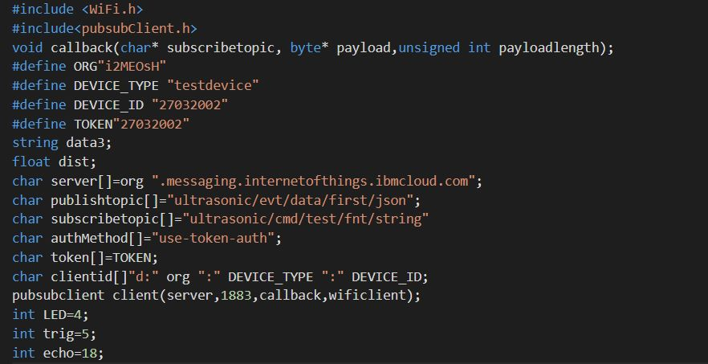

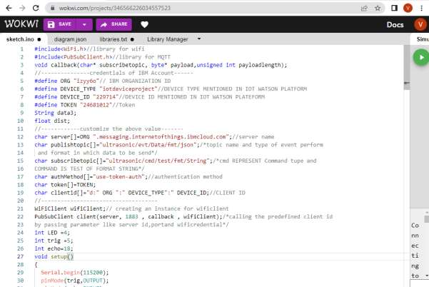

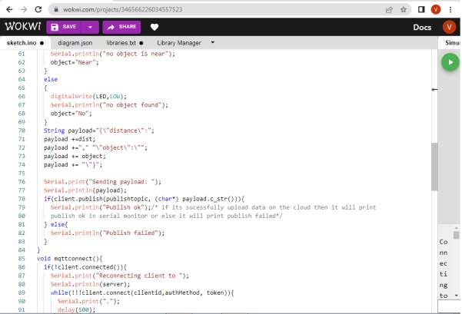

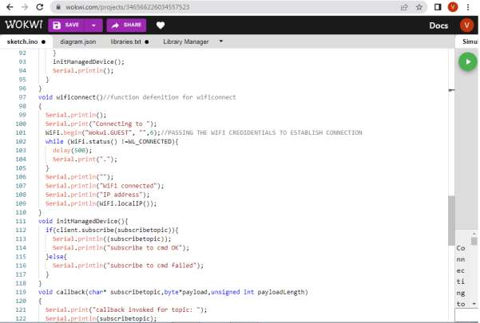

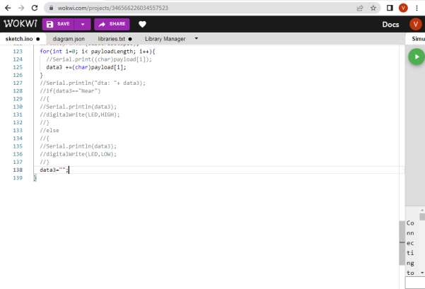

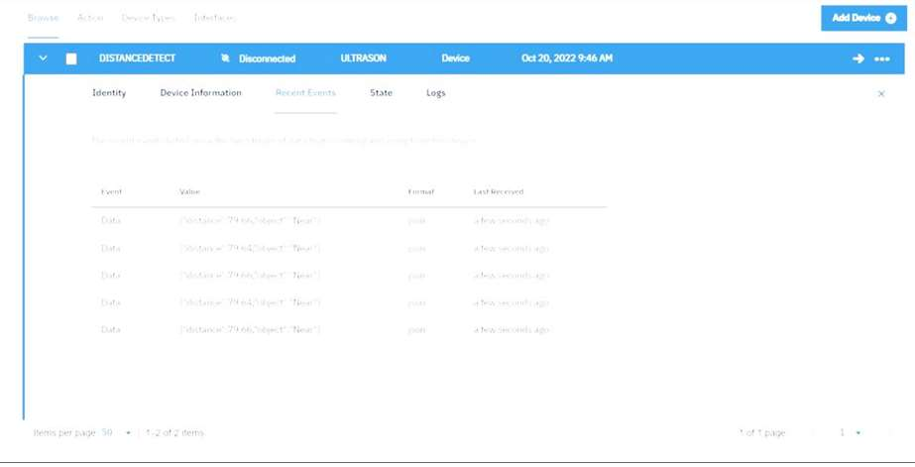



When object is detected in ultrasonic detector

