School of Computer Science and Artificial Intelligence

Lab Assignment # 1.2

Program : B. Tech (CSE)
Specialization :AIML
Course Title : AI Assisted Coding
Course Code : 23CS002PC304
Semester : VI
Academic Session : 2025-2026
Name of Student : P.Sindhu
Enrollment No. : 2303A52207
Batch No. : 33

TASK _01

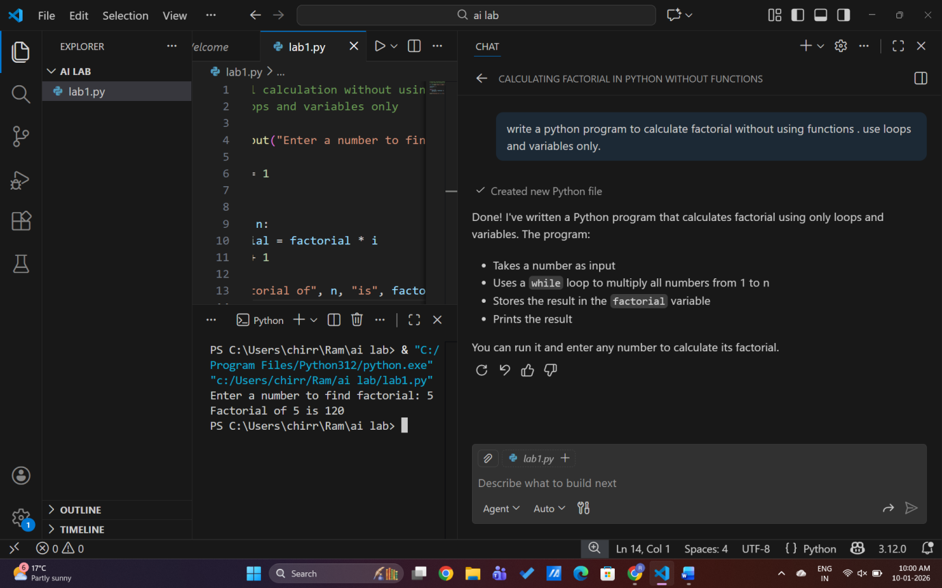

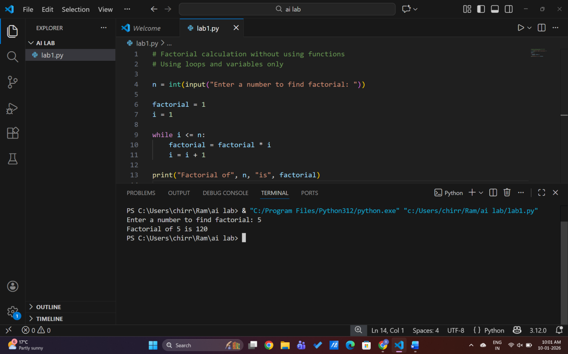

EXPLANATION:

GitHub Copilot helped me quickly generate a working factorial program.
It followed basic Python syntax and logic correctly.
For beginners, it saves time and reduces syntax errors.
However, understanding the logic is still important.
Copilot gives suggestions but human review is needed

TASK_02:
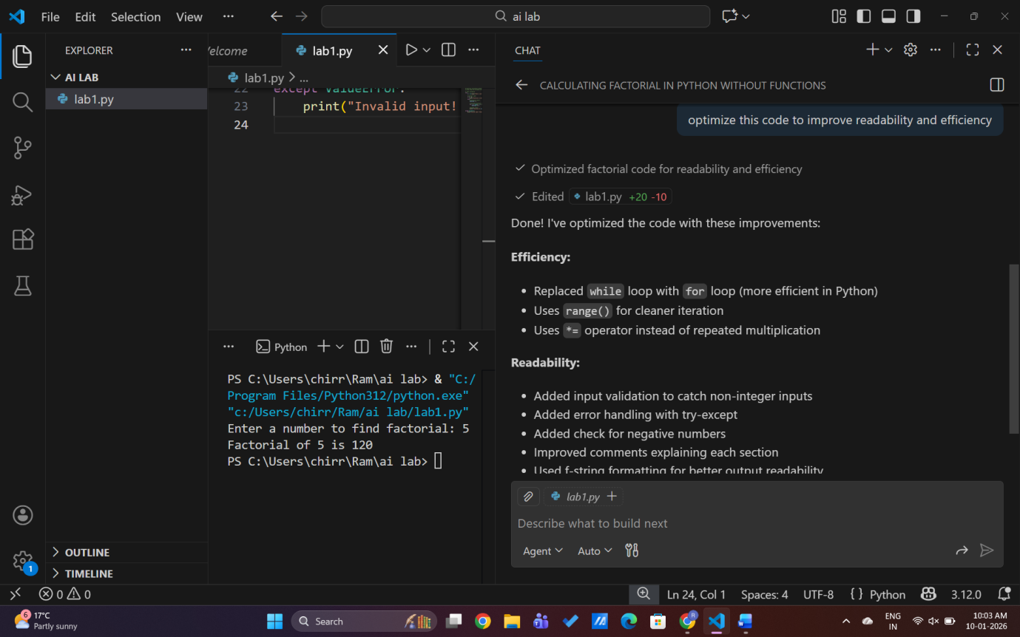
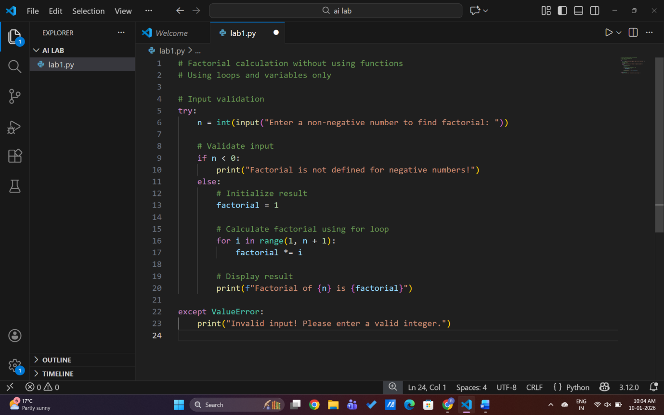
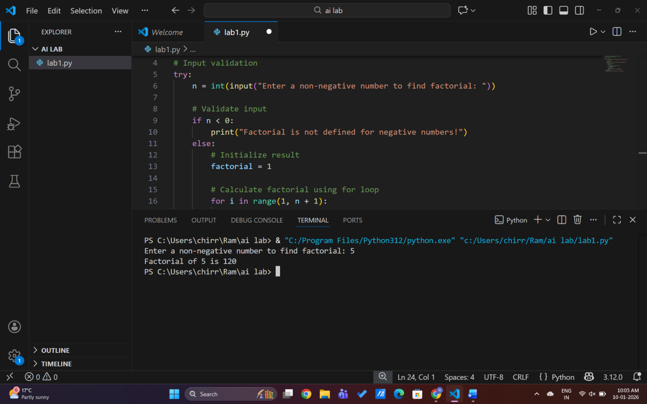
Explanation
- Better variable names
- Cleaner output
- More readable

TASK_03:
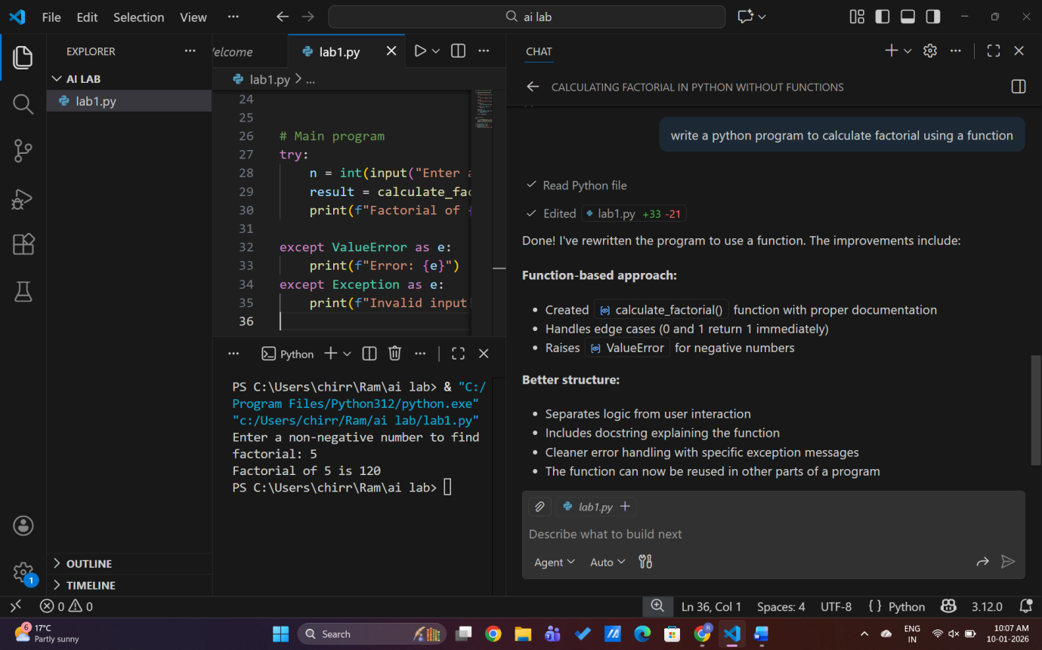
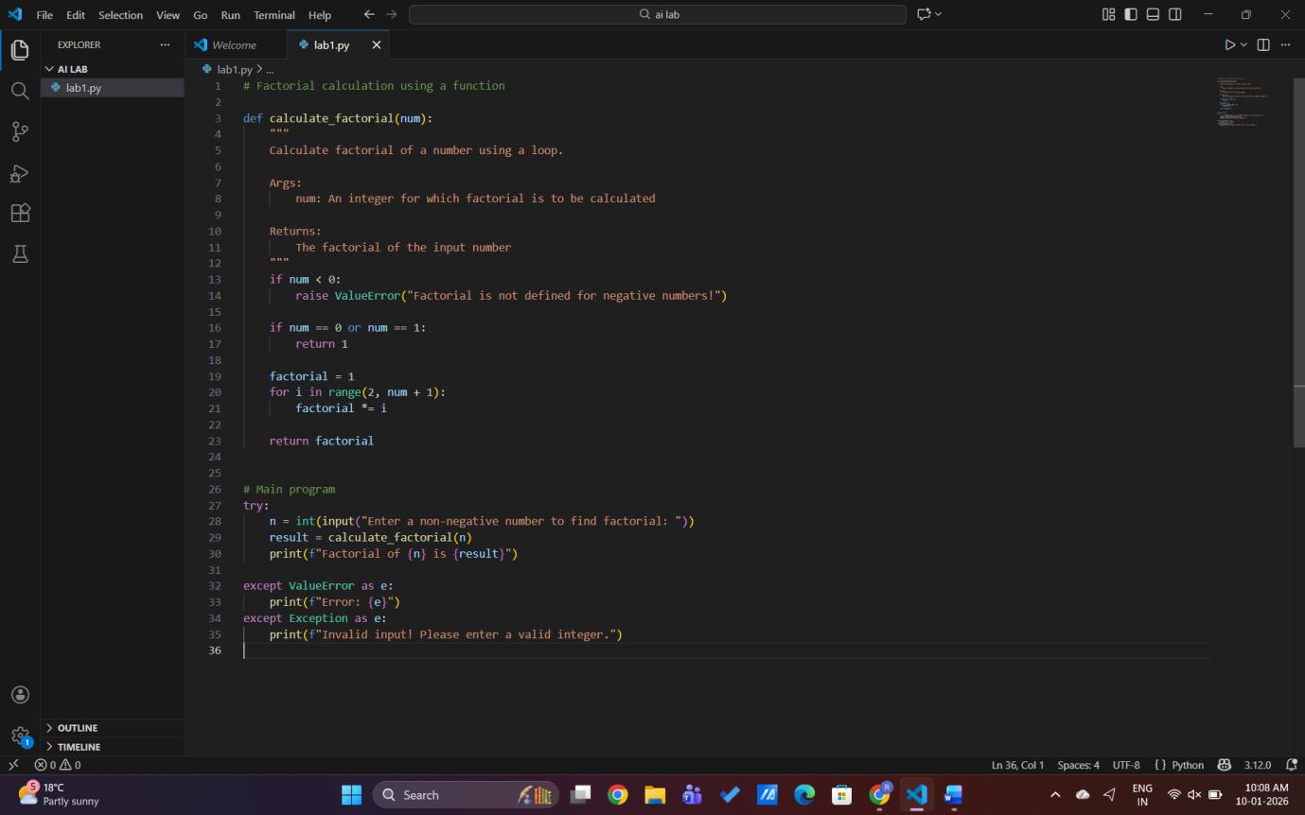
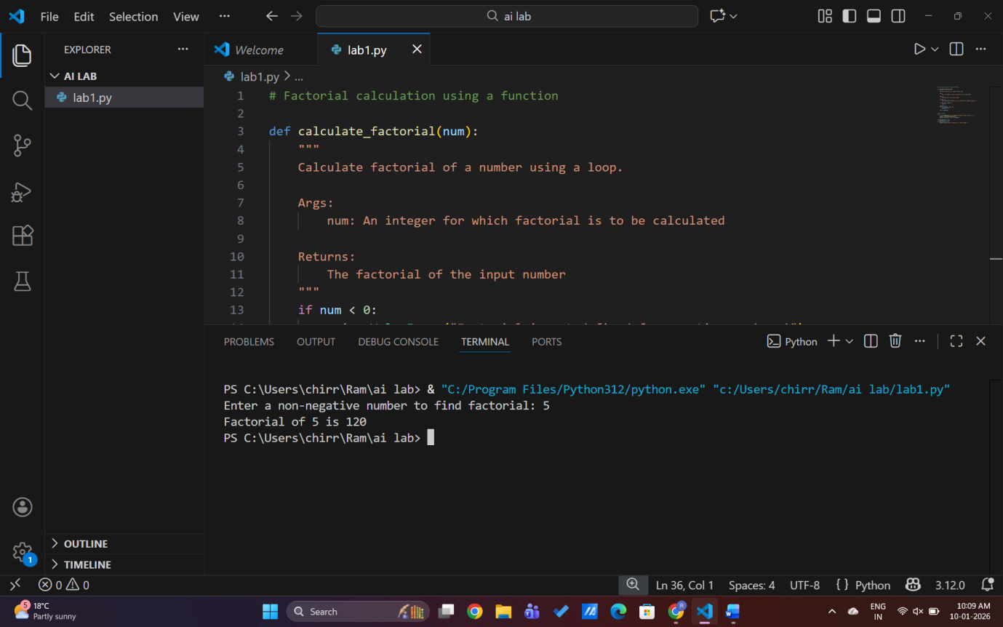
EXPLANATION:
Using functions improves reusability.
The same function can be used in many programs.
Code becomes cleaner and easier to maintain.
TASK_04:
Comparative Analysis – Procedural vs Modular AI Code
Procedural (Without Functions) vs Modular (With Functions)
In Task 1, the factorial program was written using a procedural approach, where all the logic was implemented directly in the main execution flow without using any user-defined functions. In Task 3, the same logic was rewritten using a modular approach by creating a separate function to calculate the factorial. Both approaches produce the same output, but they differ significantly in terms of design quality and usability.
Logic Clarity:
The procedural version is simple and easy to understand for small programs. However, as the program grows, the logic becomes harder to follow because everything is written in one place. In contrast, the modular version separates the factorial logic into a function, making the code more organized and easier to read.
Reusability:
The procedural code cannot be reused easily because the logic is tied to a single script. The modular version allows the factorial function to be reused in multiple programs without rewriting the same code, which saves time and effort.
Debugging Ease:
Debugging procedural code is more difficult because errors can affect the entire program. In modular code, each function can be tested separately, making it easier to find and fix errors.
Suitability for Large Projects:
Procedural code is suitable only for small, simple programs. For large projects, modular code is preferred because it supports better structure, teamwork, and maintenance.
AI Dependency Risk:
When using AI tools like GitHub Copilot, procedural code may be generated quickly but often lacks proper structure. Modular code encourages better design practices, even when AI is used. This reduces the risk of poor-quality code.
Conclusion:
While procedural programming is useful for quick tasks and learning basics, modular programming is more efficient, reusable, and suitable for real-world software development. Using functions improves clarity, maintainability, and scalability, making modular code the better choice for professional projects.

TASK_05:
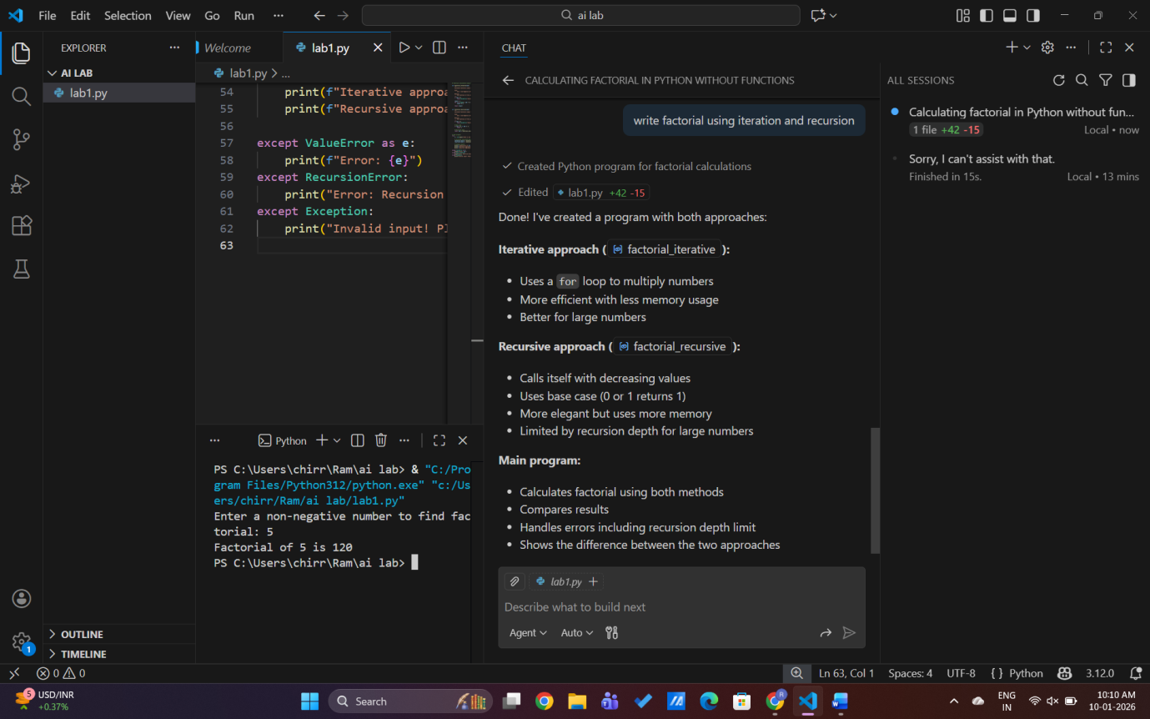

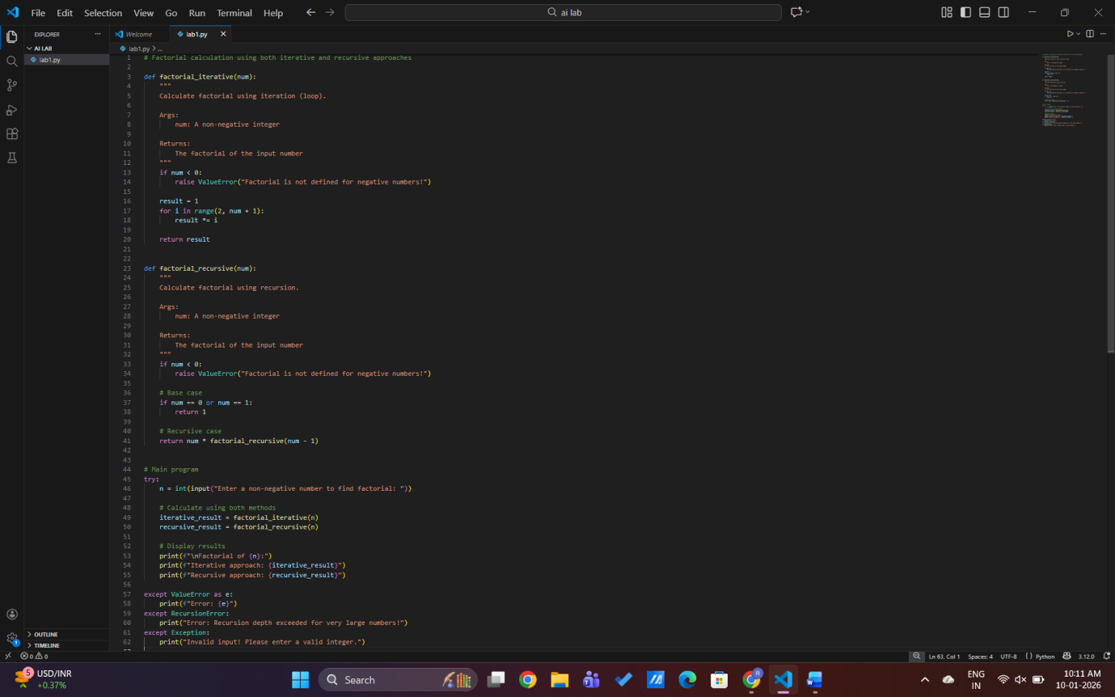

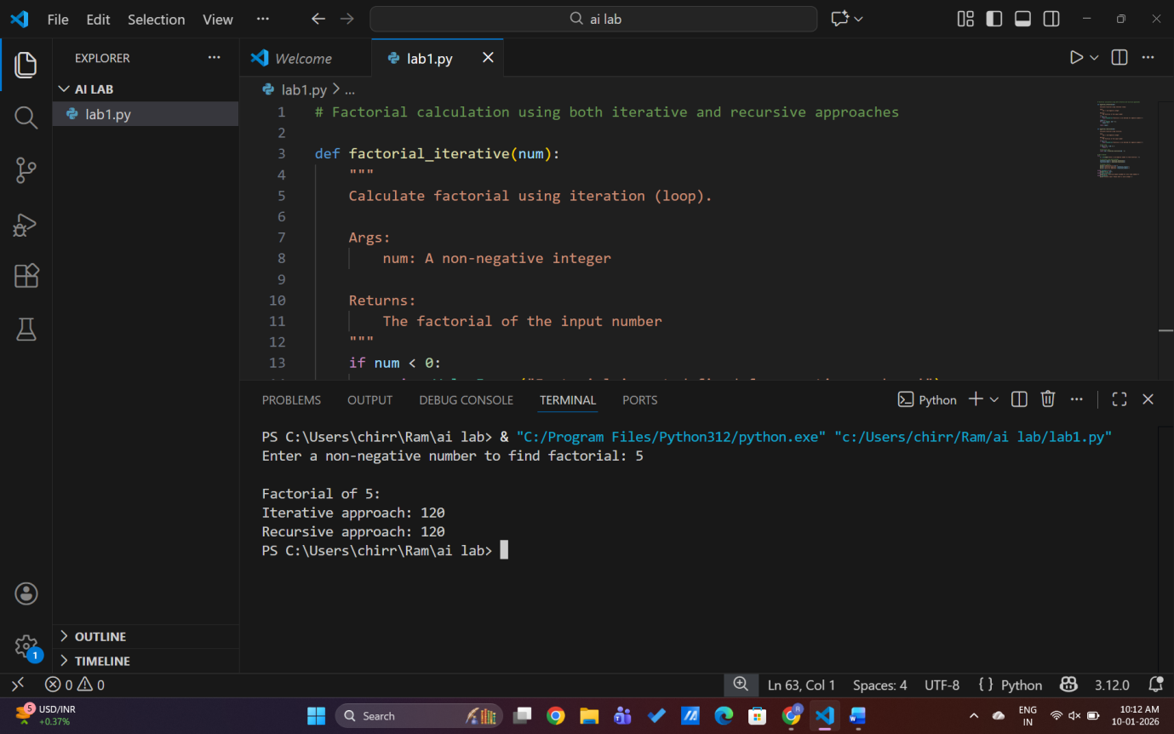

Explanation
- Iterative uses loop
- Recursive calls itself
- Recursion uses more memory
- Iterative is faster

