Customer Churn Prediction and Customer Segmentation
Using Python

DATA SCIENCE INTERNSHIP
WEEK 4 REPORT
SUPERVISED LEARNING MODEL IMPLEMENTATION

Student Name: | Sindhu Patil
Internship Track: | Data Science Internship
Week Number: | Week 4
Project Title: | Customer Churn Prediction and Customer Segmentation
Dataset Used: | IBM Telco Customer Churn Dataset

Table of Contents
• 1. Introduction
• 2. Problem Statement
• 3. Objective
• 4. Dataset Overview
• 5. Target Variable
• 6. Feature Selection
• 7. Feature Engineering
• 8. Data Preprocessing
• 9. Train-Test Split
• 10. Model Selection
• 11. Logistic Regression
• 12. Model Training
• 13. Cross-Validation
• 14. Evaluation Metrics
• 15. Confusion Matrix
• 16. ROC Curve and AUC
• 17. Precision-Recall Analysis
• 18. Classification Threshold Analysis
• 19. Feature Interpretation
• 20. Optional Model Comparison
• 21. Final Model Selection
• 22. Business Interpretation
• 23. Strengths
• 24. Limitations
• 25. Possible Improvements
• 26. Conclusion
• 27. References
• 28. Appendix

1. Introduction
Following exploratory data analysis (Week 2) and unsupervised customer segmentation (Week 3), Week 4 implements supervised machine learning classification models to predict customer churn.

2. Problem Statement
Customer churn represents a critical revenue challenge in telecommunications. Predicting churn risk prior to cancellation allows business teams to initiate proactive retention workflows.

3. Objective
Build a robust binary classification pipeline using Logistic Regression on `data/processed/cleaned_telco_churn.csv`, evaluate cross-validation performance, analyze test set metrics, and interpret predictive feature coefficients.

4. Dataset Overview
The dataset contains 7,043 customer records and 21 features. `customerID` was excluded as a non-predictive identifier.

5. Target Variable
Target `Churn` is mapped to binary indicators: 1 = Churned (1,869 customers / 26.54%), 0 = Retained (5,174 customers / 73.46%).

6. Feature Selection
Selected 18 predictor variables across continuous numerical attributes (`tenure`, `MonthlyCharges`, `TotalCharges`) and 15 categorical attributes (`Contract`, `InternetService`, `PaymentMethod`, etc.).

7. Feature Engineering
Categorical variables were One-Hot Encoded into binary dummy columns, while continuous numerical attributes were standardized.

8. Data Preprocessing
Scikit-learn `ColumnTransformer` combined `StandardScaler` and `OneHotEncoder(handle_unknown='ignore')` inside a single unified `Pipeline` to prevent data leakage.

9. Train-Test Split
Applied an 80/20 stratified split (`test_size=0.2, random_state=42, stratify=y`), producing 5,634 training records and 1,409 testing records.

10. Model Selection
Logistic Regression was chosen as the primary baseline classifier due to its interpretability, probability output generation, and computational efficiency.

11. Logistic Regression
Logistic Regression models log-odds of churn as a linear combination of input predictors using the sigmoid activation function.

12. Model Training
The pipeline was fitted strictly on the 5,634 training samples (`X_train`, `y_train`).

13. Cross-Validation
Table 1 displays 5-fold stratified cross-validation metrics across training folds:
Metric | Mean CV Score | Standard Deviation
Accuracy | 0.8056 | ± 0.0109
Precision | 0.6590 | ± 0.0216
Recall | 0.5532 | ± 0.0317
F1-Score | 0.6013 | ± 0.0273
ROC-AUC | 0.8449 | ± 0.0134

14. Evaluation Metrics
Test set performance (1,409 samples): Accuracy = 0.8055, Precision = 0.6572, Recall = 0.5588, F1-Score = 0.6040, ROC-AUC = 0.8419.

15. Confusion Matrix
Test set confusion matrix breakdown:
• True Negatives (TN): 926 (Retained customers correctly predicted as Retained)
• False Positives (FP): 109 (Retained customers incorrectly predicted as Churn)
• False Negatives (FN): 165 (Churned customers incorrectly predicted as Retained)
• True Positives (TP): 209 (Churned customers correctly predicted as Churn)
Figure 15.1: Logistic Regression Confusion Matrix
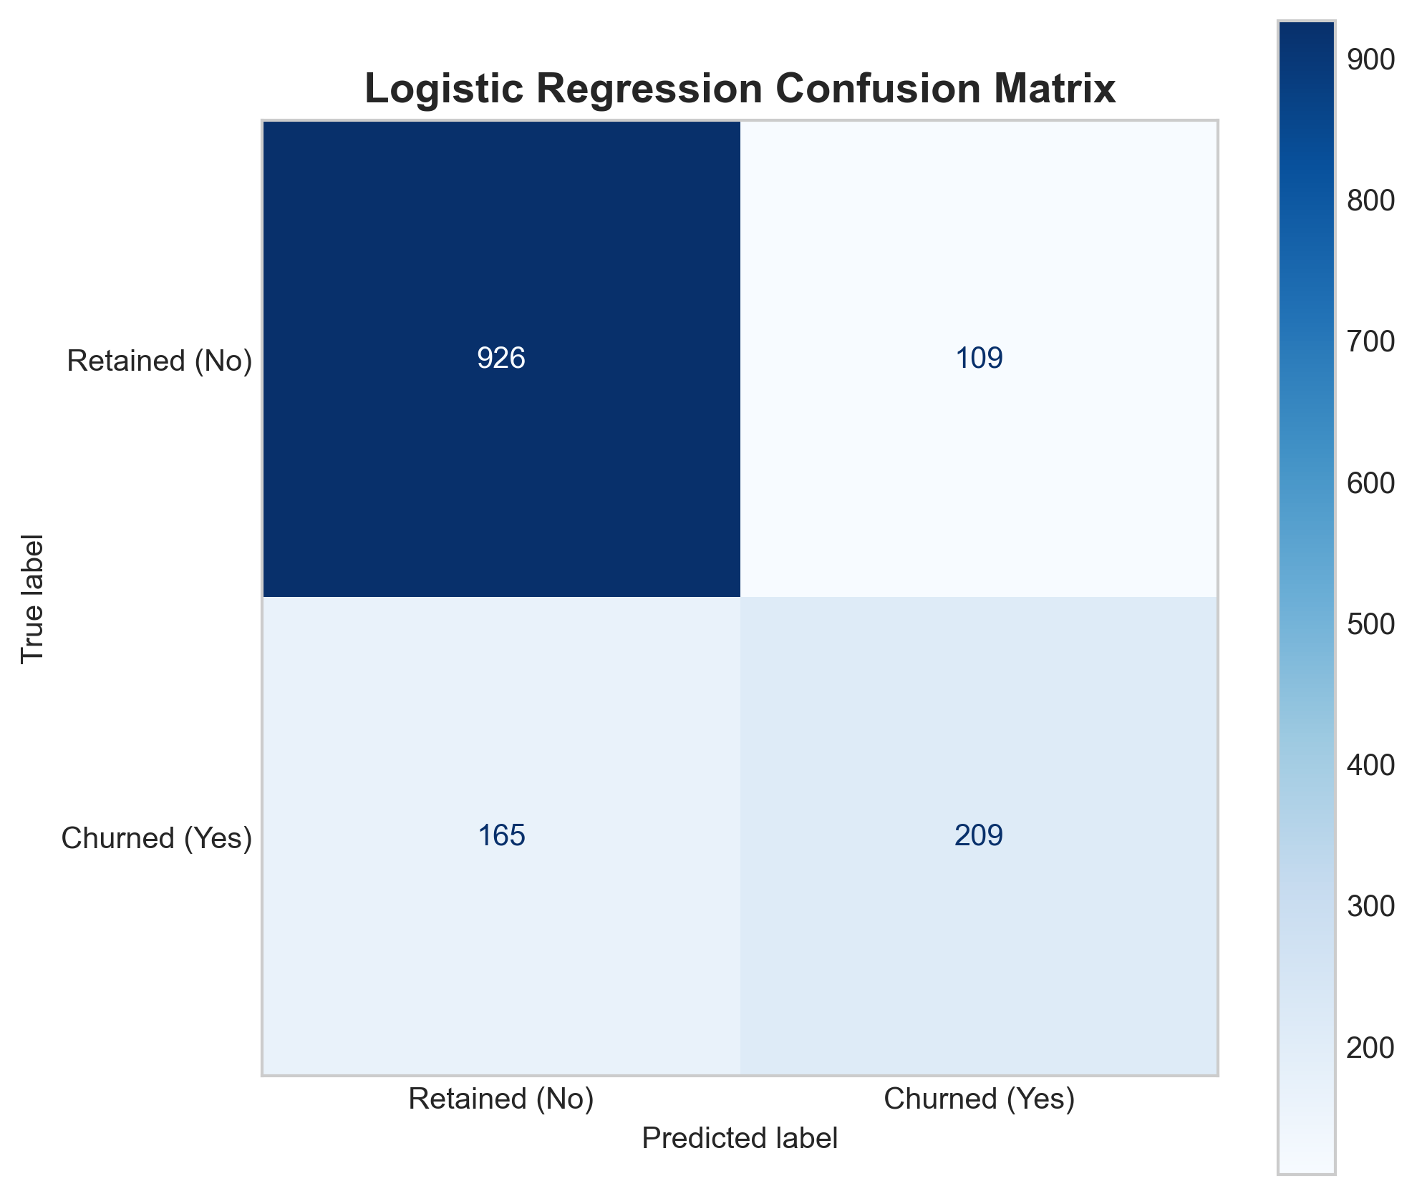

16. ROC Curve and AUC
The ROC-AUC score of 0.8419 demonstrates strong class separation capability.
Figure 16.1: Receiver Operating Characteristic (ROC) Curve
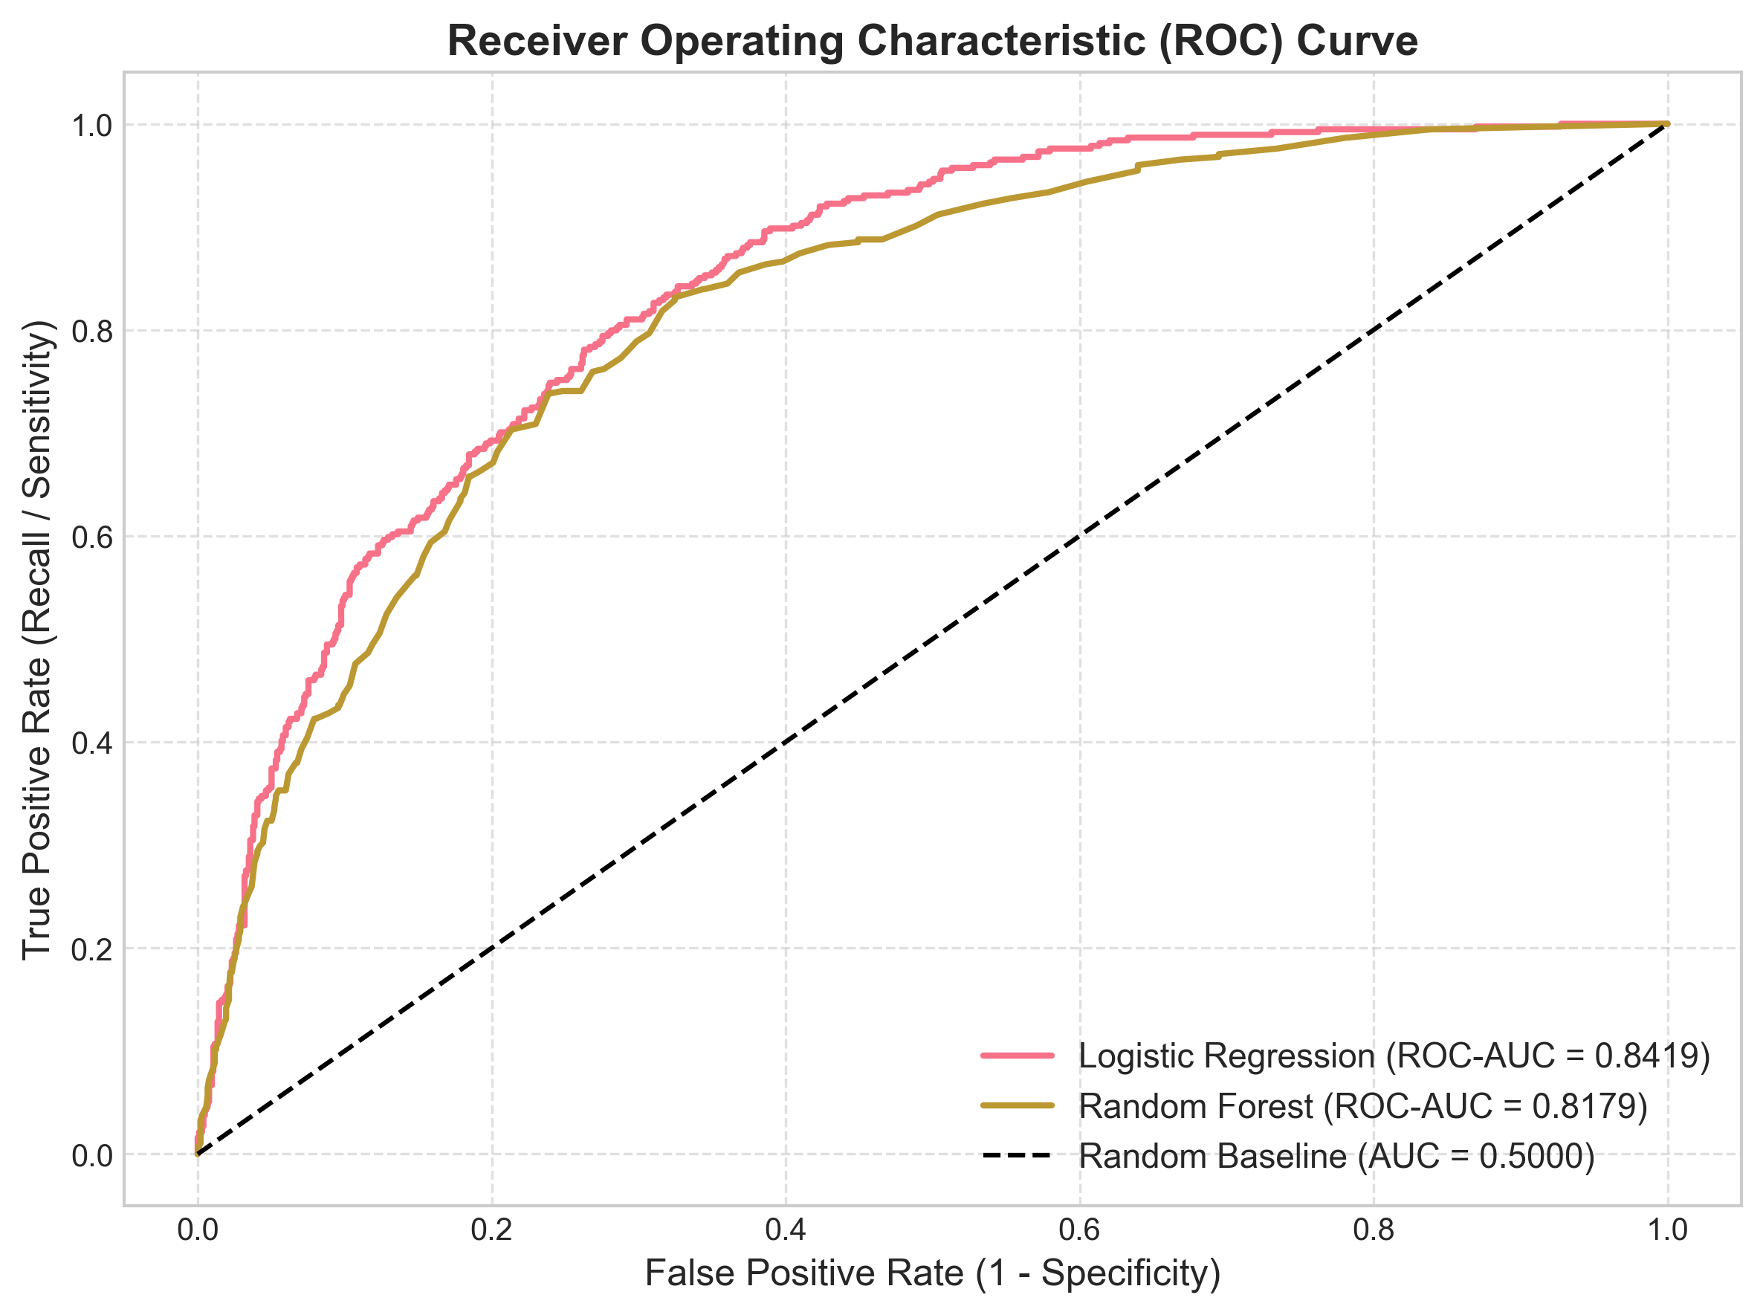

17. Precision-Recall Analysis
Average Precision score = 0.6338, outperforming the 0.2654 baseline.
Figure 17.1: Precision-Recall Curve
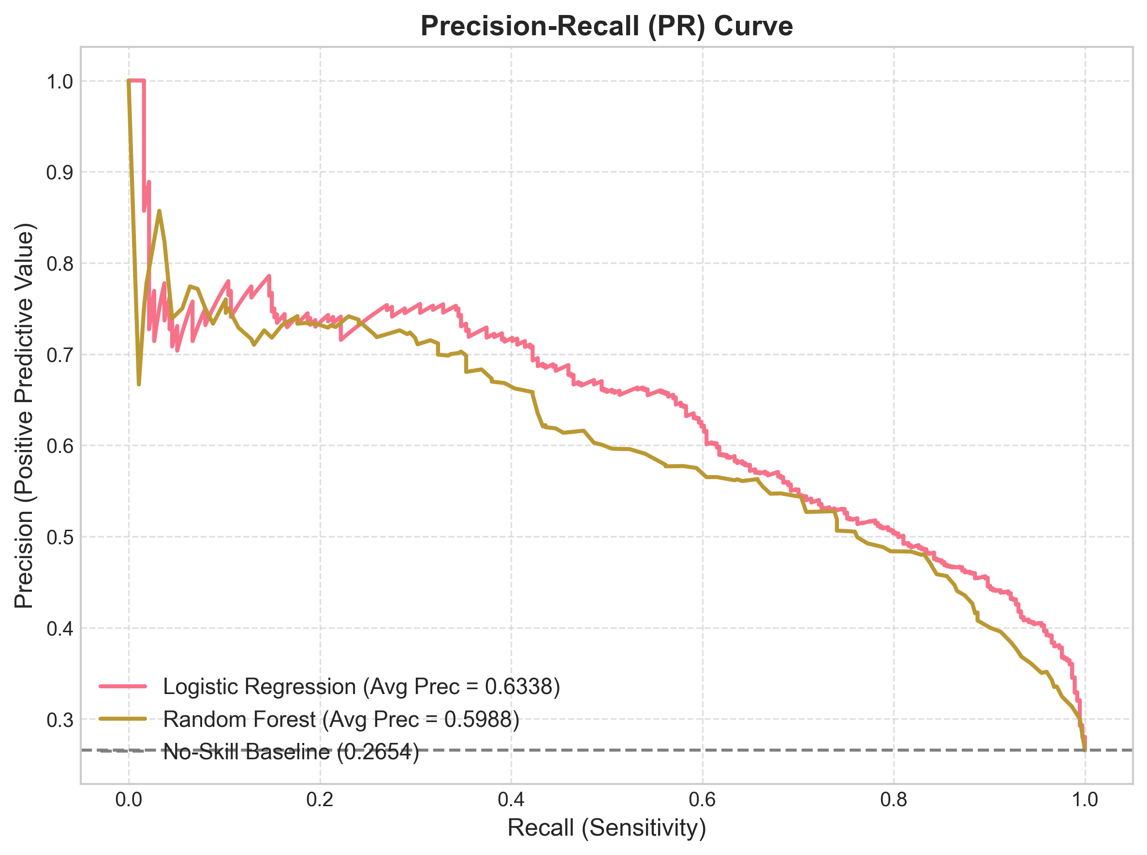

18. Classification Threshold Analysis
Lowering the classification threshold from 0.5 to 0.35 increases Recall (catching more churners) at the cost of lower Precision.
Figure 18.1: Precision-Recall-F1 Threshold Trade-off Plot
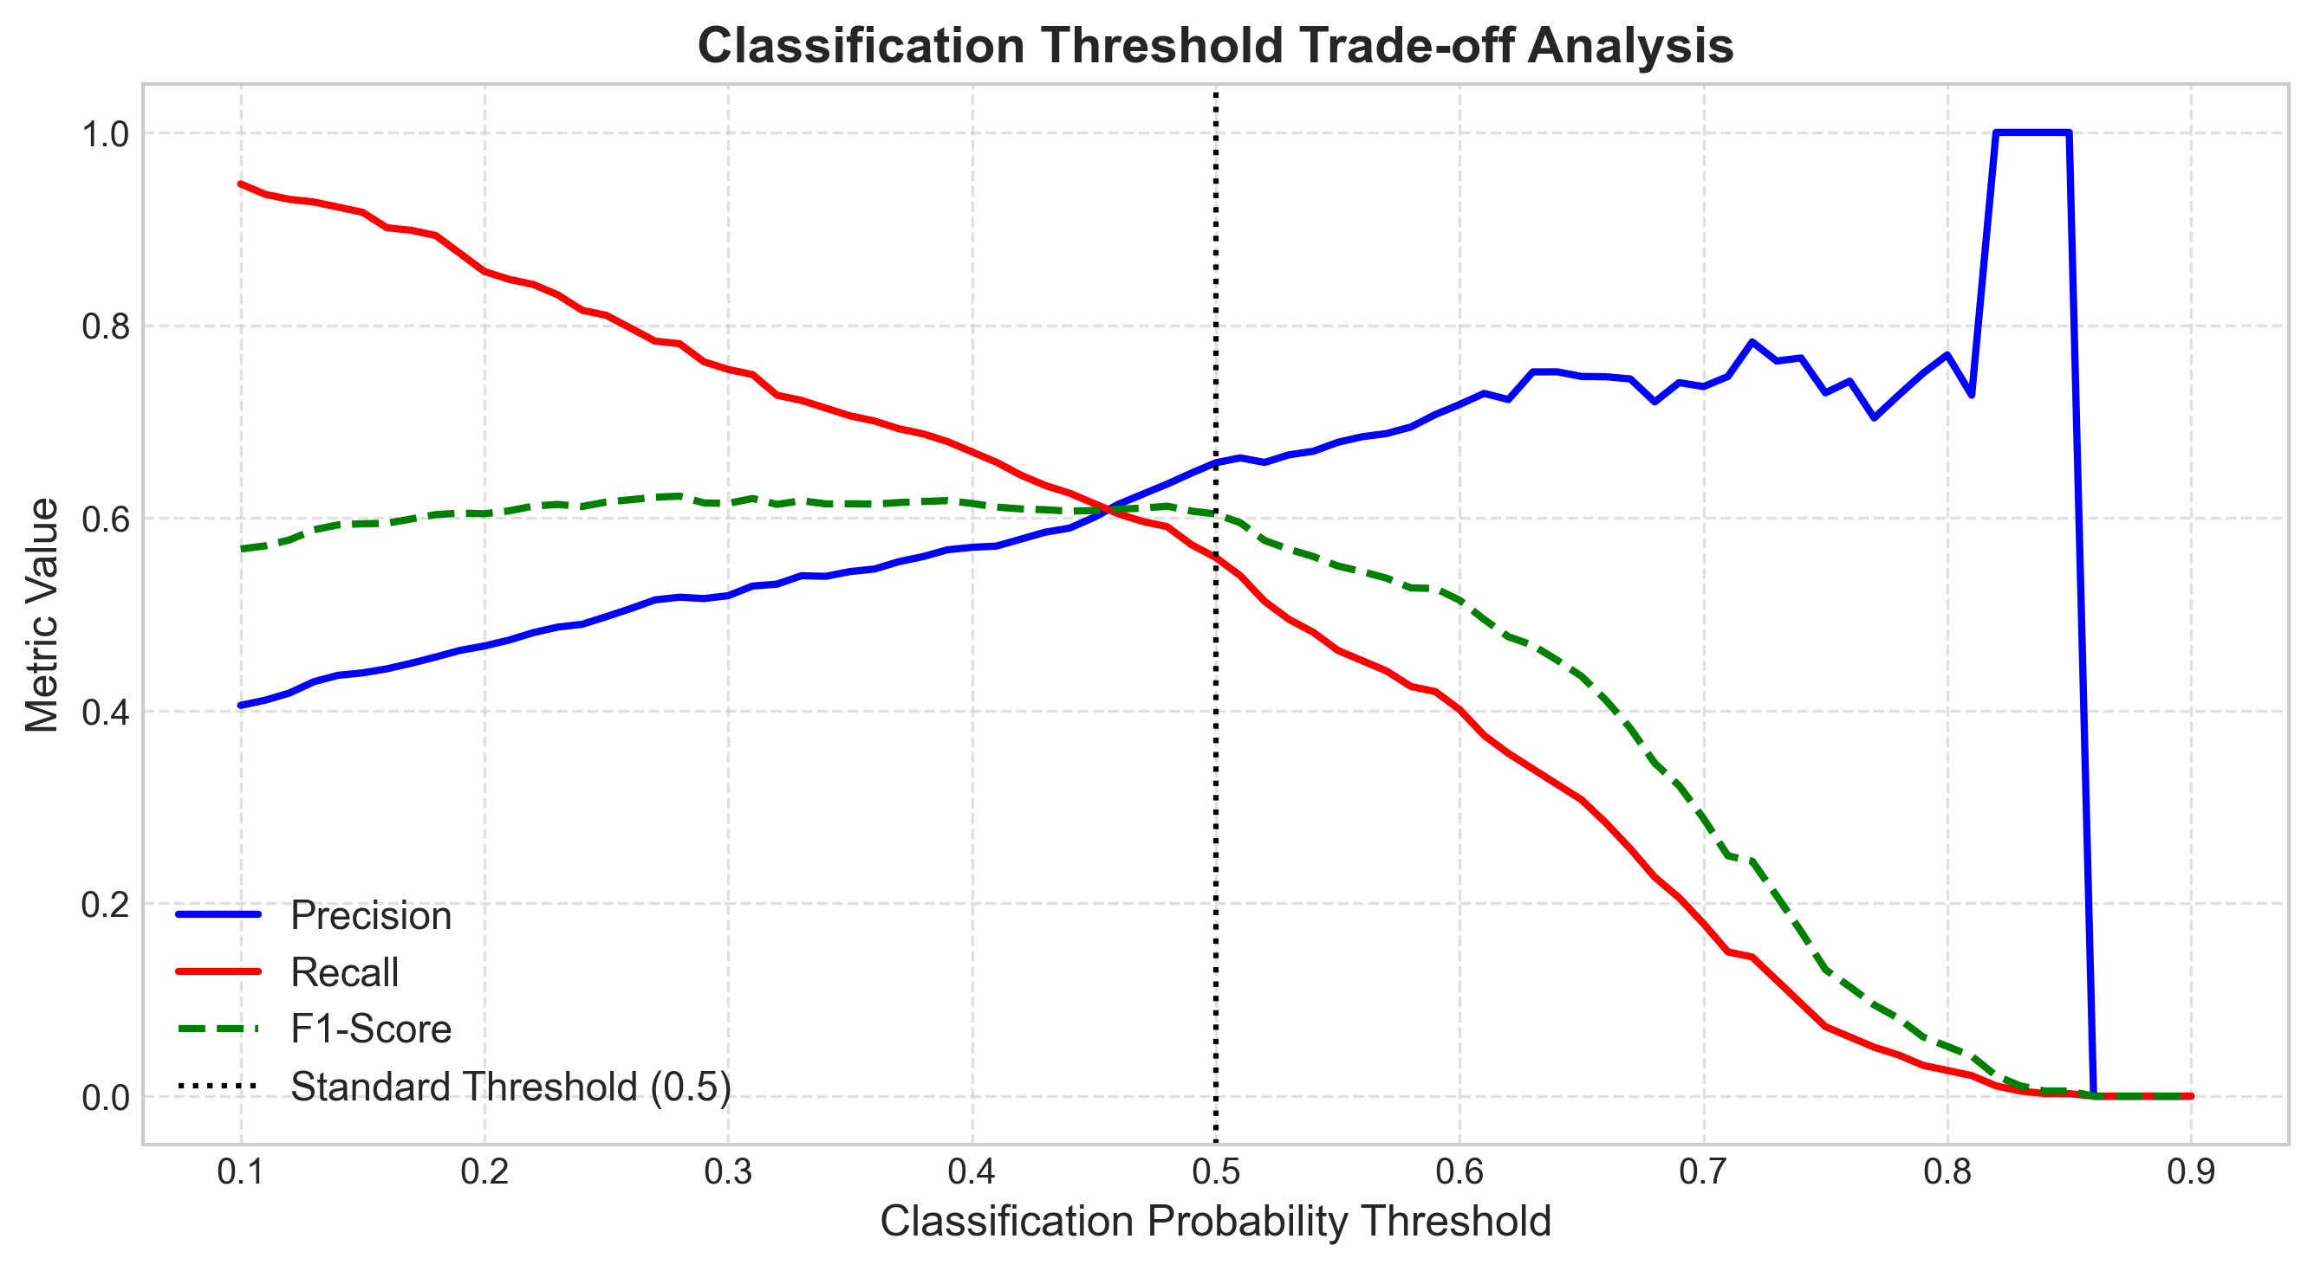

19. Feature Interpretation
Top negative coefficients (protective against churn): tenure (-1.2339), Two-year contract (-0.7627), DSL service (-0.6402). Top positive coefficients (churn risk factors): Fiber optic service (+0.6431), Month-to-month contract (+0.5873), TotalCharges (+0.5103).
Figure 19.1: Top Logistic Regression Feature Coefficients
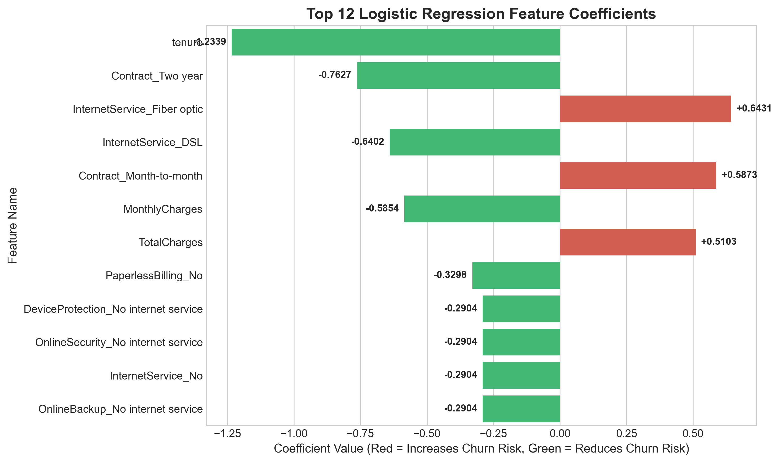

20. Optional Model Comparison
Table 2 compares Logistic Regression against Random Forest Classifier on the test set:
Model Name | Accuracy | Precision | Recall | F1-Score | ROC-AUC
Logistic Regression | 0.8055 | 0.6572 | 0.5588 | 0.6040 | 0.8419
Random Forest | 0.7821 | 0.6159 | 0.4759 | 0.5370 | 0.8179
Figure 20.1: Model Comparison Bar Chart
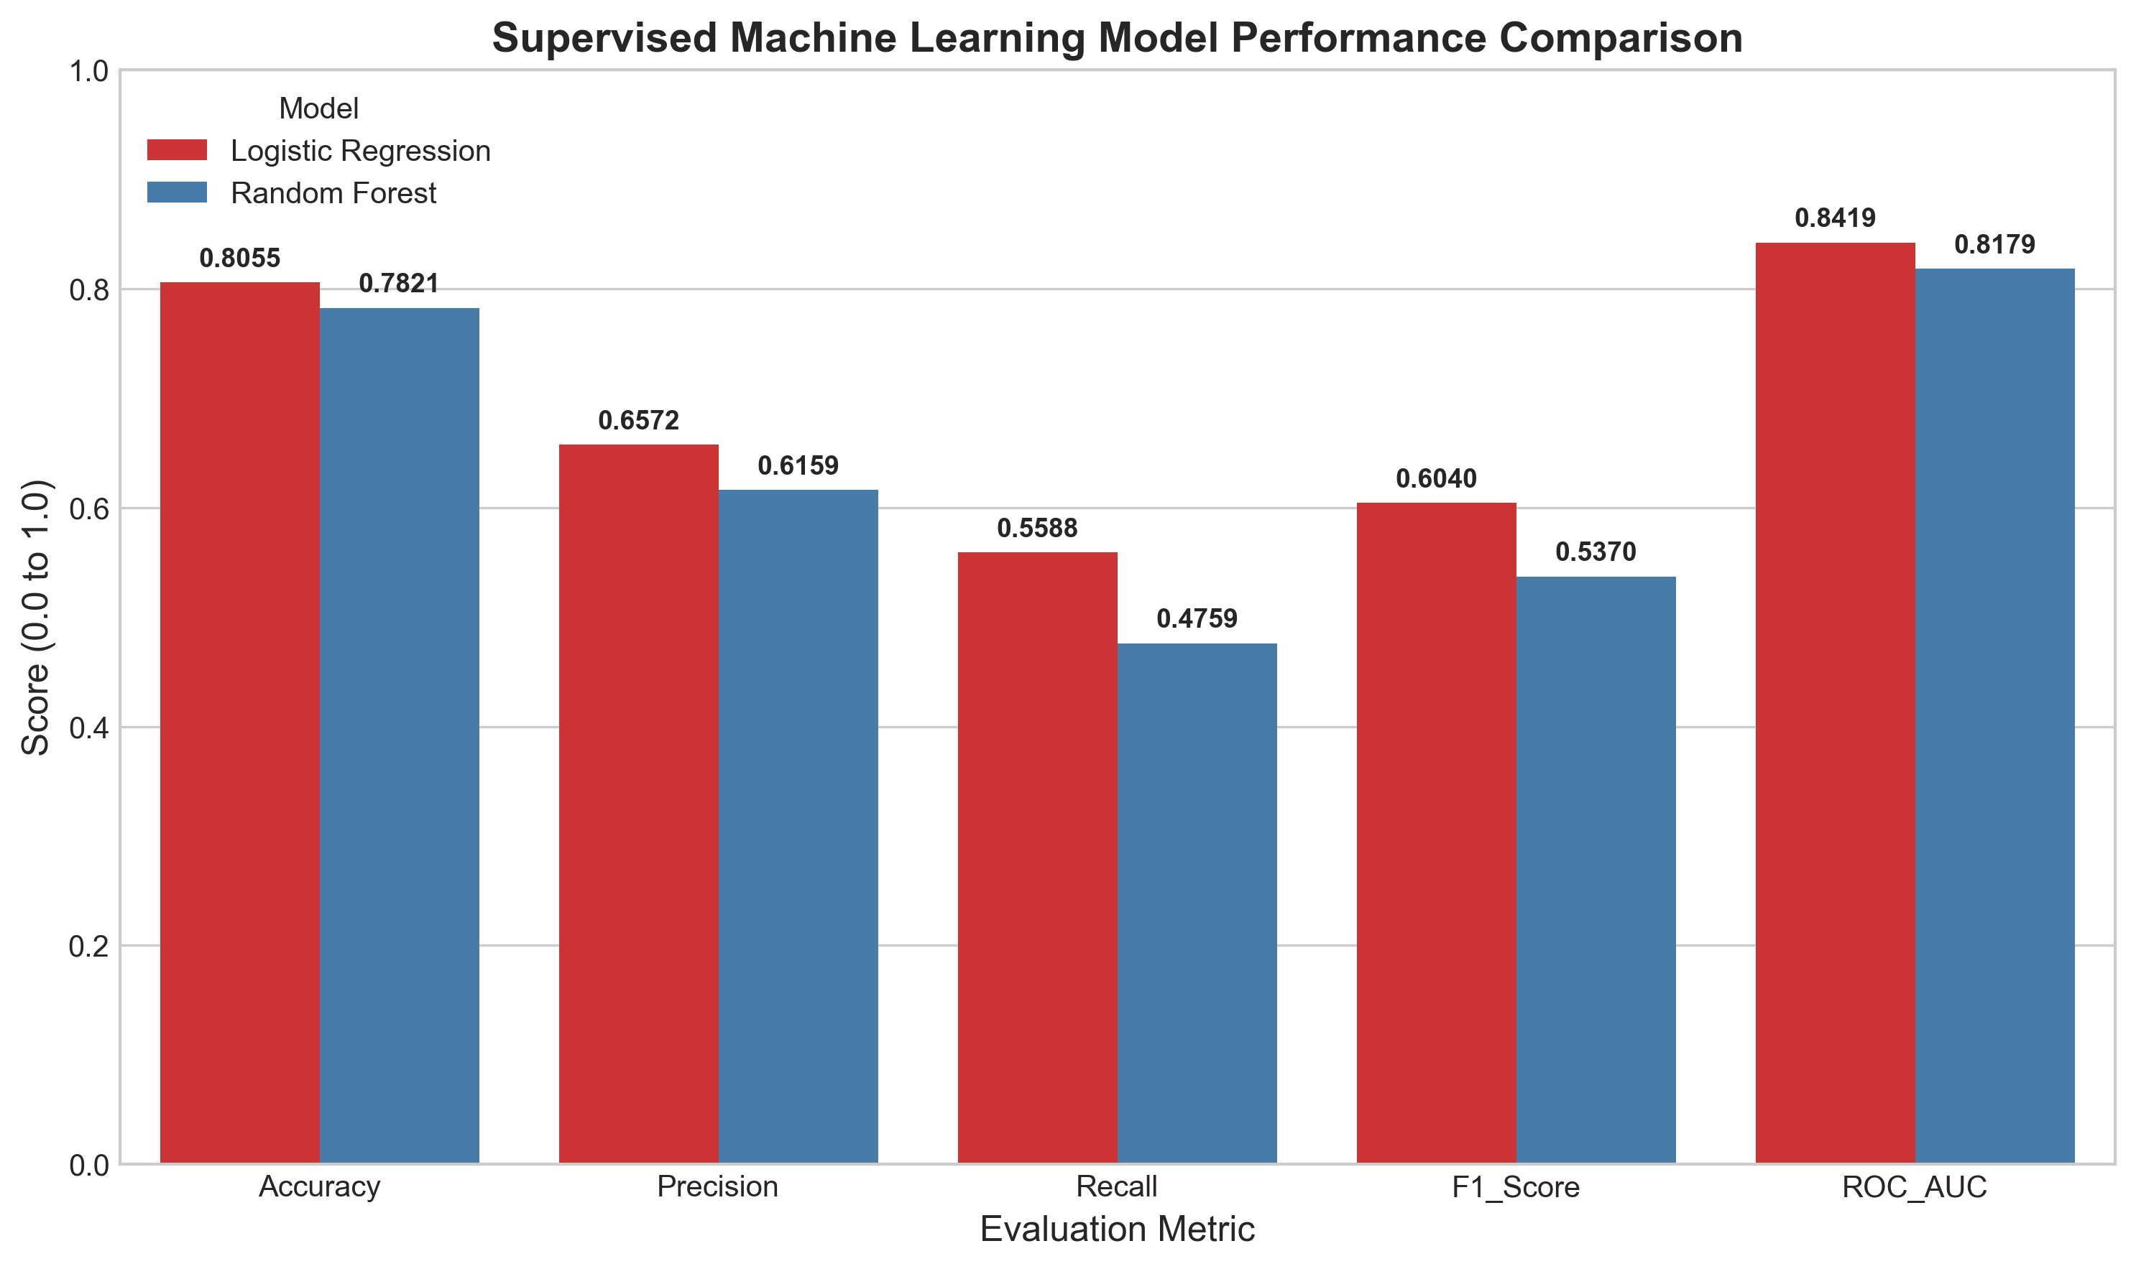

21. Final Model Selection
Logistic Regression is selected as the primary baseline model due to superior Recall (0.5588 vs 0.4759), higher F1-Score (0.6040 vs 0.5370), higher ROC-AUC (0.8419 vs 0.8179), and direct coefficient interpretability.

22. Business Interpretation
Logistic Regression probabilities allow retention teams to score customer churn risk dynamically, enabling targeted intervention for high-risk accounts.

23. Strengths
• 0% data leakage via Scikit-learn Pipeline architecture.
• High interpretability via linear feature coefficients.
• Robust cross-validation metrics.

24. Limitations
• Moderate recall (~55.9%) under standard 0.5 probability threshold due to class imbalance.

25. Possible Improvements
Future iterations may apply class weighting (`class_weight='balanced'`), hyperparameter tuning via GridSearchCV, SMOTE oversampling, or XGBoost.

26. Conclusion
Week 4 supervised classification established an effective baseline churn model achieving 80.55% accuracy and 0.8419 ROC-AUC.

27. References
1. Hosmer, D. W., Lemeshow, S., & Sturdivant, R. X. (2013). Applied Logistic Regression.
2. Pedregosa, F., et al. (2011). Scikit-learn: Machine Learning in Python.

28. Appendix — Code Snippet
```python
# Preprocessing Pipeline & Model Training
preprocessor = ColumnTransformer([
('num', StandardScaler(), numerical_features),
('cat', OneHotEncoder(handle_unknown='ignore'), categorical_features)
])
model = Pipeline([
('preprocessor', preprocessor),
('classifier', LogisticRegression(max_iter=1000, random_state=42))
])
model.fit(X_train, y_train)
```

