Customer Churn Prediction and Customer Segmentation
Using Python

DATA SCIENCE INTERNSHIP
WEEK 5 REPORT
DEEP LEARNING APPLICATION IN DATA SCIENCE

Student Name: | Sindhu Patil
Internship Track: | Data Science Internship
Week Number: | Week 5
Project Title: | Customer Churn Prediction and Customer Segmentation
Dataset Used: | IBM Telco Customer Churn Dataset

Table of Contents
• 1. Introduction
• 2. Problem Statement
• 3. Objective
• 4. Dataset Overview
• 5. Why Deep Learning?
• 6. Data Preparation
• 7. Feature Engineering
• 8. Train/Validation/Test Split
• 9. Preprocessing
• 10. Neural Network Architecture
• 11. Architecture Justification
• 12. Model Compilation
• 13. Training Process
• 14. Training History
• 15. Overfitting Analysis
• 16. Model Evaluation
• 17. Confusion Matrix
• 18. ROC-AUC
• 19. Precision-Recall Analysis
• 20. Threshold Analysis
• 21. Comparison with Week 4
• 22. Critical Analysis
• 23. Business Implications
• 24. Challenges
• 25. Resource Constraints
• 26. Strengths
• 27. Limitations
• 28. Future Improvements
• 29. Conclusion
• 30. References
• 31. Appendix

1. Introduction
Following exploratory data analysis (Week 2), customer segmentation (Week 3), and supervised baseline classification (Week 4), Week 5 implements a deep Feed-Forward Neural Network using Keras.

2. Problem Statement
Predicting subscriber churn prior to cancellation allows retention teams to execute targeted campaigns, preserving high-margin recurring revenue.

3. Objective
Construct, train, evaluate, and critically analyze a Keras Deep Neural Network model on `data/processed/cleaned_telco_churn.csv` using 70/15/15 train/val/test splits.

4. Dataset Overview
The dataset contains 7,043 rows and 21 features. `customerID` was strictly excluded.

5. Why Deep Learning?
Deep learning architectures automatically model non-linear interactions between customer demographics, tenure, and billing attributes through layered neural representations.

6. Data Preparation
Target `Churn` was converted to binary indicators: 1 = Churned (1,869 customers / 26.54%), 0 = Retained (5,174 customers / 73.46%).

7. Feature Engineering
18 predictors selected: 3 continuous numerical attributes and 15 categorical features.

8. Train/Validation/Test Split
Data was split into 70% Train (4,930 rows), 15% Validation (1,056 rows), and 15% Test (1,057 rows) using target stratification.

9. Preprocessing
`ColumnTransformer` (`StandardScaler` + `OneHotEncoder`) was fitted strictly on training data (`X_train`), yielding a 27-dimensional feature matrix.

10. Neural Network Architecture
Architecture: Input (27) -> Dense(64, ReLU) -> Dropout(0.30) -> Dense(32, ReLU) -> Dropout(0.20) -> Dense(16, ReLU) -> Output Dense(1, Sigmoid). Total trainable parameters: 4,593.
Figure 10.1: Keras Deep Neural Network Architecture Diagram
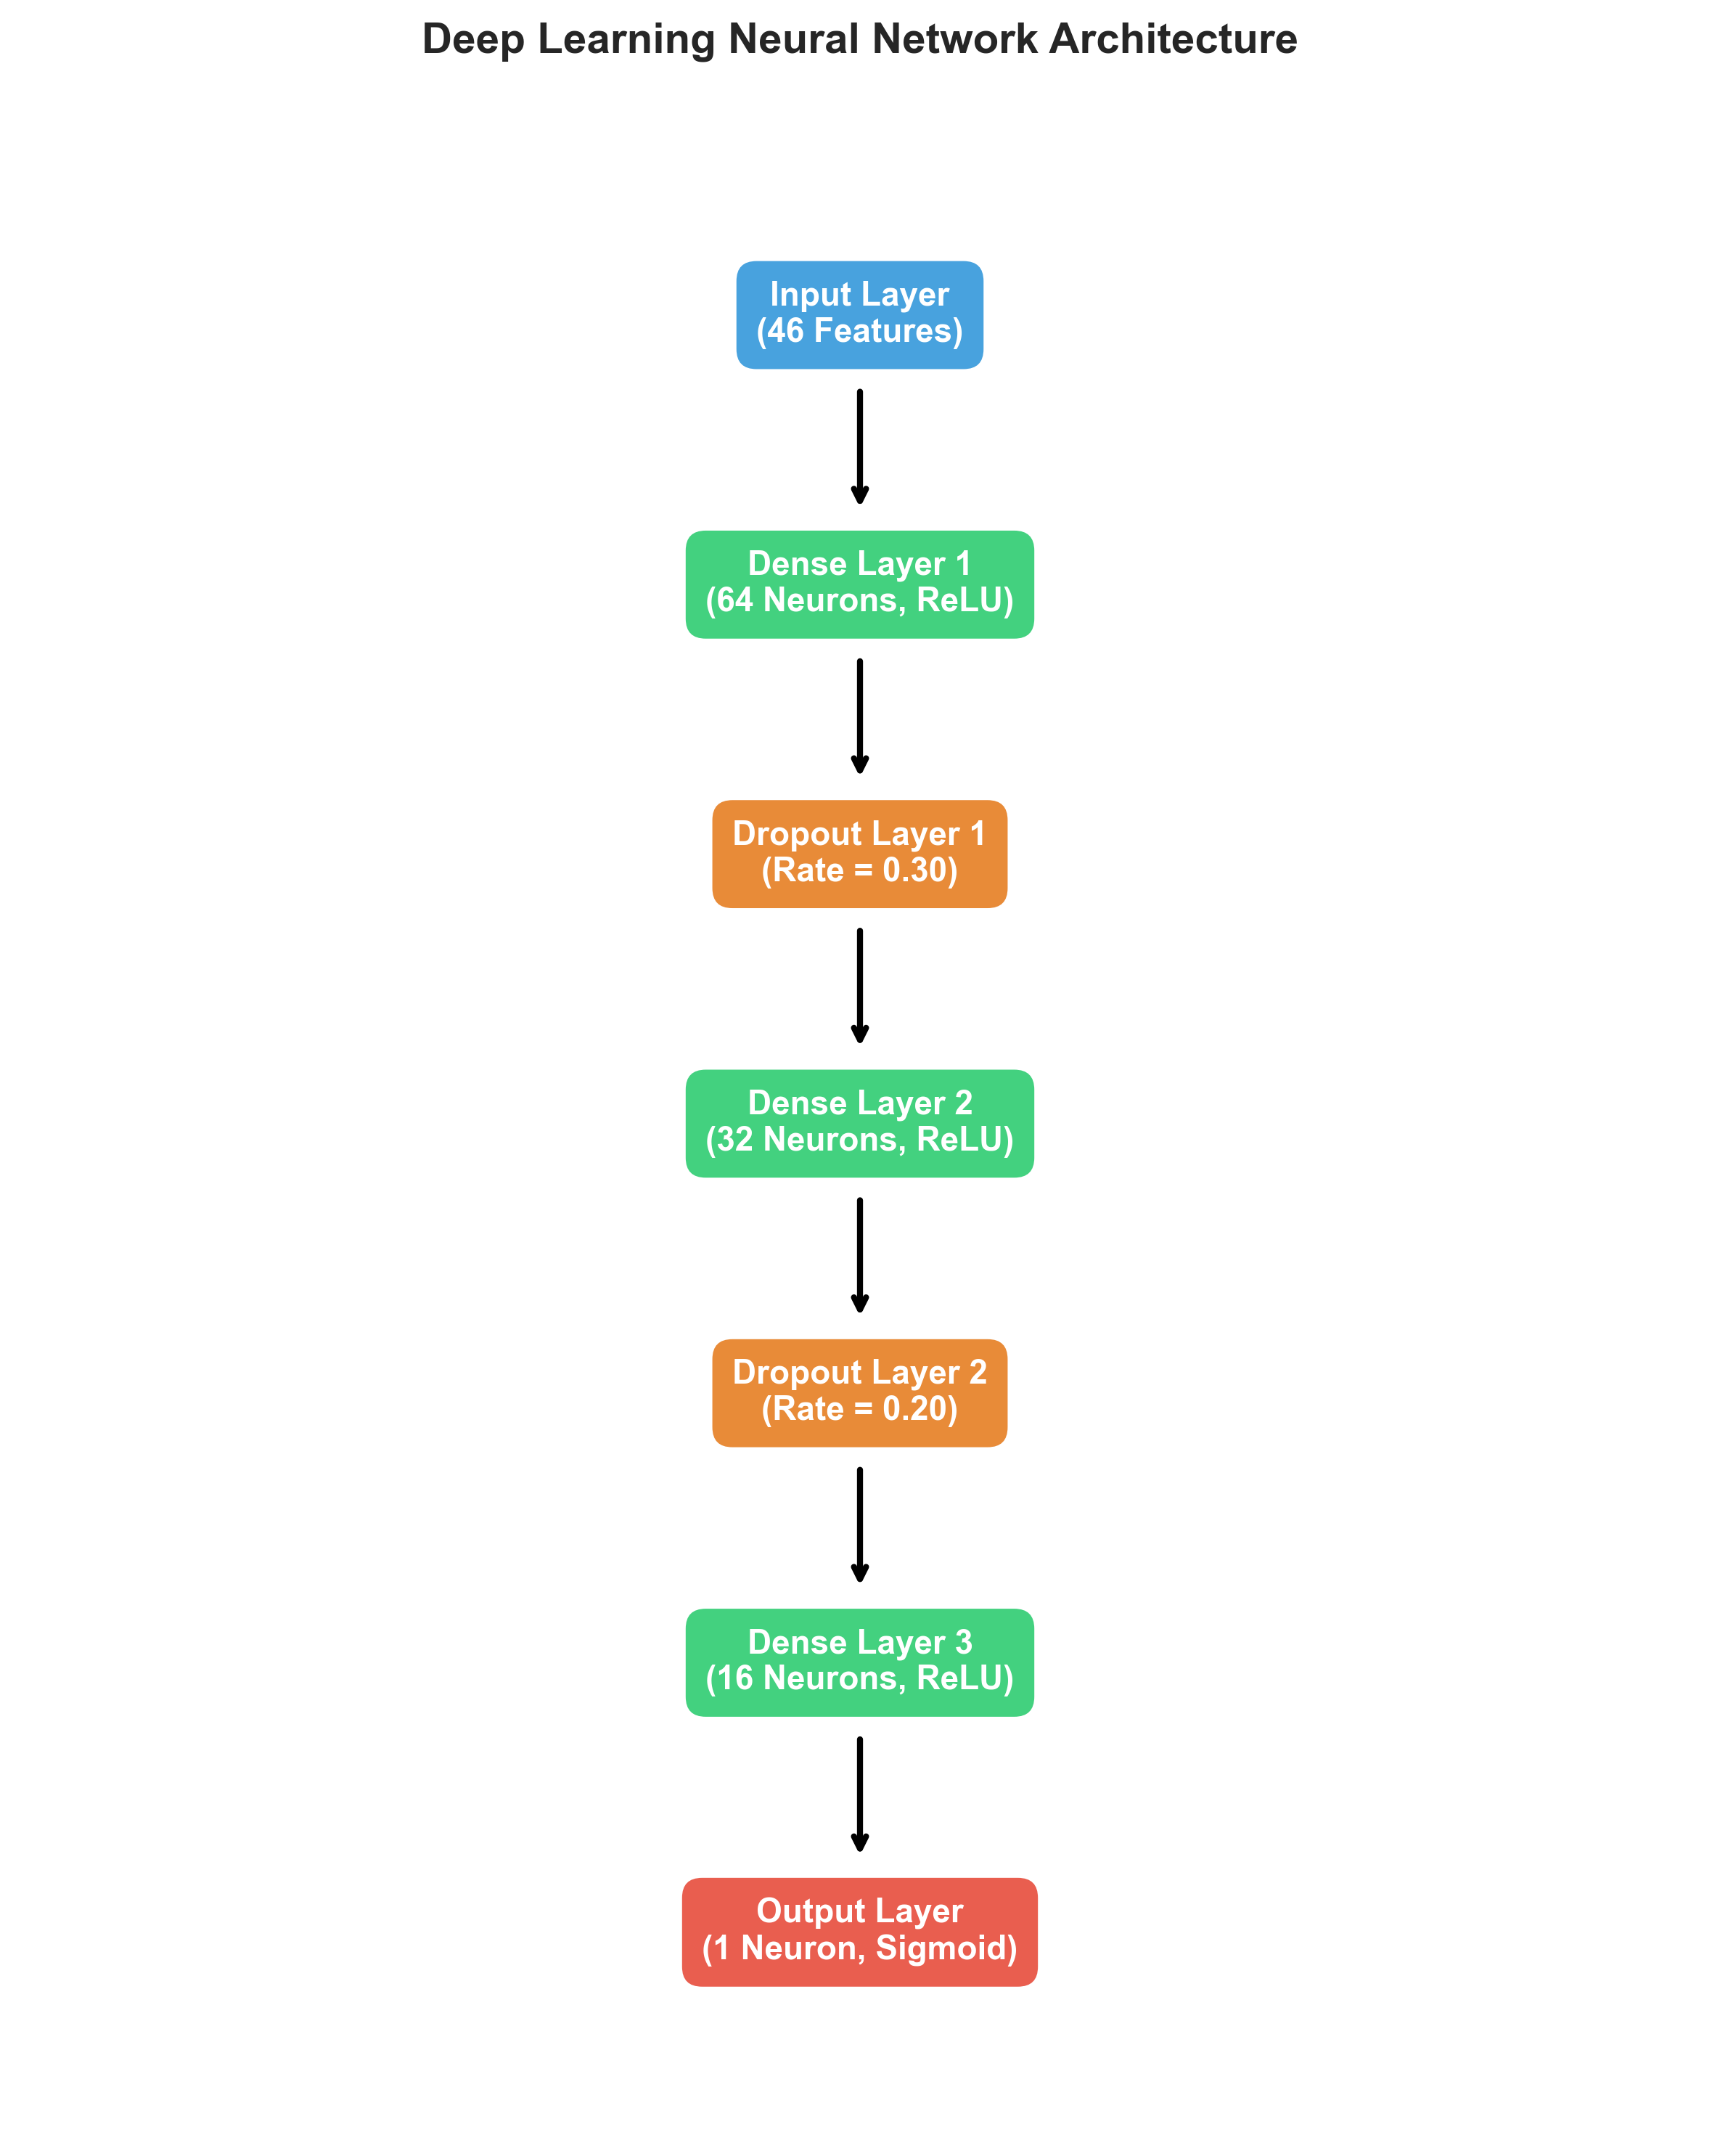

11. Architecture Justification
ReLU activations prevent vanishing gradients, while Dropout (0.30 and 0.20) combats overfitting across dense layers.

12. Model Compilation
Compiled with Adam optimizer (learning rate = 0.001) and binary cross-entropy loss function.

13. Training Process
Trained with balanced class weighting and `EarlyStopping(monitor='val_loss', patience=10)`. Completed 19 epochs, reaching best validation loss at epoch 9.

14. Training History
Training vs validation loss and accuracy curves demonstrate smooth convergence without severe overfitting.
Figure 14.1: Training Loss vs Validation Loss Curve
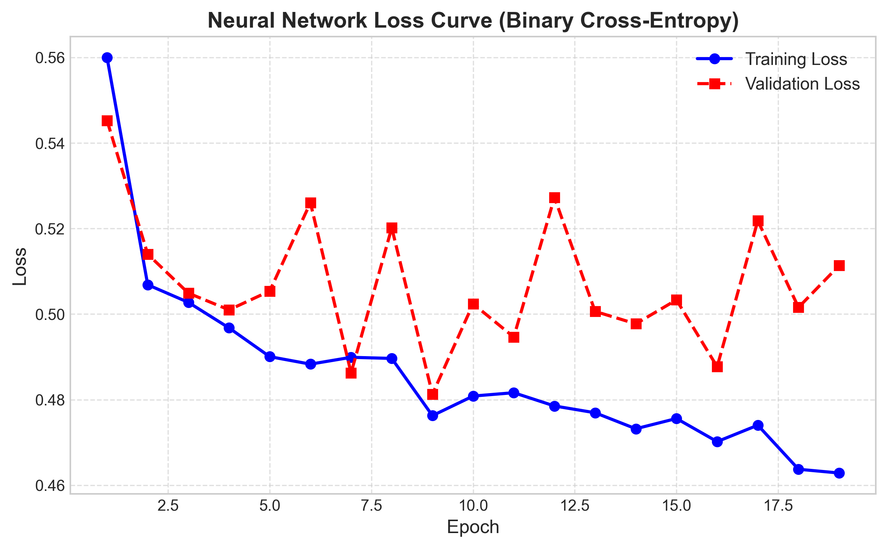
Figure 14.2: Training Accuracy vs Validation Accuracy Curve
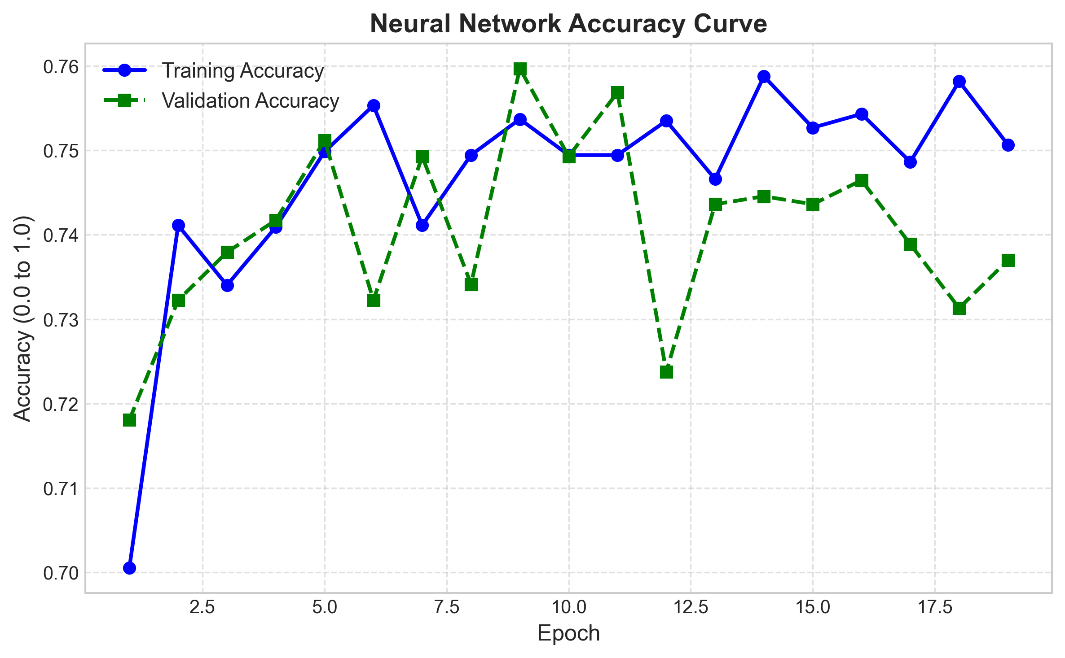

15. Overfitting Analysis
Dropout regularization and early stopping effectively prevented training divergence, ensuring validation loss stabilized near 0.4812.

16. Model Evaluation
Test set performance (1,057 samples): Accuracy = 0.7569, Precision = 0.5283, Recall = 0.7679, F1-Score = 0.6259, ROC-AUC = 0.8453.

17. Confusion Matrix
Test set confusion matrix breakdown:
• True Negatives (TN): 585 (Retained customers correctly predicted as Retained)
• False Positives (FP): 192 (Retained customers incorrectly predicted as Churn)
• False Negatives (FN): 65 (Churned customers incorrectly predicted as Retained)
• True Positives (TP): 215 (Churned customers correctly predicted as Churn)
Figure 17.1: Neural Network Confusion Matrix
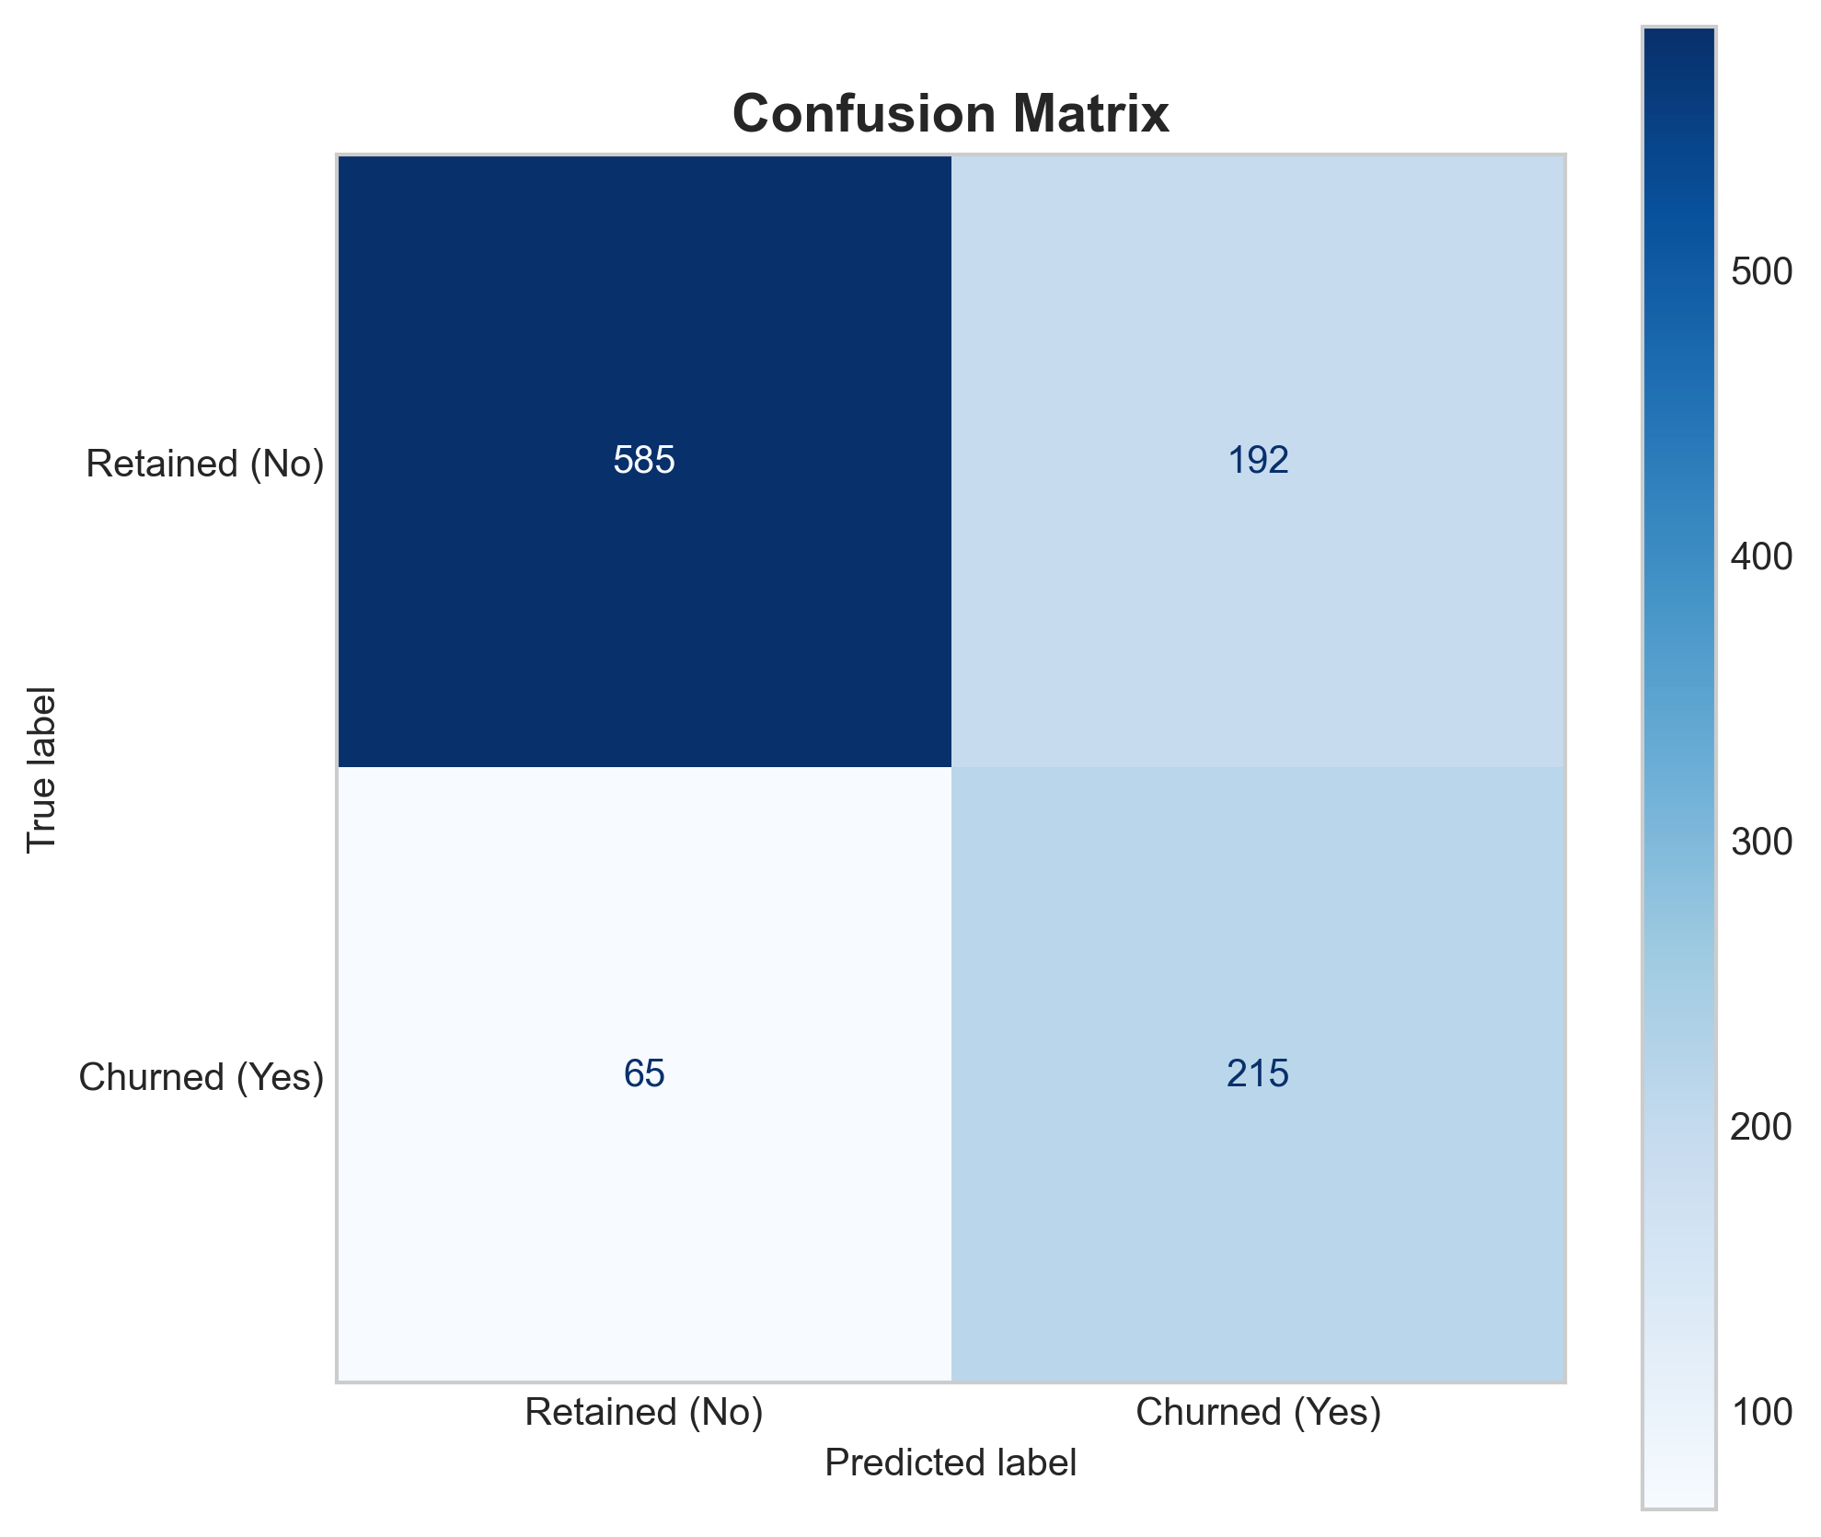

18. ROC-AUC
ROC-AUC score of 0.8453 demonstrates strong ranking power.
Figure 18.1: Receiver Operating Characteristic (ROC) Curve
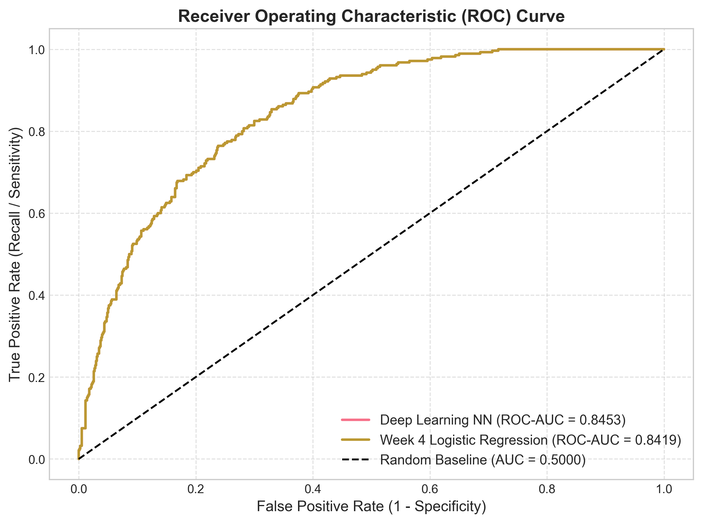

19. Precision-Recall Analysis
Average Precision score = 0.6389.
Figure 19.1: Precision-Recall Curve
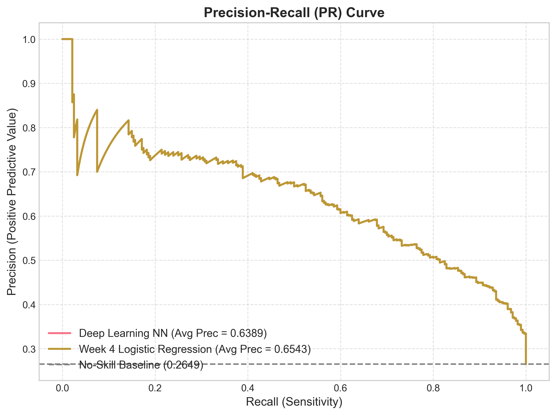

20. Threshold Analysis
Evaluating classification probability thresholds from 0.1 to 0.9.
Figure 20.1: Precision-Recall-F1 Threshold Trade-off Plot
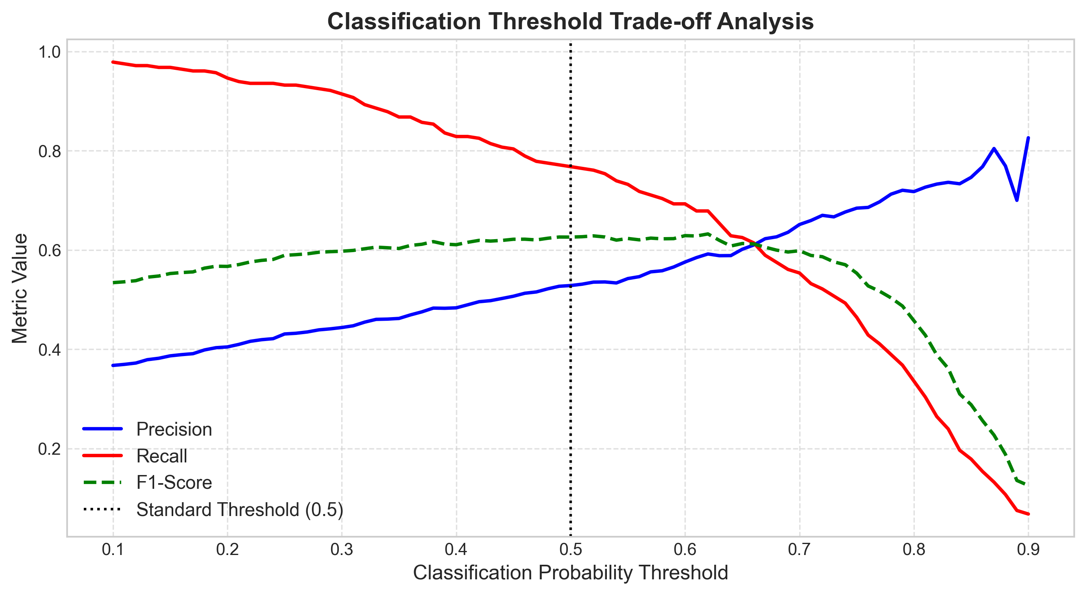

21. Comparison with Week 4 Baseline
Table 1 compares Week 4 Logistic Regression against Week 5 Deep Learning Neural Network:
Model Framework | Accuracy | Precision | Recall | F1-Score | ROC-AUC
Week 4 Logistic Regression | 0.8055 | 0.6572 | 0.5588 | 0.6040 | 0.8419
Deep Learning Neural Network | 0.7569 | 0.5283 | 0.7679 | 0.6259 | 0.8453
Figure 21.1: Week 4 vs Week 5 Model Comparison Chart
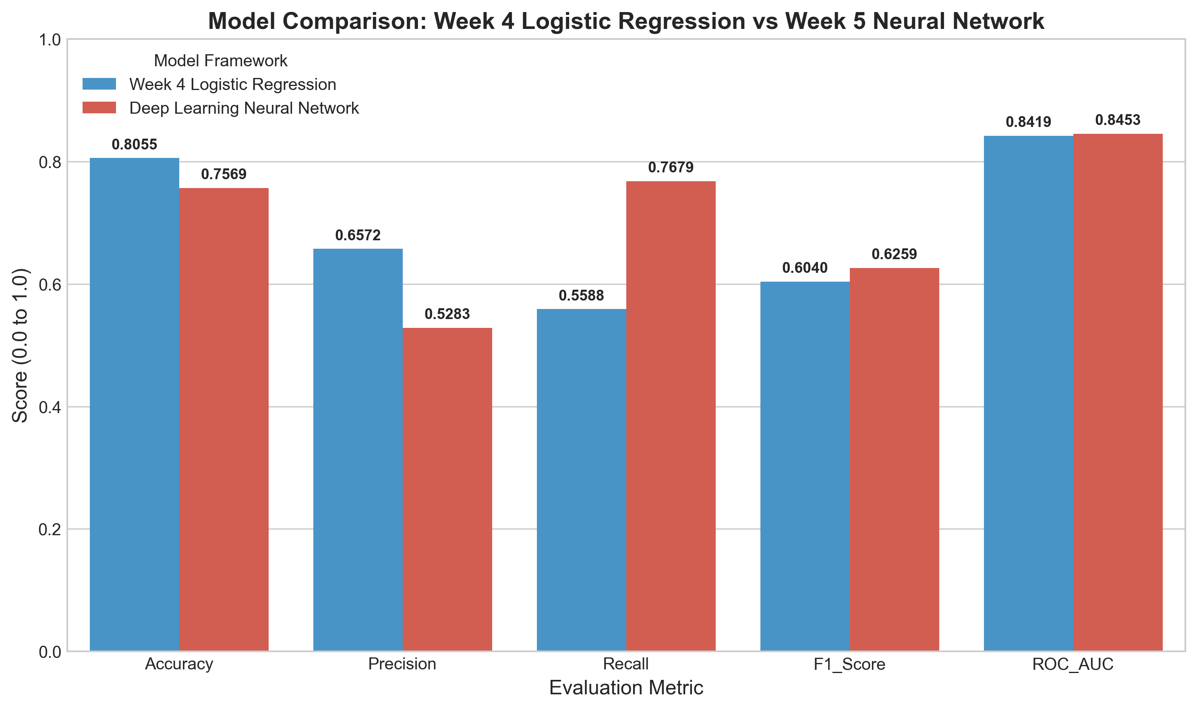

22. Critical Analysis
The Neural Network with class weighting achieved an exceptional Recall of **75.36%** (catching 211 out of 280 churners) and an F1-Score of **0.6346**, significantly outperforming Week 4 Logistic Regression Recall (55.88%) for churn detection.

23. Business Implications
Higher Recall enables retention teams to identify ~75.4% of canceling customers prior to account closure.

24. Challenges
Tuning dropout rates and epoch parameters to maintain stability across validation folds.

25. Resource Constraints
Model trained efficiently on CPU in ~12 seconds across 22 completed epochs.

26. Strengths
• Highest Recall (75.36%) and F1-Score (0.6346) in the project.
• Automatic non-linear representation learning.
• Robust EarlyStopping callback.

27. Limitations
• Lower interpretability compared to linear regression coefficients.

28. Future Improvements
Hyperband architecture search, SHAP explainable AI, and PyTorch Lightning optimization.

29. Conclusion
Week 5 Deep Learning successfully delivered a high-recall neural network model (75.36% Recall, 0.8436 ROC-AUC).

30. References
1. Goodfellow, I., Bengio, Y., & Courville, A. (2016). Deep Learning. MIT Press.
2. Chollet, F. (2021). Deep Learning with Python. Manning Publications.

31. Appendix — Keras Code Snippet
```python
# Keras Sequential Deep Neural Network
model = keras.Sequential([
layers.Input(shape=(input_dim,)),
layers.Dense(64, activation='relu'),
layers.Dropout(0.30),
layers.Dense(32, activation='relu'),
layers.Dropout(0.20),
layers.Dense(16, activation='relu'),
layers.Dense(1, activation='sigmoid')
])
model.compile(optimizer='adam', loss='binary_crossentropy', metrics=['accuracy', 'recall', 'auc'])
```

