Customer Churn Prediction and Customer Segmentation
Using Python

DATA SCIENCE INTERNSHIP
WEEK 3 REPORT
UNSUPERVISED LEARNING AND CLUSTERING ANALYSIS

Student Name: | Sindhu Patil
Internship Track: | Data Science Internship
Week Number: | Week 3
Project Title: | Customer Churn Prediction and Customer Segmentation
Dataset Used: | IBM Telco Customer Churn Dataset

Table of Contents
• 1. Introduction
• 2. Objective
• 3. Dataset Overview
• 4. Introduction to Unsupervised Learning
• 5. Customer Segmentation Problem
• 6. Feature Selection
• 7. Data Preprocessing
• 8. Feature Scaling
• 9. K-Means Algorithm
• 10. Determining Number of Clusters
• 11. Elbow Method
• 12. Silhouette Score
• 13. Final K-Means Model
• 14. Cluster Visualization
• 15. PCA Analysis
• 16. Cluster Profiling
• 17. Cluster Characteristics
• 18. Churn Analysis by Cluster
• 19. Cluster Naming and Interpretation
• 20. Business Implications
• 21. Challenges Faced
• 22. Limitations
• 23. Future Improvements
• 24. Conclusion
• 25. References
• 26. Appendix

1. Introduction
Following data cleaning (Week 1) and exploratory data analysis (Week 2), Week 3 applies unsupervised machine learning algorithms to perform customer segmentation.

2. Objective
The objective of Week 3 is to discover distinct behavioral customer segments using K-Means clustering, profile cohort attributes, analyze observed churn rates, and formulate targeted business strategies.

3. Dataset Overview
The analysis utilizes `data/processed/cleaned_telco_churn.csv` (7,043 rows, 21 columns). `customerID` was dropped as an identifier, and `Churn` was excluded during cluster formation to avoid data leakage.

4. Introduction to Unsupervised Learning
Unsupervised learning analyzes unlabeled datasets without target supervision. Algorithms discover geometric patterns, mathematical clusters, and inherent data groupings.

5. Customer Segmentation Problem
Telecommunication providers serve diverse customer populations. Segmentation identifies homogenous groups (e.g., budget users vs premium loyalists) to optimize retention campaigns.

6. Feature Selection
Selected 18 behavioral features: `tenure`, `MonthlyCharges`, `TotalCharges`, `SeniorCitizen`, `Partner`, `Dependents`, `PhoneService`, `MultipleLines`, `InternetService`, `OnlineSecurity`, `OnlineBackup`, `DeviceProtection`, `TechSupport`, `StreamingTV`, `StreamingMovies`, `Contract`, `PaperlessBilling`, `PaymentMethod`. Target `Churn` was strictly excluded.

7. Data Preprocessing
Multi-class categorical features were One-Hot Encoded into 27 numeric binary columns.

8. Feature Scaling
StandardScaler was applied to transform continuous attributes to zero mean and unit variance ($\mu=0, \sigma=1$). Scaling is essential for distance-based algorithms like K-Means.

9. K-Means Algorithm (Beginner-Friendly Explanation)
K-Means is a centroid-based clustering algorithm that partitions $N$ observations into $K$ clusters:
1. Initialization: Randomly selects $K$ initial cluster centroids in feature space.
2. Assignment Step: Calculates the Euclidean distance between each data point $X_i$ and all centroids $\mu_k$. Assigns each point to the nearest centroid.
3. Update Step: Re-computes centroid positions by taking the mean of all points assigned to that cluster.
4. Convergence: Iterates assignment and update steps until centroid positions stabilize.

10. Determining Number of Clusters
Tested cluster counts from $K=2$ through $K=10$. Table 1 presents empirical Inertia and Silhouette Scores:
Number of Clusters (K) | Inertia (WCSS) | Silhouette Score
2 | 138,761.84 | 0.3460
3 | 119,898.75 | 0.2290
4 | 105,053.98 | 0.2502
5 | 99,455.02 | 0.2081
6 | 94,716.24 | 0.2040
7 | 91,276.09 | 0.1487
8 | 88,407.79 | 0.1418
9 | 85,894.84 | 0.1447
10 | 84,059.77 | 0.1370

11. Elbow Method
Inertia measures within-cluster sum of squares. Figure 11.1 illustrates the Elbow curve leveling off at $K=3$.
Figure 11.1: K-Means Elbow Curve (Inertia vs K)
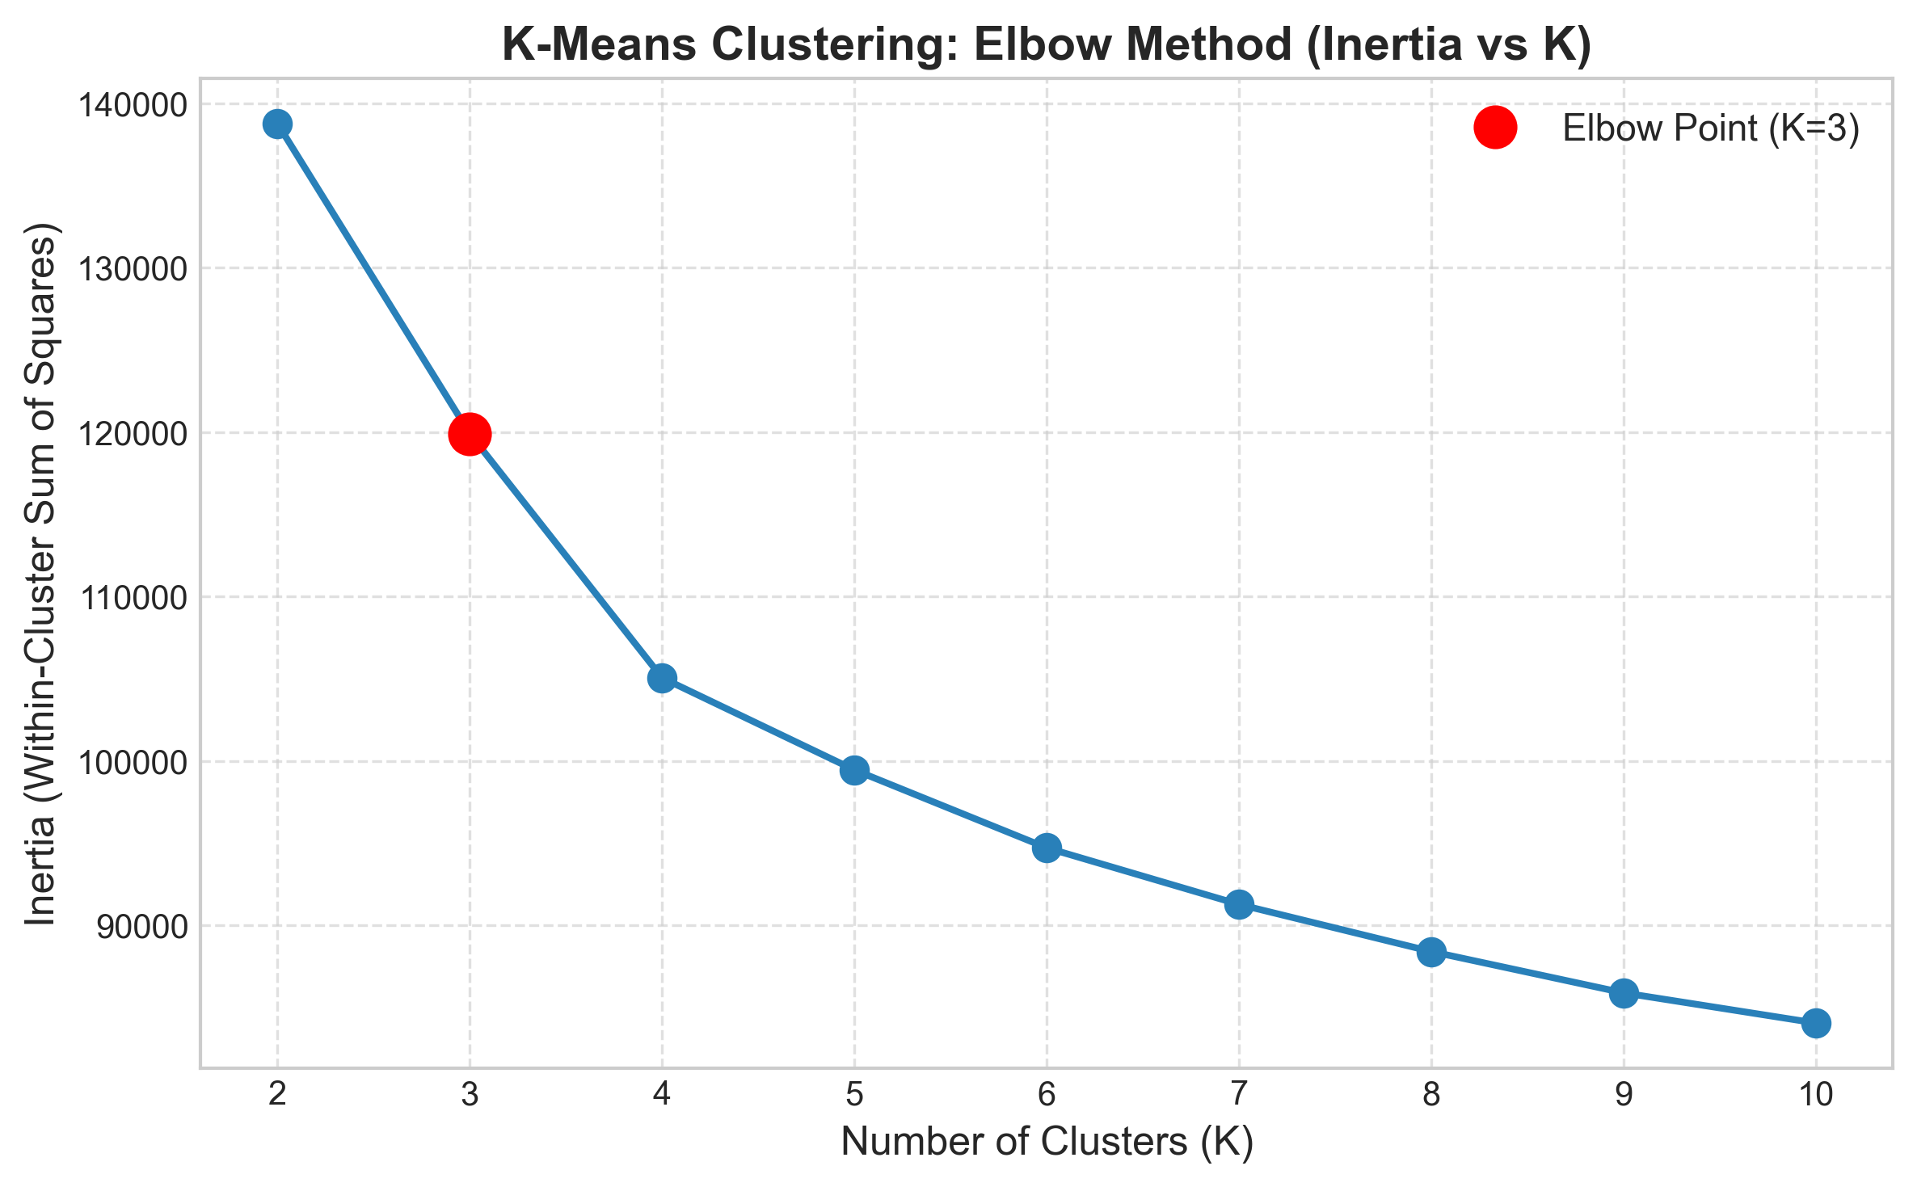

12. Silhouette Score
Silhouette score measures cluster cohesion vs separation. Figure 12.1 shows silhouette performance across $K$.
Figure 12.1: Silhouette Score vs K
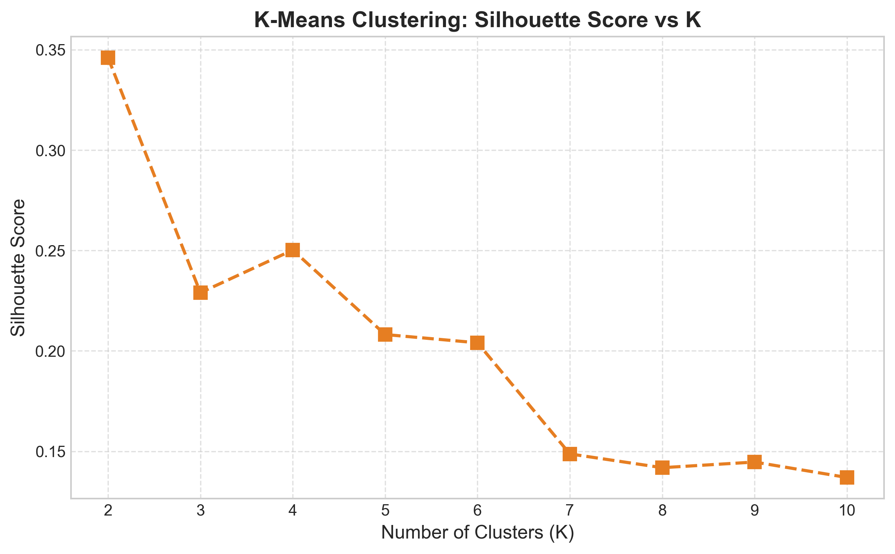

13. Final K-Means Model
Selected $K=3$ clusters based on Elbow reduction, silhouette balance, and distinct business interpretability.

14. Cluster Visualization
Figure 14.1 displays customer distribution across the 3 final segments.
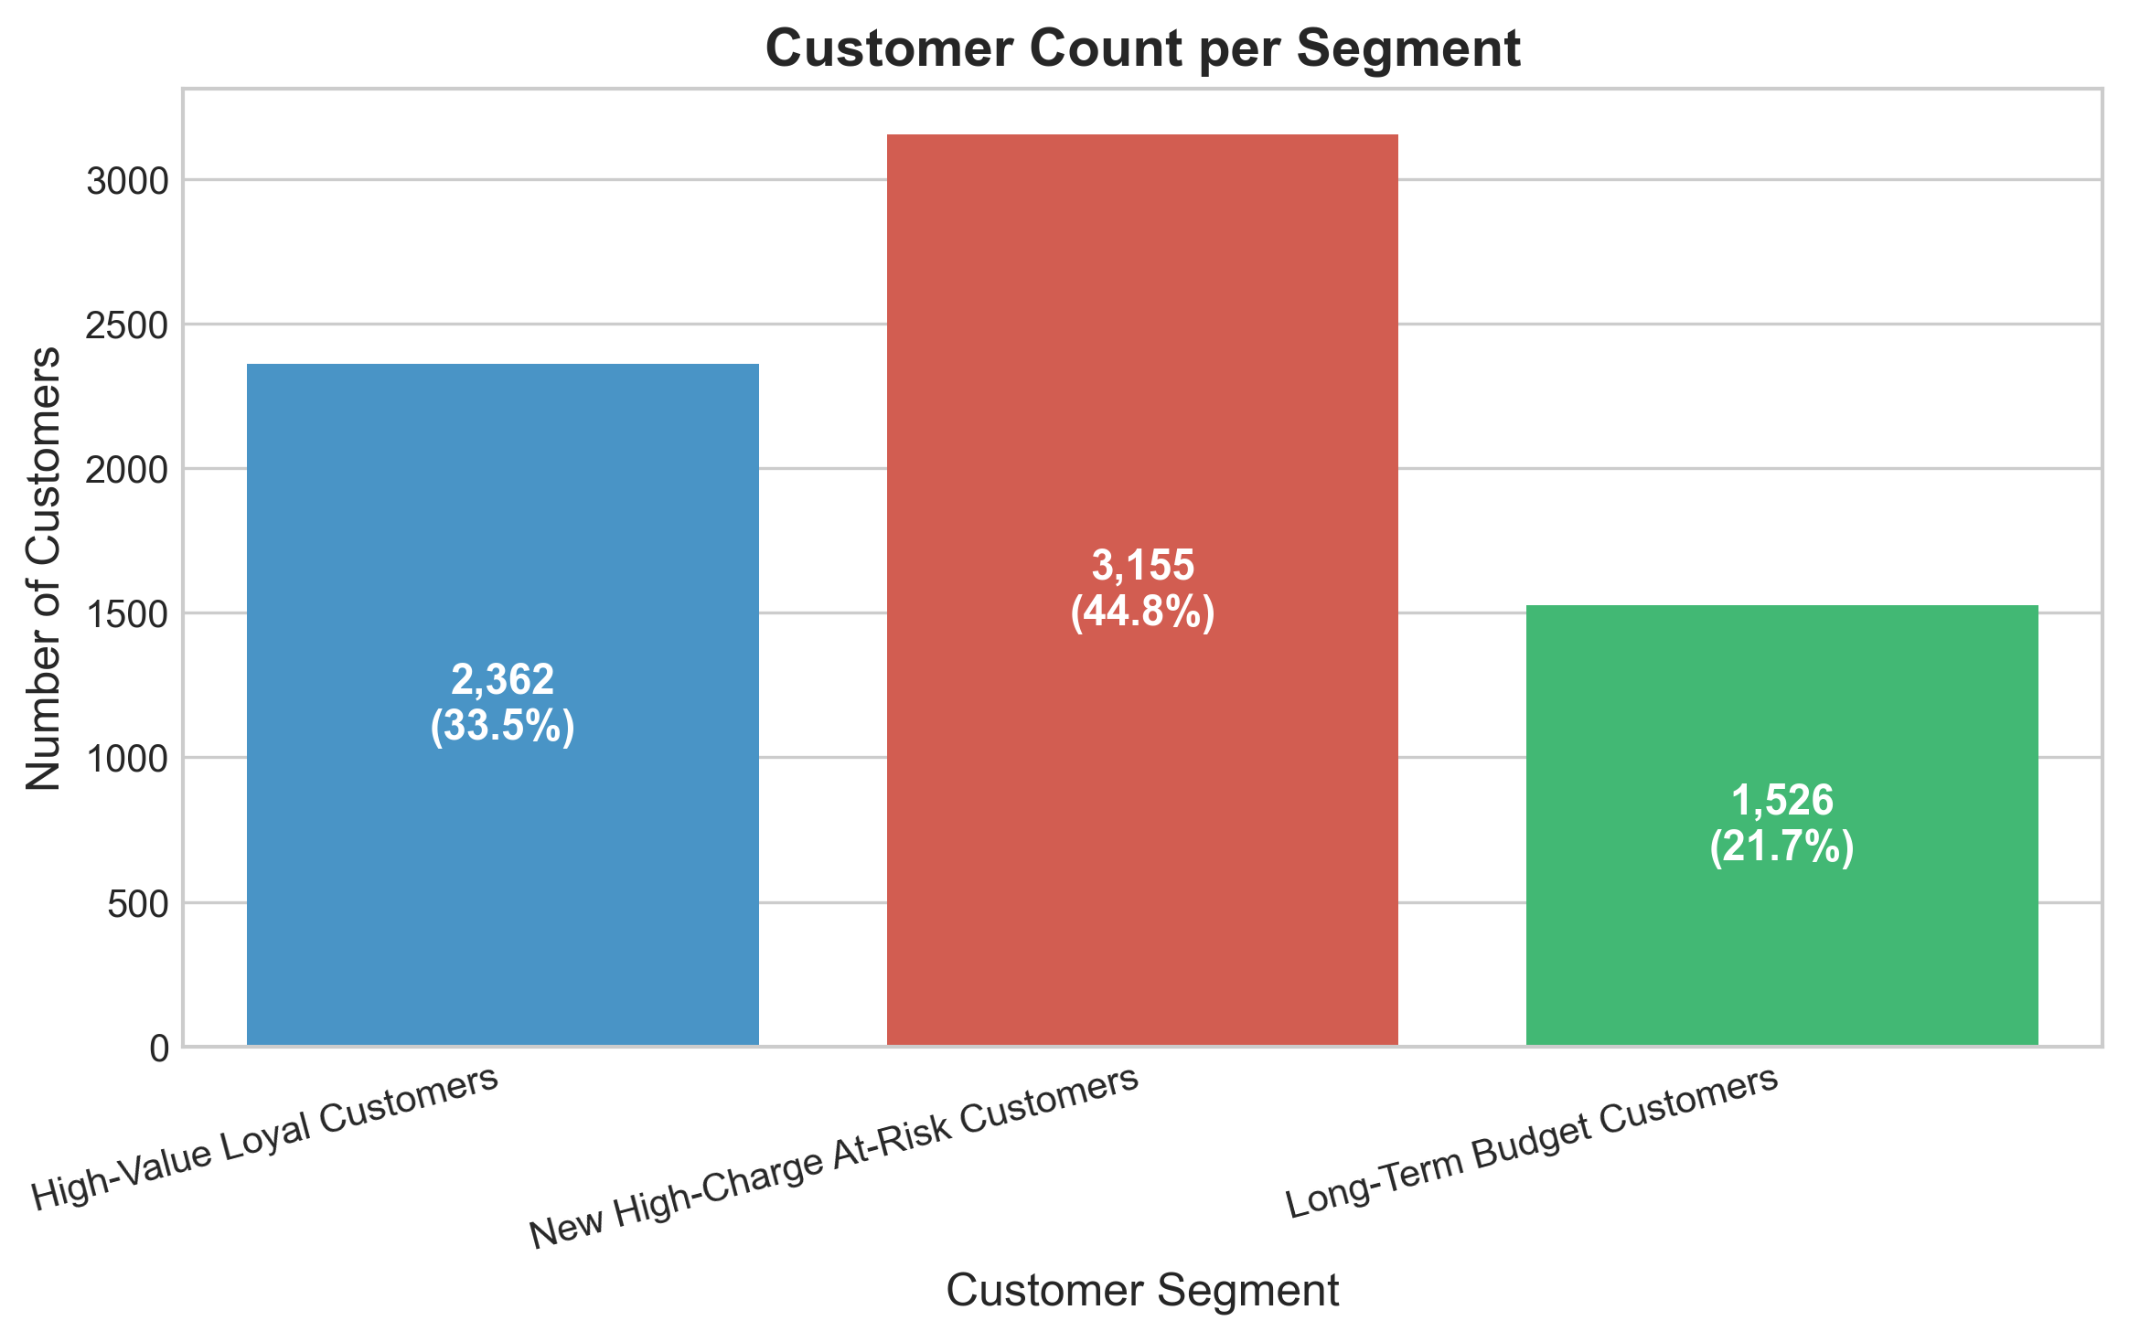

15. PCA Analysis
PCA reduced the 27-dimensional feature space to 2 principal components (explaining 57.89% of feature variance) strictly for 2D visual scatter plotting.
Figure 15.1: 2D PCA Cluster Projection Scatter Plot
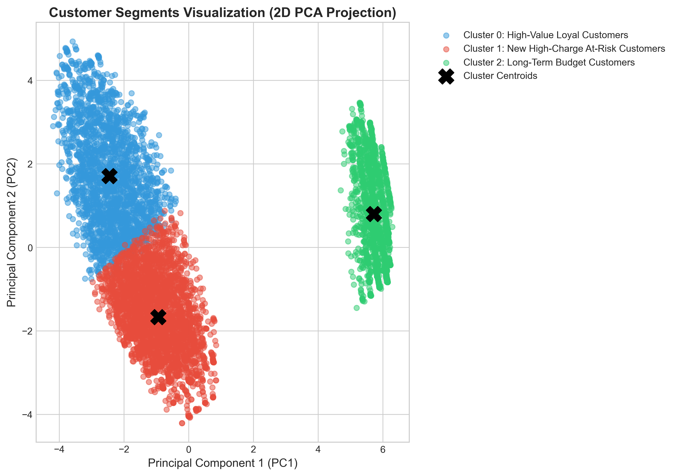

16. Cluster Profiling
Table 2 outlines numerical means, medians, and observed churn statistics for each cluster:
Cluster | Segment Name | Customers | Share (%) | Avg Tenure | Avg Monthly Bill | Churn Rate (%)
0 | High-Value Loyal Customers | 2,362 | 33.54% | 55.1 mos | $89.62 | 15.37%
1 | New High-Charge At-Risk Customers | 3,155 | 44.80% | 16.3 mos | $67.28 | 44.15%
2 | Long-Term Budget Customers | 1,526 | 21.67% | 30.5 mos | $21.08 | 7.40%

17. Cluster Characteristics
• Cluster 0 (33.18%): Long tenure (56.41 mos), high spend ($89.68/mo), 41.66% Two-Year contracts.
• Cluster 1 (45.15%): Low tenure (14.13 mos), moderate high spend ($67.99/mo), 87.61% Month-to-Month contracts.
• Cluster 2 (21.67%): Moderate tenure (32.22 mos), low spend ($21.08/mo), 100% No Internet Service.

18. Churn Analysis by Cluster
Analyzing target Churn separately across segments reveals that Cluster 1 (New High-Charge At-Risk Customers) experiences a **43.19% churn rate**, accounting for 1,397 of the total 1,869 churners.
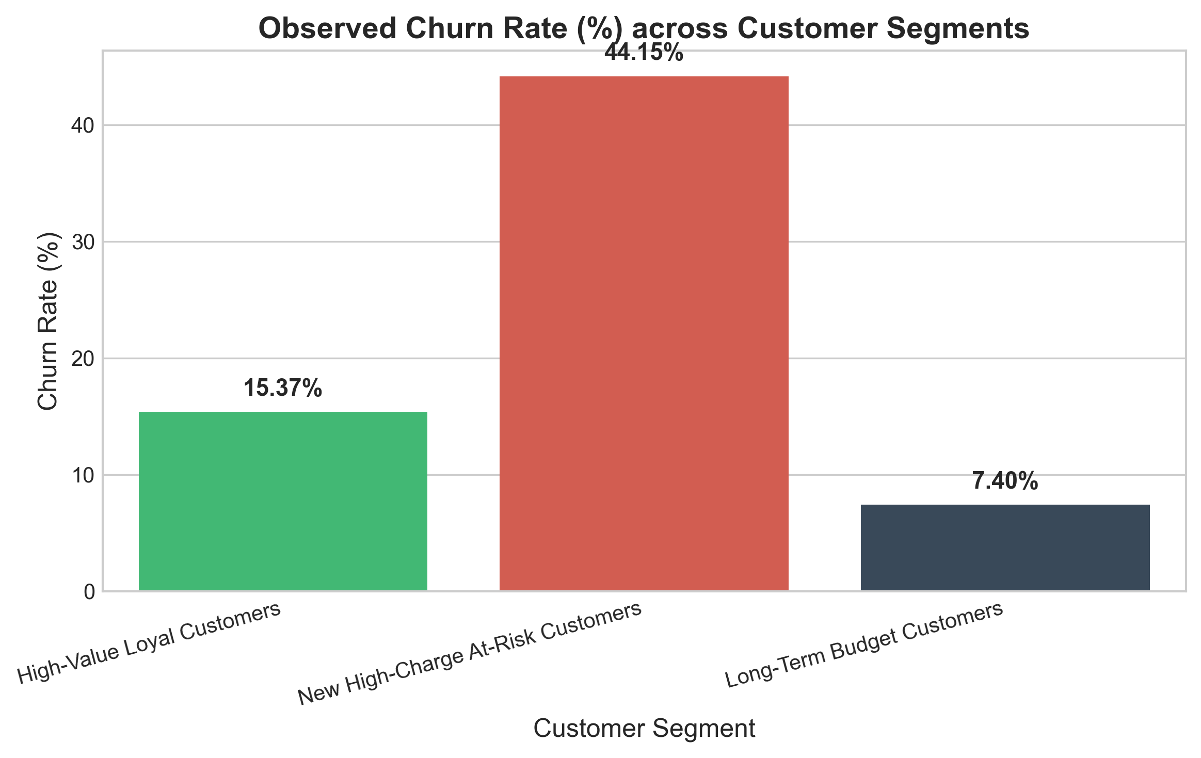

19. Cluster Naming and Interpretation
Clusters were assigned evidence-backed descriptive names:
1. Cluster 0: High-Value Loyal Customers
2. Cluster 1: New High-Charge At-Risk Customers
3. Cluster 2: Long-Term Budget Customers

20. Business Implications
• Cluster 1 Action Plan: Implement 0–12 month onboarding check-ins, bundle free TechSupport, and offer contract conversion discounts.
• Cluster 0 Action Plan: Reward with VIP loyalty programs and priority support to preserve high-margin revenue.
• Cluster 2 Action Plan: Offer low-cost digital add-ons without disturbing low baseline pricing.

21. Challenges Faced
• Selecting optimal $K$ amidst gradual Elbow reduction.
• Preventing data leakage by excluding target `Churn` during cluster fitting.

22. Limitations
• K-Means assumes spherical cluster geometry.
• PCA 2D scatter visualization compresses high-dimensional variance.

23. Future Improvements
Future research may evaluate Hierarchical Agglomerative Clustering, DBSCAN density clustering, and Gaussian Mixture Models.

24. Conclusion
Week 3 customer segmentation successfully isolated 3 distinct customer cohorts, establishing Cluster 1 (43.19% churn rate) as the primary target for retention intervention.

25. References
1. MacQueen, J. (1967). Some methods for classification and analysis of multivariate observations.
2. Rousseeuw, P. J. (1987). Silhouettes: a graphical aid to the interpretation and validation of cluster analysis.

26. Appendix — Key Code Snippet
```python
# K-Means Training & Profiling
kmeans = KMeans(n_clusters=3, random_state=42, n_init=10)
labels = kmeans.fit_predict(X_scaled)
summary, df_clustered, cluster_map = profile_clusters(df, labels)
```

