Customer Churn Prediction and Customer Segmentation
Using Python

DATA SCIENCE INTERNSHIP
WEEK 2 REPORT
EXPLORATORY DATA ANALYSIS AND VISUALIZATION

Student Name: | Sindhu Patil
Internship Track: | Data Science Internship
Week Number: | Week 2
Technologies Used: | Python, Pandas, NumPy, Matplotlib, Seaborn, docx

Table of Contents
• 1. Introduction
• 2. Objective
• 3. Dataset Overview
• 4. Tools and Technologies
• 5. Data Preparation
• 6. Descriptive Statistics
• 7. Univariate Analysis
• 8. Bivariate Analysis
• 9. Multivariate Analysis
• 10. Churn Analysis
• 11. Correlation Analysis
• 12. Key Findings
• 13. Business Insights
• 14. Challenges Faced
• 15. Limitations
• 16. Impact on Future Modeling
• 17. Conclusion
• 18. References
• 19. Submission Description

1. Introduction
Exploratory Data Analysis (EDA) represents a pivotal milestone in data science workflows. Following Week 1 data cleaning, Week 2 investigates patterns, trends, customer behaviors, and statistical anomalies within the IBM Telco Customer Churn dataset.

2. Objective
The objective of Week 2 is to perform rigorous data analysis to identify primary demographic, contractual, and service-related churn drivers, supporting subsequent machine learning model development.

3. Dataset Overview
The dataset used is `data/processed/cleaned_telco_churn.csv`, consisting of 7,043 customer records and 21 features. It contains zero missing values and zero duplicate rows.

4. Tools and Technologies
• Python 3.14
• Pandas & NumPy (Data manipulation & aggregations)
• Matplotlib & Seaborn (Statistical visualization)
• python-docx (Executive report formatting)

5. Data Preparation
Dataset integrity was verified by confirming 0 null values across all 7,043 rows. `tenure` was binned into 5 analytical cohorts: 0–12 mos, 13–24 mos, 25–48 mos, 49–60 mos, and 61–72 mos.

6. Descriptive Statistics
Table 1 summarizes descriptive statistics for continuous numerical attributes:
Feature | Mean | Std | Min | Q1 (25%) | Median | Q3 (75%) | Max | IQR
tenure | 32.37 | 24.56 | 0.00 | 9.00 | 29.00 | 55.00 | 72.00 | 46.00
MonthlyCharges | 64.76 | 30.09 | 18.25 | 35.50 | 70.35 | 89.85 | 118.75 | 54.35
TotalCharges | 2281.92 | 2265.27 | 18.80 | 402.23 | 1397.47 | 3786.60 | 8684.80 | 3384.38
Interpretation: The mean tenure is 32.37 months, with a median of 29.0 months. MonthlyCharges range from $18.25 to $118.75 (mean $64.76). TotalCharges shows right-skewness (median $1,397.47 vs mean $2,281.92).

7. Univariate Analysis
Univariate analysis evaluates single feature distributions. Tenure exhibits a bimodal distribution with peaks at early tenure (<12 months) and high tenure (>60 months).
Figure 7.1: Tenure Distribution by Churn Status
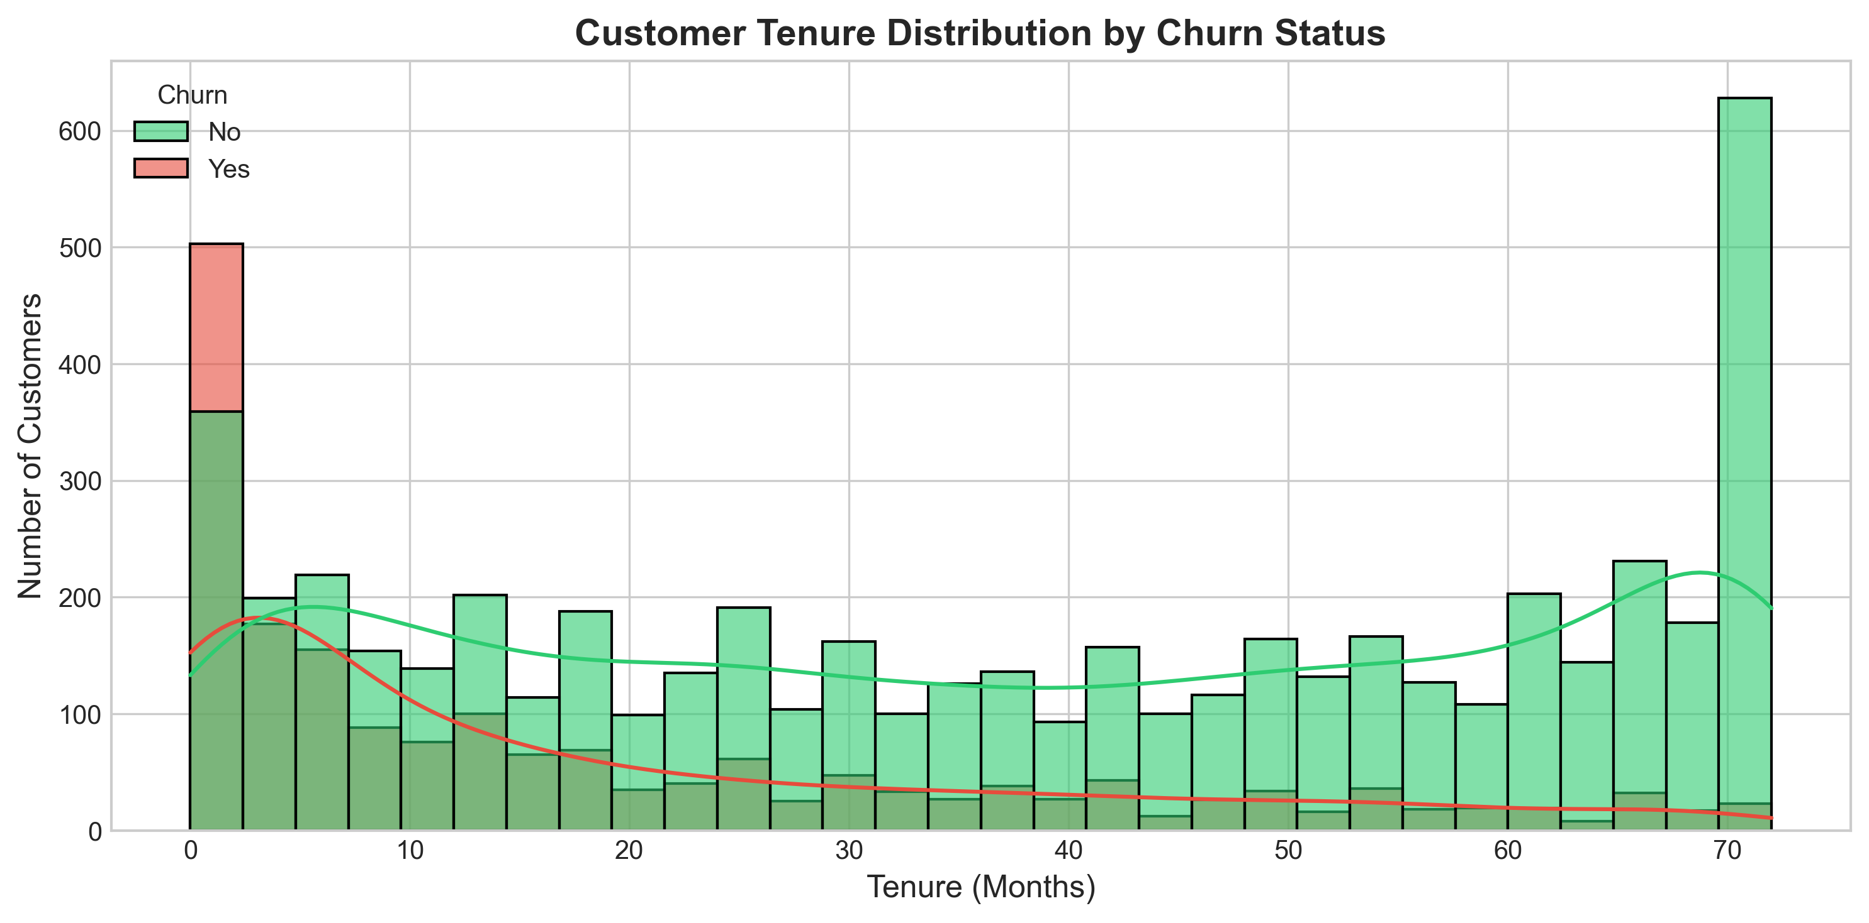

8. Bivariate Analysis
Bivariate analysis examines relationships between predictors and target `Churn`.
Figure 8.1: Customer Churn Distribution by Contract Type
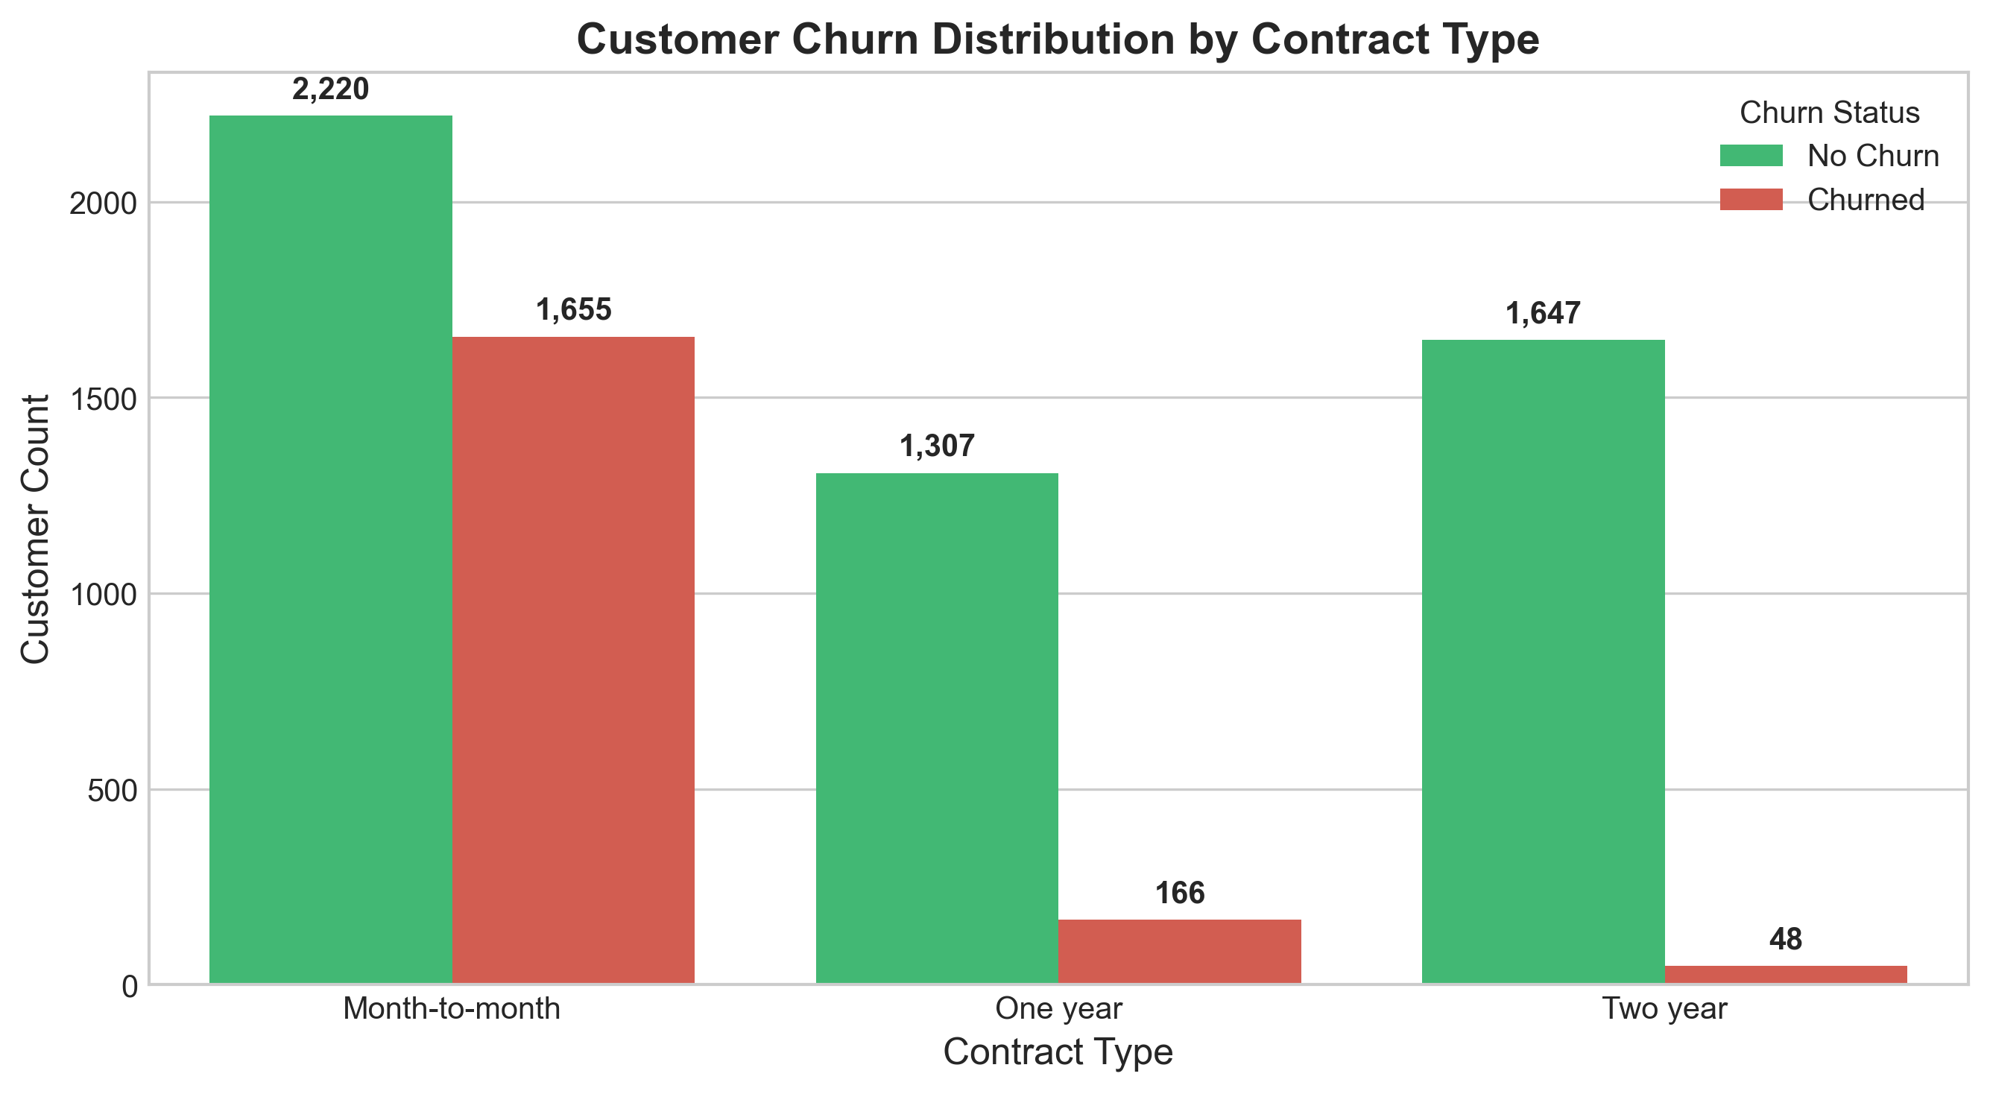
Figure 8.2: Customer Churn by Internet Service Type
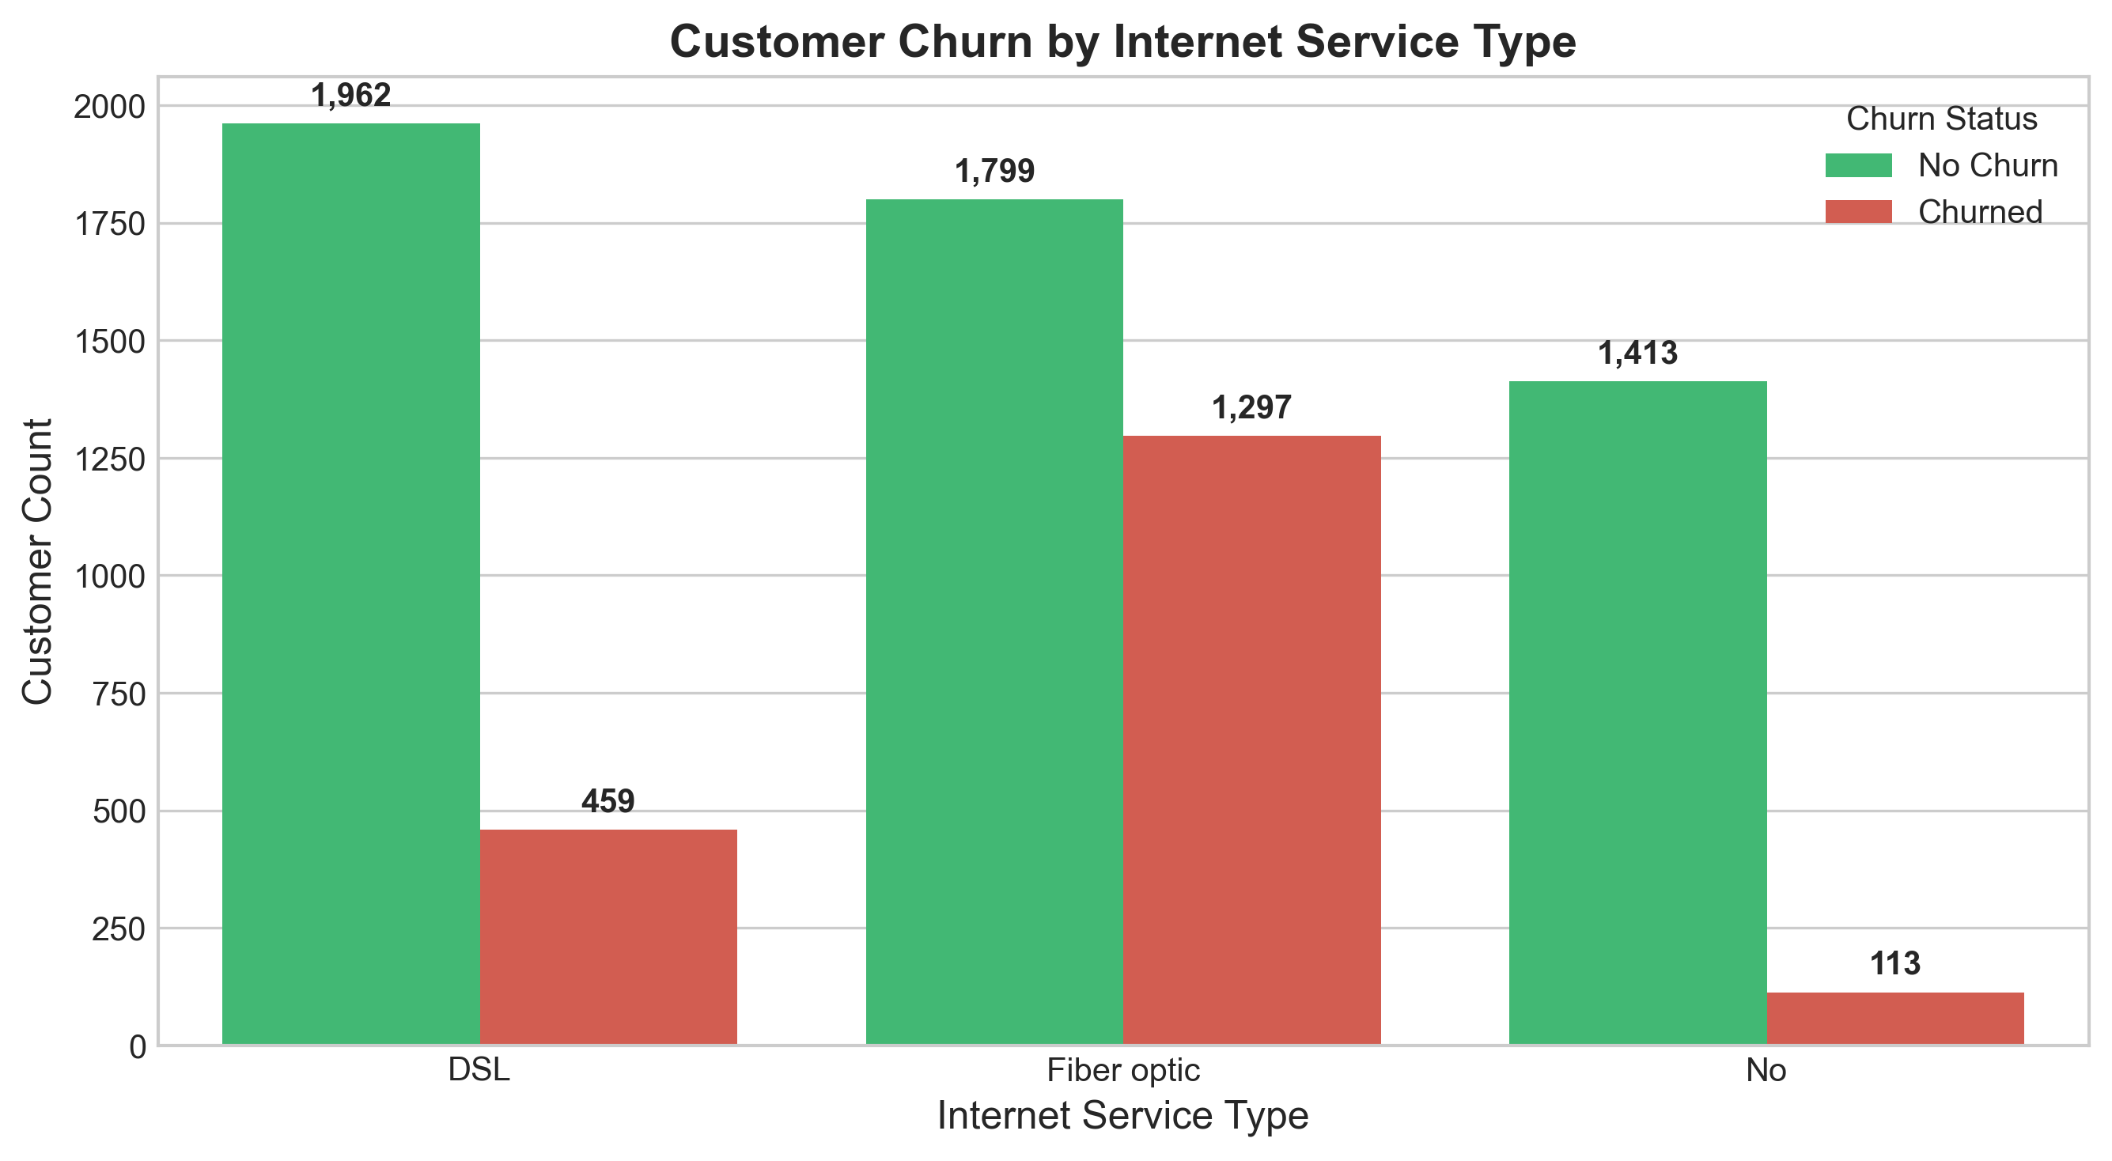

9. Multivariate Analysis
Multivariate analysis explores interaction effects between Contract, MonthlyCharges, and Churn.
Figure 9.1: Monthly Charges by Contract Type and Churn Status
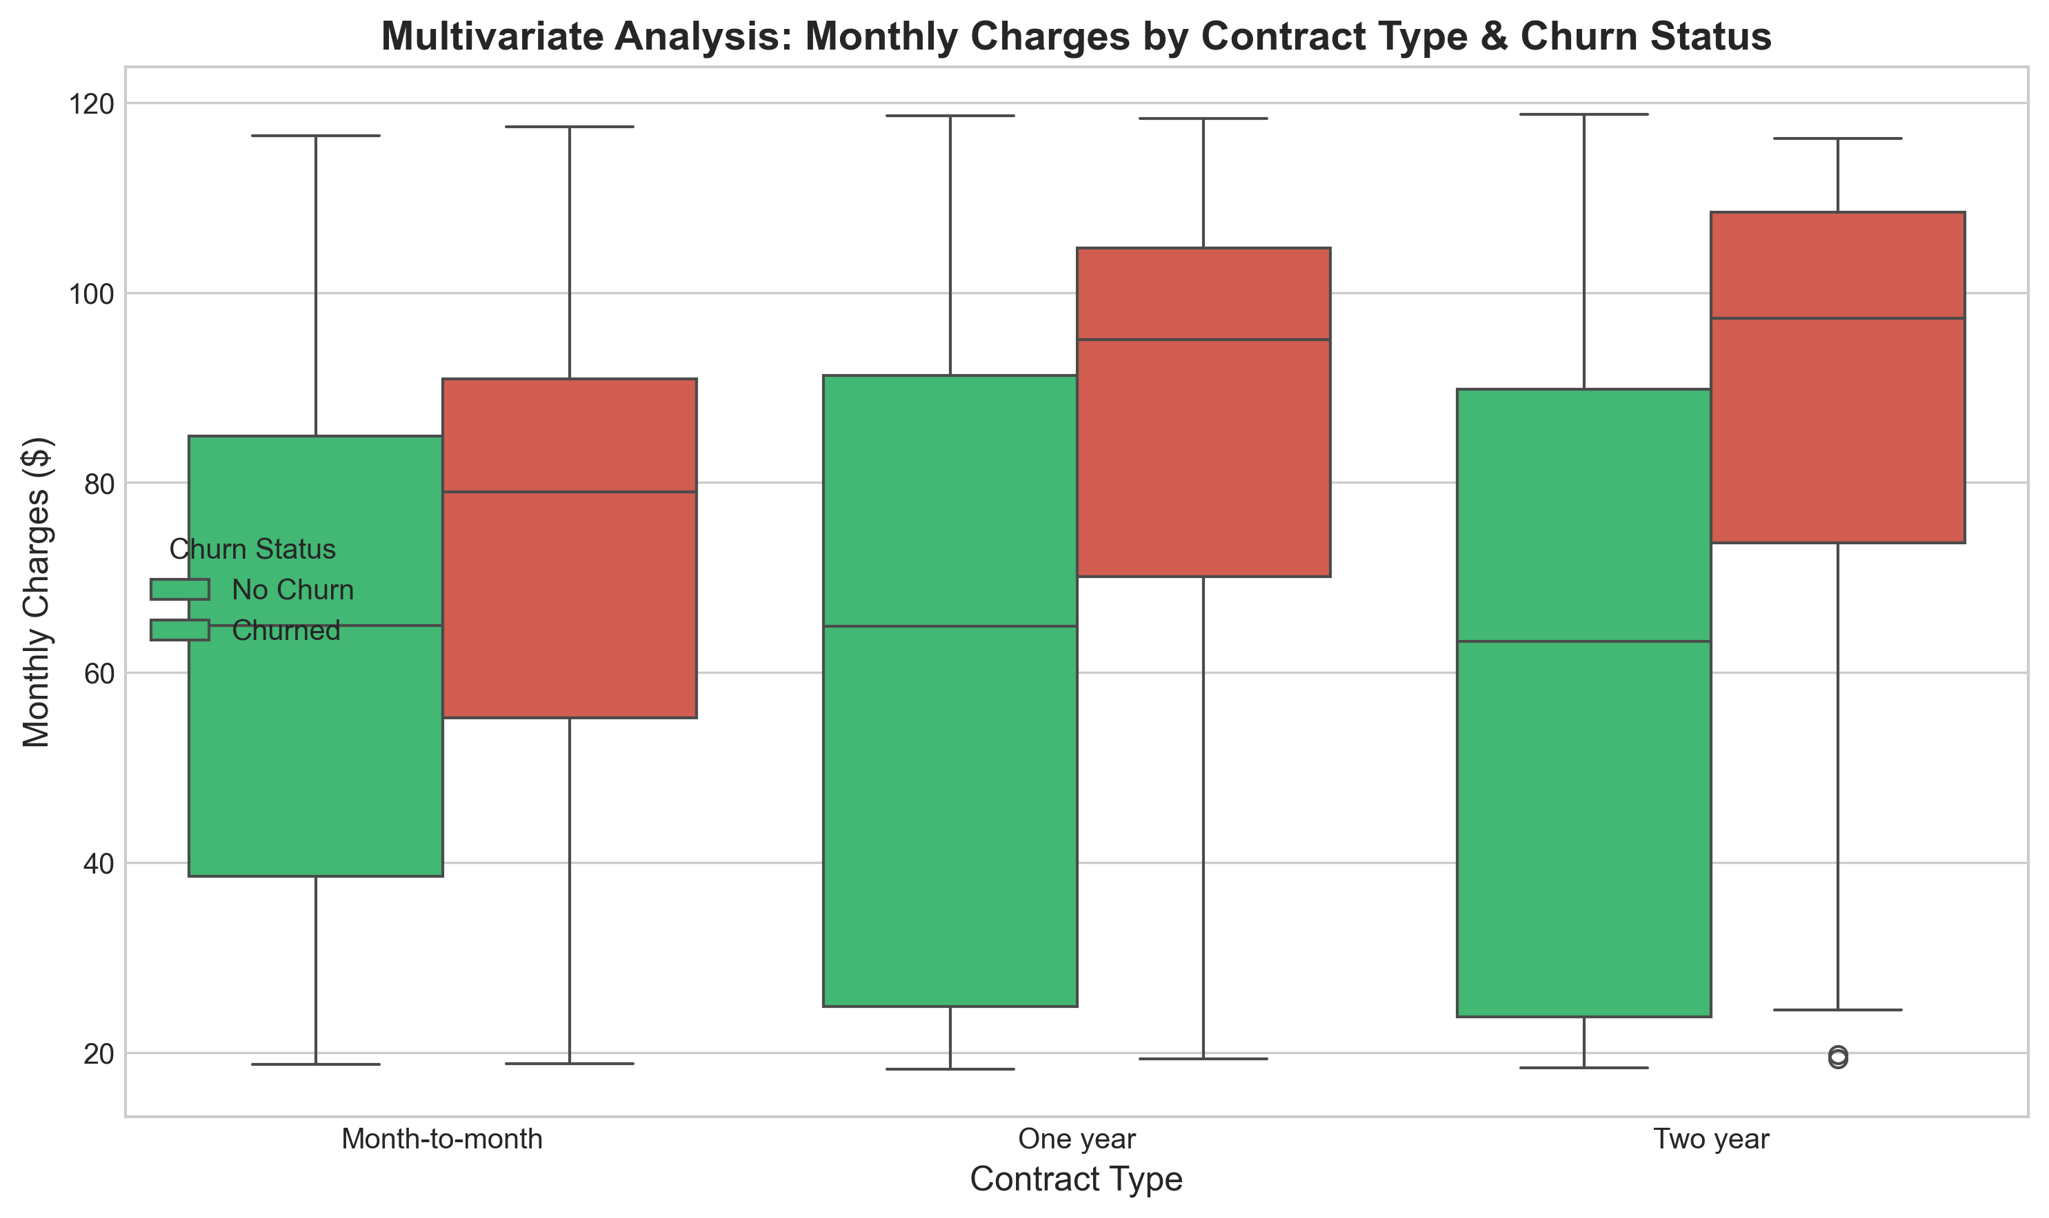

10. Churn Analysis
Overall target distribution: 5,174 retained customers (73.46%) vs 1,869 churned customers (26.54%). Table 2 outlines actual churn rates across key customer categories:
Category | Subgroup | Total Customers | Churned Count | Churn Rate (%)
Contract | Month-to-Month | 3,875 | 1,655 | 42.71%
Contract | Two Year | 1,695 | 48 | 2.83%
Internet Service | Fiber Optic | 3,096 | 1,297 | 41.89%
Payment Method | Electronic Check | 2,365 | 1,071 | 45.29%
Tenure Cohort | 0–12 Months | 2,186 | 1,037 | 47.44%
Tenure Cohort | 61–72 Months | 1,407 | 93 | 6.61%

11. Correlation Analysis
Numerical features exhibit key linear correlations with Churn (0/1): tenure (r = -0.352), MonthlyCharges (r = +0.193), TotalCharges (r = -0.199).
Figure 11.1: Correlation Heatmap Matrix
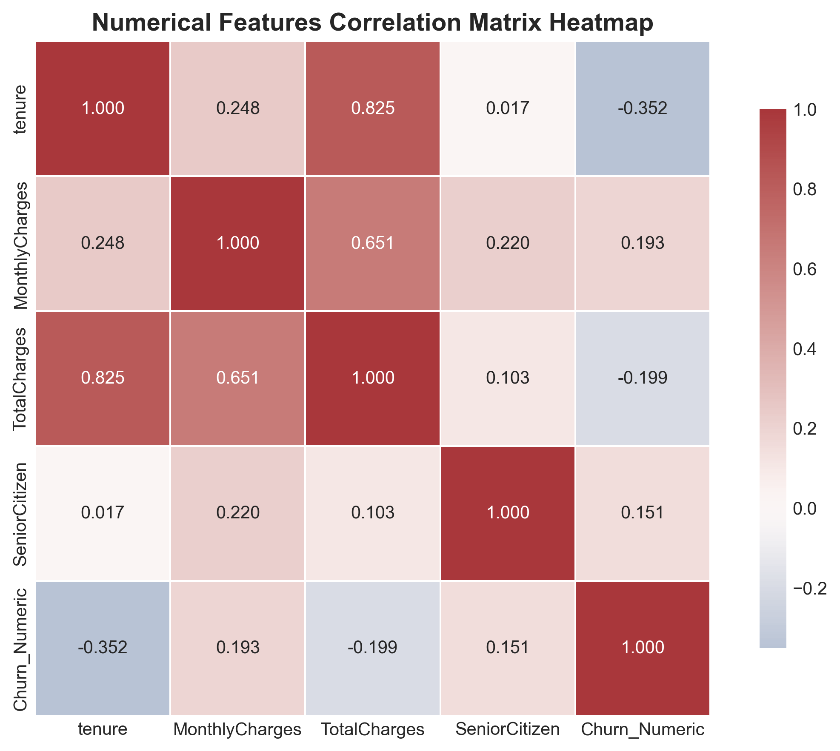

12. Key Findings
1. Target Class Imbalance: 26.54% overall churn rate.
2. Contract Risk: Month-to-Month subscribers churn at 42.71% vs 2.83% for 2-Year plans.
3. Internet Service Risk: Fiber Optic subscribers churn at 41.89% vs 18.96% for DSL.
4. Payment Method Risk: Electronic Check users churn at 45.29%.
5. Tenure Risk: 0–12 Month subscribers churn at 47.44% vs 6.61% for 61–72 Months.
6. Security Services: Lack of Online Security increases churn to 41.77%.
7. Tech Support: Lack of Tech Support increases churn to 41.64%.
8. Demographics: Senior citizens churn at 41.68% vs 23.61% for non-seniors.

13. Business Insights
• DATA FINDING: Month-to-Month contracts exhibit 42.71% churn.
- BUSINESS RECOMMENDATION: Introduce a 15% discount for 1-year contract renewals.
• DATA FINDING: Fiber Optic users churn at 41.89% with high monthly bills ($91.50 avg).
- BUSINESS RECOMMENDATION: Bundle free Online Security and Tech Support for Fiber optic tiers.
• DATA FINDING: Electronic Check users exhibit 45.29% churn.
- BUSINESS RECOMMENDATION: Provide a $5/month bill credit for switching to Auto Credit Card / ACH.

14. Challenges Faced
• Target Class Imbalance (~2.77:1 ratio) requiring careful metric selection.
• Pandas 3.0 StringDtype migration for categorical crosstab aggregations.

15. Limitations
• Historical cross-sectional snapshot lacks real-time time-series telemetry.
• Observational EDA proves correlation, not direct causality.

16. Impact on Future Modeling
EDA confirms Contract, Tenure, InternetService, MonthlyCharges, and PaymentMethod as top predictive features for Week 4 machine learning.

17. Conclusion
Week 2 EDA successfully isolated primary risk factors: short contract terms, high monthly fees, fiber optic service without support add-ons, and electronic check payment methods.

18. References
1. IBM Telco Customer Churn Public Dataset.
2. McKinney, W. (2010). Data Structures for Statistical Computing in Python.
3. Waskom, M. L. (2021). Seaborn: statistical data visualization.

19. Submission Description
This Week 2 submission for the Data Science Internship program delivers a comprehensive, data-backed Exploratory Data Analysis (EDA) and visualization pipeline built upon the sanitized IBM Telco Customer Churn dataset (`data/processed/cleaned_telco_churn.csv`). Executed by Sindhu Patil, the analysis encompasses structural dataset audits, descriptive statistics calculations (mean, median, standard deviation, interquartile range), univariate distribution plots, bivariate churn cross-tabulations, multivariate factor interactions, and numerical correlation matrix heatmaps. The analysis evaluated 7,043 customer records, establishing an overall target churn rate of 26.54% (1,869 churners vs 5,174 retained customers). Bivariate analysis isolated major churn drivers: Month-to-Month contracts (42.71% churn rate), Fiber Optic internet service (41.89% churn rate), Electronic Check payment methods (45.29% churn rate), and initial tenure subscribers under 12 months (47.44% churn rate). All visual figures were programmatically generated and exported to `outputs/figures/week2/` at 300 DPI resolution. The deliverables include an 18-section executable Jupyter Notebook (`notebooks/week2_eda.ipynb`), modular visualization source code (`src/visualization.py`), updated GitHub project documentation (`README.md`), and this formal Word executive report (`reports/week2_report.docx`). These empirical findings directly inform feature selection and strategy formulation for upcoming clustering and classification weeks.

