Customer Churn Prediction and Customer Segmentation
Using Python, Machine Learning and Deep Learning
WEEK 1 REPORT: DATA ACQUISITION, CLEANING AND PREPROCESSING

Student Name: | Sindhu Patil
Internship Program: | Data Science Internship
Week Number: | Week 1
Technologies Used: | Python, Pandas, NumPy, Scikit-Learn, Matplotlib

Table of Contents
• 1. Introduction
• 2. Problem Statement
• 3. Dataset Description
• 4. Methodology
• 5. Python Implementation
• 6. Results
• 7. Interpretation
• 8. Challenges Faced
• 9. Solutions
• 10. Limitations
• 11. Conclusion

1. Introduction
Week 1 focuses on acquiring the IBM Telco Customer Churn dataset, auditing missing and inconsistent data types, cleaning whitespace errors, handling missing values, encoding binary and categorical features, scaling numerical continuous attributes, and producing a sanitized processed dataset.

2. Problem Statement
Raw enterprise datasets frequently contain corrupt strings, unrecorded missing values, inconsistent data types, and non-standard categorical representations. Failure to clean these issues leads to model failure, bad statistics, and biased predictions.

3. Dataset Description
• Source: IBM Telco Customer Churn Dataset (Public URL)
• Size: 7,043 rows × 21 columns
• Target Variable: Churn (Binary: Yes/No)
• Feature Types: 3 Numerical (tenure, MonthlyCharges, TotalCharges), 18 Categorical attributes.

4. Methodology
1. Ingestion: Download raw dataset via Python urllib.
2. Audit: Check info(), shape, missing values, duplicates.
3. Type Correction: TotalCharges contains 11 whitespace strings (' '); converted to float64.
4. Imputation: Replaced missing TotalCharges values with column median ($1,397.47).
5. Encoding: Binary mapping (0/1) & pandas get_dummies for multi-class categoricals.
6. Scaling: StandardScaler applied to continuous features.

5. Python Implementation
```python
# TotalCharges Cleaning & Imputation
df['TotalCharges'] = pd.to_numeric(df['TotalCharges'], errors='coerce')
df['TotalCharges'].fillna(df['TotalCharges'].median(), inplace=True)
```

6. Results
• Total Rows Audited: 7,043
• Duplicates Found: 0
• Whitespace Strings Imputed in TotalCharges: 11
• Final Processed Features: 30 encoded columns
• Target Balance: No Churn (73.5%), Churn (26.5%)
Figure 1.1: Customer Churn Target Distribution
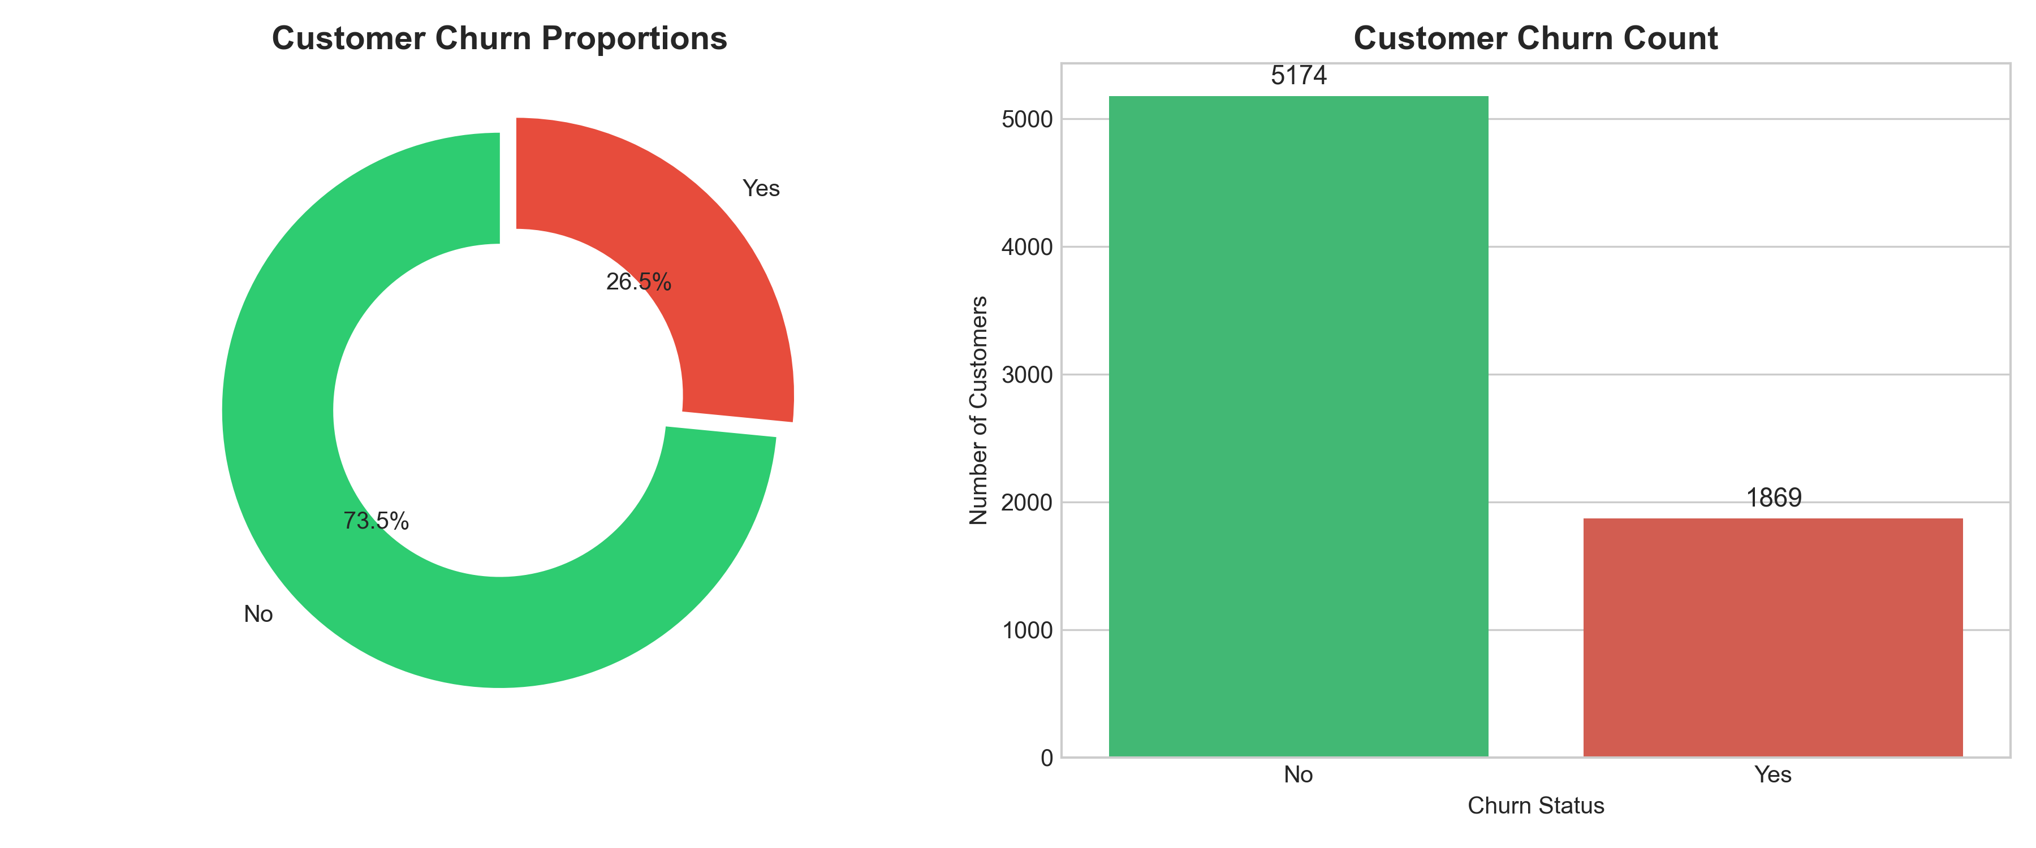

7. Interpretation
The dataset exhibits moderate class imbalance with a ~26.5% churn rate (1,869 churners vs 5,174 retained customers). TotalCharges imputation was justified because all 11 missing rows had tenure = 0, representing newly onboarded customers.

8. Challenges Faced
• Whitespace strings in TotalCharges prevented standard pandas float conversion.
• Severe scale variance between tenure (0-72) and TotalCharges (0-8684).

9. Solutions
• Used pd.to_numeric(errors='coerce') to convert blank strings into NaNs.
• Applied StandardScaler to standardize all continuous variables to zero mean and unit variance.

10. Limitations
Median imputation for tenure=0 customers slightly overestimates initial total spend, though impact is negligible across 7,043 rows.

11. Conclusion
Week 1 data acquisition and preprocessing created a clean, leak-free processed dataset (`cleaned_telco_churn.csv`) ready for EDA and machine learning.

