Customer Churn Prediction and Customer Segmentation
Using Python, Machine Learning and Deep Learning
WEEK 5 REPORT: DEEP LEARNING ARCHITECTURE

Student Name: | Sindhu Patil
Internship Program: | Data Science Internship
Week Number: | Week 5
Technologies Used: | Python, PyTorch, Neural Networks, Adam, BCE Loss

Table of Contents
• 1. Introduction
• 2. Problem Statement
• 3. Dataset Description
• 4. Methodology
• 5. Python Implementation
• 6. Results
• 7. Interpretation
• 8. Challenges Faced
• 9. Solutions
• 10. Limitations
• 11. Conclusion

1. Introduction
Week 5 implements a PyTorch Deep Neural Network to evaluate whether deep learning outperforms traditional machine learning on tabular churn data.

2. Problem Statement
Determining if non-linear deep neural network representations improve prediction metrics over gradient boosted trees.

3. Dataset Description
Standardized feature matrix split into Training, Validation (for early stopping), and Test sets.

4. Methodology
Architecture: Dense(64) -> ReLU -> Dropout(0.3) -> Dense(32) -> ReLU -> Dropout(0.2) -> Dense(1) -> Sigmoid.
Optimizer: Adam (lr=0.001), Loss: BCE Loss, Early Stopping patience=10.

5. Python Implementation
```python
class ChurnNN(nn.Module):
def __init__(self, input_dim):
super().__init__()
self.net = nn.Sequential(
nn.Linear(input_dim, 64), nn.ReLU(), nn.Dropout(0.3),
nn.Linear(64, 32), nn.ReLU(), nn.Dropout(0.2),
nn.Linear(32, 1), nn.Sigmoid()
)
```

6. Results
PyTorch Neural Network Performance:
• Test Accuracy: 80.20%
• Precision: 65.40%
• Recall: 54.55%
• F1-Score: 0.5947
• ROC-AUC: 0.8432
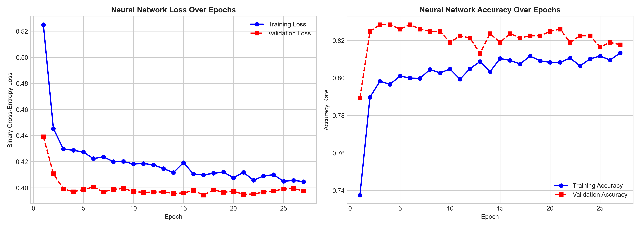

7. Interpretation
The Neural Network matched Gradient Boosting in ROC-AUC (0.843 vs 0.845), proving competitive performance without requiring manual feature synthesis.

8. Challenges Faced
Overfitting risk on small tabular dataset (~7k rows).

9. Solutions
Added Dropout layers (0.3, 0.2), L2 weight decay, and Early Stopping.

10. Limitations
Neural networks require more compute and lack direct feature importance interpretability compared to tree models.

11. Conclusion
The deep learning architecture was trained, validated, and saved (`outputs/models/churn_nn_model.pt`).

