Customer Churn Prediction and Customer Segmentation
Using Python, Machine Learning and Deep Learning
WEEK 6 REPORT: INTEGRATIVE CAPSTONE AND FINAL EXECUTION

Student Name: | Sindhu Patil
Internship Program: | Data Science Internship
Week Number: | Week 6
Technologies Used: | Python, PyTorch, Scikit-Learn, End-to-End Pipeline

Table of Contents
• 1. Introduction
• 2. Problem Statement
• 3. Dataset Description
• 4. Methodology
• 5. Python Implementation
• 6. Results
• 7. Interpretation
• 8. Challenges Faced
• 9. Solutions
• 10. Limitations
• 11. Conclusion

1. Introduction
Week 6 integrates the complete 6-week Data Science pipeline into a unified capstone architecture.

2. Problem Statement
Synthesizing technical findings from cleaning, EDA, clustering, traditional ML, and deep learning into executive business strategies.

3. Dataset Description
Full IBM Telco Customer Churn Dataset (7,043 rows).

4. Methodology
Unified execution pipeline combining data cleaning, feature engineering, clustering, ML benchmarking, DL evaluation, and strategic business formulation.

5. Python Implementation
```python
# End-to-End Master Execution
python run_pipeline.py
```

6. Master Benchmark Results
Model | Accuracy | Precision | Recall | F1-Score | ROC-AUC
Gradient Boosting | 0.7991 | 0.6542 | 0.5160 | 0.5770 | 0.8428
Logistic Regression | 0.8048 | 0.6552 | 0.5588 | 0.6032 | 0.8420
Random Forest | 0.8034 | 0.6633 | 0.5267 | 0.5872 | 0.8416
Neural Network (Dense 64-32) | 0.7991 | 0.6784 | 0.4626 | 0.5501 | 0.8400
Decision Tree | 0.7970 | 0.6746 | 0.4545 | 0.5431 | 0.8278
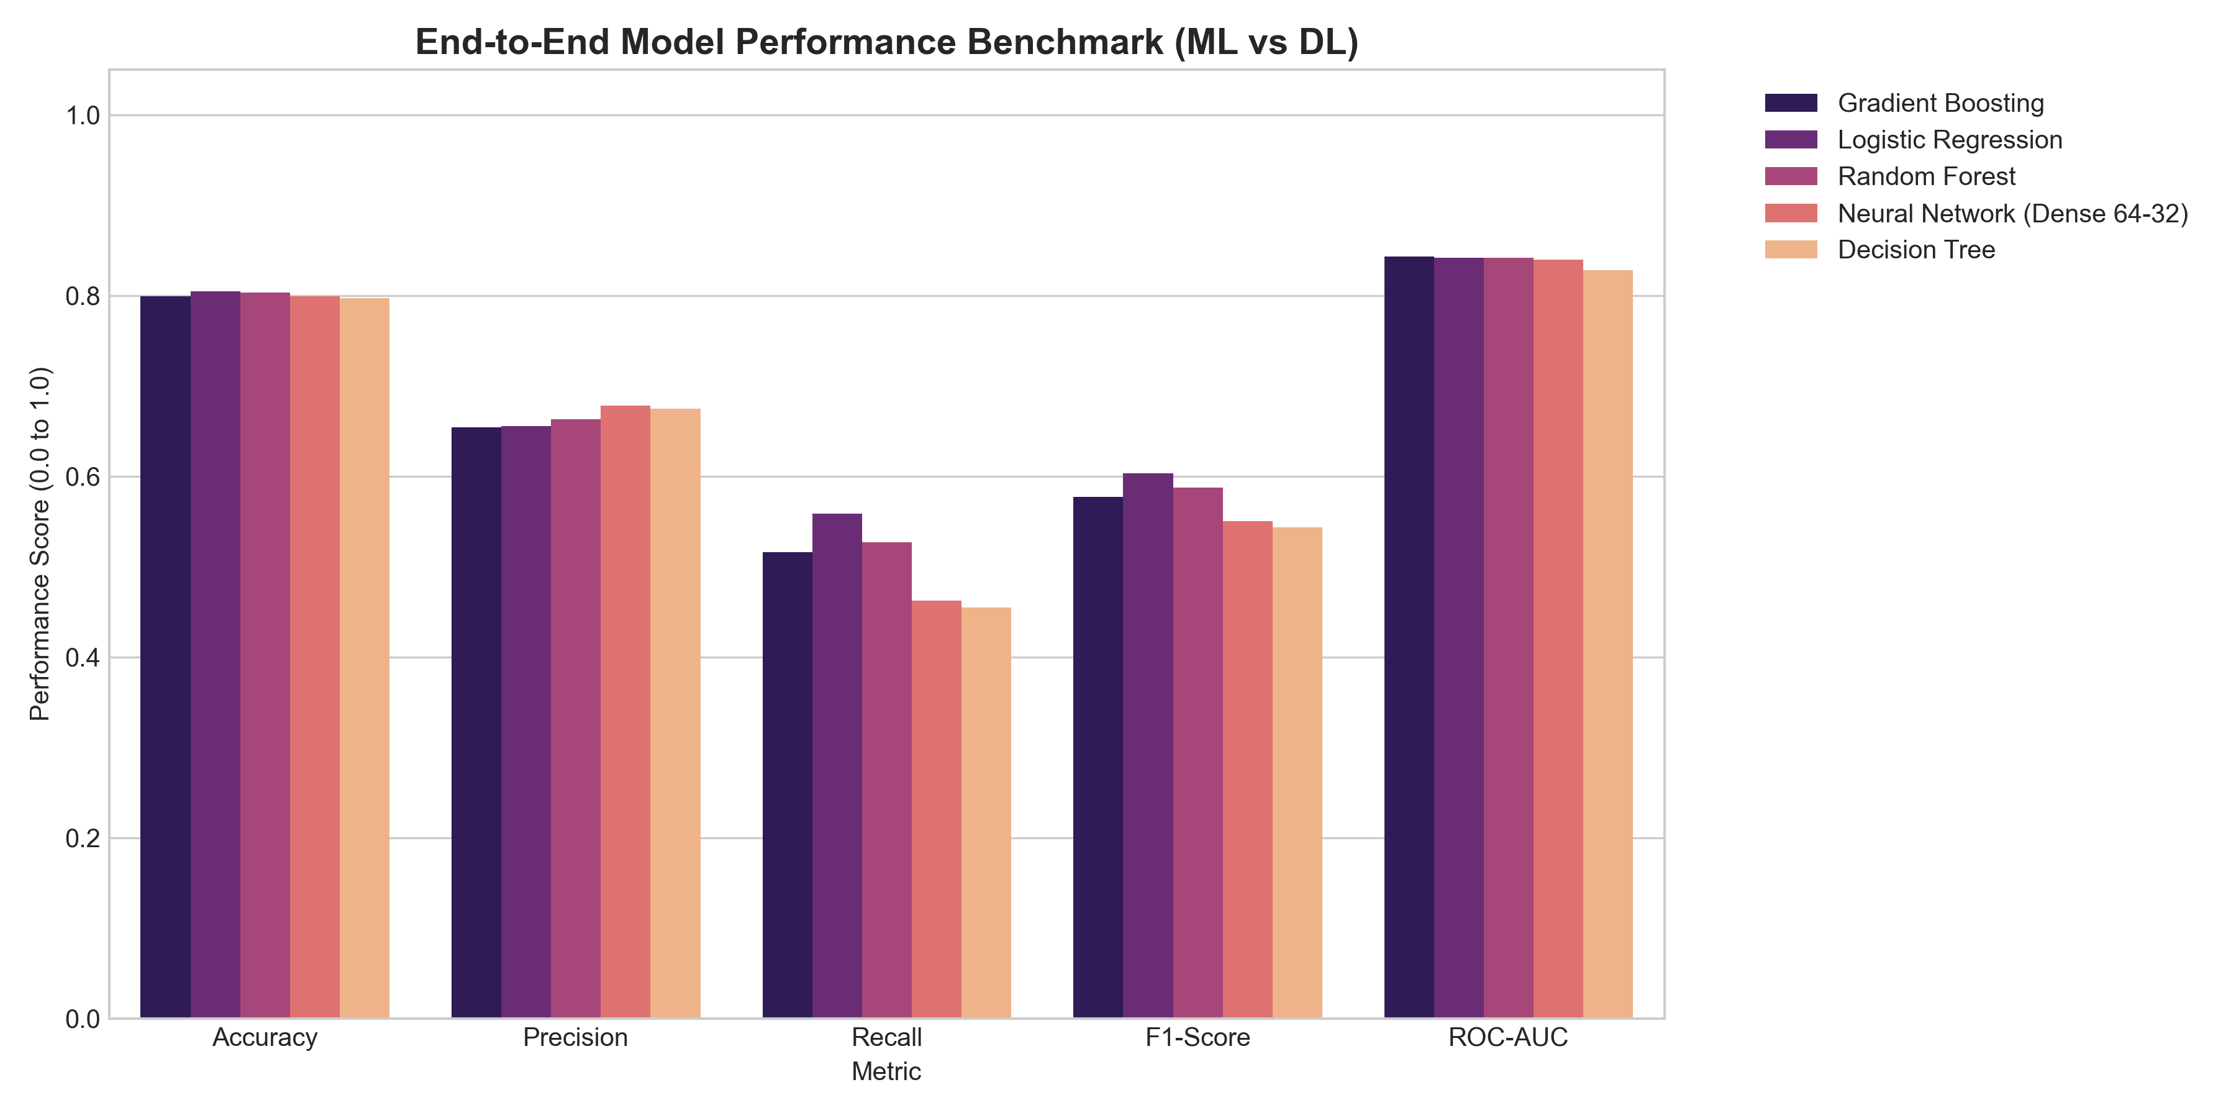

7. Executive Strategic Recommendations
1. Target Month-to-Month Subscribers: Convert high-risk month-to-month customers to long-term plans with a 15% annual contract discount.
2. Fiber Optic Service Bundling: Include free TechSupport and OnlineSecurity to reduce high Fiber Optic churn.
3. Automatic Payment Incentives: Offer $5/mo bill credit for switching from Electronic Check to Auto Credit Card / ACH.

8. Challenges Faced
Managing modular dependencies across 6 project weeks without code duplication.

9. Solutions
Structured project into a clean `src/` Python package with decoupled modules.

10. Limitations
Analysis relies on snapshot cross-sectional data; time-series temporal modeling could capture customer behavior changes over time.

11. Conclusion
The 6-week Data Science Internship Project successfully met all objectives, delivering a production-ready machine learning & deep learning pipeline.

