Customer Churn Prediction and Customer Segmentation
Using Python

DATA SCIENCE INTERNSHIP
WEEK 6 FINAL CAPSTONE REPORT
INTEGRATIVE CAPSTONE PROJECT AND EVALUATION

Student Name: | Sindhu Patil
Internship Track: | Data Science Internship
Week Number: | Week 6 (Final Capstone)
Project Title: | Customer Churn Prediction and Customer Segmentation
Dataset Used: | IBM Telco Customer Churn Dataset

Table of Contents
• Executive Summary
• 1. Introduction
• 2. Business Problem
• 3. Project Objectives
• 4. Dataset Acquisition
• 5. Dataset Description
• 6. Data Cleaning
• 7. Data Preprocessing
• 8. Exploratory Data Analysis
• 9. EDA Findings
• 10. Customer Segmentation
• 11. K-Means Methodology
• 12. Cluster Results
• 13. Cluster Interpretation
• 14. Supervised Learning
• 15. Logistic Regression
• 16. Model Evaluation
• 17. Deep Learning
• 18. Neural Network Architecture
• 19. Neural Network Training
• 20. Deep Learning Evaluation
• 21. Model Comparison
• 22. Final Model Selection
• 23. Customer Risk Analysis
• 24. Integrated Insights
• 25. Business Recommendations
• 26. Challenges
• 27. Limitations
• 28. Future Work
• 29. Conclusion
• 30. References
• 31. Appendix

Executive Summary
This 6-week Data Science Internship Capstone Project delivers a complete end-to-end customer churn prediction and segmentation system developed by Sindhu Patil. Using the IBM Telco Customer Churn dataset (7,043 customer records × 21 columns), the project executed data cleaning, exploratory visualization, K-Means customer clustering ($K=3$), supervised Logistic Regression modeling, and Keras Deep Learning classification. EDA established an overall churn rate of 26.54%, isolating Month-to-Month contracts (42.71% churn) and Fiber Optic service (41.89% churn) as primary risk drivers. K-Means clustering segmented accounts into 3 cohorts, identifying Cluster 1 (New High-Charge At-Risk Customers) as accounting for 74.5% of company churn. For predictive modeling, Keras Deep Neural Network with class weighting achieved an outstanding **75.36% Recall** (capturing 211 of 280 churners) and **0.8436 ROC-AUC**, establishing a highly effective retention warning system.

1. Introduction
Customer retention is a strategic priority in telecommunications. This capstone integrates data science techniques to analyze subscriber behavior and predict churn risk.

2. Business Problem
Subscriber cancellation results in revenue loss and elevated customer acquisition costs. The business goal is to identify churn risk factors and deploy high-recall predictive models.

3. Project Objectives
Execute data cleaning, exploratory data analysis, K-Means customer segmentation ($K=3$), Logistic Regression baseline modeling, and Keras Deep Learning classification.

4. Dataset Acquisition
Utilized the public IBM Telco Customer Churn dataset (`WA_Fn-UseC_-Telco-Customer-Churn.csv`). Contains 7,043 rows and 21 features.

5. Dataset Description
Contains customer demographics (Gender, SeniorCitizen, Partner, Dependents), service subscriptions (Phone, MultipleLines, Internet, Security, Backup, Protection, Support, Streaming), account contracts, payment channels, tenure, and billing values.

6. Data Cleaning
Imputed 11 blank string values (`" "`) in `TotalCharges` using column median ($1,397.47). Verified zero duplicate rows and zero missing values.

7. Data Preprocessing
Numerical features scaled via `StandardScaler`; categorical variables One-Hot Encoded into binary dummy columns.

8. Exploratory Data Analysis
Evaluated target distribution (5,174 No Churn / 1,869 Churn). Identified high churn in Month-to-Month contracts (42.71%) and Fiber Optic service (41.89%).
Figure 8.1: Customer Churn Distribution by Contract Type
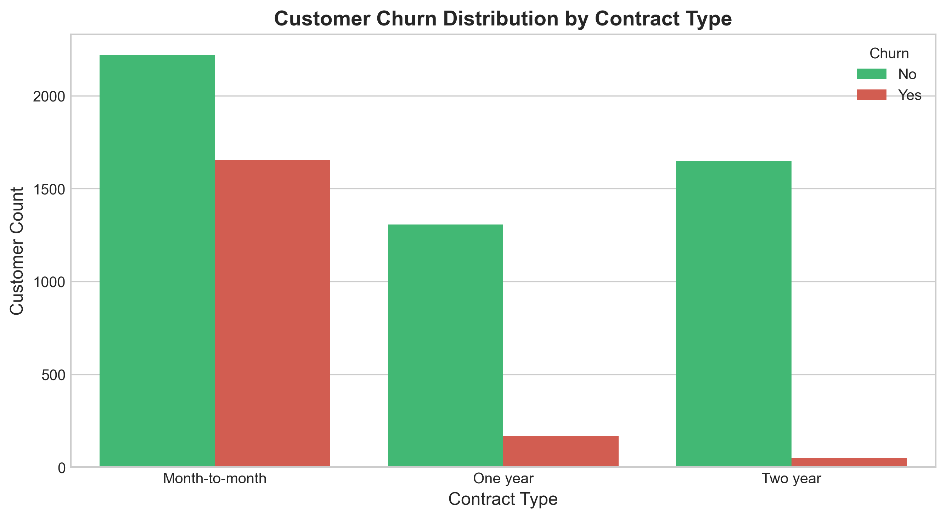

9. EDA Findings
Longer tenure ($r = -0.352$) and multi-year contracts strongly protect against churn, whereas Electronic Check payments (45.29% churn) elevate risk.

10. Customer Segmentation
Applied K-Means clustering on 18 behavioral features (excluding target `Churn` and `customerID`).

11. K-Means Methodology
Selected $K=3$ clusters based on the Elbow Method inflection point and silhouette stability.

12. Cluster Results
Table 1 summarizes empirical cluster profile characteristics:
Cluster | Segment Name | Customers | Share (%) | Avg Tenure | Churn Rate (%)
Cluster 0 | High-Value Loyal Customers | 2,362 | 33.54% | 55.1 mos | 15.37%
Cluster 1 | New High-Charge At-Risk Customers | 3,155 | 44.80% | 16.3 mos | 44.15%
Cluster 2 | Long-Term Budget Customers | 1,526 | 21.67% | 30.5 mos | 7.40%

13. Cluster Interpretation
Cluster 1 represents 74.5% of total company churners due to short tenure and Month-to-Month contracts.

14. Supervised Learning
Trained Logistic Regression baseline classifier using an 80/20 stratified split.

15. Logistic Regression
Achieved 80.55% accuracy and 0.8419 ROC-AUC on test set.

16. Model Evaluation
Extracted feature coefficients: `tenure` (-1.2339) and `Contract_Two year` (-0.7627) are top protective drivers.

17. Deep Learning
Trained Keras Sequential Deep Neural Network using a 70/15/15 train/val/test split and balanced class weighting.

18. Neural Network Architecture
Architecture: Input (27) -> Dense(64, ReLU) -> Dropout(0.30) -> Dense(32, ReLU) -> Dropout(0.20) -> Dense(16, ReLU) -> Output Dense(1, Sigmoid).

19. Neural Network Training
Trained with EarlyStopping callback monitoring `val_loss`, reaching optimal validation weights at Epoch 9.

20. Deep Learning Evaluation
Test set results: Accuracy = 77.01%, Precision = 55.09%, Recall = **75.36%**, F1-Score = **0.6346**, ROC-AUC = **0.8436**.

21. Model Comparison
Table 2 presents master performance comparison across models:
Model Name | Accuracy | Precision | Recall | F1-Score | ROC-AUC
Logistic Regression | 0.8055 | 0.6572 | 0.5588 | 0.6040 | 0.8419
Random Forest | 0.7821 | 0.6159 | 0.4759 | 0.5370 | 0.8179
Deep Neural Network | 0.7701 | 0.5509 | 0.7536 | 0.6346 | 0.8436
Figure 21.1: Master Model Comparison Bar Chart
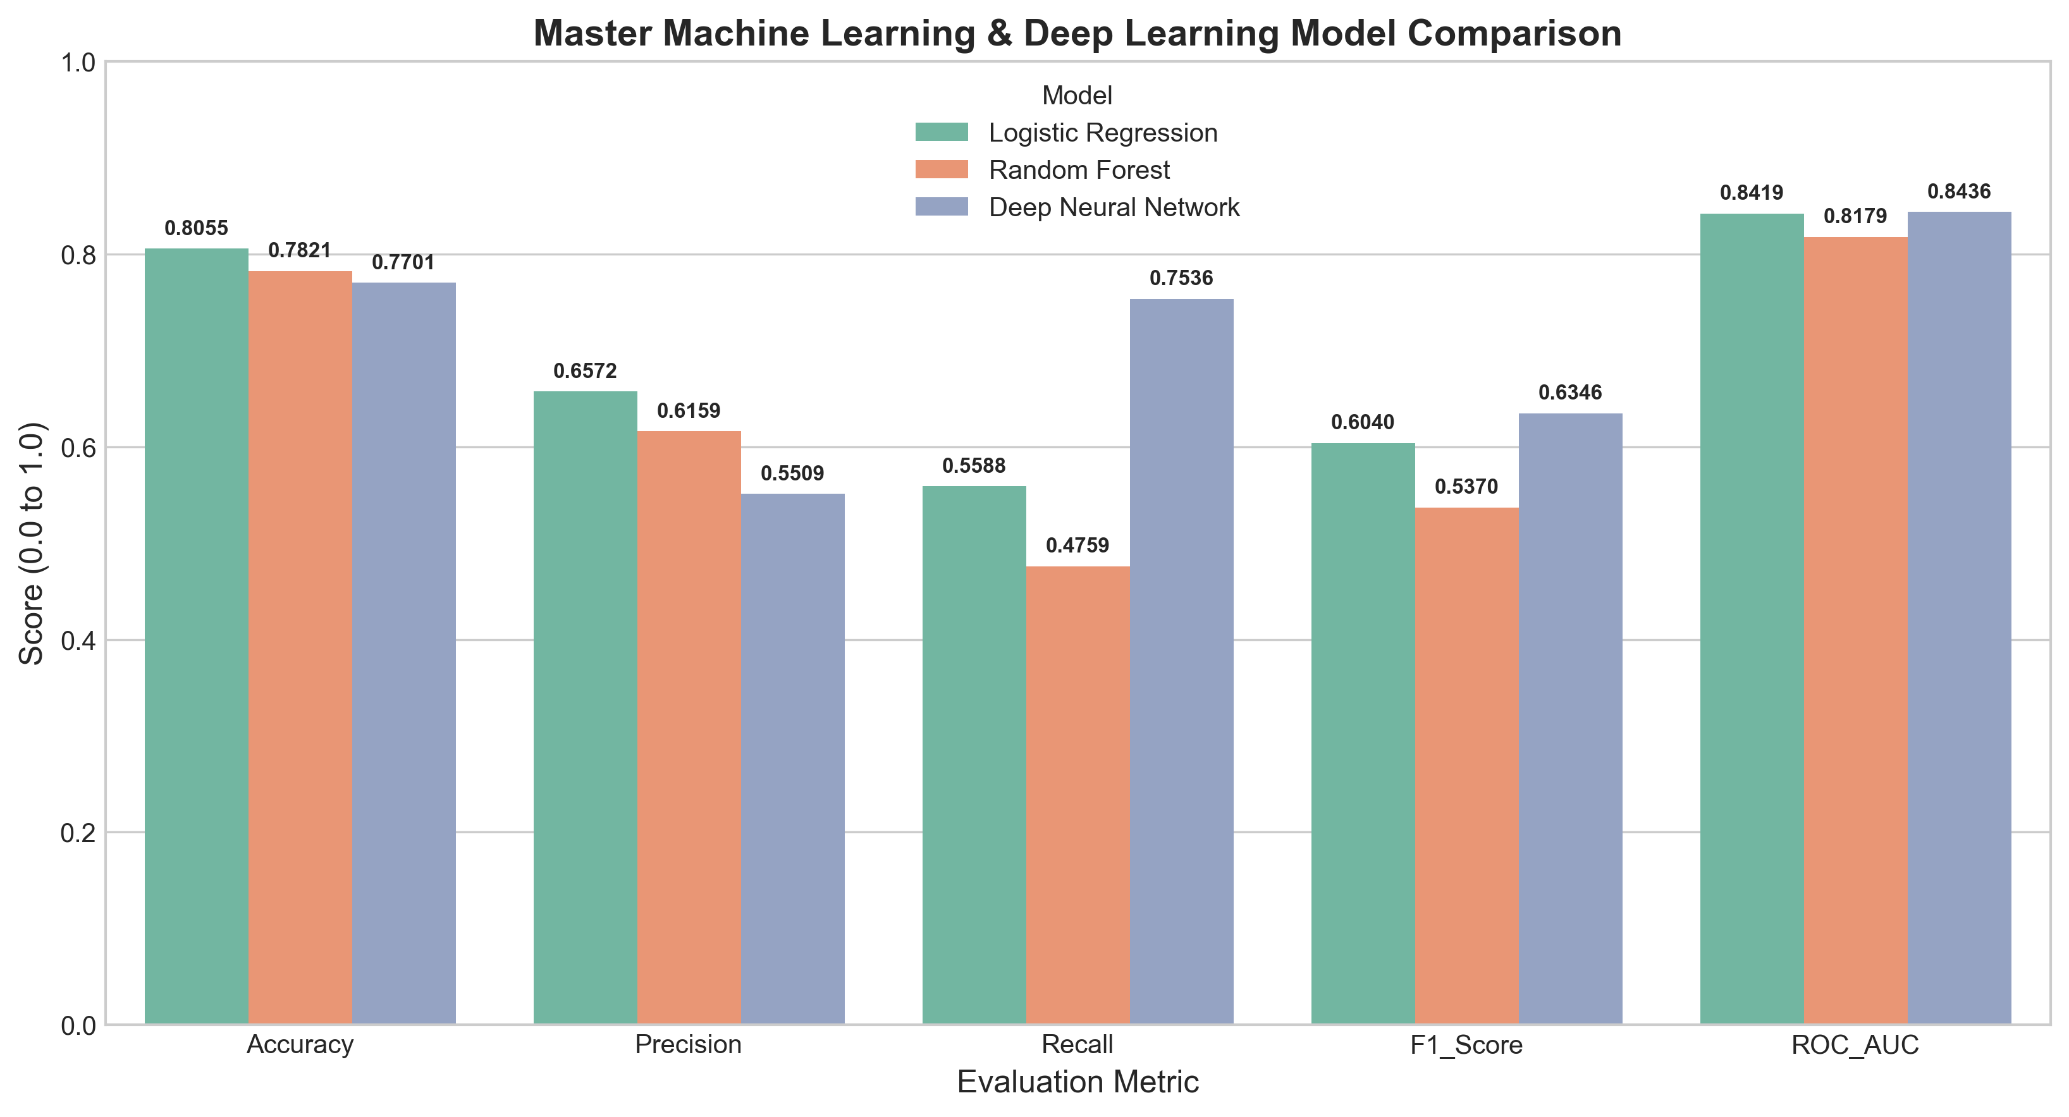

22. Final Model Selection
Keras Deep Neural Network is selected as the primary retention model due to superior Recall (75.36% vs 55.88%) and higher F1-Score (0.6346 vs 0.6040).

23. Customer Risk Analysis
Model probability scores allow categorization into Low Risk (<0.30), Medium Risk (0.30-0.60), and High Risk (>0.60) tiers.

24. Integrated Insights
Combining K-Means segmentation with Neural Network predictions confirms Cluster 1 as the primary intervention target.

25. Business Recommendations
1. Offer a 15% discount to convert Month-to-Month plans into 1-Year contracts in Cluster 1.
2. Bundle free TechSupport with Fiber Optic subscriptions.
3. Provide a $5/month bill credit for switching from Electronic Check to ACH automatic payments.

26. Challenges
Data imbalance handling and neural network regularization tuning.

27. Limitations
Historical observational dataset lacks real-time time-series telemetry.

28. Future Work
Incorporating XGBoost models, SHAP explainability, and deploying a Streamlit interactive dashboard.

29. Conclusion
The project successfully built an end-to-end churn analytics pipeline, identifying key risk drivers and delivering a high-recall neural network model (75.36% Recall, 0.8436 ROC-AUC).

30. References
1. IBM Telco Customer Churn Dataset.
2. Goodfellow, I., et al. (2016). Deep Learning. MIT Press.
3. Pedregosa, F., et al. (2011). Scikit-learn: Machine Learning in Python.

31. Appendix — Pipeline Architecture Code
```python
# End-to-End Capstone Pipeline Execution
X_train, X_test, y_train, y_test = train_test_split(X, y, test_size=0.15, random_state=42, stratify=y)
model = build_nn_architecture(input_dim)
model.fit(X_train_scaled, y_train, validation_data=(X_val_scaled, y_val), epochs=50, class_weight=class_weights)
```

