CAPSTONE PROJECT

Echo - Al Mental Health Companion

Emp Name: Reddyvari Sai Sindhu
Emp Id: 8173490

Project Title

Echo - An Empathetic, Multi-Agent Al Mental Health Companion
Built using Google Agent Development Kit (ADK) and Gemini models

Problem Statement
In today's fast-paced world, millions of people experience stress, anxiety, low mood, or momentary crises but do not have immediate access to professional mental health support due to:
  - High cost of therapy

  - Long waiting times

  - Social stigma (especially in countries like India)

  - Lack of 24/7 human availability

  - Language and cultural barriers

While many chatbots exist, most of them are either
- purely conversational with no real therapeutic value, or
- clinically oriented and therefore legally restricted.

There is a clear need for a free, always-available, non-clinical Al companion that can:

  - Listen empathetically without judgment

  - Detect escalating crises in real time (multi-language support)

  - Track mood trends over weeks

  - Deliver evidence-based, personalized coping strategies

  - Strongly encourage professional help when needed

Proposed Solution - Echo
Echo is a compassionate Al companion (NOT a therapist) that combines reflective listening, mood tracking, crisis detection, and high-quality coping strategy generation in a single multi-agent architecture.
Key differentiators:

  - 100% non-clinical positioning with clear disclaimers

  - Real-time crisis detection in English, Hindi, Spanish, Arabic(+ easy to extend)

  - Evidence-based coping strategies sourced live from HelpGuide.org

  - Iterative quality assurance loop (Generator ➔ Checker ➔ Refiner) ensuring every strategy is safe, personalized, and useful
  - Weekly progress reports that celebrate growth

Objectives

Primary Objectives Secondary Objectives
Provide empathetic emotional support 24/7 Multilingual crisis keyword detection Detect crisis situations instantly Generate personalized coping strategies

Track mood patterns over time Deliver compassionate weekly progress reports Deliver safe, evidence-based coping tools Easy to extend with new languages/countries

5.System Architecture {High-Level}

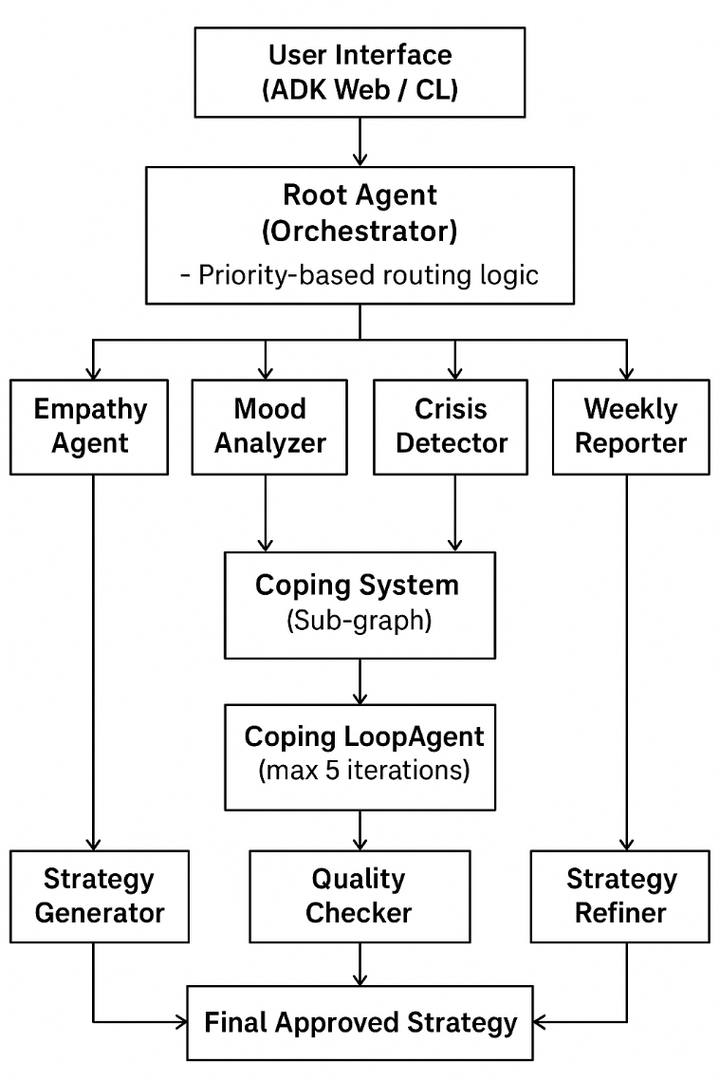
 |  |  | Triggers I
Agent | File | Responsibility | Conditions
Root Agent | agent.py | Orchestrates everything, | Every user message
 |  | decides routing priority
Empathy | empathy_agent.py | Reflective listening, | Default path, venting,
Agent |  | validation, warm responses | casual check-ins
Mood | mood_analyzer.py | Scores mood 0-10, stores | Every 3-5 messages
Analyzer |  | history for trends | or on low mood
Crisis | crisis_detector.py | Immediate safety response+ | Keywords detected
Detector |  | hotline numbers (multi- | (highest priority
 |  | country & multi-language) | override)
Weekly | weekly_reporter.py | Beautiful weekly summary | User asks or 7+ days
Reporter |  | with graphs & positive | since last report
 |  | reinforcement
Strategy | strategy_generator.py | Searches HelpGuide.org live, | Coping request or
Generator |  | drafts 100-200 word strategy | prolonged low mood
Quality | quality_checker.py | Checks 7 quality criteria, | After every generated
Checker |  | gives structured feedback | strategy
Strategy | strategy_refiner.py | Improves strategy using | When quality score <
Refiner |  | feedback, may search again | 100%
Coping LoopAgent | (ADK LoopAgent) | Runs Generator➔ Checker ➔ Refiner up to 5 times until | Initiated by root when coping needed
 |  | perfect

Agent Routing Priority {Root Agent Logic)

1. Crisis keywords detected → crisis_detector (immediate override)

2. User asks for weekly report AND 7+ days passed → weekly_reporter

3. User explicitly asks for coping help OR mood ≤ 4 for 2 consecutive days → coping sub-graph

4. Every 3–5 messages → mood_analyzer (background)

5. Everything else → empathy_agent

Data Flow & Shared State {via ADK GraphState)

State Key  user_context | Type  List[dict] | Used by  All agents | Example Value  Conversation history
user_mood | float(0-10) | Mood Analyzer, Coping, Reporter | 3.2
mood_history | List[{date, mood}] | Weekly Reporter | [{"2025-11-28": 4.1},...]
crisis_response | str | Crisis Detector ➔ User | "I'm really worried about you... call 988"
coping_strategy | str | Coping sub-graph ➔ User | Full 150-word strategy
feedback | diet | Quality Checker ➔ Refiner | {"criteria_1": False, "notes":"..."}
weekly_report | str | Weekly Reporter➔ User | Markdown report with chart

Crisis Detection Keywords {Multilingual)
Language Example Keywords

English kill myself, want to die, suicidal, end it all, no reason to live

Spanish quiero morir, matarme, suicidarme

Hotline numbers are automatically selected based on detected country or default to findahelpline.com.

Technology Stack

Component Technology Used

Framework Google Agent Development Kit (ADK) 1.11.0

LLM gemini-1.5-flash-lite (default)
Search for coping Google Custom Search JSON API ➔ HelpGuide.org Environment management uv (recommended) or pip

Hosting (demo) ADK Web UI / Streamlit possible

Feature  Empathetic conversation | Status  Done | Notes  Reflective listening & validation
Mood tracking & history | Done | 0-10 scale, weekly charts
Multilingual crisis detection | Done | 4 languages, easy to add more
Immediate crisis resources | Done | Country-specific hotlines
Personalized coping strategies | Done | Live search + personalization
7-criteria quality assurance loop | Done | Max 5 iterations
Weekly progress reports | Done | Positive, encouraging tone
Clear non-clinical disclaimer | Done | Shown on every session start

Features Summary

Limitations & Ethical Considerations
  - Echo is explicitly non-clinical and shows a disclaimer on every session.

  - No diagnosis, no medication advice, no therapy claims.

  - Crisis escalation is immediate and overrides everything.

  - User data is not persisted beyond the session unless explicitly saved locally for mood history (opt-in).

Future Enhancements {Roadmap)
- Voice mode integration (Gemini multimodal)

- Mobile app (React Native + ADK backend)

- More languages & regional hotlines

- Integration with wearable mood data (Fitbit/Oura)

- Journaling & gratitude prompts module

- Therapist hand-off workflow (encrypted export)

Installation & Running {Quick Start)

Bash
git clone <your-repo-url> cd capstone_project
python -m venv .venv && source .venv/bin/activate
uv sync # or: pip install google-adk==l.11.0 pytho
cp .env.example .env # add your GOOGLE_API_KEY
adk web Echo.agent:root_agent # launches beautiful web UI

Acknowledgments
  - Google Agent Development Kit team

  - HelpGuide.org for evidence-based articles

  - Gemini 1.5 Flash Lite model

  - Open-source mental health community

Final Note
Echo is designed with one core principle:

"First, do no harm - then, do as much good as possible."

We sincerely hope Echo can be a small light for someone on a dark day.

-while always pointing them toward professional care when truly needed.

- Reddyvari Sai Sindhu
- 5 DEC 2025

