**Module 1 Activity 1: Installation of Tools**

Naga Sindhuri Munjila

IFT 554: Middleware Programming & Database Security

Dinesh Sthapit

21st January, 2024

**Module 1 Activity 1: Installation of Tools**

Task 1 - Visual Studio Code Installation Proof

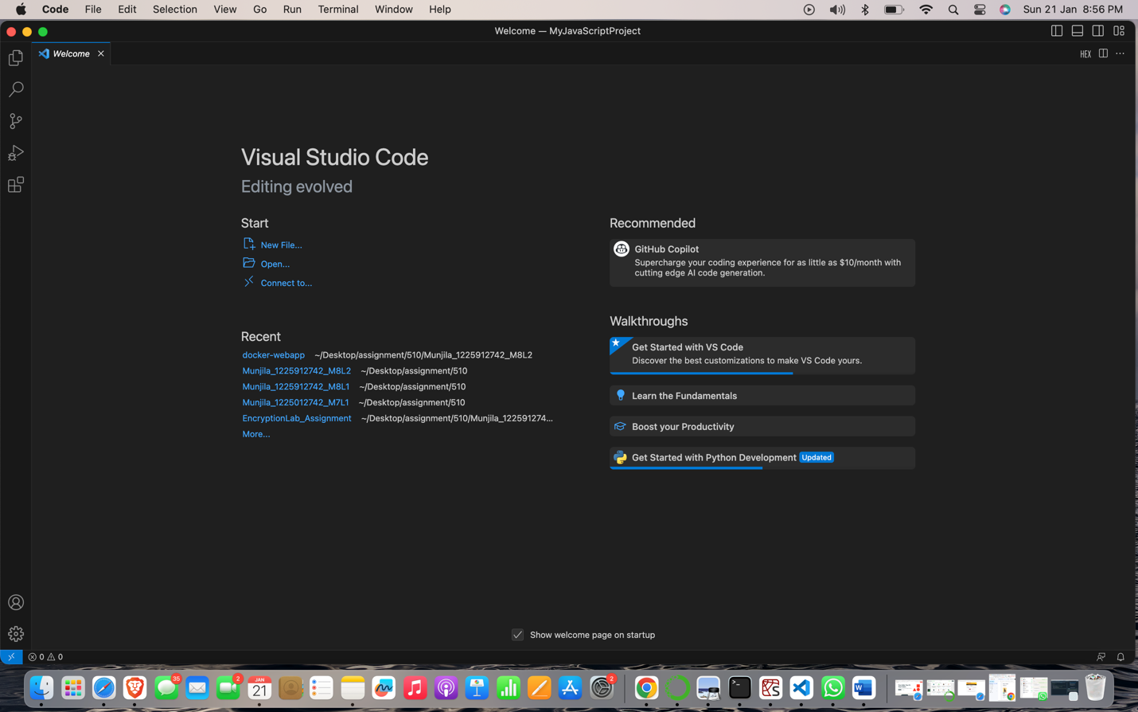

Task 2 - Node.js Installation Proof

NPM

