**Module 1 Lab 1: JavaScript Hello World**

Naga Sindhuri Munjila

IFT 554: Middleware Programming & Database Security

Dinesh Sthapit

21st January, 2024

**Module 1 Lab 1: JavaScript Hello World**

Task 1: Create a Project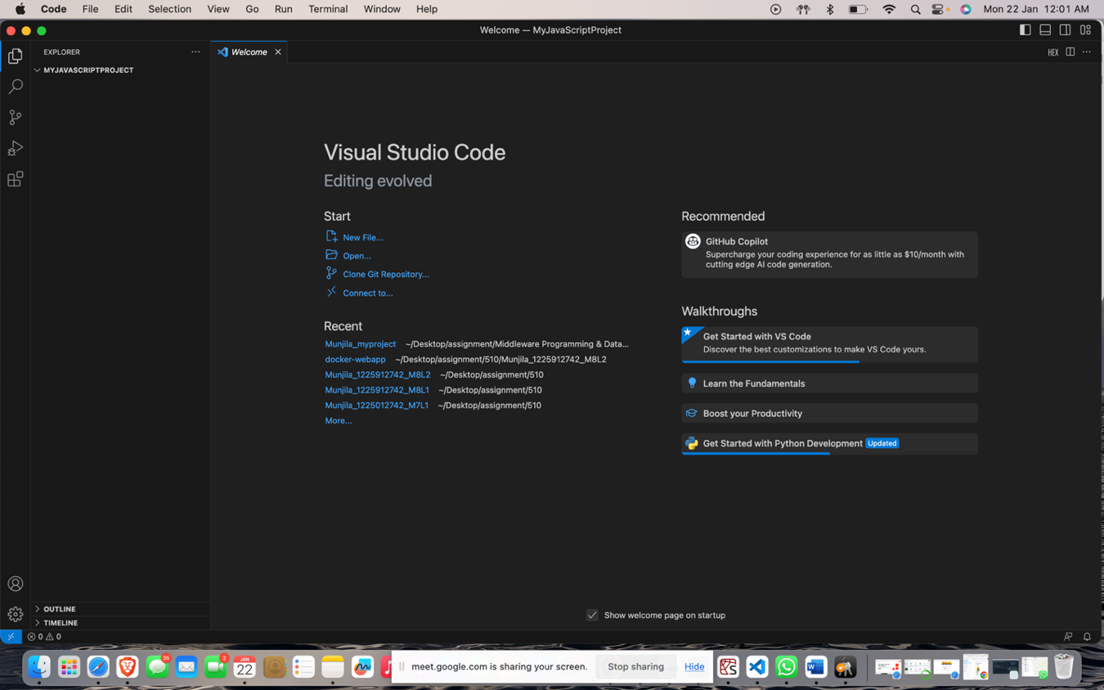

Task 2: Create a JavaScript File

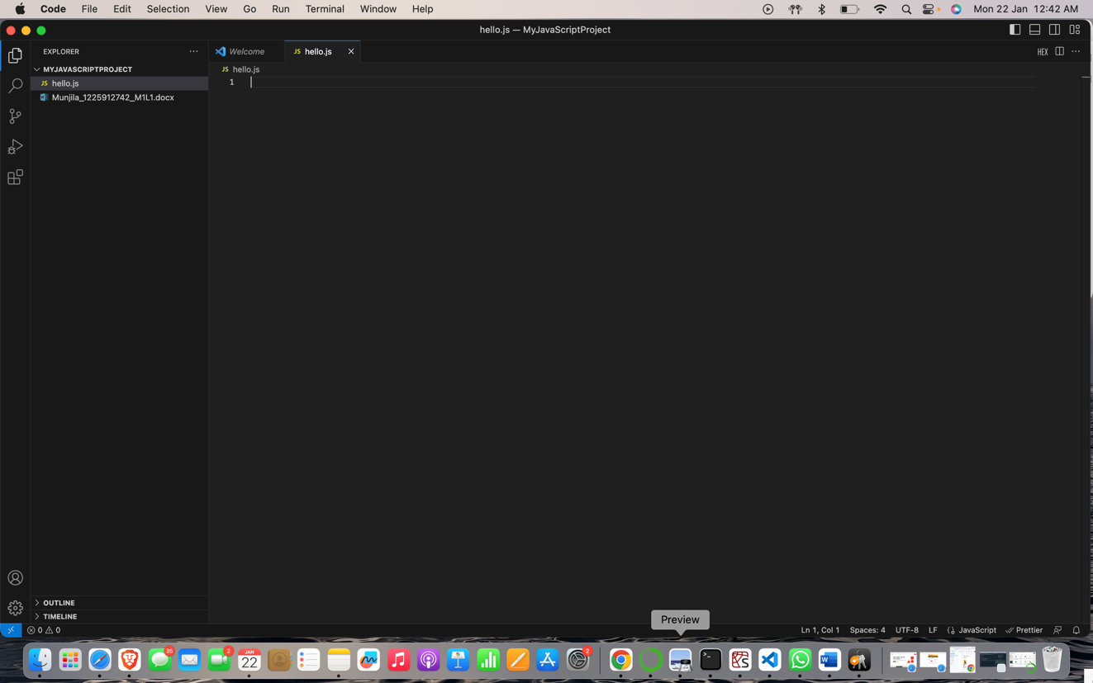

Task 3: Write a JavaScript Program

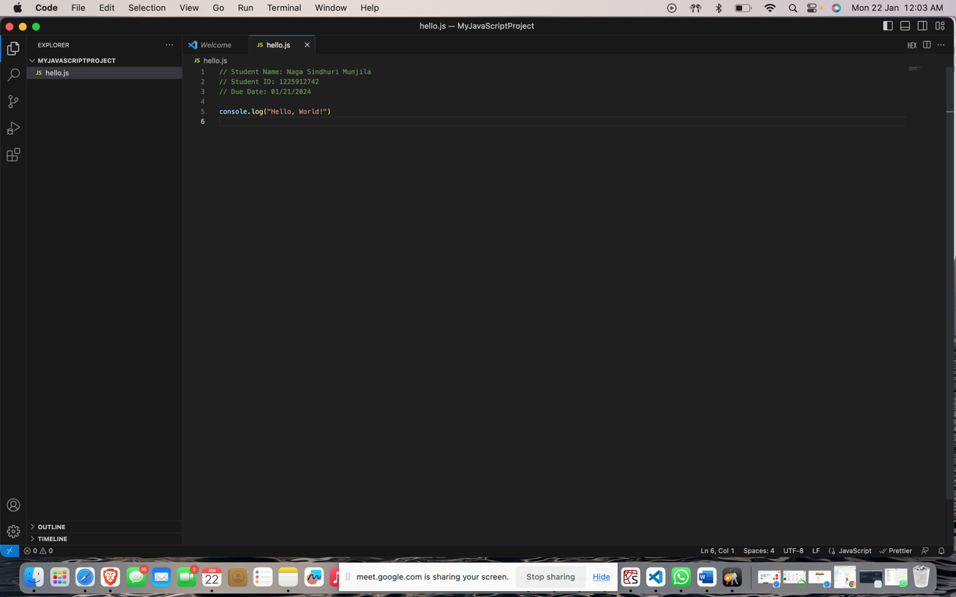

Task 4: Execute the JavaScript File

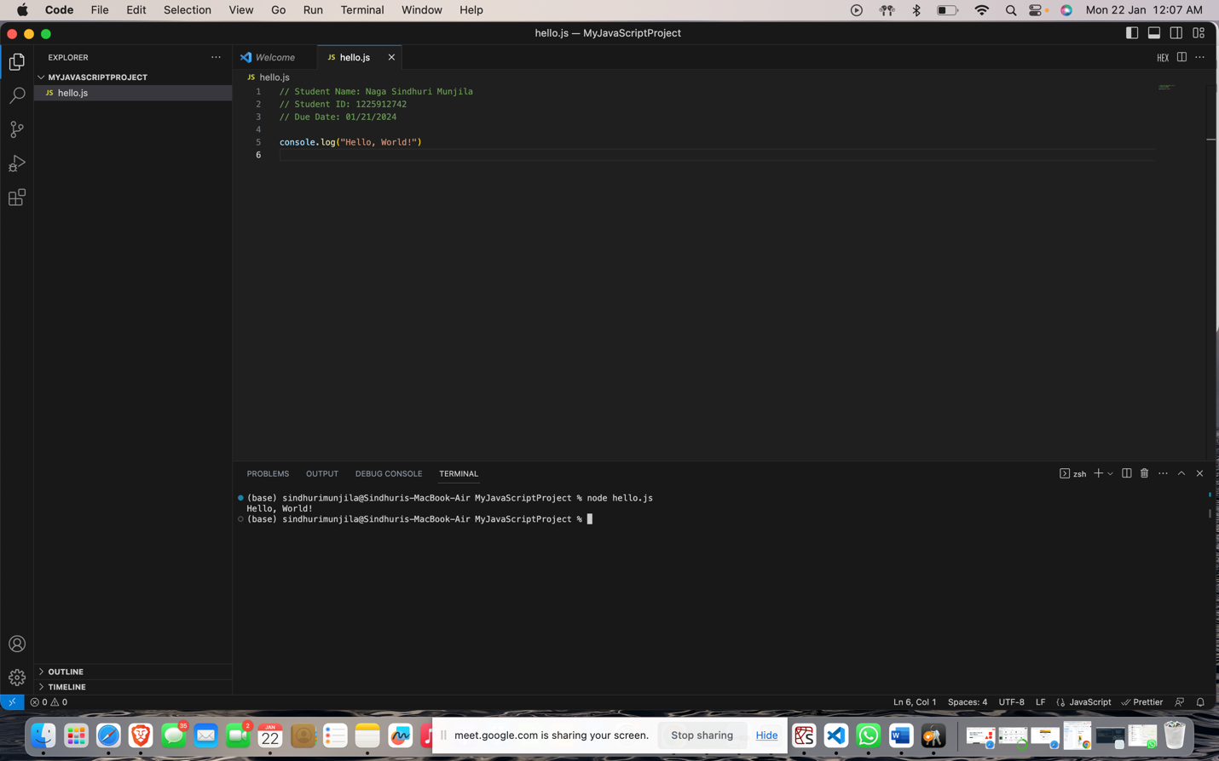

Task 5: Observe the Output

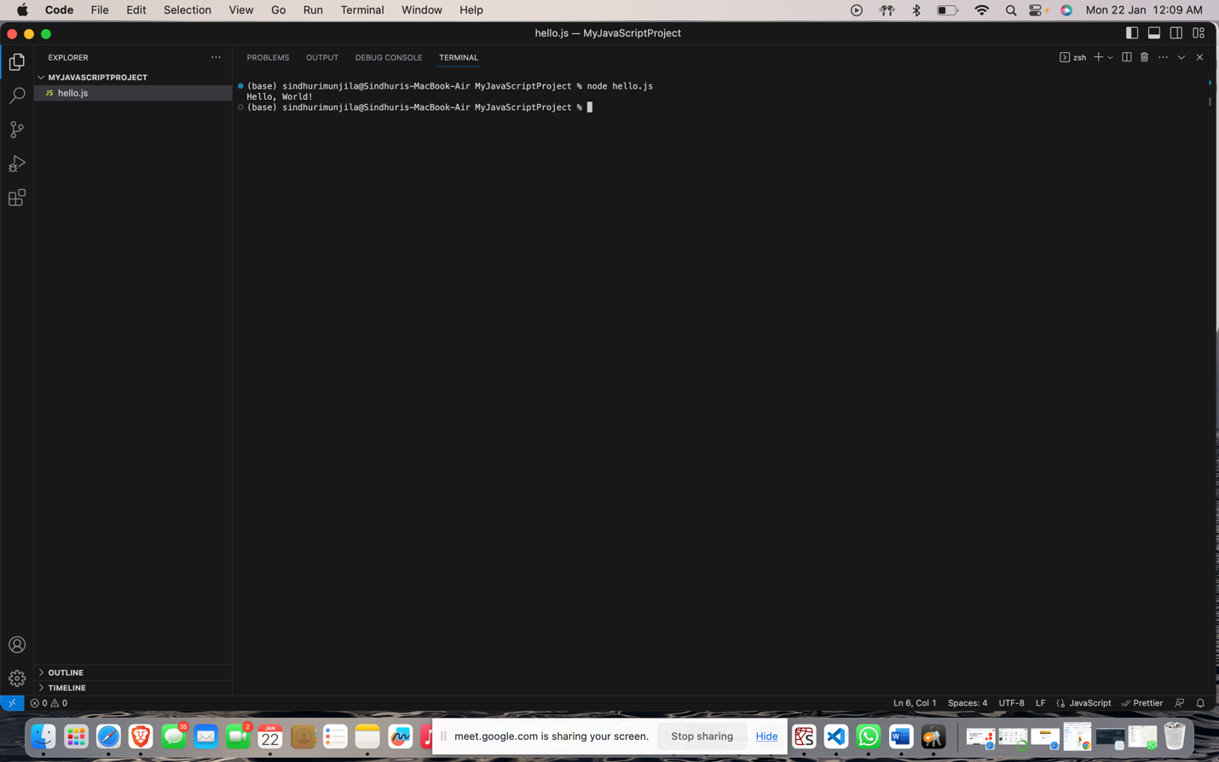

Task 6: Create Screenshots

