Advanced Software Engineering
Problem Set-2 (PS-2)
Deadline: March 14, 2019
Submit a hard copy of your answers to the instructor in the class on March 14.

Name: Sindhusha Tiyyagura
Class ID: 24

Rent Video Use Case
A customer wishes to rent a video that is picked from the store's shelves or that have been previously reserved. Provided the customer has a non-delinquent account, the tape is rented out once the payment has been received. If the tape is not returned in a timely fashion, an overdue notice is mailed to the customer. A customer asks an employee about video availability (including a reserved video) or picks one or more videos from the shelves. The videos and the membership card are scanned and any delinquent or overdue details are brought to the employee's attention. If the customer does not have a delinquent rating, then he/she can rent up to a maximum of eight videos. However, if the rating of the customer is "unreliable" then a deposit of one rental period for each video is requested. Once the amount payable is received, the stock is updated and the videos are given to the customer together with a receipt. The customer may pay by cash, credit card, or electronic transfer. Each rental record stores (under the customer's account) the check-out and due dates for each video together with the identification of the employee. A separate rental record is created for each rented video. The use case will generate an overdue notice to the customer if a video has not been returned within two days of the due date, and a second notice after another two days (and at that time the customer is noted as "delinquent").
- Draw a class diagram for the video store, and be sure to label all associations with appropriate multiplicities.
- Describe the difference between aggregation and composition relations using the video store.
- Draw a sequence diagram for renting a movie from a video store.
- Draw a state diagram that describes the lifetime of a video tape in a video store.
- Draw an activity diagram that describes renting a movie from a video store.
- Class Diagram for Video Rental Store.
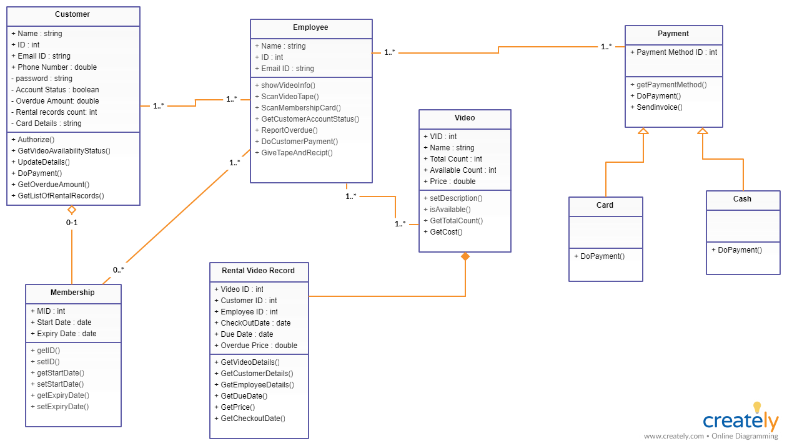

- Difference between aggregation and composition relations using the video store?

- Sequence diagram for renting a movie from a video store.
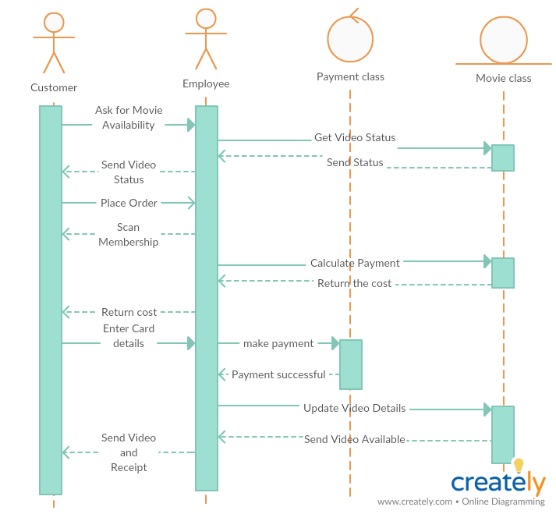

- State diagram that describes the lifetime of a video tape in a video store.
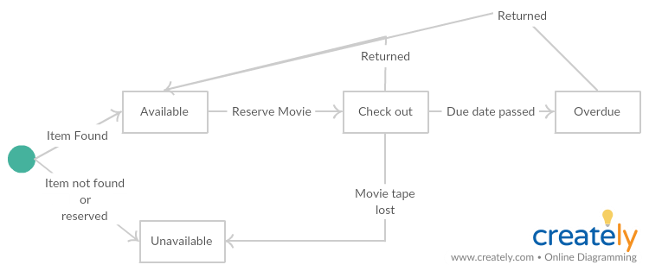

- Activity diagram that describes renting a movie from a video store

