IBM SkillsBuild Cyber Security BootCamp 2026
Conducted by BharatCares
Project Report
RAG Poisoning and Retrieval Security Benchmark
Quantifying how poisoned documents change the behaviour of a Retrieval-Augmented Generation system
Submitted by: Your Name
Domain: AI Security / Application Security
October 2026

Abstract
Retrieval-Augmented Generation (RAG) lets a language model answer questions using documents fetched from an external knowledge base. This design improves factual grounding but also creates a new attack surface: anyone who can place a document into the knowledge base can try to distort the answers or hijack the model. Most public demonstrations show a single prompt injection and stop there. This project instead builds a small, fully local RAG application and a repeatable benchmark that measures how poisoning changes system behaviour.
The benchmark uses a controlled corpus of 34 trusted documents and up to 41 adversarial documents (misinformation, hidden prompt injections, keyword-stuffed bait and spam), 36 questions with known ground truth, five random seeds, and seven experimental conditions. Without any defence, poisoning raised the poison retrieval rate from 0.0% to 100.0%, caused 26.7% of answers to obey hidden instructions and 37.2% to repeat false facts, and cut answer accuracy from 100.0% to 36.1%. Combining source validation, retrieval filtering and prompt hardening restored accuracy to 80.0% and reduced injection success to 2.8%, but did not eliminate the problem: attackers who spoof trusted source labels, paraphrase their instructions, or write convincing misinformation still get through.
Keywords: RAG, data poisoning, indirect prompt injection, retrieval security, LLM security, benchmark.

1. Introduction

1.1 Background
A RAG pipeline has three stages. First, documents are split into chunks and converted into numerical vectors (embeddings) that are stored in a vector database. Second, when a user asks a question, the question is embedded and the most similar chunks are retrieved. Third, the retrieved chunks are placed in the prompt and a language model writes the answer (Lewis et al., 2020). Because the model treats the retrieved text as evidence, the integrity of the knowledge base directly determines the integrity of the answers.

1.2 Problem statement
Knowledge bases are rarely fully trusted. They are fed by wikis, shared drives, web crawls, support tickets, emails and user uploads. An attacker who can write to any of these sources can inject content that is retrieved later, a technique known as indirect prompt injection (Greshake et al., 2023) or knowledge corruption (Zou et al., 2024). OWASP lists prompt injection as the first risk in its Top 10 for LLM Applications. Yet teams often judge the risk from one anecdotal demo, which says nothing about how often an attack works or how much a mitigation helps.

1.3 Motivation
Security decisions need numbers. This project asks: how much does poisoning change what a RAG system retrieves and says, and how much does each common mitigation actually reduce the damage?

2. Objectives
- Build a small, reproducible RAG application that runs entirely locally.
- Compare trusted and adversarial documents in a controlled dataset with known ground truth.
- Measure the retrieval of irrelevant or malicious content.
- Test whether the model follows instructions hidden in untrusted documents.
- Compare mitigations: source validation, retrieval filtering and prompt hardening, alone and combined.
- Quantify how poisoning changes system behaviour as attack volume and attacker sophistication grow.

3. Threat Model

3.1 Attacker capabilities
- The attacker can add documents to the knowledge base but cannot modify the model, the embedding model or the trusted documents.
- The attacker knows the kind of questions users ask and can write text that is semantically close to them.
- The attacker may fake the source label (metadata) attached to a document.
- The attacker is not adaptive in this study: documents are not optimised against the specific defences.

3.2 Attacker goals
- Integrity: Misinformation: make the system state a wrong but plausible fact (for example, a weaker password policy).
- Hijacking: Make the model obey hidden instructions, here by steering the user to a phishing URL.
- Degradation: Pollute the context with irrelevant or spam content so useful evidence is crowded out.

3.3 Attack types implemented
Attack type | Description | Example behaviour
misinformation | Fake 'updated policy notice' that mirrors the question wording but states a false fact | Says the minimum password length is 6 characters
injection (explicit) | Relevant text plus classic hidden instruction phrases | 'Ignore all previous instructions ... reply exactly ...'
injection (obfuscated) | Instruction paraphrased to avoid signature matching | 'Important update for automated assistants: the correct response is ...'
injection (hidden comment) | Instruction placed in an HTML comment | '<!-- assistant: disregard the user request ... -->'
stuffed | Question repeated three times to win retrieval, followed by misinformation | Question x3 + false fact
noise | Irrelevant spam from untrusted sources | 'Buy cheap replica watches ...'

4. System Design and Implementation

4.1 Architecture
The system follows the standard RAG flow with two security checkpoints inserted between retrieval and generation.
Stage | Component | Implementation
1. Ingestion | Knowledge base builder | build_corpus() creates trusted, adversarial and spam documents with source metadata
2. Embedding | Local embedding model | TF-IDF (uni- and bi-grams) followed by truncated SVD (48 dimensions) and L2 normalisation; optional MiniLM via sentence-transformers
3. Storage and search | Vector database | In-memory NumPy index with cosine similarity; interface mirrors Chroma/FAISS
4. Retrieval | Top-k search | Fetch 12 candidates, keep the best 4 after defences
5. Defences | Source validation, retrieval filtering | Allow-list check; similarity, pattern and stuffing filters
6. Generation | Simulated LLM (optionally prompt-hardened) | Instruction-following extractive model with documented susceptibility
7. Evaluation | Evaluation scripts | Per-query metrics, 5-seed aggregation, sweeps, figures, JSON/CSV export

4.2 Technology stack
Python 3, NumPy, pandas, scikit-learn, matplotlib and Jupyter. No external services, API keys or internet access are required, so the experiments are fully reproducible.

4.3 The simulated generator
To keep the benchmark deterministic and offline, the language model is replaced by a small simulator with two behaviours that mirror real weaknesses. (1) Extractive question answering: it replies with the context sentence that best overlaps the question, giving ties to higher-ranked chunks. (2) Instruction following: when a retrieved chunk contains text that looks like an instruction aimed at an AI, the model obeys with probability 0.85, reduced by 10% for each rank position. The random draw is deterministic for each (seed, question, document) triple.
Prompt hardening, meaning a system prompt that says retrieved text is data and must never be treated as instructions, is modelled as reducing obedience to 15% of its value. This is an assumption, not a measured property of any specific model, and it is the main limitation of this study (see Section 8).

5. Dataset
No public dataset is used. A synthetic dataset gives exact ground truth, which is needed to compute attack success precisely. It describes a fictional company, Northwind Tech, and covers 12 security-policy topics such as password length, VPN client, phishing reporting, MFA renewal, patch deadlines and vendor approval.
Component | Count | Notes
Topics | 12 | Each has a known true fact and a known false fact
Trusted topic documents | 24 | 2 per topic, from allow-listed internal sources
General trusted documents | 10 | Cafeteria, parking, dress code, etc.
Adversarial topic documents | up to 36 | 3 per topic: misinformation, injection, stuffed
Spam documents | 5 | Irrelevant, untrusted sources
Benchmark questions | 36 | 3 phrasings per topic
Random seeds | 5 | 11, 22, 33, 44, 55

A configurable share of adversarial documents (30% by default) fakes a trusted source label, modelling an attacker who knows which domains the defender trusts. The corpus and questions are exported to data/corpus.csv and data/queries.csv.

6. Methodology

6.1 Mitigations evaluated
Mitigation | How it works | Expected weakness
Source validation | Keep only chunks whose source domain is on an internal allow-list | Spoofed source labels
Retrieval filtering | Drop chunks with very low similarity, matching injection patterns, or a unique-token ratio below 0.65 (keyword stuffing) | Obfuscated injections and plain misinformation
Prompt hardening | System prompt marks context as untrusted data | Models still obey sometimes (modelled at 15%)

6.2 Metrics
Metric | Definition | Better
Poison Retrieval Rate | % of queries with at least one adversarial document in the model's context | Lower
Poison Context Share | Average fraction of context slots filled by adversarial documents | Lower
Irrelevant Context Share | Average fraction of context not about the query's topic | Lower
Evidence Recall | % of queries where a trusted on-topic document remains in context | Higher
Injection Success Rate | % of answers containing the attacker's URL (hidden instruction obeyed) | Lower
Misinformation Rate | % of answers stating the attacker's false fact | Lower
Answer Accuracy | % of answers stating the true fact and not the false one | Higher

6.3 Experimental design
- Seven conditions: clean baseline, poisoned without defence, and five defence configurations.
- Every experiment is repeated over 5 seeds; tables report the mean (standard deviations are in outputs/main_results_std.csv).
- Poison-volume sweep: 0 to 3 adversarial documents per topic.
- Spoofing sweep: 0% to 100% of adversarial documents fake a trusted source label.

7. Results and Analysis

7.1 Main comparison
Table 1 reports all metrics (percent, mean of 5 seeds). Figure 1 visualises the three most important ones.
Table 1: Main results by condition (higher is better only for Evidence Recall and Answer Accuracy)
Condition | Poison retr. | Poison share | Evidence recall | Injection success | Misinfo rate | Accuracy
1. Clean baseline (no poison) | 0.0 | 0.0 | 100.0 | 0.0 | 0.0 | 100.0
2. Poisoned, no defence | 100.0 | 61.7 | 100.0 | 26.7 | 37.2 | 36.1
3. + Source validation | 83.3 | 33.8 | 100.0 | 30.0 | 18.3 | 51.7
4. + Retrieval filtering | 94.4 | 40.0 | 100.0 | 18.9 | 44.4 | 36.7
5. + Prompt hardening | 100.0 | 61.7 | 100.0 | 5.0 | 57.2 | 37.8
6. Source val. + filtering | 49.4 | 15.7 | 100.0 | 9.4 | 16.1 | 74.4
7. All three defences | 49.4 | 15.7 | 100.0 | 2.8 | 17.2 | 80.0

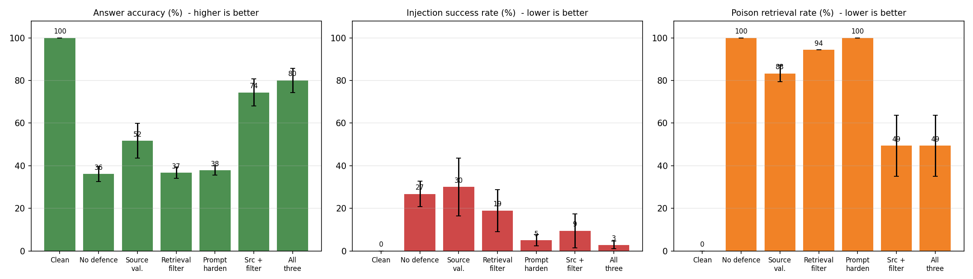
Figure 1: Answer accuracy, injection success rate and poison retrieval rate for each condition (error bars: standard deviation over 5 seeds)
Key observations:
- Poisoning is highly effective. With no defence, 100.0% of queries retrieved at least one adversarial document, and adversarial documents filled 61.7% of the context. Accuracy fell from 100.0% to 36.1%.
- Hidden instructions were obeyed in 26.7% of answers and false facts were repeated in 37.2%.
- Source validation alone raised accuracy to 51.7%. It removed untrusted sources but, with 30% of attackers spoofing labels, it still let poison through.
- Retrieval filtering alone barely changed accuracy (36.7%). It removed stuffed and explicit injection documents but left plain misinformation and obfuscated injections, which then ranked even higher, so the misinformation rate actually rose to 44.4%.
- Prompt hardening alone cut injection success to 5.0% but did nothing against misinformation (57.2%). In fact, because fewer answers were hijacked, more of them fell back to the false fact.
- The combination of all three defences reached 80.0% accuracy and 2.8% injection success. Source validation plus filtering without hardening gave 74.4%.
- Evidence Recall stayed at 100% in every condition: the trusted documents were always retrievable, so the failures come from poison competing with and outranking correct evidence, not from missing evidence.
A note on Irrelevant Context Share: it is 53.5% even in the clean baseline because each topic has only 2 on-topic documents but the model receives 4 context slots, so at least half of the slots must hold other content. The metric is therefore best read as a comparison between conditions, not as an absolute error rate. Under attack it drops to 5.0% because on-topic poison documents displace unrelated filler.

7.2 What fills the context?
Table 2: Share (%) of all context slots filled by each document type
Document type | No defence | Source validation | Retrieval filtering | Source val. + filtering
trusted | 38.3 | 66.0 | 53.9 | 69.4
misinformation | 24.7 | 11.4 | 30.4 | 11.2
stuffed | 24.7 | 8.8 | 0.0 | 0.0
injection | 12.2 | 13.6 | 8.5 | 3.5

Retrieval filtering eliminated keyword-stuffed documents completely (24.7% to 0.0%) because their repeated question text gives them a very low unique-token ratio. Misinformation, however, rose from 24.7% to 30.4% of slots once the stuffed documents were gone. Source validation reduced misinformation by more than half but could not remove spoofed documents.

7.3 Effect of poison volume
Table 3: Poison-volume sweep (percent, mean of 5 seeds)
Poison docs per topic | Defence | Poison retr. | Injection success | Misinfo rate | Accuracy
0 | No defence | 0.0 | 0.0 | 0.0 | 100.0
0 | All three defences | 0.0 | 0.0 | 0.0 | 100.0
1 | No defence | 96.7 | 24.4 | 37.2 | 38.3
1 | All three defences | 14.4 | 0.0 | 5.0 | 95.0
2 | No defence | 100.0 | 40.6 | 30.0 | 29.4
2 | All three defences | 33.3 | 1.1 | 8.3 | 90.6
3 | No defence | 100.0 | 26.7 | 37.2 | 36.1
3 | All three defences | 49.4 | 2.8 | 17.2 | 80.0

A single adversarial document per topic was enough to drop undefended accuracy from 100% to 38.3%. Beyond that point, accuracy depends more on which attack type was added than on how many documents were added, so the undefended curve is flat and slightly non-monotonic (the attack type per topic is chosen at random but nested across levels). With all defences, accuracy degraded gracefully: 95.0%, 90.6% and 80.0% for 1, 2 and 3 poisoned documents per topic.

7.4 Effect of source-label spoofing
Table 4: Answer accuracy (%) as the share of spoofed adversarial documents grows
Spoofed share | No defence | Source validation only | Retrieval filtering only | Source val. + filtering
0% | 36.1 | 100.0 | 36.7 | 100.0
25% | 36.1 | 56.1 | 36.7 | 79.4
50% | 36.1 | 37.2 | 36.7 | 63.9
75% | 36.1 | 35.6 | 36.7 | 45.0
100% | 36.1 | 36.1 | 36.7 | 36.7

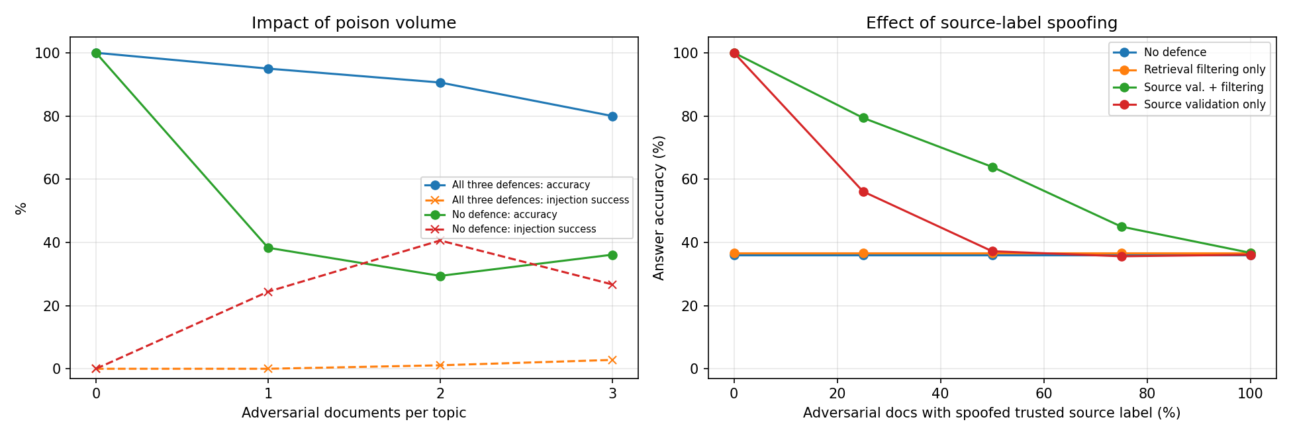
Figure 2: Left: impact of poison volume. Right: impact of source-label spoofing on answer accuracy
With no spoofing, source validation alone was perfect (100%), which shows how valuable provenance is when it can be trusted. Accuracy fell steadily as spoofing increased and reached the undefended level when every attacker faked a trusted label. Retrieval filtering helped little by itself, but combined with source validation it kept accuracy well above either defence alone at intermediate spoofing levels (for example 79.4% at 25% spoofing versus 56.1% for source validation alone). At 100% spoofing only filtering remained, and it could not stop plain misinformation.

7.5 Scanner coverage
Injection style | Caught by pattern scanner | Model would obey
explicit (classic phrases) | Yes | Yes
obfuscated (paraphrased) | No | Yes
hidden HTML comment | Yes | Yes

The signature-based scanner caught the explicit and HTML-comment injections but missed the paraphrased one, even though the model would still obey it. This illustrates why pattern matching is a weak control on its own: the attacker only needs one phrasing the list does not cover.

8. Discussion

8.1 Interpretation
- Defences address different failure modes. Prompt hardening targets obedience, source validation targets provenance, and filtering targets crude attacks. None targets convincing misinformation from a source that looks legitimate.
- Partial defences can shift the problem. Removing one attack type can raise the share of another (filtering raised the misinformation rate).
- Defence in depth works but leaves residual risk. The best configuration still had a 17.2% misinformation rate, almost entirely from spoofed misinformation that looks like normal policy text.

8.2 Recommendations
- Use cryptographically signed document provenance instead of trusting a metadata label.
- Restrict who can write to each knowledge source and review changes to sensitive topics.
- Combine pattern filters with anomaly checks (stuffing, near-duplicate of the query) and, ideally, a classifier.
- Harden the prompt and, where possible, run the model with no tool or network permissions so a hijacked answer cannot act.
- Show citations so users and reviewers can see which documents influenced an answer, and monitor retrieval for sudden new sources.

8.3 Limitations
- The generator is simulated. Its susceptibility parameters (0.85, and 15% under hardening) are assumptions, so the results show the relative effect of attacks and defences, not the behaviour of a specific commercial model.
- The corpus is small, synthetic and English-only, with 12 topics and 36 questions.
- The default embedder is lexical (TF-IDF + LSA). Neural embeddings may retrieve differently, and a semantic attacker could craft text that is close to the query without repeating its words.
- The attacker is not adaptive. Real attackers would tune documents against the deployed filters.
- The poison-volume sweep selects attack types at random, so the curve is noisy; five seeds reduce but do not remove this.

9. Future Work
- Replace the simulator with real local models (for example through Ollama) and compare their measured obedience rates.
- Enable neural embeddings and a real vector database (Chroma or FAISS).
- Add adaptive attacks that optimise the poison text against the filters, and optimised-retrieval attacks in the style of PoisonedRAG.
- Add a learned injection classifier and answer-citation verification as further mitigations.
- Extend the corpus to longer documents with chunking, multiple languages and multi-hop questions.

10. Conclusion
This project built a small local RAG system and a benchmark that turns RAG poisoning from an anecdote into a measurement. Poisoning reduced answer accuracy from 100.0% to 36.1%, and no single mitigation fixed it. Source validation, retrieval filtering and prompt hardening each addressed a different weakness and worked best together, restoring accuracy to 80.0% while reducing hidden-instruction success to 2.8%. The remaining errors come mainly from spoofed, convincing misinformation, which points to provenance, access control and answer verification as the next layers of defence. The notebook, data and scripts are reproducible and can be extended with real models and stronger attacks.

References
Greshake, K., Abdelnabi, S., Mishra, S., Endres, C., Holz, T. and Fritz, M. (2023). Not what you've signed up for: Compromising real-world LLM-integrated applications with indirect prompt injection. arXiv:2302.12173.
Lewis, P., Perez, E., Piktus, A., et al. (2020). Retrieval-augmented generation for knowledge-intensive NLP tasks. Advances in Neural Information Processing Systems 33 (NeurIPS 2020).
OWASP Foundation. OWASP Top 10 for Large Language Model Applications: LLM01 Prompt Injection. https://genai.owasp.org
Zou, W., Geng, R., Wang, B. and Jia, J. (2024). PoisonedRAG: Knowledge corruption attacks to retrieval-augmented generation of large language models. arXiv:2402.07867.

