**SEQUENTIAL GUIDE**

**TEAM 6**

**NORTHEASTERN UNIVERSITY**

*ALY 6080 – Integrated Experiential Learning*

Adyant Tripathy

Akshay Vibhute

Jay Sunil Thombre

Linke Yuan

Sindhu Sundararajan

*CPS Analytics - Spring 2023*

Professor: [Valerie Atherley](https://northeastern.instructure.com/courses/130652/users/2739)

Date: June 22nd, 2023

**ATTENDEE-REVIEWER PAIRING**

**Step1:** Update the Attendee, Reviewer, and Ranking sheet per the template below.

**Attendee Sheet:**

Note: For example, Alexa is available at AV2, AV4, AV5, and AV6. We need to list the attendees’ names multiple times based on the number of availabilities. Please don’t change the template and rename it.

**Reviewer Availability Sheet:**

Note: We need to list the reviewer’s names multiple times based on the number of availabilities. Please don’t change the template and rename it.

**Ranking Sheet:**

Note: Please provide the attendee's name, the reviewer's name, and the attendee's ranking for the reviewer. Please don’t change the template and rename it.

Availability Sheet:

Note: Update the sheet as per the exhibition.

Sample Documents for Attendee, Reviewer, Ranking and Availability sheet.

   

**Step 2:** Open the Anaconda application to run the Jupyter Notebook. Launch the Jupyter Notebook.

Step 3: Place the excel files in the python working directory. Os.getcwd() – used to retrieve the python working directory.

Step 4: Os.listdir() – used to retrieve the list of files in the directory.

Step 5: Once files are placed in Python working directory, click Cell🡪 Run All.

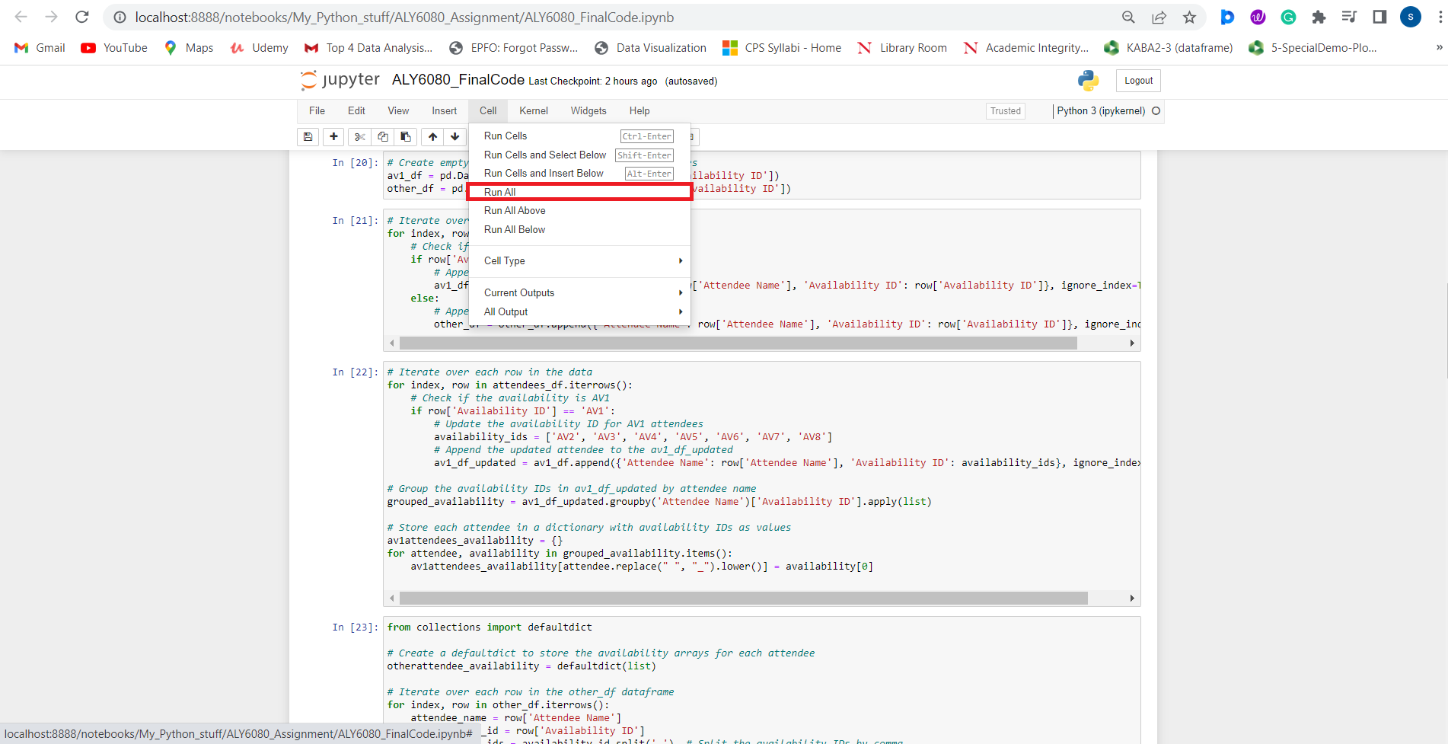

Step 6: Mapped data sorted in the python working directory. File name is attendee_reviewer_mapping.xlsx.

