**UNIT-I**

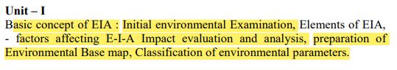

1. Discuss objectives, merits and demerits of EIA?
2. Define EIA? Briefly explain Basic concept of EIA?
3. What is the necessary of preparing an environmental base map?
4. Briefly Explain Initial Environmental Examination in Environmental Impact Assessment?
5. Explain the limitations of EIA?
6. Discuss about the factors affecting E-I-A Impact evaluation and analysis?
7. Write about the Classification of environmental parameters?

***Extras*:**

1. *Discuss about the procedure for conducting environmental impact assessment report and write the evaluation of EIA report?*
2. *Briefly explain the various types of Socio-economic impacts?*
3. *Define Planning. Explain environmental management planning. Give two practical examples?*

**UNIT-II**

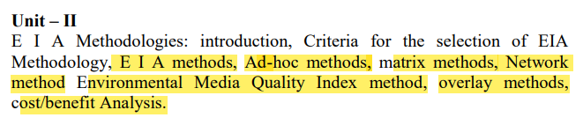

1. List out different EIA methods. Explain Ad-hoc methods in detail?
2. Explain the use of Leopold matrix?

[OR]

Present the Leopold matrix method in EIA and highlight its strengths and applicability?

1. Discuss in brief network methodologies?
2. Explain about check list method of EIA analysis?
3. Give a brief account on cost benefit analysis of EIA?
4. Discuss in brief overlay methods methodologies?
5. Discuss in brief Environmental Media Quality Index method?

[OR]

Write about quality index method for carrying out EIA?

1. Describe matrix method in detail?

**UNIT-III**

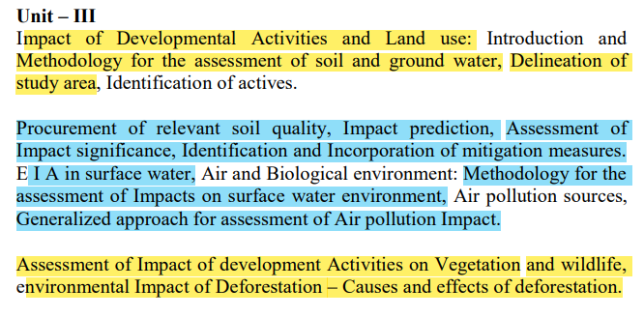

1. Write a detailed note on Direct land use impact?
2. Discuss on development activities on EIA?
3. Give the systematic approaching for the study of environmental impact on soil?

[OR]

How to assess the impact significance on the soil due to project activity?

[OR]

What type of soil quality parameters to be studied to assess the impact of project activity on soil environments?

1. Write the methodology for assessment of ground water characteristics in the study area?
2. Write on delineation of study area?
3. Explain the development activities on vegetation with example?
4. Explain how to study the impact of any project on direct loss of wild life and habitat?
5. Explain about the environmental impact of deforestation?

[OR]

Discuss on environmental Impact of Deforestation?

***Extras:***

1. *Write a detailed note on generalized approach for assessment of air pollution Impact.*
2. *Write a detailed note on identification of surface water Quantity or Quality impacts.*
3. *Draw the schematic diagram for conceptual approach to the study focused on surface water Environment impacts?*
4. *Explain the Box-model approaches for prediction of various environmental impacts for engineering projects?*
5. *Discuss about environmental indices for water and air quality?*
6. *Explain in detail about impact significance and mitigation measures*
7. *Explain the various kinds of impact mitigation? Also explain in detail the objectives and methods of mitigation with an example?*

**UNIT-IV**

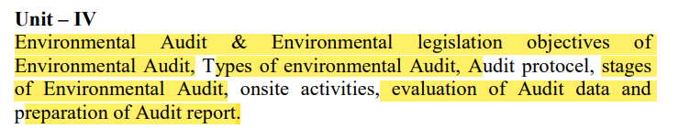

1. Give different stages of environment audit?
2. Write about different types of environmental Audit?

[OR]

Write about the types of Audit?

1. Describe the advantages and disadvantages for the existing environment audit?

[OR]

Write the advantages of environmental Audit?

1. Discuss about the procedure for conducting environmental impact assessment report.
2. Write the evaluation of EIA report?

**UNIT-V**

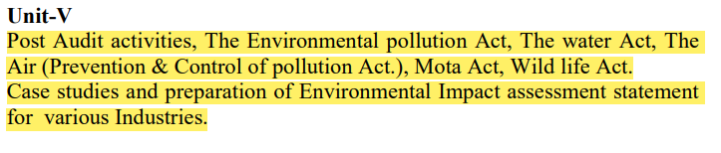

1. Briefly explain post audit activities.
2. What is the purpose of post Environmental Audit?
3. Explain air pollution act?
4. Explain the water act?
5. Explain Motor Act?
6. Explain Wild life Act?
7. Explain The Environmental Protection Act?
8. Explain one case study on EIA in industries?

[OR]

Briefly Explain A Case Study for Environmental Impact Assessment in the Process Industry: Municipal Solid Waste Incineration (MSWI)?