Introduction:

New York City is known for the noisy ambiance and for its fast-paced atmosphere.

However, in a busy city, it is important to have places where people can unwind and enjoy the bustle from a distance like the cafes in Europe provide the serenity with the view of the city.

The modern-day café provides the perfect ambiance for people to come in and enjoy a slow-paced life style, whether it’s to have a conversation, get some reading done, or to just sip of a latte, the café helps to provide the escape. New York City, although, has its plethora of coffee shops, it lacks the cafe and introducing it to this bustling city could help bring the balance of busy and leisure.

Before launching a place of leisure into New York City, it is essential to investigate where the ideal locations, and the potential of customers could be the most and based on that there can be a concrete plan put into motion.

Problem:

New York City is a crowded city with several Patisseries and coffee shops however, identifying if they have the café setting is an important aspect. And spotting where the café could be effectively located is also a significant aspect, because it needs to draw the crowds of the city for an unwinding experience.

Data:

In order to determine whether opening up a café is a beneficial aspect for the people of New York City it is critical to inspect similar businesses around in the city. In order to determine the businesses, the website of Foursquare provided the necessary data through the calling of the APIs. By creating the necessary credentials and utilizing the APIs provided, the part of New York City with the bustling financial and fashion districts were taken into consideration.

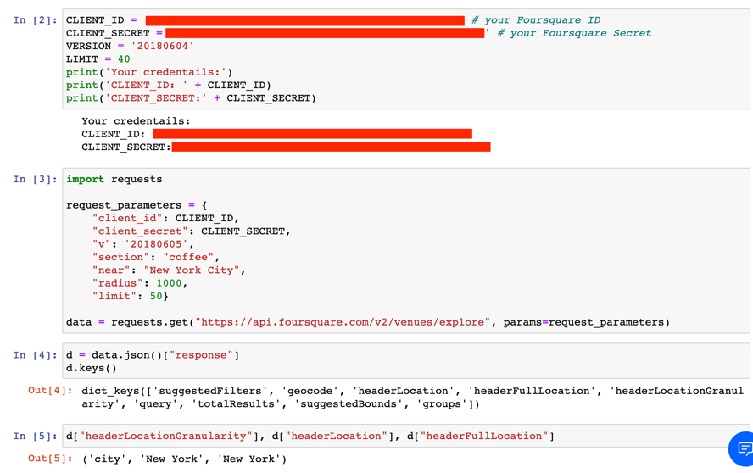

Methodology:

The city of New York is huge to determine where a café could be placed, and with the focus on the financial district, Foursquare’s features of geolocation was used to narrow down the possible café sites.

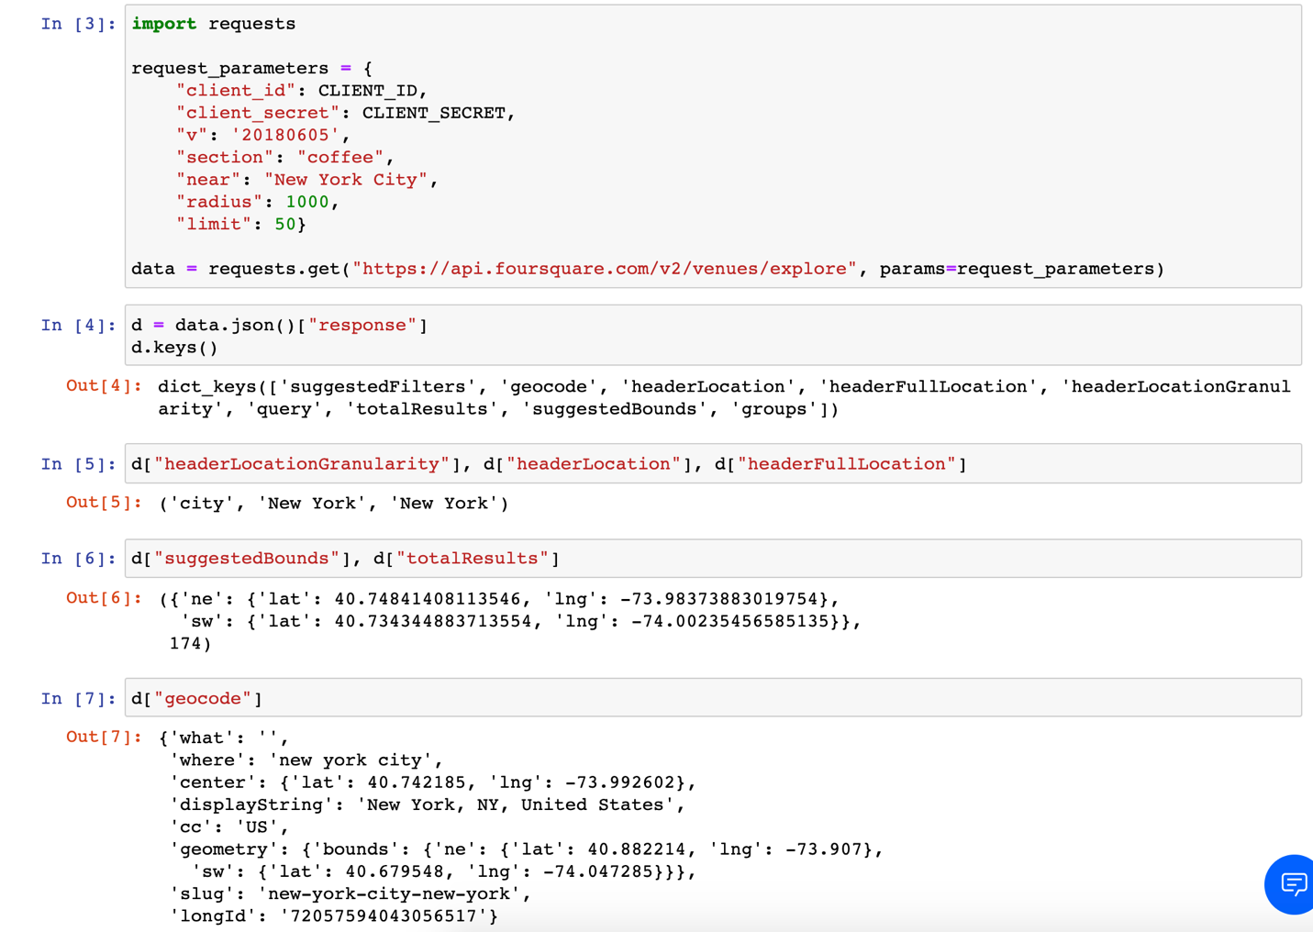

The best method of inquiry was to use clustering methods which were available with the help of the Foursquare API data, and the following coffee related enterprises were shown.

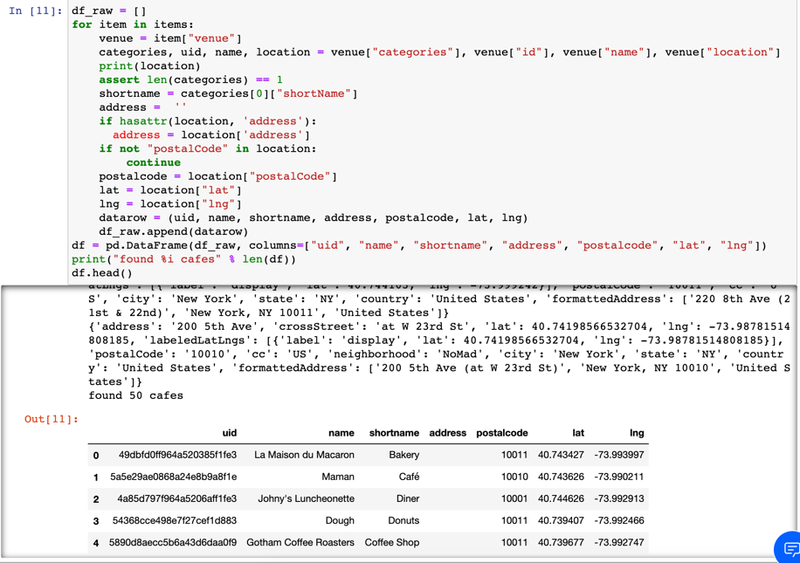

The condensed list consists of a variety of shops however, apart from Maman, the rest of the businesses provide either pastries or coffee but not the experience of a café. Using the information above, and by inputting the respective coordinates, it was determined that several businesses existed which could be considered as ‘coffee’ related businesses, as shown in the Heat Map below.

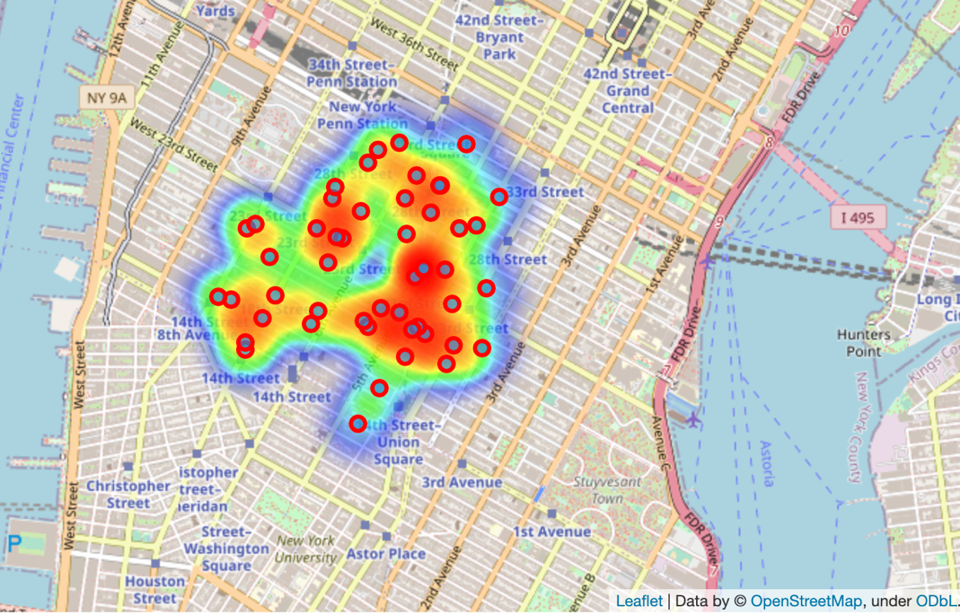

Results:

After determining the similar places around the area with the help of df.head() code snippet below and the heat map provided above, the possible location for the new site was able to be seen.

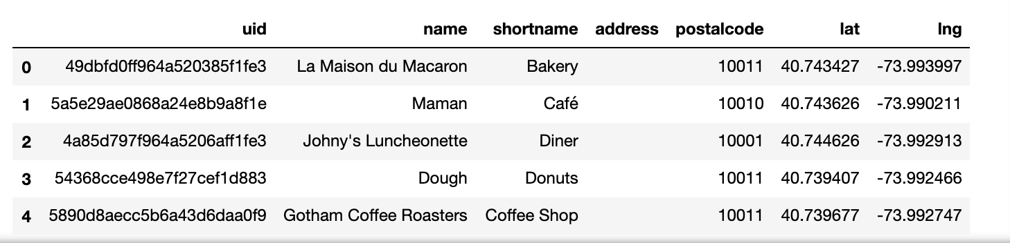

With the help of the CircleMarker which is one of the many features in Foursquare API, the area of a possible café location was determined which was in the middle of the cluster of the coffee shops, and eateries, and it is highlighted below as Café Chill!

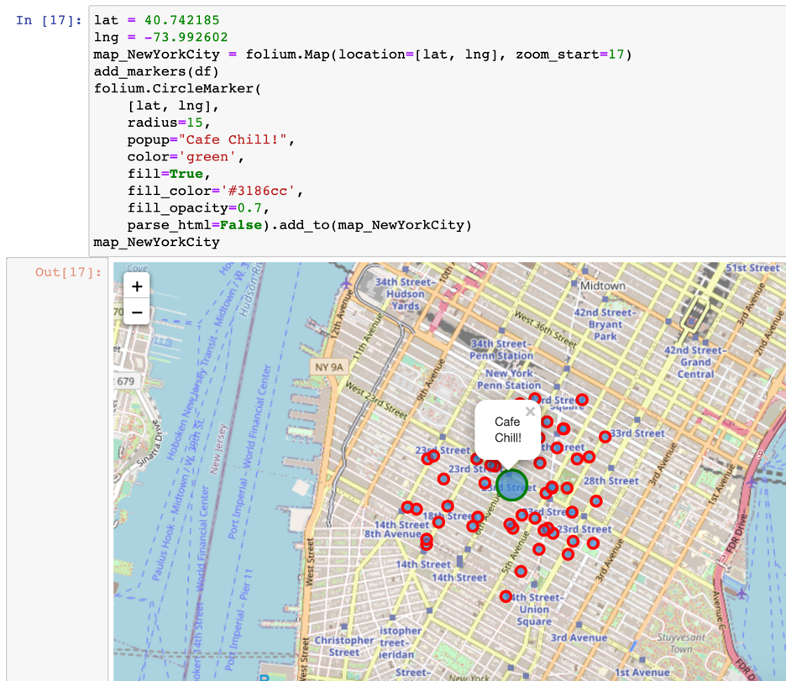

Discussion:

As someone that has worked in New York City in the particular location where the plethora of coffee shops and eateries appear, I longed for a café. A place where I can sit, have a sip of coffee, a bite to eat, and most importantly unwind after a long, arduous day. Although, there were some cafes they were not as readily available nor do they provide the experience as I had stated before, that the European cities are widely famous for, their cafes to unwind at.

Conclusion:

Having a map and walking around New York City to scout out all the possible café locations are one thing, however for a business person to be able to determine a potential café that can be established in the heart of New York would be a challenge but also a rewarding experience. Having the right tools such as Foursquare API for the data as well as the visual tools to help bring to life the clustering methods, and algorithms helped to create a rewarding experience throughout this project.