TSAM project 1

1.a
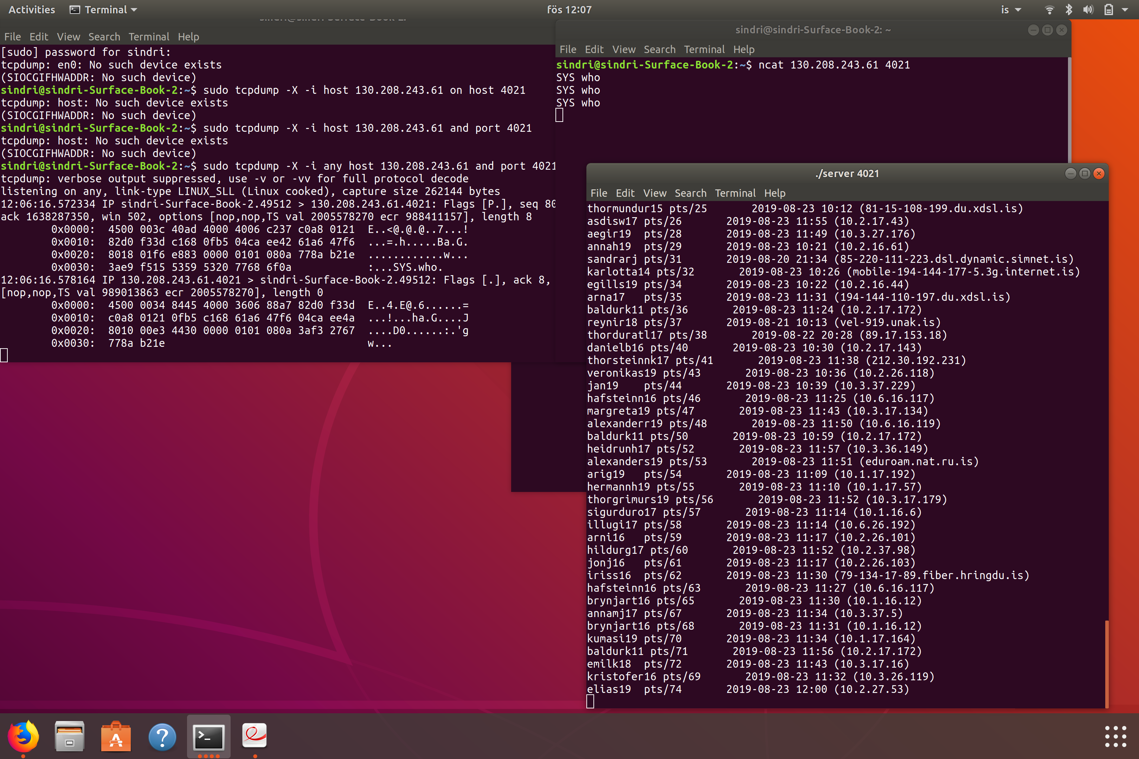
2.a
Code is in my Skel, TSAM19, Project1

2.b
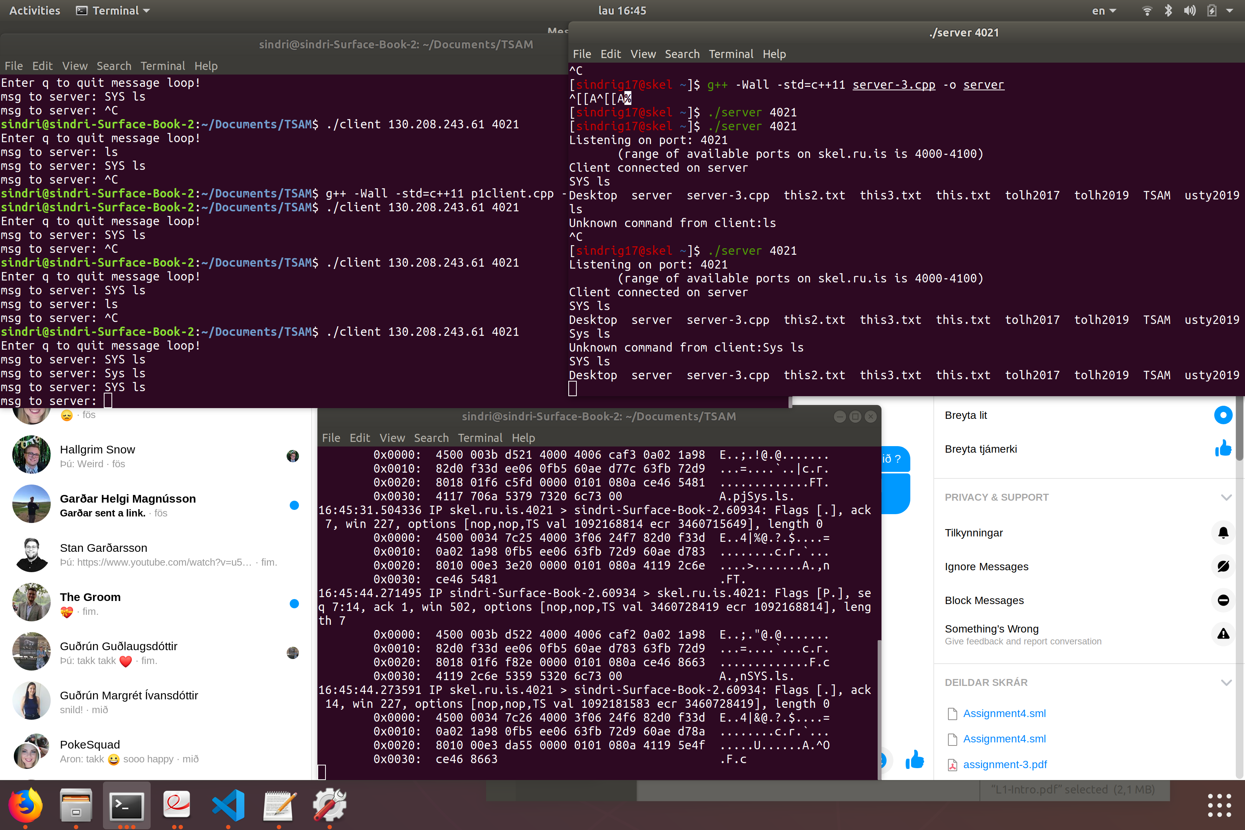

2.c
16:45:44.273591 IP skel.ru.is.4021 > sindri-Surface-Book-2.60934: Flags [.], ack 14, win 227, options [nop,nop,TS val 1092181583 ecr 3460728419], length 0
0x0000: 4500 0034 7c26 4000 3f06 24f6 82d0 f33d E..4|&@.?.$....=
0x0010: 0a02 1a98 0fb5 ee06 63fb 72d9 60ae d78a ........c.r.`...
0x0020: 8010 00e3 da55 0000 0101 080a 4119 5e4f .....U......A.^O
0x0030: ce46 8663 .F.c

