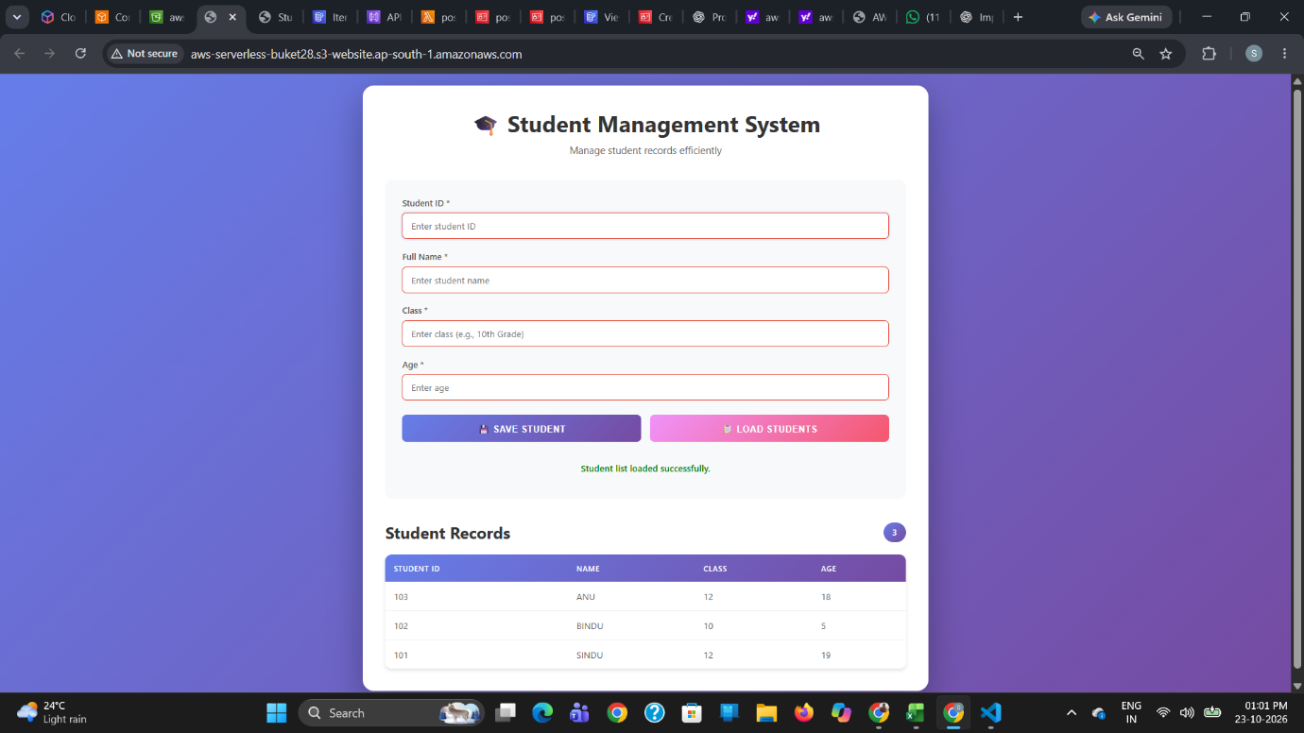
pic 1.0: The webpage provides a simple interface to add student details, including student ID, name, class, and age, to the system.

