**DAY 1 - ASSIGNMENT 1**

## **Question 1**

## Plot a line plot between a and b:

a=np.arange(40,50)

b=np.arange(50,60)

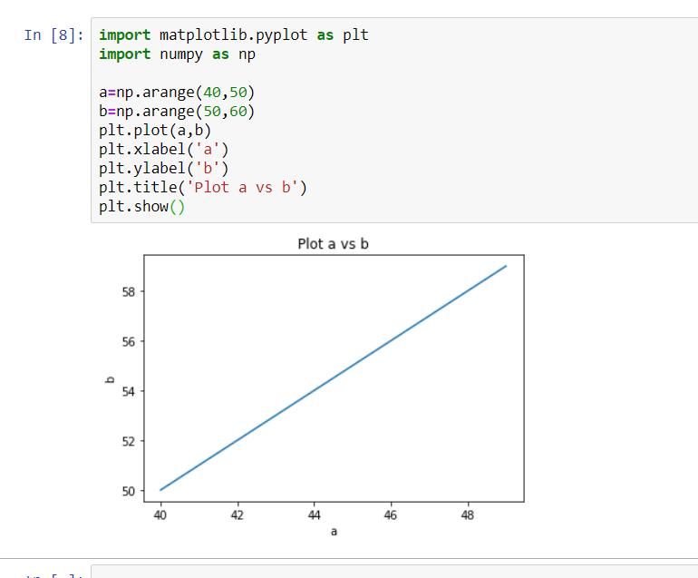

## **Question 2**

Plot a line plot showing the sales trend in company 1 and 2:

days = [1,2,3,4,5,6,7] #days of d week

sales_1 = [160,150,140,145,175,165,180] #sales of company1

sales_2 = [70,90,160,150,140,145,175]  #sales of company2

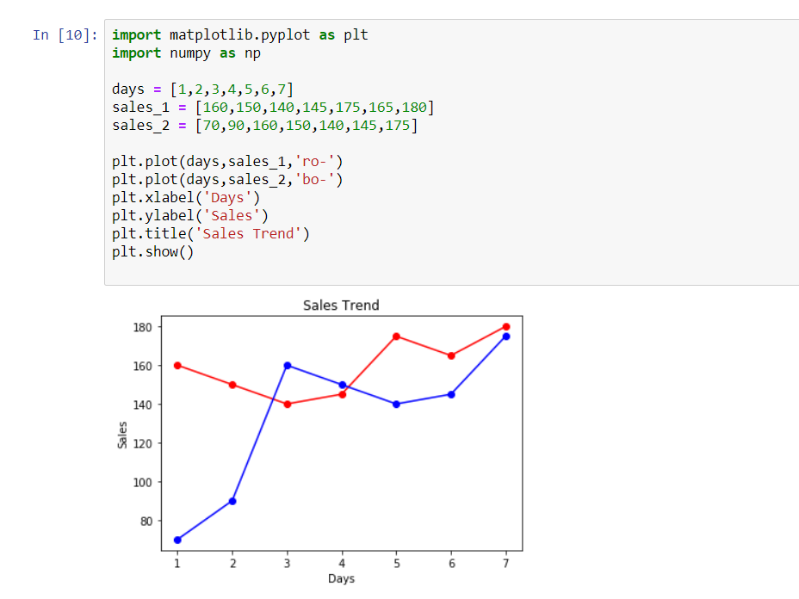

## **Question 3**

  Create a 3 by 3 subplots:

multiple plots

x = [1,2,3,4]

y1 = [4,3,2,1]

y2 = [10,20,30,40]

y3 = [40,30,20,10]

y4 = [1,2,1,2]

y5 = [40,70,90,70]

