INTRODUCTION

The goal of our project is to provide a model for the propagation of random scanning worms and the corresponding development of automatic containment mechanisms that prevent the spread of worms beyond their early stages. This containment scheme is then extended to protect an enterprise network from a preference scanning worm. A host infected with random scanning worms finds and infects other vulnerable hosts by scanning a list of randomly generated IP addresses. Worms using other strategies to find vulnerable hosts to infect are not within the scope of this work. Some examples of nonrandom-scanning worms are e-mail worms, peer-to-peer worms, and worms that search the local host for addresses to scan.
In this project, we adopt a stochastic branching process model for the early phase of worm propagation. We consider the generation-wise evolution of worms, with the hosts that are infected at the beginning of the propagation forming generation zero. The hosts that are directly infected by hosts in generation n are said to belong to generation n þ 1. Our model captures the worm spreading dynamics for worms of arbitrary scanning rate, including stealth worms that may turn themselves off at times.
We show that it is the total number of scans that an infected host attempts, and not the more restrictive scanning rate, which determines whether worms, can spread.These insights lead us to develop an automatic worm containment strategy. The main idea is to limit the total number of distinct IP addresses contacted (denote the limit as MC) per host over a period we call the containment cycle, which is of the order of weeks or months. We show that the value of MC does not need to be as carefully tuned as in the traditional rate control mechanisms. Further, we show that this scheme will have only marginal impact on the normal operation of the networks. Our scheme is fundamentally different from rate limiting schemes because we are not bounding instantaneous scanning rates. Preference scanning worms are a common class of worms but have received significantly less attention from the research community. Unlike uniform scanning worms, this type of worm prefers to scan random IP addresses in the local network to the overall Internet. We show that a direct application of the containment strategy for uniform scanning worms to the case of preference scanning worms makes the system too restrictive in terms of the number of allowable scans from a host. We therefore propose a local worm containment system based on restricting a host’s total number of scans to local unused IP addresses (denoted as N). We then use a stochastic branching process model to come up with a bound on the value of N to ensure that the worm spread is stopped.

Modules of the Project:
- Designing User Interface and reports
- Scanning worms
- Containment of worms

Module Description:
Designing User Interface and reports :
In this module we design the user interface for all the hosts. We design the user interface in a graphical manner or GUI. By showing the output in GUI gives more attractive and understandable to everyone. we design the containment window to show the scanning, detection of worms. Report generation is also been done in this module. Thus we design the whole user interface in this module.

Scanning worms:
Our strategy is based on limiting the number of scans to dark-address space. The limiting value is determined by our analysis. Our automatic worm containment schemes effectively contain both uniform scanning worms and local preference scanning worms, and it is validated through simulations and real trace data to be non-intrusive. The model is developed for uniform scanning worms and then extended to preference scanning worms. We detect these two worms and categorize it in this module.
Containment of worms:
This module leads to the development of an automatic worm containment strategy that prevents the spread of a worm beyond its early stage. Specifically, for uniform scanning worms, we are able to 1) provide a precise condition that determines whether the worm spread will eventually stop and 2) obtain the distribution of the total number of hosts that the worm infects.

System Requirements
Software:
FRONT END : JAVA, SWING
TOOLS USED : JFRAME BUILDER
OPERATING SYSTEM : WINDOWS XP

Hardware:
PROCESSOR : PENTIUM IV 2.6 GHz
RAM : 512 MB
HARD DISK : 20 GB

ABOUT US:

SQL InfoTech is leaders in IT industry and has been providing creative software solutions for businesses of all sizes. The objective is to leverage the web and utilize the new technologies available today. The organization has made its footage with an inspired team of young and talented engineers who represent the fastest growing IT hub in the world with a focused drive to provide professional IT services across the globe. “SQL Infotech Pvt Ltd” is fast paced IT company with tremendous growth rate by showcasing dynamic strategies capturing the market segment that many of its peers way ahead of them.

OUR VISION:

SQL InfoTech is committed to delivering world-class technology solutions to a virtually integrated business community. Our vision is to be the Premier Technology Solutions Provider.
Our goal is to implement our process driven methodologies for the rapid deployment of business functionality in a dynamic, engaging and interactive environment by practicing lean processes.
COMMITMENT TO INDUSTRY:
We are committed to achieving effective results for the success of our clients. We will consistently deliver a superior solution and end user product by following lean processes.
We will set objectives for our client’s success and continually leverage our resources and expertise to gain a competitive advantage in the technology community.

MISSION STATEMENT:

To provide Cost effective and timely solutions exceeding customer expectations, engineered by high quality professionals and managed by matured process.

QUALITY AT SQL INFOTECH:

Quality is the hallmark of our services and solutions and we aim at delivering the best results in any endeavor we undertake for our partner sites. We build long term strategic business relationships resulting in mutual benefits to bring forth effective solutions to our customers. Each application developed for our clients is carefully customized to complement our Partner Company’s services and guarantee complete satisfaction. We follow lean and six sigma process to bring service improvements to customers.
SOLUTIONS:

Dedicated Development center

SQL InfoTech has Offshore Development Center (ODC) acts as a virtual extension of our client's development teams. Offshore outsourcing offers you flexible and comfortable options to expand your software solution profile in the form of:
- Resourceful engineers
- World-class infrastructure
- Experienced project managers
- Security and confidentiality
- Real cost savings and service improvements.
- Total quality management process
We maintain global standards in process and policy implementation while delivering projects for you. Our ODC is connected to every client and a round-the-clock communication channel is established with the required bandwidth. With such assurances in place, our ODC seamlessly integrates with development teams world over.

KEY ATTRIBUTES OF THE SQL INFOTECH ODC:
Infrastructure (Hardware and software) | Risk management plan
Project management | Security and confidentiality
Quality management | Recruitment and training
Change management | Protection of IP

PRODUCT DEVELOPMENT SERVICES:
Your product could be the next big wave on the horizon. Executing the idea from which you define the product requires the right partner who can be entrusted with this project. SQL InfoTech has partnered with global clients to launch software products. Our Offshore Development Model has ensured clients minimize risks, improve production and launch their products on time, thus ensuring the perfect release of a successful product.

SQL INFOTECH professionals enable us to offer the following services to product development companies:
- Co-create
- Maintenance
- Testing
- Migration
- Implementation
- Hire a lab
- Production support
- Contracted research
Product Development Solutions to Industry Segments

E-Commerce:

- Online Shopping Cards
- Online Gaming Portals

Web Applications:

- Discuss Forums
- Advertisement Portals
- Polling Portals

Domain Experience:

Microsoft Technologies:
Operating Systems
Windows

Languages
C-SHARP(C#)
Visual Java ("VJ++")
Visual Basic ("VB")

Front End
.Net Suite
Middle Ware
Common Object Model (“COM”)
COM + Distributed Com (“DCOM”)
Microsoft Messaging Queue (“MSMQ”)
Common Object Request Broker Architecture
Microsoft Transaction Server ("MTS")
Extended Markup Language ("XML")

Tools
Front Page, Active-X
Application/Web/ Database servers
Internet Information Services ("IIS")
MTS
Microsoft Exchange Server
SQL Server
SharePoint Server

INDIA USA
Sun Technologies:
Operating Systems
Linux

Development
Enterprise Edition (“J2EE”)
Enterprise Java Beans (“EJB”)

J2EE complaint app server –WebSphere Weblogic, Apache Tomcat, iplane
Java Server Pages (“JSP”) Servelets
SWING Remote Method Invocation (“RMI”)
Java Native Interfaces (“JNI”)
Java Secure Socket Extension ("JSSE")
Simple Object Access Protocol ("SOAP")
Model View Controller ("MVC 2") Architecture

java 2

Applications/Web/ Database Servers
Sun Enterprise Server, Netscape Enterprise Server, Oracle

PHP:

Offshore Development Company from India, SQL InfoTech offers hi-end PHP, ASP.Net, XML, web development, web database design, custom web applications, software development, content management system (CMS), and Ecommerce solutions to clients globally using PHP/MySQL Programming & .NET Application Framework.

Know more about our Hire Dedicated Developer & Offshore Dedicated Development Team Work Model. Our offshore development team of 25+ full time professionals, located in our offshore development center (ODC) in Hyderabad, India comprises of highly skilled software developers, web developers and programmers.

Service Offers:-
- Hire Dedicated Developer
- Custom Applications Develop
- Web Application Development
- Ecommerce Solutions
- Shopping Cart Development

Website Development Company in India:

Functionality is the core attribute for websites without which the very purpose of hosting a website is questioned. SQL InfoTech has been in business for several years now and our PHP web developers, ASP .Net programmers have extensive experience in programming database and backend solutions for companies. We develop advanced web applications that can handle huge amounts of data and transactions. Irrespective of the scale of operations of an organization, SQL InfoTech is a master provider of efficient and cost effective websites.

We produce visually attractive, innovative and professional designs, individually created to reflect the style, presence and corporate identity of the Client through our website development solutions.

Offshore Web Development Outsourcing:

The retention rate of highly experienced & qualified technical and software professionals in SQL InfoTech has been an outstanding 98% since its inception. Apart from the experience in SQL InfoTech, team members have several years of expertise in developing customized, fully integrated systems.

Apart from highly skilled Software Architects, Software Engineers and web developers, our assemblage features Visualizers, Web Developers, Web Graphic Designers, Quality Assurance Analysts, Document Writers, Network Engineers, Management, Finance & Administrative Experts, Business Development Managers, and others. We combine all these skills with our management skills to provide our clients with excellent end results. In all, we have a team exposed to high-end software services and updated platform knowledge.

SQL InfoTech believe that all good websites should be easy to find using search engines and we have the expertise to create a website design such that the webpages will be found on the major search engines (search engine optimization). Marketing your website is as important as good website design, and we can advise on this.

Offshore Development Solutions:

- Portal Solutions
- Ecommerce Application Development
- Shopping Cart Development
- Payment Gateway Integration
- Dynamic News System
- Portal Site Design
- Yellow Pages / Web Directory Development

Contact Us:
SQL InfoTech Pvt Ltd
India:
Plot #47,
Vittal Rao Nagar, MadhaPur
Hyderabad-500034
Ph: 040-65267164 info@fortunesystemsinc.com www.fortunesystemsinc.com
INDIA , USA

LITERATURE SURVEY
Introduction:
- The goal of our project is to provide a model for the propagation of random scanning worms and the corresponding development of automatic containment mechanisms that prevent the spread of worms beyond their early stages.
- This containment scheme is then extended to protect an enterprise network from a preference scanning worm.
- A host infected with random scanning worms finds and infects other vulnerable hosts by scanning a list of randomly generated IP addresses.
- Worms using other strategies to find vulnerable hosts to infect are not within the scope of this work.
- Some examples of non random-scanning worms are e-mail worms, peer-to-peer worms, and worms that search the local host for addresses to scan.
In this project, we adopt a stochastic branching process model for the early phase of worm propagation. We consider the generation-wise evolution of worms, with the hosts that are infected at the beginning of the propagation forming generation zero. The hosts that are directly infected by hosts in generation n are said to belong to generation n+1. Our model captures the worm spreading dynamics for worms of arbitrary scanning rate, including stealth worms that may turn themselves off at times.

worms:
Definition of computer worm:
A computer worm is a self-replicating computer program. It uses a network to send copies of itself to other nodes (computers on the network) and it may do so without any user intervention. Unlike a virus, it does not need to attach itself to an existing program. Worms almost always cause harm to the network, if only by consuming bandwidth, whereas viruses almost always corrupt or modify files on a targeted computer.
Worms are hated because of:
    - Bandwidth consumption
    - Might crash computers they infect
    - Infected computers may be used for other attacks such as DDoS, Phishing attacks etc
Types of computer worms :
- Host computer worms - Host computer worms are entirely contained in the computer they run on and use network connections only to copy themselves to other computers. Host computer worms where he original terminates itself after launching a copy on another host (so there is only one copy of the worm running somewhere on the network at a given moment) are also called "rabbits".
- network worms- Network worms consist of multiple parts (called "segments"), each running on different machines (and possibly performing different actions) and using the network for several communication purposes. Propagating a segment from one machine to another is only one of those purposes. Network worms that have one main segment, which coordinates the work of the other segments are sometimes called "octopuses."
History:
The first ever programme that could be called a worm, as per definition, was developed for the assistance of air traffic controllers by Bob Thomas in 1971. This worm" programme would notify air traffic controllers when the controls of a plane moved from one computer to another. In fact, this worm named "creeper" would travel from one computer screen to the other on the network showing the message, "I'm reeper! Catch me if you can!" The difference from most worms was that this creeper did not reproduce itself. Even later, although the idea of developing worms slowly faded away, a few people did try to experiment with these. These included John Shock and Jon Hepps of Xerox's Palo Alto Research Center, who in the early 1980s began working on worm programmers. This was also the first time that this type of programmer was called a worm.
Both of them developed a total of 5 worms, each specially designed to perform a particular function. They were programmed to do certain tasks around the network. The simplest of these worms was a "town crier" worm. Its job was only to post announcements on all the computers of the network. Then there were the more complicated worms, like the one, which would remain completely dormant during the day and would activate only in the night. Once all the employees had left for the day, this worm would harness the extra computing power of the idle computers to do tasks which required more computing power. In the morning, before the arrival of the employees it would save all the work done during the night and become dormant till the next evening.
Some World Famous Worms
The Internet Worm – 1988:On November the 22nd, 1988, Robert Morris, a Cornell University science graduate accidentally released his worm on a very large network in the area. This network was named Arpanet, which later went on to become the Internet. The worm managed to infect approximately three thousand computers during eight hours of activity. The Internet worm as it came to be known, disabled all those machines by making copies of itself and thus clogging them. Apart from clogging all the security loopholes, many machines had to be completely taken off the network till all copies of the worm could be totally removed.
The SPAN network worm – 1989:On the 16th of October 1989, a worm named WANK infected many VAX and VMS computers on the SPAN network. This worm, if it found that it had system privileges, would then change the system announcement message to "Worms against Nuclear Killers!" The message was then graphically displayed as the first letters of each word and the last three letters of the last word.

The Christmas tree Worm – 1987:The Christmas tree worm, which was a combination of a Trojan Horse and a chain letter. This was a mainframe worm and managed to paralyze the IBM network on Christmas day 1987. The worm was written in a language called Exec. It asked the user to type the word "Christmas" on the screen. Then it drew a Christmas tree and sent itself to all the names of people stored in the user files "Names" and "Netlog" and in this way propagating itself.
Code Red worm-2001: Code Red worm Version 2 that exploited a buffer overflow vulnerability in the Microsoft IIS Web servers. It was released on19 July 2001 and over a period of less than 14 hours infected more than 359,000 machines. The cost of the epidemic, including subsequent strains of Code Red, has been estimated by Computer Economics to be $2.6 billion .
How a Worm Works:

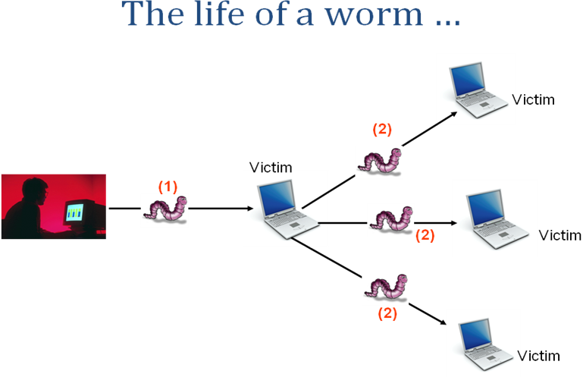
The Life Cycle of a Simple Worm:
- Scanning for a victim
- Exploiting the victim
- Cloning itself onto the victim
- Running the clone to further spread infection
- Stealth techniques used to hide itself
Scanning for a victim:
- Random scan – random IP
- Selective random scan – IP from global and local routing addresses
- Full scan – scan all IP addresses
- Divide and conquer scan – divide IP addresses among child worms
- Subnet scan – detect and scan local subnet
- Etc etc
Exploiting the victim:
- What is an exploit? – simply put: a piece of code which provides “access” to a victim computer by utilizing some flaw in the logic of a program running on the victim computer
- By “access” I mean the ability to run commands/programs on the remote computer.
- Network worms use what is called a “remote exploit” – an exploit which can be launched remotely and which gives some code running privileges on the victim
- Find a suitable exploit to use in the worm
- Understand the exploit
    - Black box approach (wrapper around the exploit)
    - White box approach (modifying the exploit)

Cloning itself onto the victim:
- Once the victim has been exploited the worm needs to get a copy of itself on the victim
- Tftp?? Blaster worm
- Http server ??
- Ftp server ??
- Compile source??
- Include worm in the shellcode??
Running the clone to further spread infection:
- Once the clone has been downloaded run it
- Make it a service??
- Add a registry entry for startup??
- …
- Clone starts scanning again
- Clone finds a victim
Cycle continues …
Stealth techniques used to hide itself:
- Hide process
- Hide files
- Hide activity
- Delete logs
- …rootkit…??
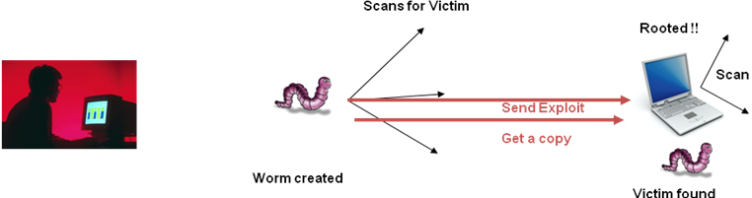

Some worm detection tools used:
Avira AntiVir Removal Tool for Windows 3.0.1.16:Avira AntiVir Removal Tool detects and eliminates Worm/Sober.J, Worm/Sober.P, Worm/Sober.Y and Worm/Stanit.A worms

W32/Sober Worm and its variants removal 3.0:W32/Sober Worm and its variants removal - removal tool will detect and remove W32/Sober Worm and its variants

Klez Removal Tool 1.0.11:Klez Removal Tool - removal for Klez worm

I-Worm.Zafi.b removal tool 12.0.0.0:I-Worm.Zafi.b removal tool- removal tool for I-Worm.Zafi.b and I-Worm.Bagle.at,au
Microsoft Blaster Worm Removal Tool for Win2k/XP:Microsoft Blaster Worm Removal Tool is a removal tool for the MSBlast worm

W32.Blaster.Worm Removal Tool 1.0.6.1:Removal tool to clean the W32.Blaster.Worm infections (fix the RPC vulnerability)

W32.Welchia.Worm Removal Tool 1.06:W32.Welchia.Worm Removal Tool .
AVIRA Removal Tool for Windows 3.0.1.16:Avira AntiVir Removal Tool detects and eliminates Worm/Sober.J, Worm/Sober.P, Worm/Sober.Y and Worm/Stanit.A worms

Blaster Worm Removal Tool 1.0.6.1:Removal tool to clean the W32.Blaster.Worm infections

Existing System:
- In previous simulation model uses a combination of the deterministic epidemic model and a general stochastic epidemic model to model the effect of large-scale worm attacks.
- In an Existing system the complexity of the general stochastic epidemic model makes it difficult to derive insightful results that could be used to contain the worm.
- In a previous study it is used to detect the presence of a worm by detecting the trend, not the rate, of the observed illegitimate scan traffic.
- The filter is used to separate worm traffic from background non worm scan traffic.

Drawbacks of Existing System:
- Very complex.
- By the time the worm is recognized it leads to lot of damage because of the fastness of worm propagation.

For example,consider the Code Red worm Version 2 that exploited a buffer overflow vulnerability in the Microsoft IIS Webservers. It was released on19 July 2001 and over a period of less than 14 hours infected more than 359,000 machines.

Proposed System:
- This model leads to the development of an automatic worm containment strategy that prevents the spread of a worm beyond its early stage.
- Specifically, for uniform scanning worms, we are able to
  - Provide a precise condition that determines whether the worm spread will eventually stop.
  - Obtain the distribution of the total number of hosts that the worm infects.
- We obtain the probability that the total number of hosts that the worm infects is below a certain level, as a function of the scan limit.
- Our strategy can effectively contain both fast scan worms and slow scan worms without knowing the worm signature in advance or needing to explicitly detect the worm.
- We restrict the total number of scans per host to the dark-address space.

Advantages of Proposed System:
- Early containment helps in saving lots of damage.
- It can effectively contain both fast scan worms and slow scan worms without knowing the worm signature in advance or needing to explicitly detect the worm.
- we also obtain the probability that the total number of hosts that the worm infects is below a certain level, as a function of the scan limit.
- Using the branching process model, we are able to provide a precise bound on the total number of scans that ensure that the worm will eventually die out.

Modules of the Project
- Designing UserInterface and reports
- Scanning worms
- Containment of worms

Module Description:
Designing User Interface and reports :
In this module we design the user interface for all the hosts. We design the user interface in a graphical manner or GUI. By showing the output in GUI gives more attractive and understandable to everyone. we design the containment window to show the scanning, detection of worms. Report generation is also been done in this module. Thus we design the whole user interface in this module.

Scanning worms:
Our strategy is based on limiting the number of scans to dark-address space. The limiting value is determined by our analysis. Our automatic worm containment schemes effectively contain both uniform scanning worms and local preference scanning worms, and it is validated through simulations and real trace data to be non-intrusive.The model is developed for uniform scanning worms and then extended to preference scanning worms. We detect these two worms and categorize it in this module.

Containment of worms
This model leads to the development of an automatic worm containment strategy that prevents the spread of a worm beyond its early stage. Specifically, for uniform scanning worms, we are able to
- Provide a precise condition that determines whether the worm spread will eventually stop.
- Obtain the distribution of the total number of hosts that the worm infects.

Technique used:
Branching Process Model:
To the problem of combating worms, we have developed a branching process model to characterize the propagation of Internet worms. Unlike deterministic epidemic models studied in the literature, this model allows us to characterize the early phase of worm propagation
Scanning worms are those that generate a list of random IP addresses to scan from an infected host. The uniform scanning worms are those in which the addresses are chosen completely randomly while preference scanning worms weigh the probability of choosing an address from different parts of the network differently. In this project we first describe the model for uniform scanning worms, and then, we present the extension for preference scanning worms. In our model, a host under consideration is assumed to be in one of three states: susceptible, infected, or removed. An infected host generates a list of random IP address to scan. If a susceptible host is found among the scans, it will become infected. A removed host is one that has been removed from the list of hosts that can be infected.

FEASIBILITY STUDY

A Feasibility Study is a preliminary study undertaken before the real work of a project starts to ascertain the likely hood of the projects success. It is an analysis of possible alternative solutions to a problem and a recommendation on the best alternative.

Economic Feasibility
Technical Feasibility
Operational Feasibility

Economic Feasibility: It is defined as the process of assessing the benefits and costs associated with the development of project. A proposed system, which is both operationally and technically feasible, must be a good investment for the organization.

The technology used also freeware,can be obtained through any web browser with free of cost and can can be learnt providing very low cost. Not much sophisticated computer hardware is required. It is a simulation model so there is no need to maintain the network cost. So it is economically feasible. With the proposed system the cost estimated for developing a project is affordable

Technical Feasibility: The technical feasibility infers whether the proposed system can be developed considering the technical issues like availability of the necessary technology, technical capacity, adequate response and extensibility.

The project is decided to build using Java Technology which can be easily accessed through any web browser. This system uses Advanced Java Components which implements code behind functionality for implementing the business logic. It also controls the access and other security requirements. Java can be easily learned. As all the resources available to build the system therefore the proposed system is technically feasible.

Operational Feasibility: Operational feasibility is defined as the process of assessing the degree to which a proposed system solves business problems or takes advantage of business opportunities.

The system is self-explanatory and doesn’t need any extra sophisticated training. The system has been built by concentrating on the graphical user interface concepts. The application can be handled very easily with a novice user. The overall time that a user needs to get trained is very less. As the software that is used for developing this application is very economical and is readily available in the market the only time that is lost by the customer is just installation time. Therefore the proposed system is operationally feasible.

COST AND SCHEDULE ESTIMATION

Function Point Model

This class of models usually referred to as Albrecht’s function points is related to requirement specification document where the functionality of a software system is determined.
The starting point of the construction of the model is to determine a number of items occurring in the system.

External Inputs: - External inputs are the inputs from the user that provide distinct application oriented data.
External Outputs: - External outputs are directed to the user; they come in the form of various reports and messages.
User Inquiries: - User inquiries are interactive inputs requiring a response.
External Files: - External files deal with all machine readable interfaces to other systems.
Internal Files: - Internal files are the master files in the system.
To accommodate various levels of complexity of each sub function, one adds a subjective complexity rating. The rating includes three levels of complexity:
- Simple
- Average
- Complex.

The suggested mapping of three levels on a numerical scale is shown next.
Item | Simple | Average | Complex
External Input | 3 | 4 | 6
External Output | 4 | 5 | 7
User Inquiry | 3 | 4 | 6
External interface File | 7 | 10 | 15
Logical Internal File | 5 | 7 | 10

This model is used to estimate cost and schedule of the project using its requirement.Each function has different values at each complexity level. The unadjusted function count (UFC) is determined by counting the number of items falling under these categories and combining them additively using the corresponding weight factors:

Functions | CountValue | AverageWeightingFactor
Number of External inputs | 10 | 04
Number of External outputs | 07 | 05
Number of External Inquiries | 03 | 04
Internal logical Records/files | 00 | 10
External interface Records/files | 01 | 07

External Inputs:

- Enter type of worm to spread
- Click on OK button
- Click on startspreading
- Click on stopspreading
- Click on startscanning
- Click on stopscanning
- Click on containmentON
- Click on ContainmentOFF
- Click on Delete button
- Click on Quarantine button
External Outputs:
- Showing Worm Spread
- Showing details of worm spread such as no of hosts infected,time etc
- Showing Worm Scanning status such as worm found etc
- Containment details
- Showing status information
- Worm deletion information
- Showing system is free of worms information
External Enquiries:
- User interacts with the System.
- Scanning depends on Spreading.
- Containment depends on Scanning.
External Interface files:
- CD ROM
UFC=item_{i} * W_{i}
UFC=10*4+7*5+3*4+0*10+1*7
=94
During the second phase, the function points count is further
refined by including a technical complexity factor (TCF)

producing the adjusted cost function count FP:
FP=UFC * TCF
The TCF is calculated as
TCF=0.65+0.01*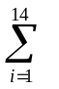f_{i}
Factors Contributing TCF
- Reliable backup and recovery
- Distributed functions
- Heavily used configuration
- Operational use
- Complex interface
- Reusability
- Multiple sites
- Data communications
- Performance
- Online data entry
- Online update
- Complex processing
- Installation ease
- Facilitate change
Each factor is rated on 0 to 5 scales with 0- irrelevant, 1-incidental, 2-moderate, 3-average,4-significant, and 5-essential.
Technical Complexity Factors:
- Reliable backup and recovery=3
- Distributed functions=3
- Heavily used configuration=2
- Operational use=4
- Complex interface=3
- Reusability =3
- Multiple sites=2
- Data communications=2
- Performance=5
- Online data entry=3
- Online update=3
- Complex processing=3
- Installation case=3
- Facilitate change=4

TCF= 0.65+0.01*43
TCF=1.08
Function Points (FP) =UFC*TCF
FP=94*1.08=101.52
FP101 fp
Calculation of Project Cost:
Project Cost=planning cost + number of function points * cost per function point
Project Cost = 3000 + 101 *300
Project Cost = 3000 + 30,300
Project Cost = Rs 33,300/-
Therefore the cost of the project is: Rs. 33,800/-

COCOMO MODEL
Constructive Cost Mode(COCOMO ) developed by Boehm. This model is used for estimating Effort (person-months), Development time (months) , number of persons and cost of the project.
COCOMO consists of a hierarchy of three increasingly detailed and accurate forms. The first level, Basic COCOMO is good for quick, early, rough order of magnitude estimates of software costs, but its accuracy is limited due to its lack of factors to account for difference in project attributes (Cost Drivers). Intermediate COCOMO takes these Cost Drivers into account and Detailed COCOMO additionally accounts for the influence of individual project phases.
COCOMO applies to three classes of software projects:
- Organic projects - are relatively small, simple software projects in which small teams with good application experience work to a set of less than rigid requirements.
- Semi-detached projects - are intermediate (in size and complexity) software projects in which teams with mixed experience levels must meet a mix of rigid and less than rigid requirements.
- Embedded projects - are software projects that must be developed within a set of tight hardware, software, and operational constraints.
Here we use Intermediate COCOMO Model for cost estimation
Intermediate COCOMO:
The basic steps in this model are:
- Obtain an initial estimate of the initial effort from the estimate of thousands of delivered lines of Source code(KLOC).
- Determine a set of multiplying factors from different attributes of the project.
- Adjust the effort estimate by multiplying the initial estimate with all the multiplying factors.
Our proposed system(Modeling and Automated Containment of Worms) comes under Semi-detached model.
The minimum lines of code required for the development of the proposed system is 1500 i.e 1.5KLOC.
The initial effort E_{i} in person-month is calculated as
E_{i}=a*(KLoC)^{b}
where E_{i} is the effort applied in person-months, KLoC is the estimated number of thousands of delivered lines of code for the project.The coefficient a and the exponent b are given in the below table.
Software project | a | b
Organic | 3.2 | 1.05
Semi-detached | 3.0 | 1.12
Embedded | 2.8 | 1.20
Initial Effort E_{i}=3.0*(1.5)^{1.12}=4.7 person-months
Each of the 15 attributes receives a rating on a six-point scale that ranges from "very low" to "extra high" (in importance or value). An effort multiplier from the table below applies to the rating. The product of all effort multipliers results in an effort adjustment factor (EAF).
VL - Very Low, LO ( Low ),NM-Nominal, HI-High, VHI-Very High, EHI(Extra High)
Typical values for EAF range from 0.9 to 1.4
Attributes: |  | Ratings
Attributes: |  | VL | LO | NM | HI | VHI | EHI
Product attributes
Required software reliability |  | 0.75 | 0.88 | 1.00 | 1.15 | 1.40
Size of application database |  |  | 0.94 | 1.00 | 1.08 | 1.16
Complexity of the product |  | 0.70 | 0.85 | 1.00 | 1.15 | 1.30 | 1.65
Hardware attributes
Run-time performance constraints |  |  |  | 1.00 | 1.11 | 1.30 | 1.66
Memory constraints |  |  |  | 1.00 | 1.06 | 1.21 | 1.56
Volatility of the virtual machine environment |  |  | 0.87 | 1.00 | 1.15 | 1.30
Required turnabout time |  |  | 0.87 | 1.00 | 1.07 | 1.15
Personnel attributes
Analyst capability |  | 1.46 | 1.19 | 1.00 | 0.86 | 0.71
Applications experience |  | 1.29 | 1.13 | 1.00 | 0.91 | 0.82
Software engineer capability |  | 1.42 | 1.17 | 1.00 | 0.86 | 0.70
Virtual machine experience |  | 1.21 | 1.10 | 1.00 | 0.90
Programming language experience |  | 1.14 | 1.07 | 1.00 | 0.95
Project attributes
Use of software tools |  | 1.24 | 1.10 | 1.00 | 0.91 | 0.82
Application of software engineering method |  | 1.24 | 1.10 | 1.00 | 0.91 | 0.83
Required development schedule |  | 1.23 | 1.08 | 1.00 | 1.04 | 1.10

Product Attributes:
Required reliability (RELY): It is used to express an effect of software faults ranging from slight inconvenience (VL) to loss of life (VH). The nominal value (NM) denotes moderate recoverable losses.
Data bytes per DSI (DATA): The lower rating comes with lower size of a database.
Complexity (CPLX): The attribute expresses code complexity again ranging from straight batch code (VL) to real time code with multiple resource scheduling (XH).

Computer Attributes
Execution time (TIME) and memory (STOR) constraints: This attribute identifies the percentage of computer resources used by the system. NM states that less than 50% is used; 95% is indicated by XH.]
Virtual machine volatility ( VIRT): It is used to indicate the frequency of changes made to the hardware, operating system, and overall software environment. More frequent and significant changes are indicated by higher ratings.
Development turnaround time (TURN): This is a time from when a job is submitted until output becomes received. LO indicated a highly interactive environment, VH quantifies a situation when this time is longer than 12 hours.
Personal attributes:
Analyst capability (ACAP) and programmer capability (PCAP): describe skills of the developing team. The higher the skills the higher the rating.
Application experience (AEXP), language experience (LEXP), and virtual machine experience (VEXP): These are used to quantify the number of experience in each area
by the development team; more experience, higher rating.
Project attributes:
Modern development practices (MODP): deals with the amount of use of modern software practices such as structural programming and object oriented approach.
Use of software tools (TOOL): is used to measure a level of sophistication of automated tools used in software development and a degree of integration among the tools being used. Higher rating describes levels in both aspects.
Schedule effects (SCED): concerns the amount of schedule compression ( HI or VH), or schedule expansion (LO or VL) of the development schedule in comparison to a nominal (NM) schedule.
The attributes required in our system are as follows:
Attributes: |  |  |  |  | Ratings
 |  |  |  |  | VL | LO | NM | HI | VHI | EHI
Product attributes
Required software reliability |  |  |  |  |  |  | 1.00
Size of application database |  |  |  |  |  | 0.94
Complexity of the product |  |  |  |  |  |  | 1.00
Hardware attributes
Run-time performance constraints |  |  |  |  |  |  |  | 1.11
Memory constraints |  |  |  |  |  |  | 1.00
Volatility of the virtual machine environment |  |  |  |  |  |  | 1.00
Required turnabout time |  |  |  |  |  | 0.87
Personnel attributes
Analyst capability |  |  |  |  |  |  |  | 0.86
Applications experience |  |  |  |  |  |  | 1.00
Software engineer capability |  |  |  |  |  | 1.17
Virtual machine experience |  |  |  |  |  |  | 1.00
Programming language experience |  |  |  |  |  |  | 1.00
Project attributes
Use of software tools |  |  |  |  |  |  |  | 0.91
Application of software engineering methods |  |  |  |  |  | 1.10
Required development schedule |  |  |  |  |  |  | 1.00
EAF(Effort Adjustment Factor) is calculated by multiplying the above attributes EAF=1.00*0.94*1.00*1.11*1.00*1.00*0.87*0.86*1.00*1.17*1.00*1.00*0.91*1.10*1.00=0.91
Effort estimate is calculated as
E=E_{i} *EAF
E=4.7*0.91=4.3 person-months
Development time is calculated as
D_{Time}=2.5E^{.38}
D_{Time}=4.3 months
≈4 months

Number of persons=E/D_{Time}
No. of persons=4.3/4=1.075 ≈ 1 person
Cost per programmer=Rs 8000/-
Planning Cost=Rs 3000/-

Total project Cost=E*programmer cost + planning cost
=4.3*8000+3000=Rs 37,400/-

SOFTWARE REQUIREMENT SPECIFICATION
Contents
1. Introduction
1.1. Purpose
1.2. Scope
1.3. Definitions, Acronyms, Abbreviations
1.4. References
1.5. Overview
2. Overall Description
2.1. Product Perspective
2.2. Product Function
2.3. User Characteristics
2.4. Constraints
2.5. Assumptions and Dependencies
3. Specific Requirements
3.1. Interface Requirements
3.2. Functional Requirements
3.3. Performance Requirements
3.4. Logical Database Requirements
3.5. Design Constraints
3.6. Software System Attributes
4. Supporting Information

1. INTRODUCTION
1.1. Purpose:
The purpose of the proposed system is to provide network security, Containing the worms can be applied in any networks to contain the worms. Because worms will not allow the network give its full performance. It degrades the network’s performance. It will use the network for its propagation. Thus in order to use the network efficiently and effectively we need to contain the propagation of worms inside our network. Thus containment of worms can be used in office networks, military networks, etc. Generally it can be used in any networks to avoid worm propagation.

1.2. Scope:
In this project we are going model a worm and show the propagation of worms. Then we design a containment which is automated and it is used to contain the spreading of worms beyond its early stages. Thus this project can be used understand the worm propagation. This can be useful to design an Antivirus technique to contain worms. Thus our project can be used in the domain of Network Security. The System is generic and can be delivered to any client who wishes to provide security from worms connected over network.

1.3. Definitions, Acronyms, and Abbreviations
1.3.1. Definitions:
Software Requirements Specification: It’s a description of a particular software product, program or set of programs that performs a set of function in target environment.
Propagation:it deals with worm spreading
Scanning:scans to know whether the worm is present , detect and categorize whether it is uniform scanning worms or preference scanning worms.
containment: prevents the spread of a worm beyond its early stage
JFRAMEBUILDER: JFrameBuilder is an easy – to – use visual Java GUI Builder for Java Swing applications. It provides the application GUI solution for Java developers
1.3.2. Acronyms and Abbreviations:
GUI: Graphical User Interface
SRS:Software requirement specification
1.4. References:
- IEEE std 830-1993, IEEE Recommended practice for Software Requirements Specifications.
- H. Andersson and T. Britton, “Stochastic Epidemic Models and Their Statistical Analysis, ” Lecture Notes in Statistics, vol. 151, 2000.
- James F.peters, Witold Pedrycz, “Software Engineering an Engineering Approach”.
- Google, URL: http://www.google.co.in
1.5. Over view:
- The SRS for this project build in the IEEE format.
- It constitutes of four sections ,of which the very first section deals with Introduction.
- The second section is of Overall description of the project. The third section deals with specific requirements.
- The fourth section constitutes of index.
2. OVERALL DESCRIPTION:
2.1. Product Perspective:
The goal of this project is to provide a model for the propagation of random scanning worms and the corresponding development of automatic containment mechanisms that prevent the spread of worms beyond their early stages. This containment scheme is then extended to protect an enterprise network from a preference scanning worm.
2.2. Product Functions:
This proposed system performs several functions such as:

- It can stop the spreading of worms automatically.
- Scanning of worms
- Detecting and categorizing the worms
- Containment of worms manually can also be done.

2.3 User Characteristics:
- The User should have a basic knowledge of worms.
- User has full access to all modules of the system
2.4 Constraints:
- It should provide user friendly GUI environment.
- It should provide a low limiting value so that the systems effected by worms should be less.
- It should provide early containment strategy.
- It should maintain status information to see whether the worm is been detected or contained.
2.5 Assumptions and dependencies:
- The system should be user friendly as much as possible.
- Our strategy is based on limiting the number of scans to dark-address space.
- Branching process model is been used in this system.
3. SPECIFIC REQUIREMENTS:
3.1 Interface Requirements:
It has different interfaces which are used in the system.
3.1.1. User Interfaces:
The User Interfaces will be a JFRAMEBUILDER designed screen. JFrameBuilder is an easy-to-use visual Java GUI Builder for Java Swing applications. It provides the application GUI solution for Java developers

3.1.2. Hardware Interface:
A pc with configuration mentioned below or greater than specifiec must be connected over network.
- 20 GB hard disk
- 512 MB RAM
- P4 processor
3.1.3. Software Interface:
- Java , Swings
- windows xp/2000
- JFRAMEBUIDER
3.1.4. Communication Interface:
- Socket programming
3.2. Functional Requirements:
NO. | Requirements | Essential/desirable | Description
RS1 | Facility to stop the spreading of worms automatically | Essential | Worms spreading is been stopped.
RS2 | Facility to Scanning | Essential | Scanning is done to know whether worm is present.
RS4 | Facility to detect and categorize the worms | Desirable | To detect and categorize as uniform scanning worms and preference scanning worms.
RS4 | Facility of containment of worms manually | Essential | Containment at early stage is done.
3.3. Performance Requirements:
- The system should be reliable fast and must produce expected results.
- The system should be at 95% of the time , the result should get at less than 2 sec speed.
- It should be efficient.
3.4. Design Constraints:
- The proposed systems strategy is based on limiting the number of scans to dark-address space.
3.5. Software System Attributes:
- 3.5.1. Reliability: The system is reliable and produces accurate resulting from implementation.
- 3.5.2. Maintainability: The system will be designed as an closed system. New methods can be added easily with little or no changes in the existing architecture.
- 3.5.3. Portability: The system should be portable. It can be deployed on any platform and it should be used on all platforms.
4. SUPPORTING INFORMATION:
4.1. Keyword Index:
Keyword SRS Section
Containment 1.1
Scanning 3.2
Detecting & categorizing 3.2
GUI 3.1.1
JFRAMEBUILDER 1.3.2
Swing 3.1.3

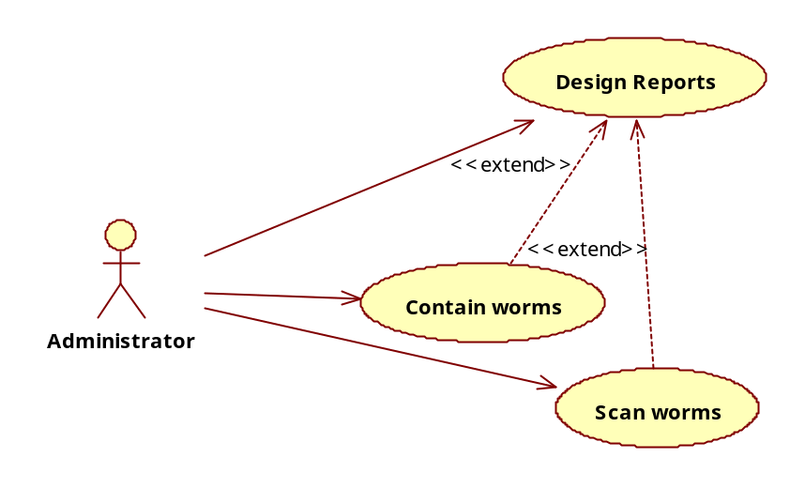
USECASE SPECIFICATION FOR THE USECASE DESIGN REPORTS:

- Name: Design Reports

Participating Actors: Administrator

Description: this usecase is meant for designing the UserInterface and reports.

Main flow :
- In this we design the user interface for all the hosts.
- We design the user interface in a graphical manner or GUI. By showing the output in GUI gives more attractive and understandable to everyone.
- we design the containment window to show the scanning, detection of worms.
- Report generation is also been done in this usecase only.

.Post Condition: If the above steps are successfully completed, user Interface is designed.

USECASE SPECIFICATION FOR THE USECASE SCAN WORMS:

- Name: Scan worms

Participating Actors: Administrator

Description: this usecase is meant for Scanning, detecting and categorizing the worms

Main flow :
- Scanning of worms is done to know whether worm is present.
- Detects the worms.
- Categorize the worms whether they are uniform scanning worms or preference scanning worms.
- If worm is present it deletes the worm.

Post Condition: If the above steps are successfully completed worms are been deleted.

USECASE SPECIFICATION FOR THE USECASE CONTAIN WORMS:

- Name : Contain worms

Participating Actors: Administrator

Description: This usecase is meant for automatic containment of worms.

Main flow:
- preventing the spread of worm at the early stage is done.
- Automatic worm stoppage is to be done.
- Manual containment of worms if it is not stopped at early stage , is to be done.

Post Condition: If the above steps are successfully completed the worm is contained and the status information is displayed in confirmation.

ACTIVITY DIAGRAMS
ACTIVITY DIAGRAM FOR USECASE DESIGN USERINTERFACE AND REPORTS:
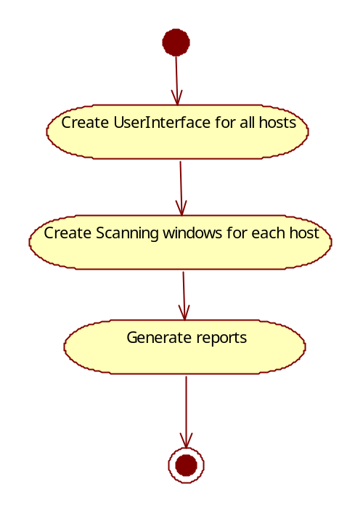

ACTIVITY DIAGRAM FOR THE USECASE SCAN WORM:
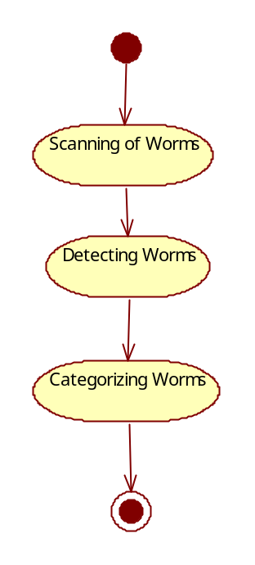

ACTIVITY DIAGRAM FOR THE USECASE CONTAIN WORMS:
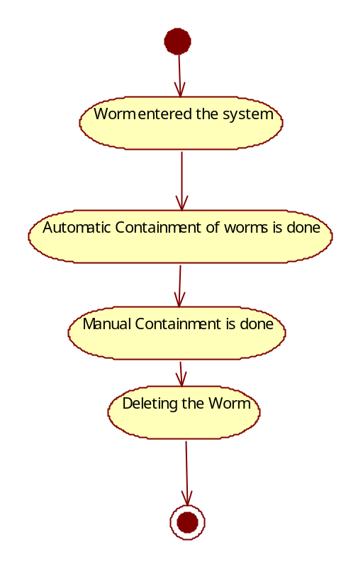

SEQUENCE DIAGRAMS
SEQUENCE DIAGRAM FOR USERINTERFACE:

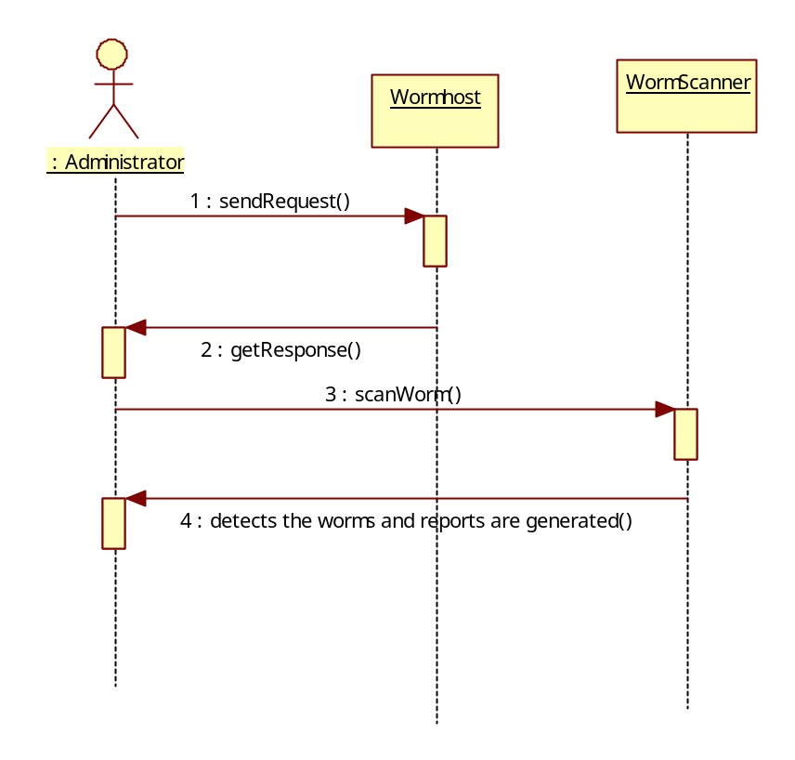

SEQUENCE DIAGRAM FOR SCANNING WORMS:
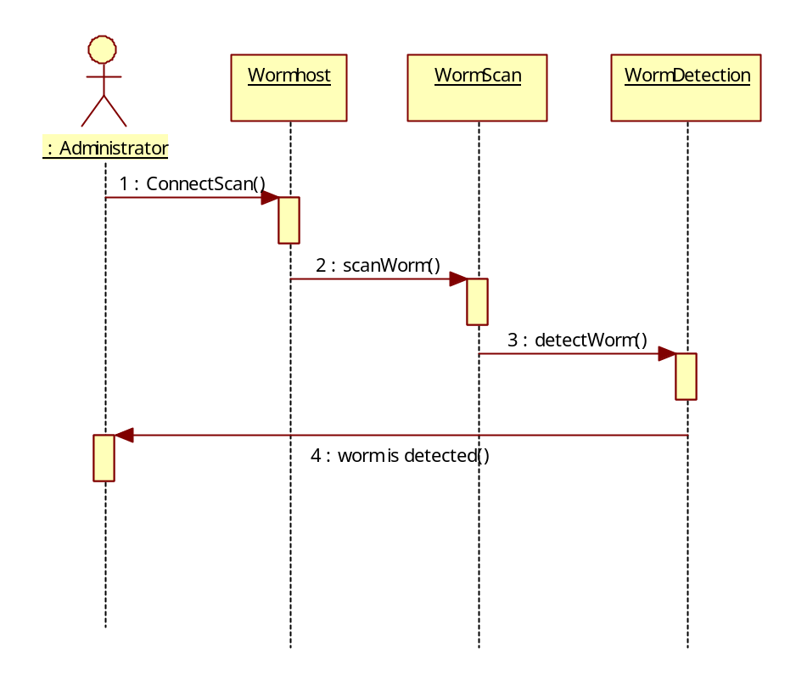

SEUENCE DIAGRAM FOR CONTAINING WORMS:
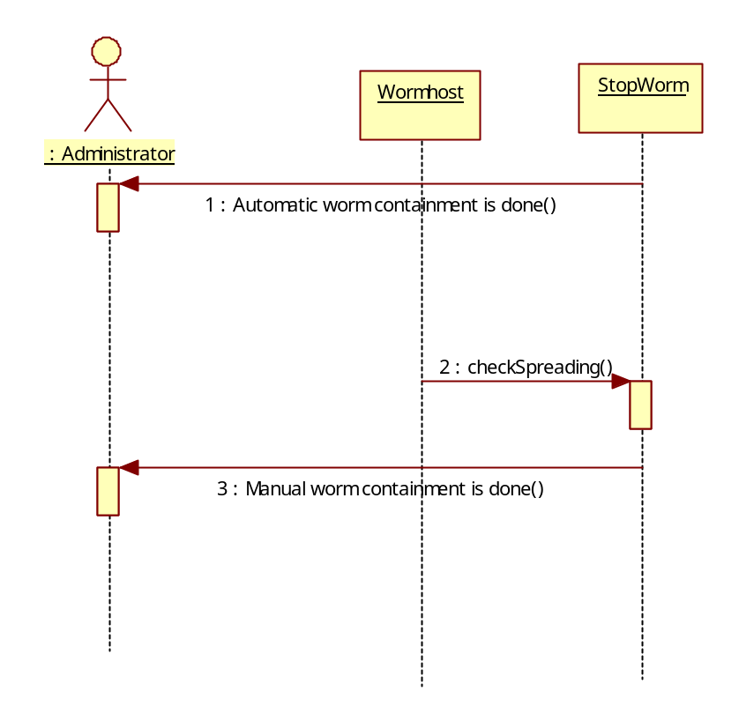

CLASS DIAGRAM
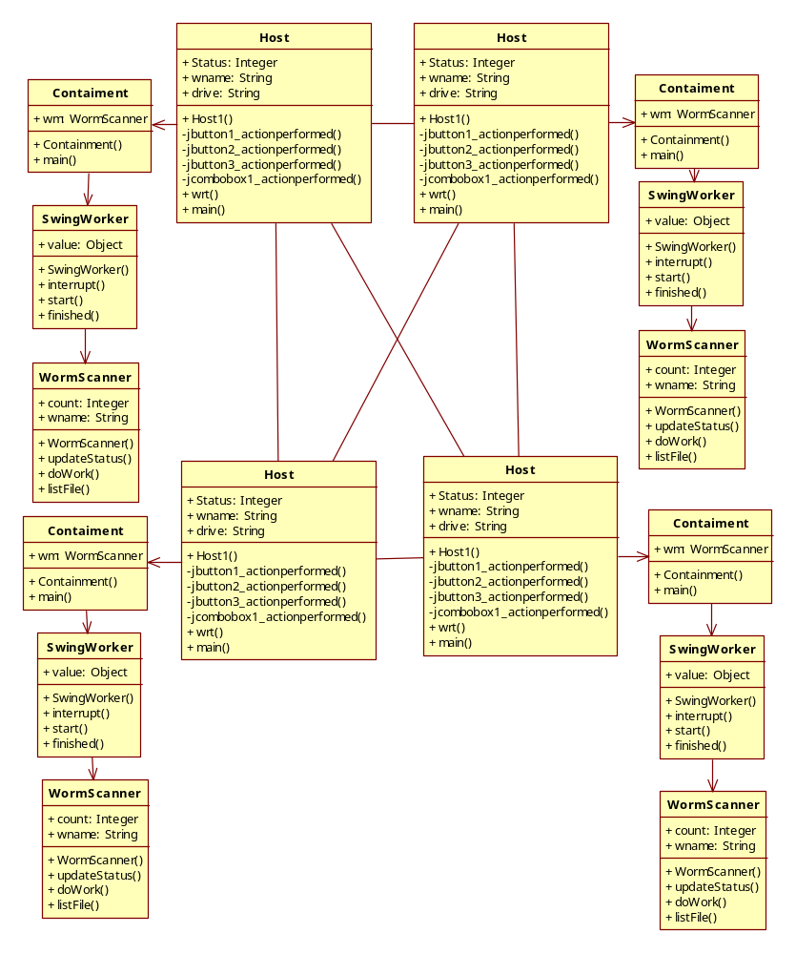

System Requirements
Software Requirements:
FRONT END : JAVA, SWING
TOOLS USED : JFRAME BUILDER
OPERATING SYSTEM : WINDOWS XP

Hardware Requirements:
PROCESSOR : PENTIUM IV 2.6 GHz
RAM : 512 MB
HARD DISK : 20 GB

TFeatures of Software:
JAVA:
Java is a high-level programming language which consists of the following features:
• Simple | • Architecture-neutral
• Object-oriented | • Portable
• Distributed | • High-performance
• Interpreted | • Multithreaded
• Robust | • Dynamic
• Secure
Each Java program is both compiled and interpreted. With a compiler, you translate a Java program into an intermediate language called Java bytecodes--the platform-independent codes interpreted by the Java interpreter. With an interpreter, each Java bytecode instruction is parsed and run on the computer. Compilation happens just once; interpretation occurs each time the program is executed. This figure
illustrates how this works. 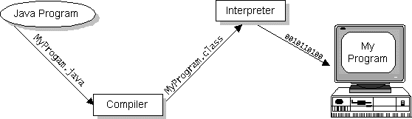
Java Compilation
You can think of Java bytecodes as the machine code instructions for the Java Virtual Machine (Java VM). Every Java interpreter, whether it's a Java development tool or a Web browser that can run Java applets, is an implementation of the Java VM. The Java VM can also be implemented in hardware.
Java bytecodes help make "write once, run anywhere" possible. You can compile your Java program into bytecodes on any platform that has a Java compiler. The bytecodes can then be run on any implementation of the Java VM. For example, the same Java program can run on Windows NT, Solaris, and Macintosh.

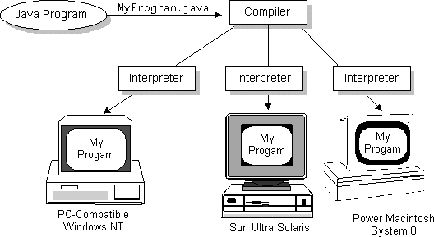

The Java Platform:
A platform is the hardware or software environment in which a program runs. The Java platform differs from most other platforms in that it's a software-only platform that runs on top of other, hardware-based platforms. Most other platforms are described as a combination of hardware and operating system.
The Java platform has two components:
- The Java Virtual Machine (Java VM)
- The Java Application Programming Interface (Java API)
SWING:
The Swing toolkit includes a rich set of components for building GUIs and adding interactivity to Java applications. Swing includes all the components you would expect from a modern toolkit: table controls, list controls, tree controls, buttons, and labels. Swing is far from a simple component toolkit, however. It includes rich undo support, a highly customizable text package, integrated internationalization and accessibility support. To truly leverage the cross-platform capabilities of the Java platform, Swing supports numerous look and feels, including the ability to create your own look and feel. The ability to create a custom look and feel is made easier with Synth, a look and feel specifically designed to be customized. Swing wouldn't be a component toolkit without the basic user interface primitives such as drag and drop, event handling, customizable painting, and window management.
Swing is part of the Java Foundation Classes (JFC). The JFC also include other features important to a GUI program, such as the ability to add rich graphics functionality and the ability to create a program that can work in different languages and by users with different input devices.
The Swing toolkit includes a rich array of components: from basic components, such as buttons and check boxes, to rich and complex components, such as tables and text. Even deceptively simple components, such as text fields, offer sophisticated functionality, such as formatted text input or password field behavior. There are file browsers and dialogs to suit most needs, and if not, customization is possible. If none of Swing's provided components are exactly what you need, you can leverage the basic Swing component functionality to create your own.
JFrame Builder:
JFrameBuilder is an easy – to – use visual Java GUI Builder for Java Swing applications. It provides the application GUI solution for Java developers. The Java GUI designer enables Java developers to create sophisticated GUI applications using drag-and-drop interface without spending a lot of time writing code.

Features:
- What you see is truly what you get.
- Generates human readable Java code.
- Generated Java code doesnt require any additional library to compile and run.
- Retrieves GUI design from Java source code.
- Sets component properties and event handling methods with easy understandable interface.
- Supports 4 kinds of layout manager for the JPanel.
- Ability to set Look&Feel at any time.

JFrameBuilder supports these components:
JFrame, JInternalFrame, JDialog, JSplitPane, JScrollPane, JabbedPane, JPanel, JSeparator, JProgressBar, JSlider, JSpinner, JTree, JTable, JList, JComboBox, JTextPane, JEditorPane, JTextArea, JPasswordField, JTextField, JLabel, JCheckBox, JRadioButton, JToggleButton, JButton

CONCLUSION

In this project, we have studied the problem of combating Internet worms. To that end, we have developed a branching process model to characterize the propagation of Internet worms. Unlike deterministic epidemic models studied in the literature, this model allows us to characterize the early phase of worm propagation.
Using the branching process model, we are able to provide a precise bound M on the total number of scans that ensure that the worm will eventually die out. Further, from our model, we also obtain the probability that the total number of hosts that the worm infects is below a certain level, as a function of the scan limit.
The insights gained from analyzing this model also allow us to develop an effective and automatic worm containment strategy that does not let the worm propagate beyond the early stages of infection. Our strategy can effectively contain both fast scan worms and slow scan worms without knowing the worm signature in advance or needing to explicitly detect the worm. We show via simulations and real trace data that the containment strategy is both effective and non-intrusive.

BIBLIOGRAPHY

- http://cobweb.ecn.purdue.edu/~dcsl/publications/papers/2005/worm.pdf
- http://en.wikipedia.org/wiki/Computer_worm
- http://ieeexplore.ieee.org/xpl/freeabs_all.jsp?arnumber=4358715
- https://www.cerias.purdue.edu/apps/reports_and_papers/view/3112/
- http://www2.computer.org/portal/web/csdl/doi/10.1109/TDSC.2007.70230
- http://www.google.co.in

