I have generated the jsonl file
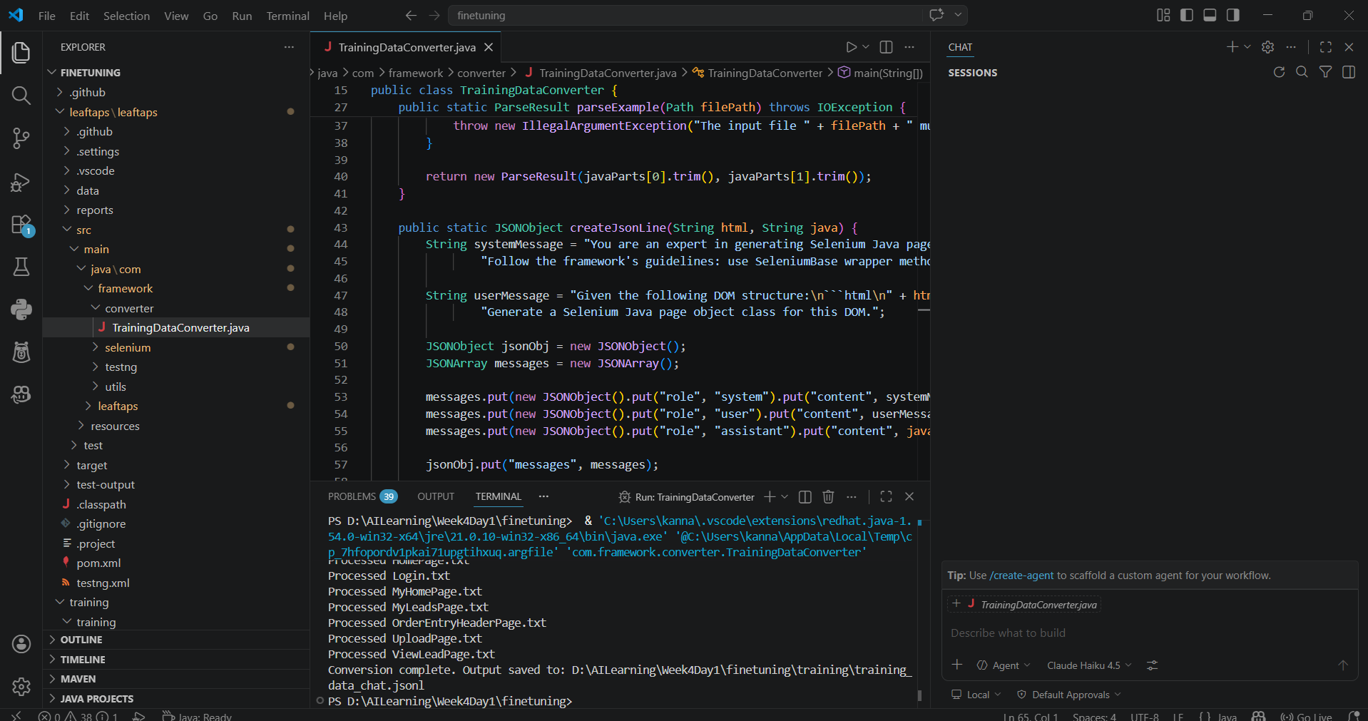
Jsonl file generated and placed
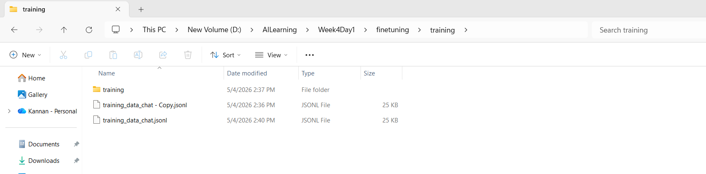
Create a finetune model with json file in Testleaf API

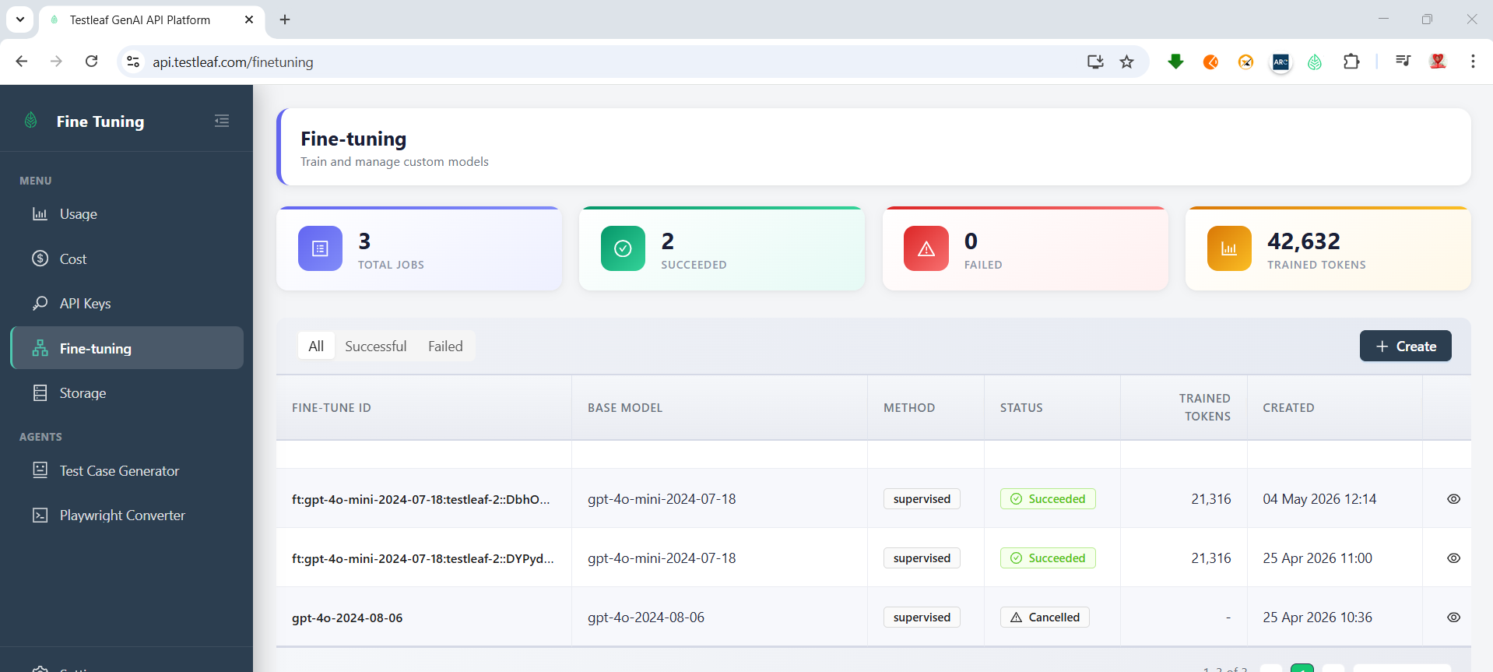
I have added this model details in ai-extension 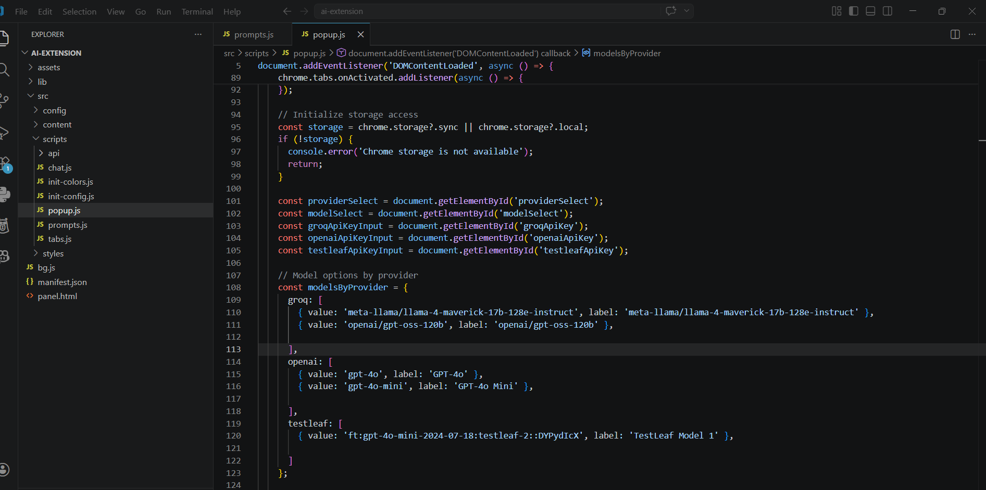

Remove and load the ai-extension again. Select the model which we have added
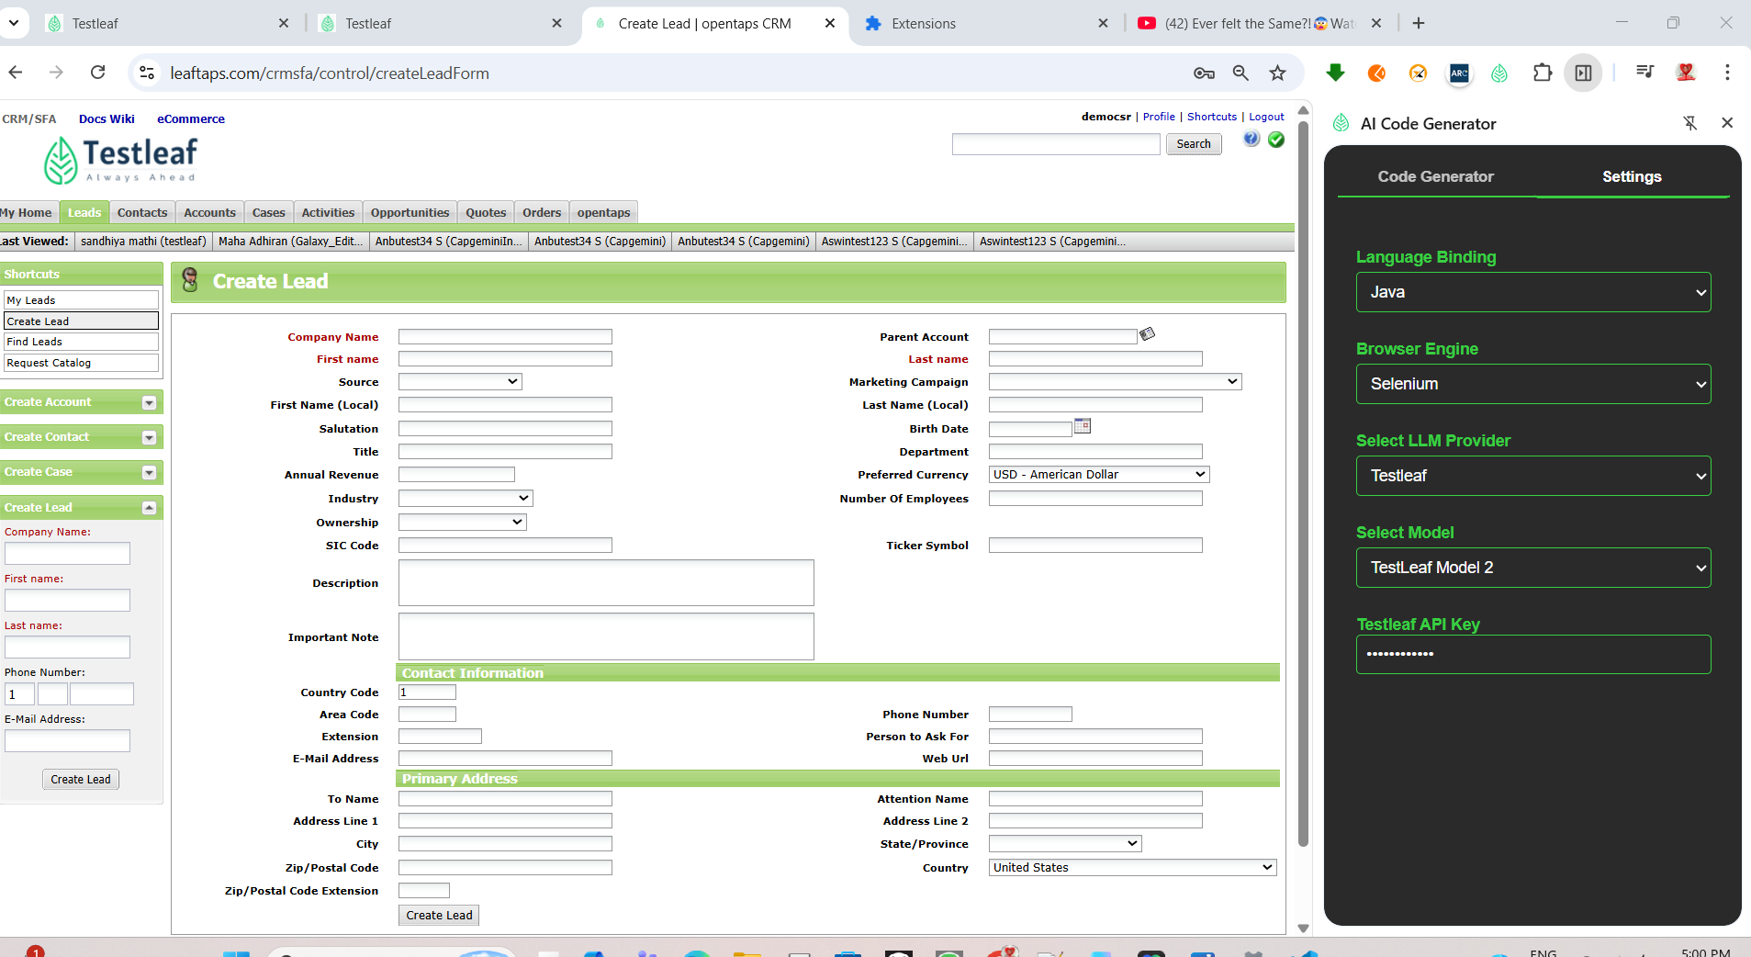

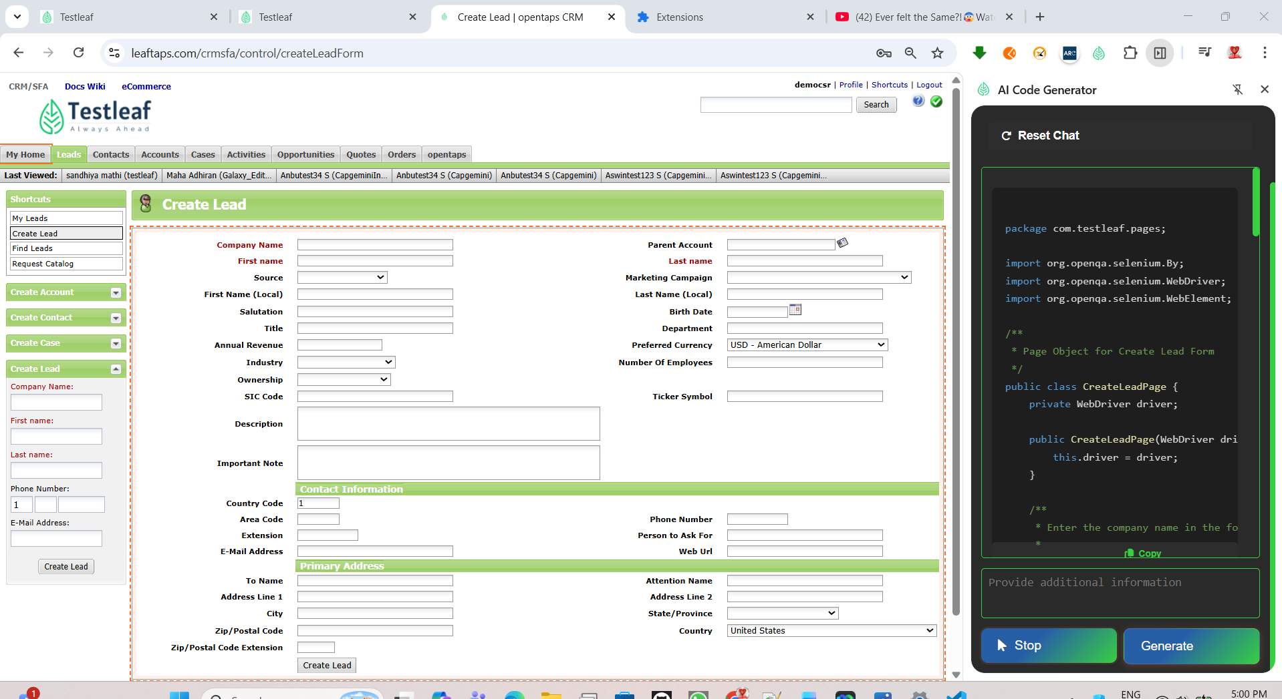
Response
package com.testleaf.pages;

import org.openqa.selenium.By;
import org.openqa.selenium.WebDriver;
import org.openqa.selenium.WebElement;

/**
* Page Object for Create Lead Form
*/
public class CreateLeadPage {
private WebDriver driver;

public CreateLeadPage(WebDriver driver) {
this.driver = driver;
}

/**
* Enter the company name in the form.
*
* @param companyName the company name to enter
*/
public void enterCompanyName(String companyName) {
WebElement companyNameField = driver.findElement(By.id("createLeadForm_companyName"));
companyNameField.clear();
companyNameField.sendKeys(companyName);
}

/**
* Enter the first name in the form.
*
* @param firstName the first name to enter
*/
public void enterFirstName(String firstName) {
WebElement firstNameField = driver.findElement(By.id("createLeadForm_firstName"));
firstNameField.clear();
firstNameField.sendKeys(firstName);
}

/**
* Enter the last name in the form.
*
* @param lastName the last name to enter
*/
public void enterLastName(String lastName) {
WebElement lastNameField = driver.findElement(By.id("createLeadForm_lastName"));
lastNameField.clear();
lastNameField.sendKeys(lastName);
}

/**
* Select the source from the dropdown.
*
* @param source the source to select
*/
public void selectSource(String source) {
WebElement sourceDropdown = driver.findElement(By.id("createLeadForm_dataSourceId"));
sourceDropdown.sendKeys(source);
}

/**
* Click on the Create Lead button to submit the form.
*/
public void clickCreateLeadButton() {
WebElement createLeadButton = driver.findElement(By.name("submitButton"));
createLeadButton.click();
}

/**
* Enter the primary phone number in the form.
*
* @param phoneNumber the phone number to enter
*/
public void enterPrimaryPhoneNumber(String phoneNumber) {
WebElement phoneNumberField = driver.findElement(By.id("createLeadForm_primaryPhoneNumber"));
phoneNumberField.clear();
phoneNumberField.sendKeys(phoneNumber);
}

/**
* Enter the primary email in the form.
*
* @param email the email to enter
*/
public void enterPrimaryEmail(String email) {
WebElement emailField = driver.findElement(By.id("createLeadForm_primaryEmail"));
emailField.clear();
emailField.sendKeys(email);
}

/**
* Enter the address line 1 in the form.
*
* @param addressLine1 the address line 1 to enter
*/
public void enterAddressLine1(String addressLine1) {
WebElement addressLine1Field = driver.findElement(By.id("createLeadForm_generalAddress1"));
addressLine1Field.clear();
addressLine1Field.sendKeys(addressLine1);
}

/**
* Enter the city in the form.
*
* @param city the city to enter
*/
public void enterCity(String city) {
WebElement cityField = driver.findElement(By.id("createLeadForm_generalCity"));
cityField.clear();
cityField.sendKeys(city);
}

/**
* Select the country from the dropdown.
*
* @param country the country to select
*/
public void selectCountry(String country) {
WebElement countryDropdown = driver.findElement(By.id("createLeadForm_generalCountryGeoId"));
countryDropdown.sendKeys(country);
}
}

